

**Name – Devashish Choudhary**

**Roll. No – R171218122**

**SAP ID – 500070510**

**DevOps Batch-2 (6th Semester)**

**Subject – Application Containerization**

**Experiment –** Working with Log Files in Docker

When you start a container, Docker will track the Standard Out and Standard Error outputs from the process and make them available via the client.

**Follow these steps below:**

1. So, there is an instance of Redis running with the name *redis-server*. Using the Docker client, we can access the standard out and standard error outputs using **docker logs redis-server**

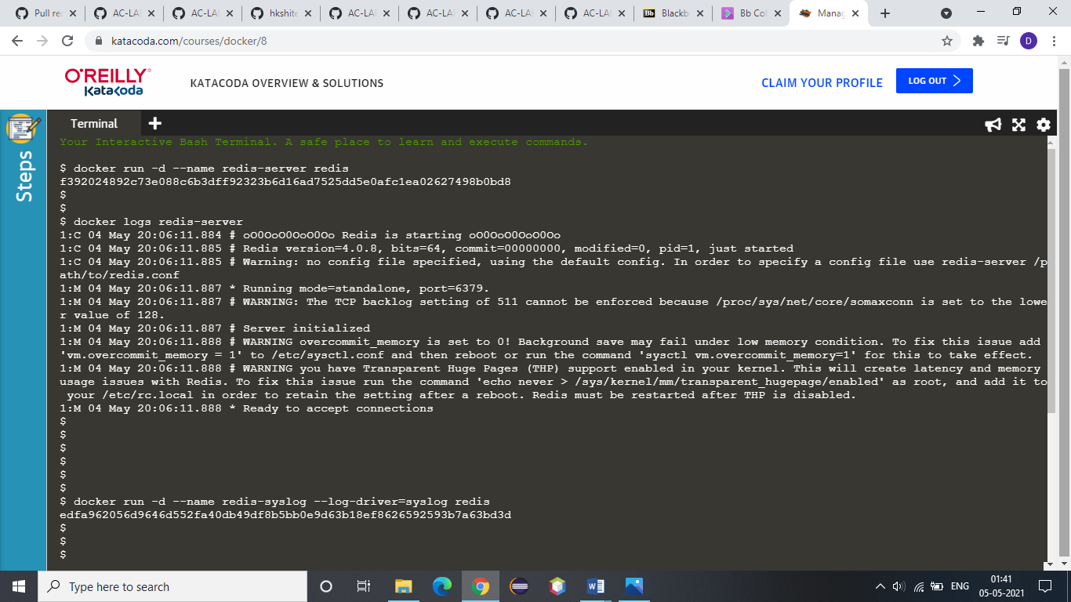

2. Now, studying the concept of syslog:

The Syslog log driver will write all the container logs to the central syslog on the host. The command below will redirect the redis logs to syslog.



3. Now, we are focusing on disabling the logging on the container. This is particularly useful for containers which are very verbose in their logging.



4. The *inspect* command allows you to identify the logging configuration for a particular container. The command below will output the LogConfig section for each of the containers.

a) Server created in step 1:

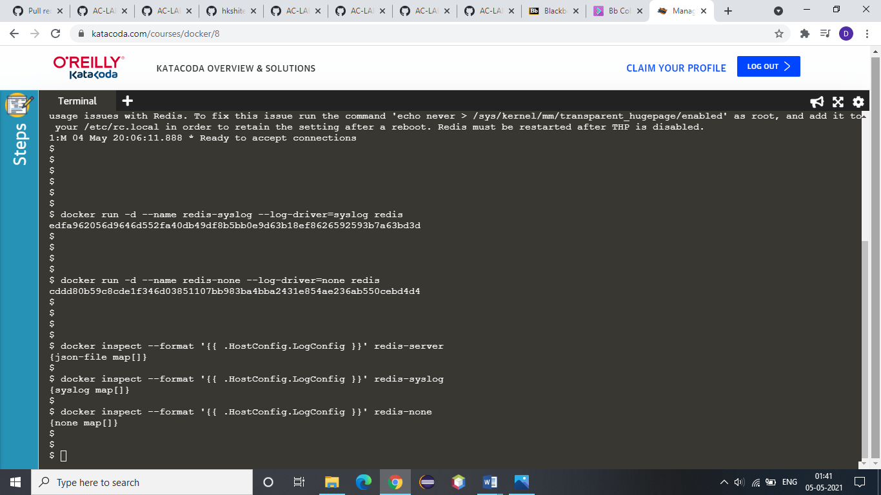

b) Server created in step 2:



c) Server created in Step 3:

