

EXPERIMENT-5

NAME- ISHITA BANSAL

ROLL NO -R171218124

SAP ID- 500071818

SUBMITTED TO-

MR. HITESH KUMAR SHARMA

AIM- CREATING A COMPOSE FILE

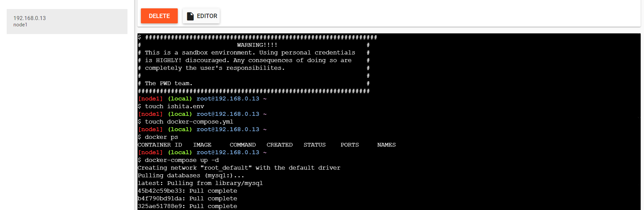

Create a ishita.env file and docker-compose.yml

