***Application containerization***

*Name – Ishita Bansal*

*Roll No - R171218124*

*Sap id - 500071818*

*Course – Devops Batch 2*

*Submitted To- Mr. Hitesh Kumar Sharma*

1. **COMMAND-: docker search redis**

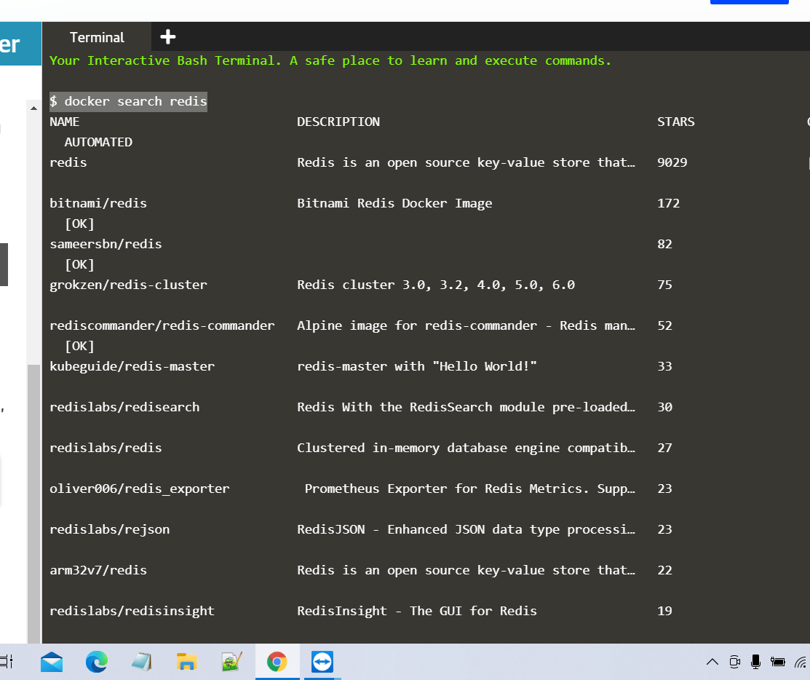

1. **COMMAND-: docker run –d redis**

