Application containerization

EXPERIMENT-4

Name - Ishita Bansal
Roll no. - R171218124
Sap id - 500071818
Course - Devops Batch 2
Submitted To - Mr. Hitesh Kumar Sharma

1) To Create Network-

docker network create “network_name”

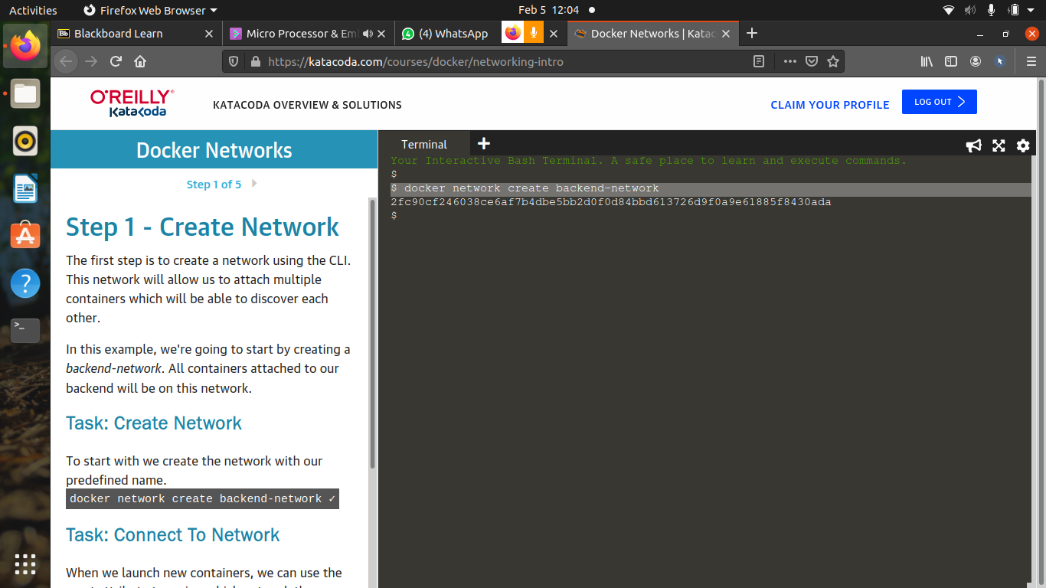

2) To list the network-
docker network ls

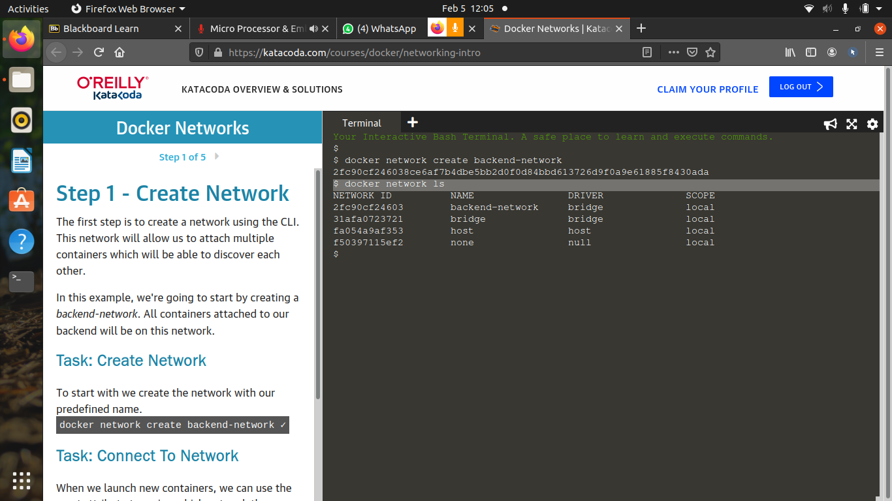

3)To connect the network to a container-
docker run -d –name=”container_name” –net=”network_name” “container_name”

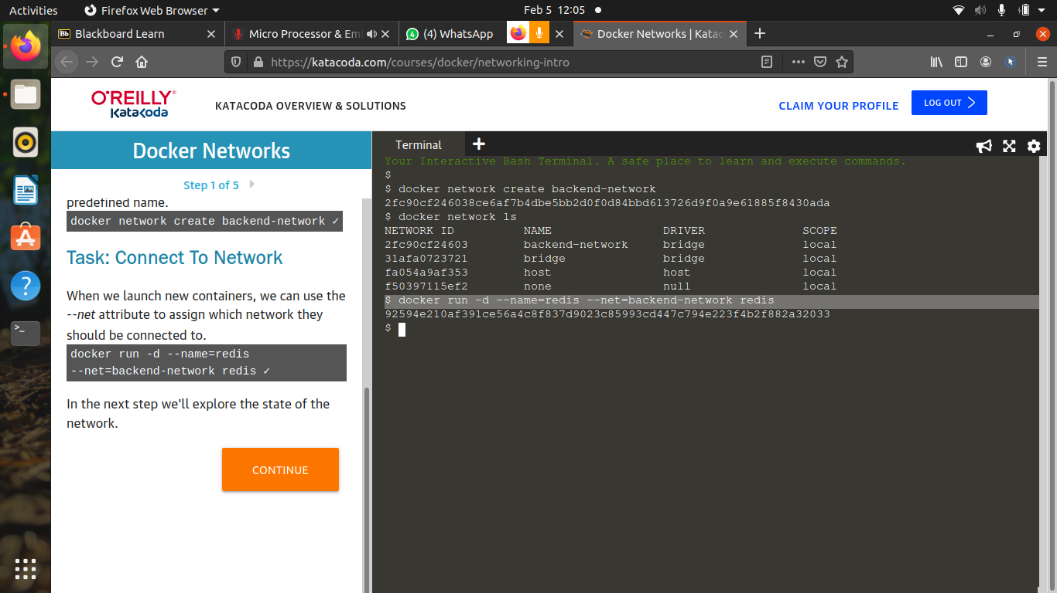
4) To ckeck the container-
docker ps

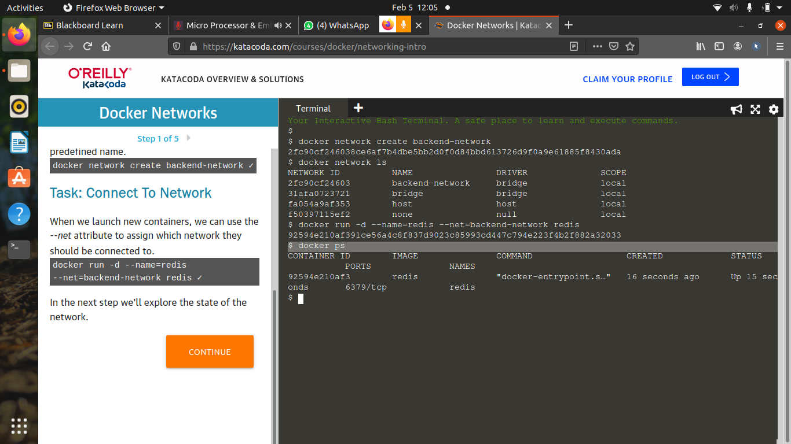
5) For network communication-

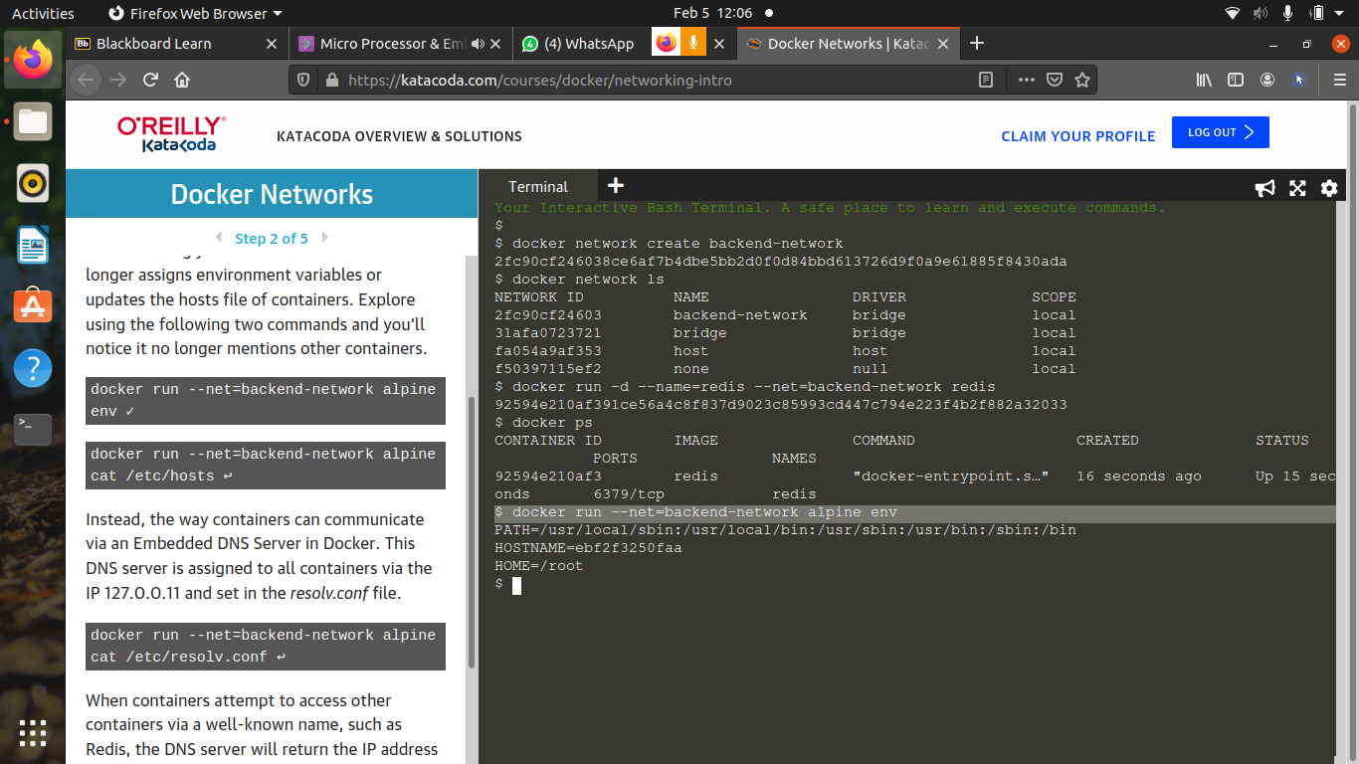
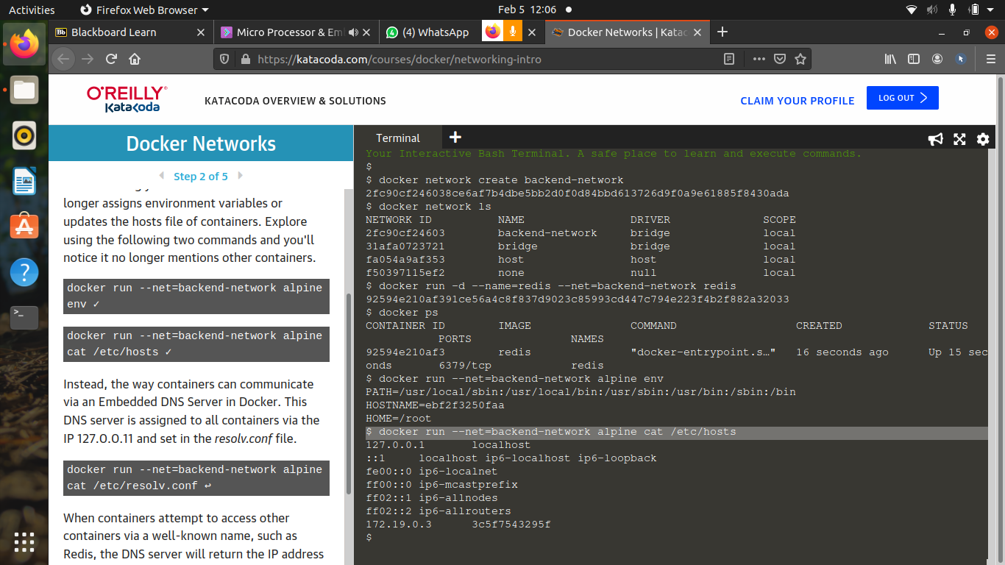
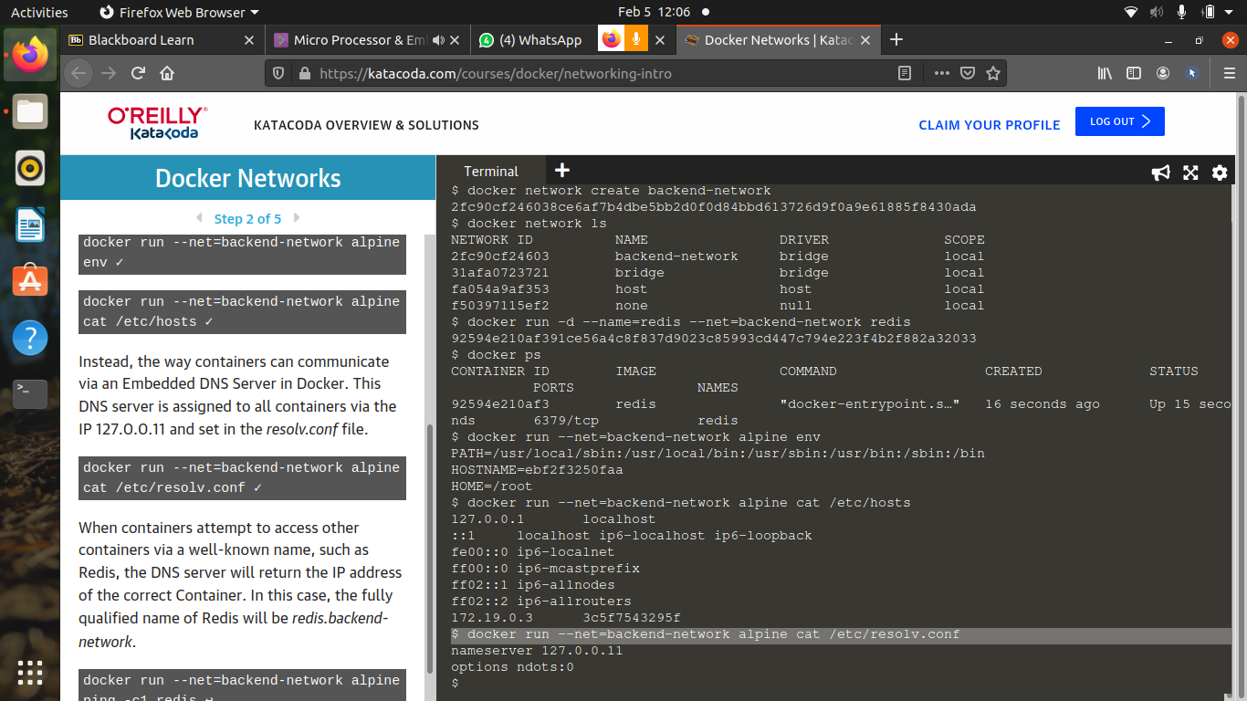
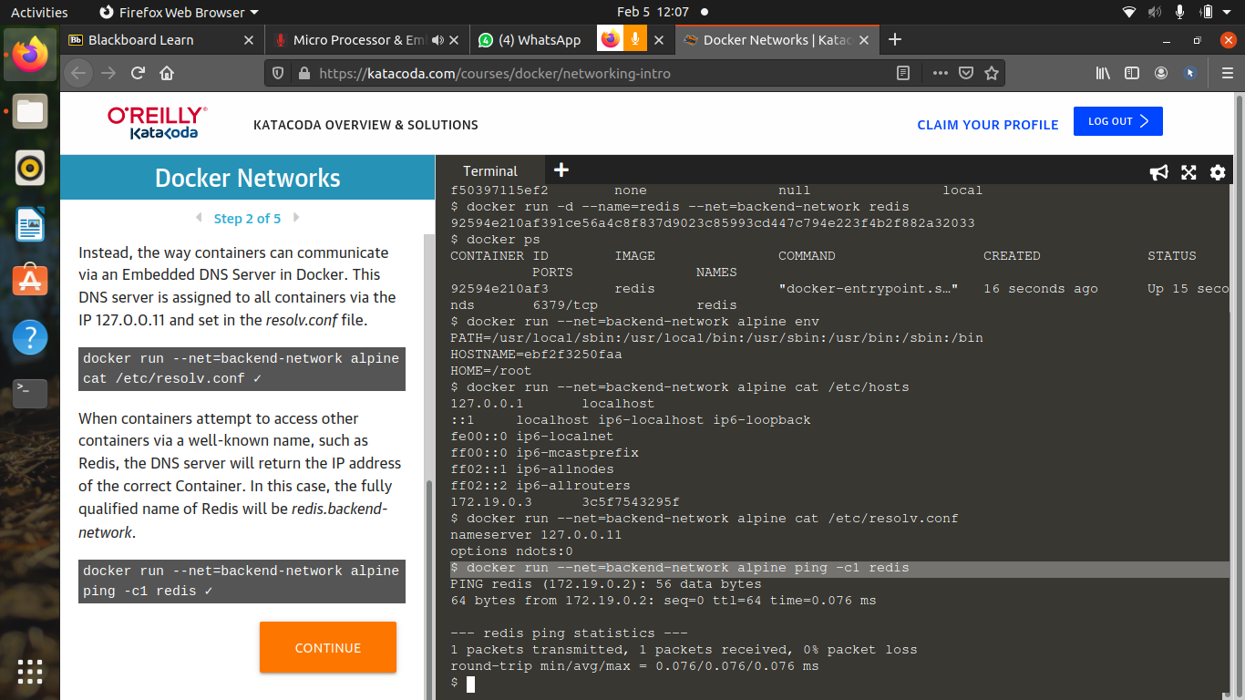
6) To connect two containers-

a) Create a new network:

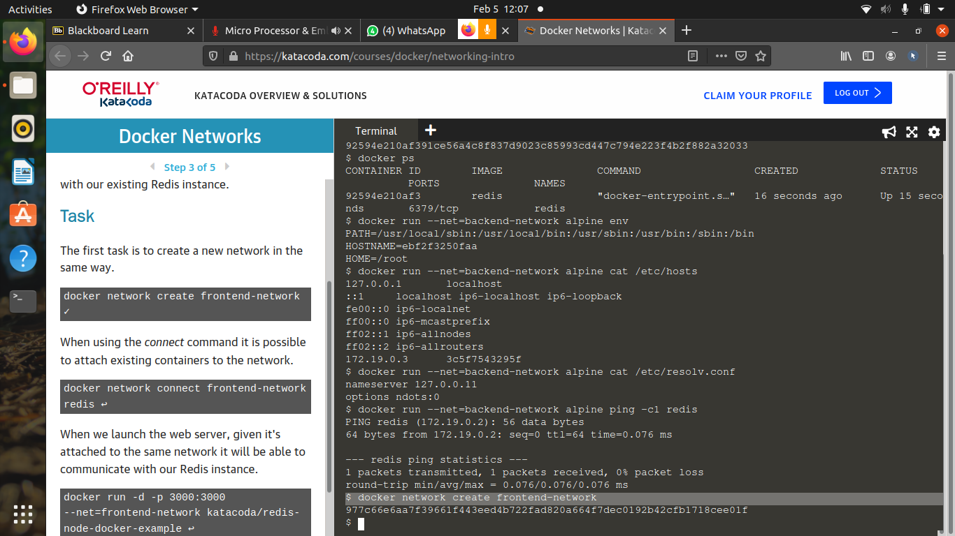

b) List the container:

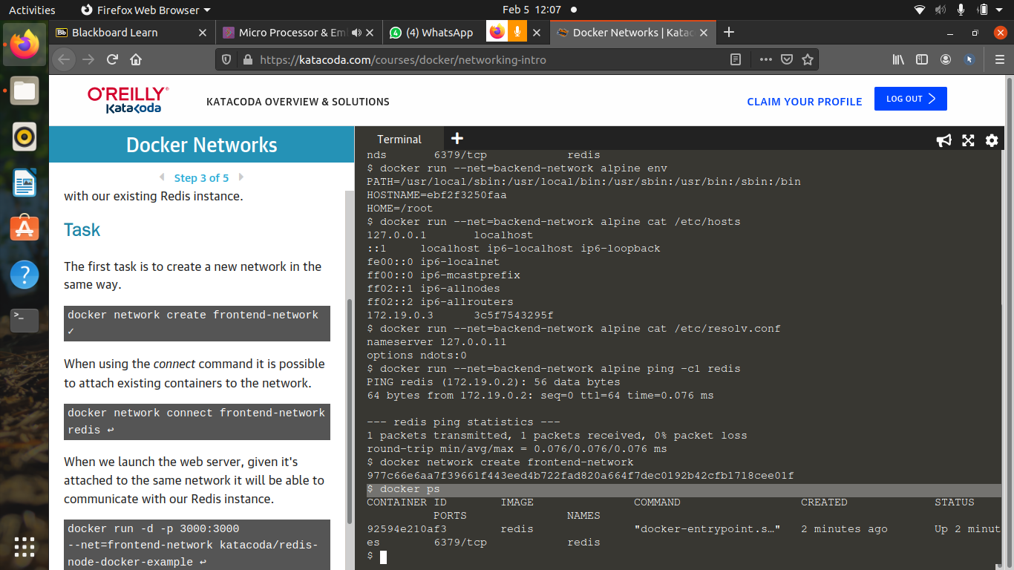
c) Inspect the container:
docker inspect “container_name”

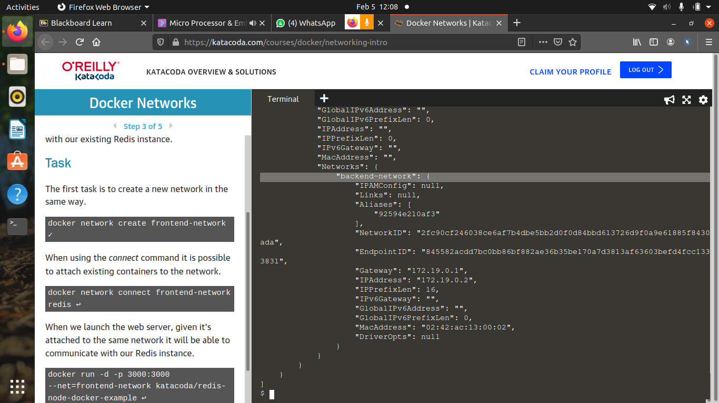

d) To connect container to new network:
docker network connect “new_network_name” “container_name”

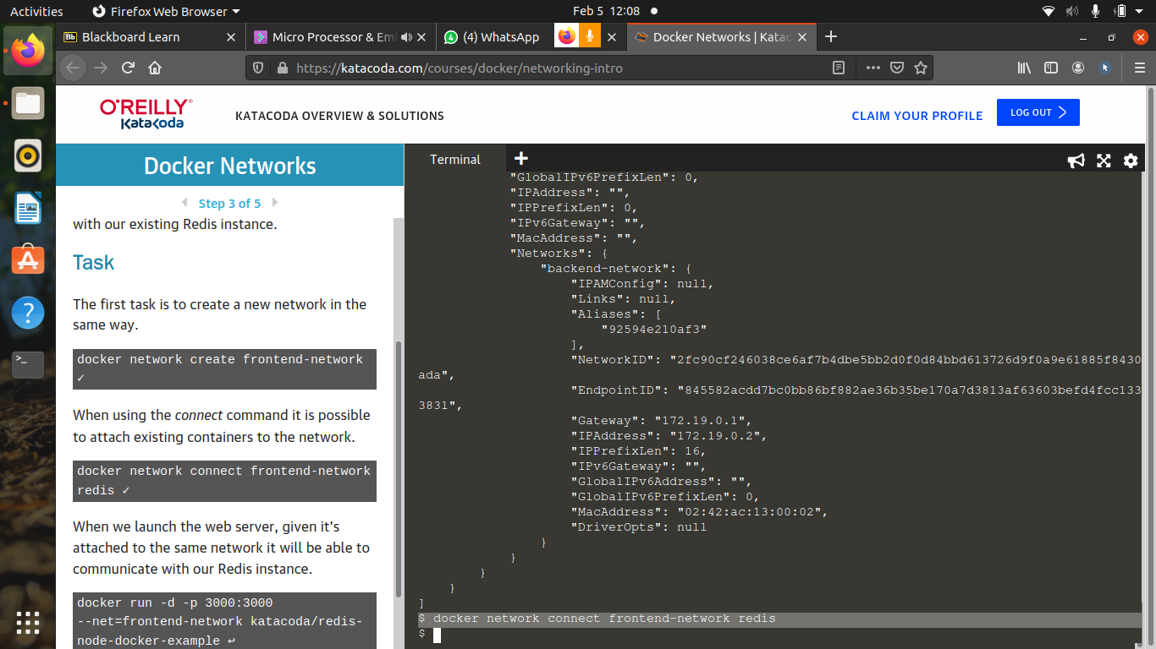
e) To check the network connection:
docker inspect “container_name”

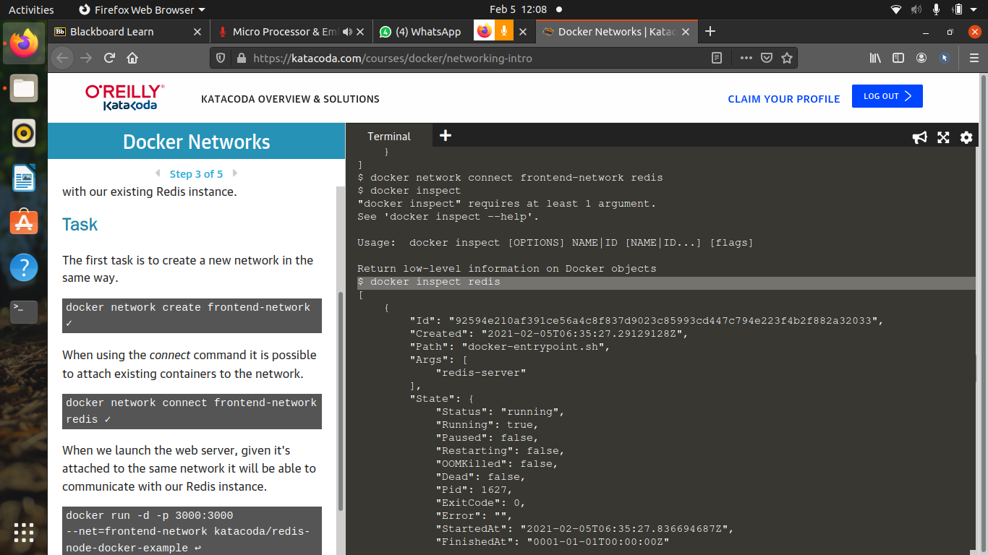
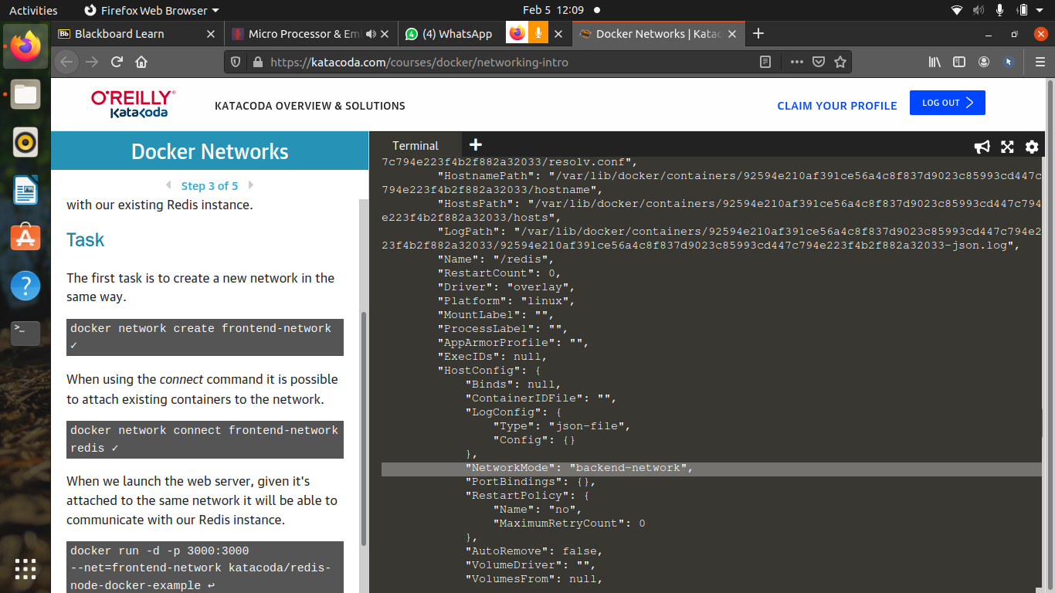
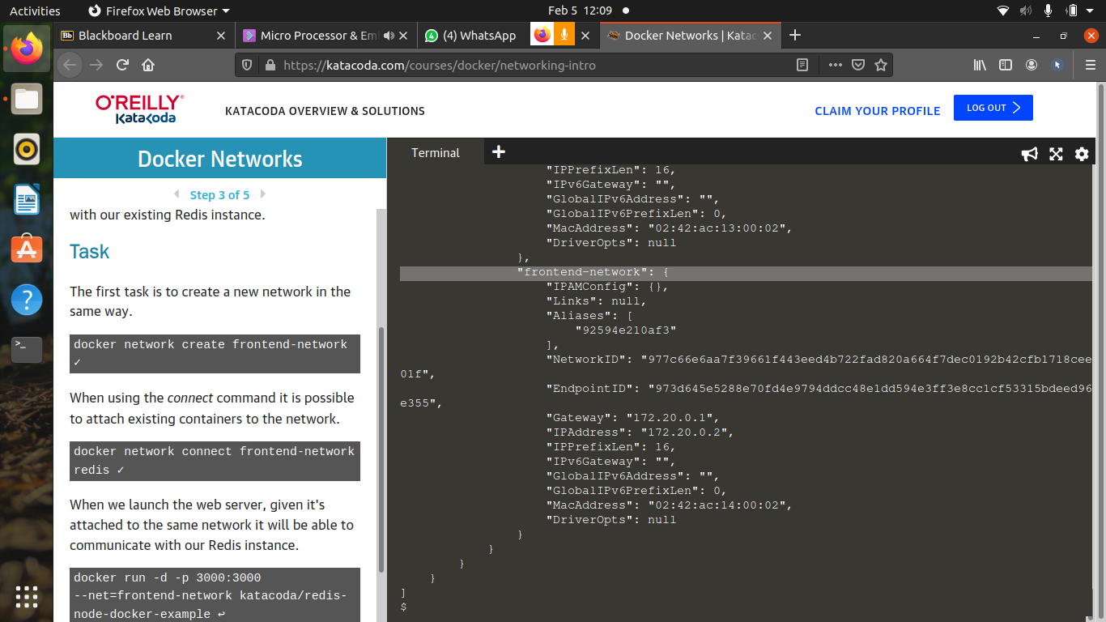
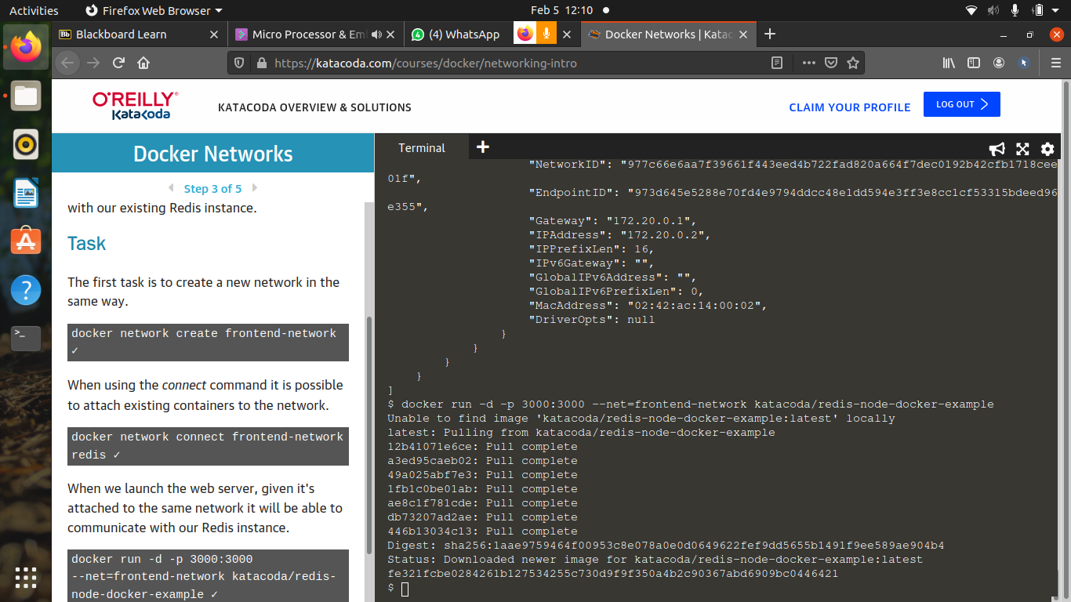
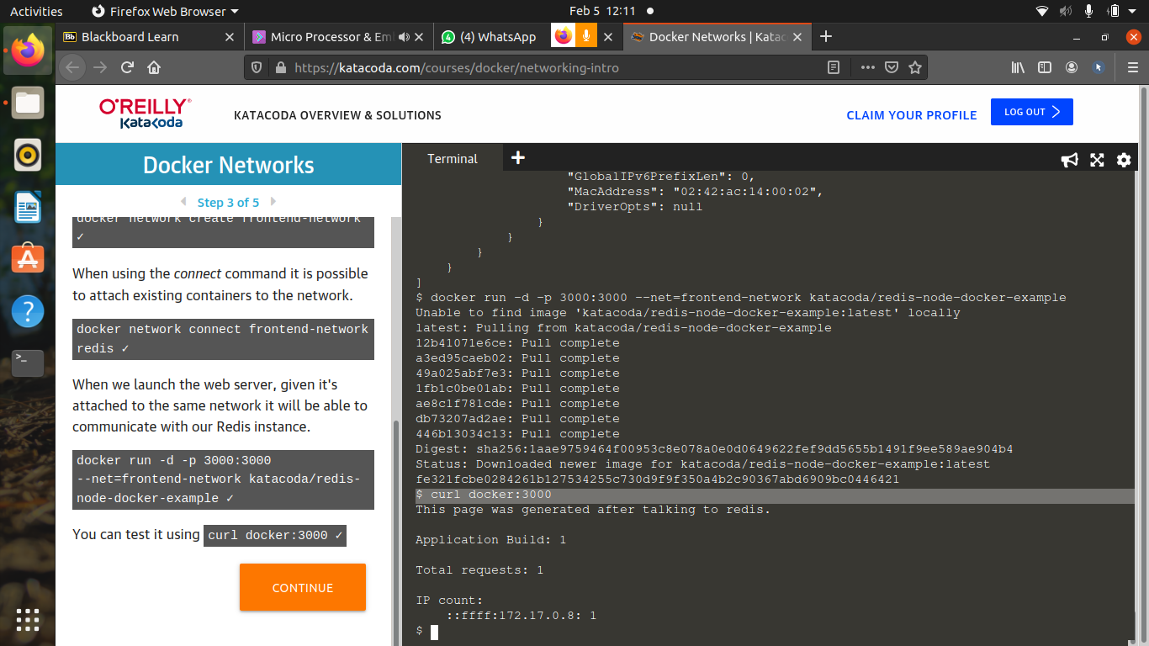
7) To connect container with alias:

a) create new network
b) connect new network with alias
docker network connect –alias db “network_name” “container_name”

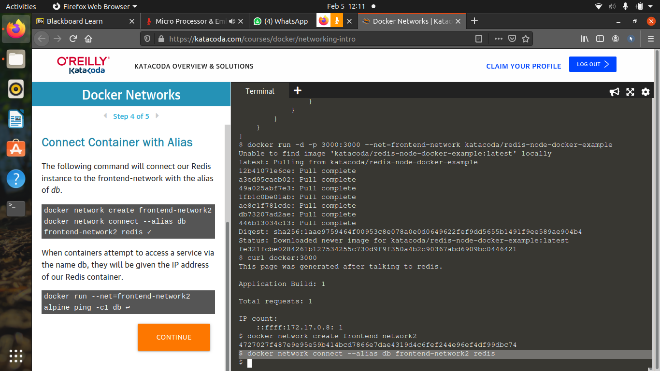

b) To ping the containers-
docker run –net=“network_name” “container_name” ping c1 db

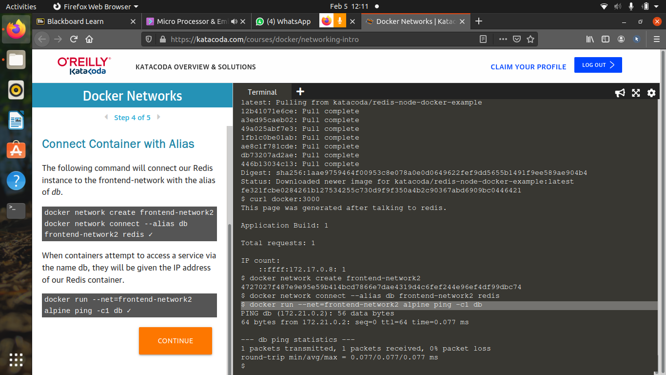

8) Check available networks:

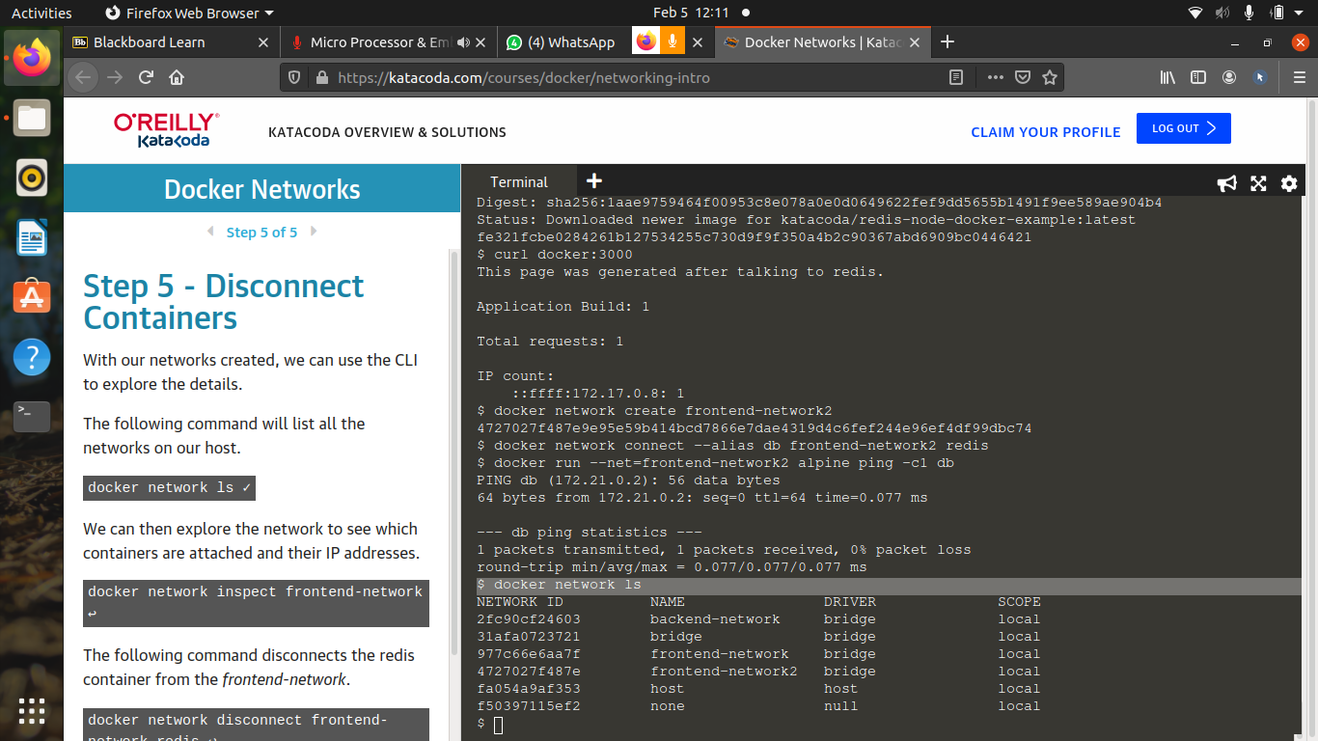

9) To inspect the network:
docker network inspect “network_name”

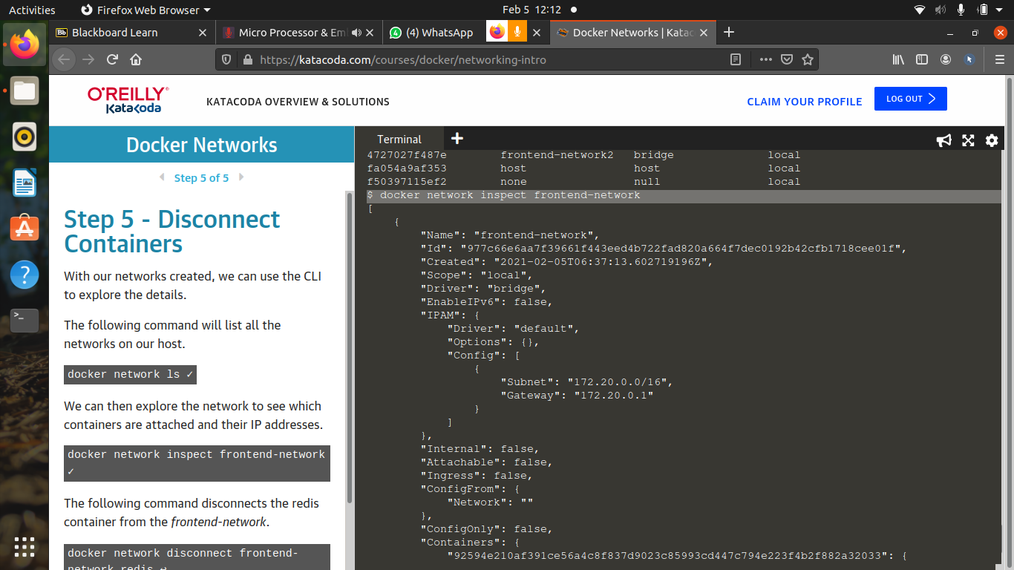

10) To disconnect the network from a container:
docker network disconnect “network_name” “container_name”



