Application Containerization

EXPERIMENT – 9

Name – Ishita Bansal
Roll No - R171218124
Sap id - 500071818
Course – Devops Batch 2
Submitted To – Mr. Hitesh Kumar Sharma

AIM – Build docker image using .dockerignore file

1. To view the dockerfile -

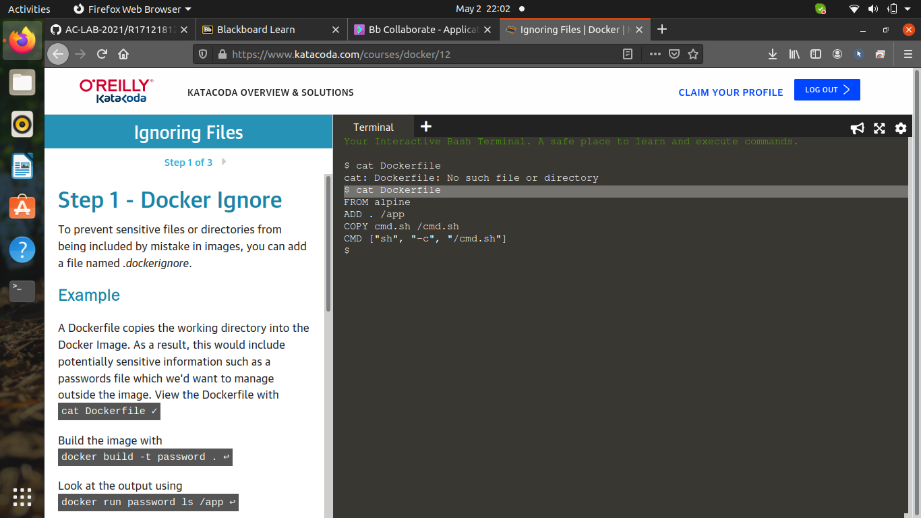
2. To look at the docker images -

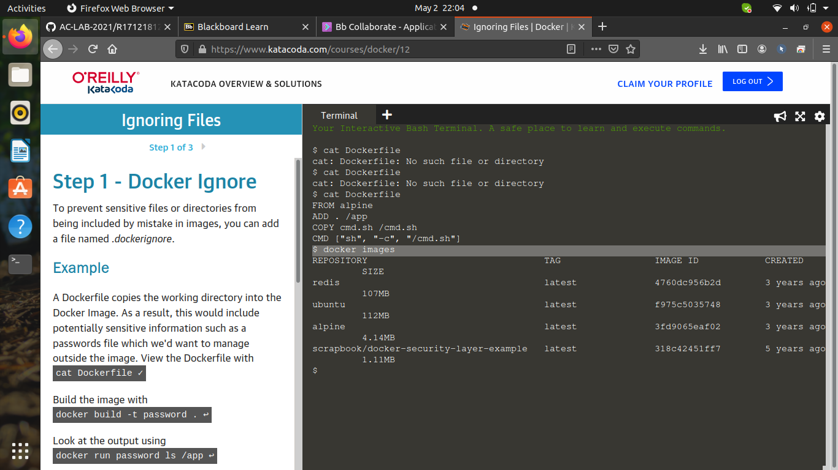

3. To build the image -

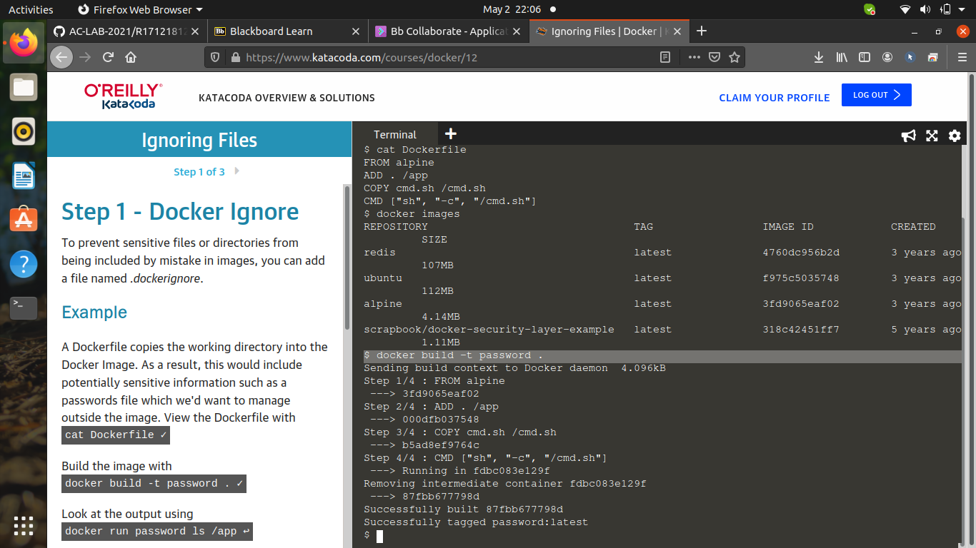
4. To check if the image is built or not -

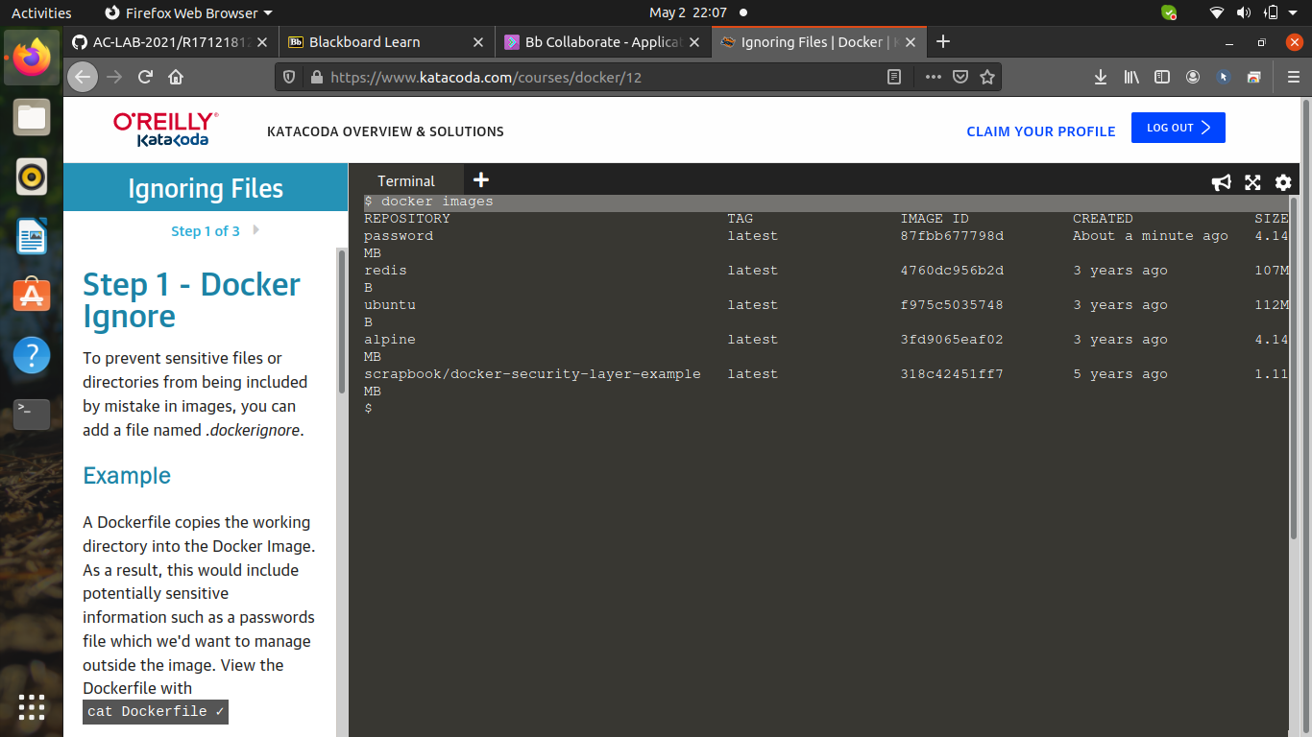

5. Check the output -

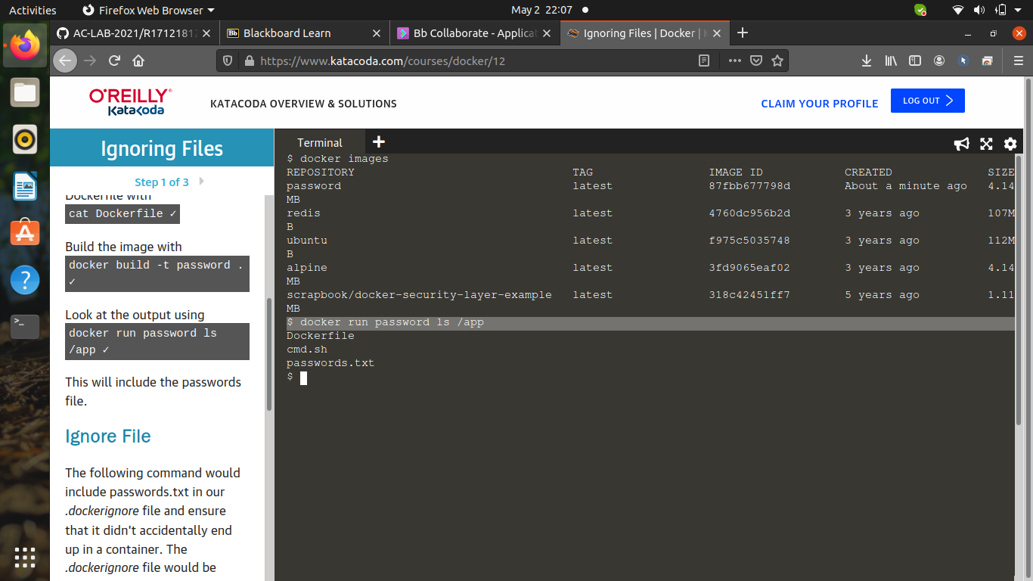

6. To store the dockerignore file -

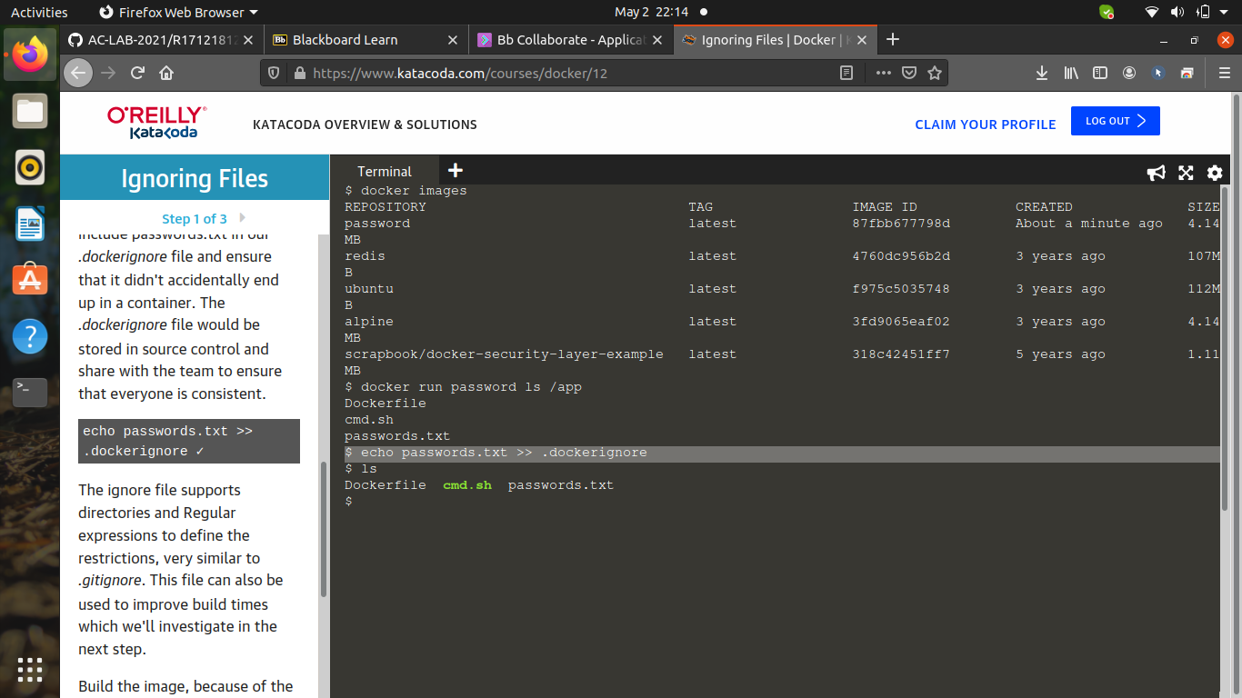

7. Buil a nopassword image -

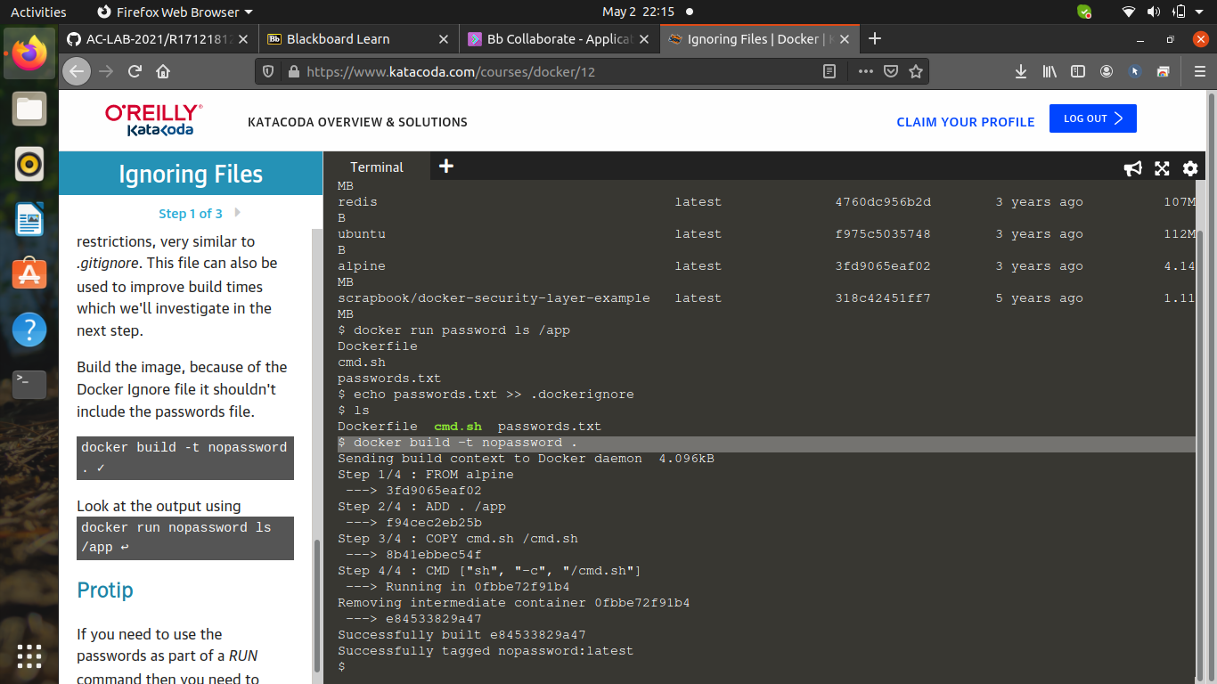

8. To check if the image is created or not -

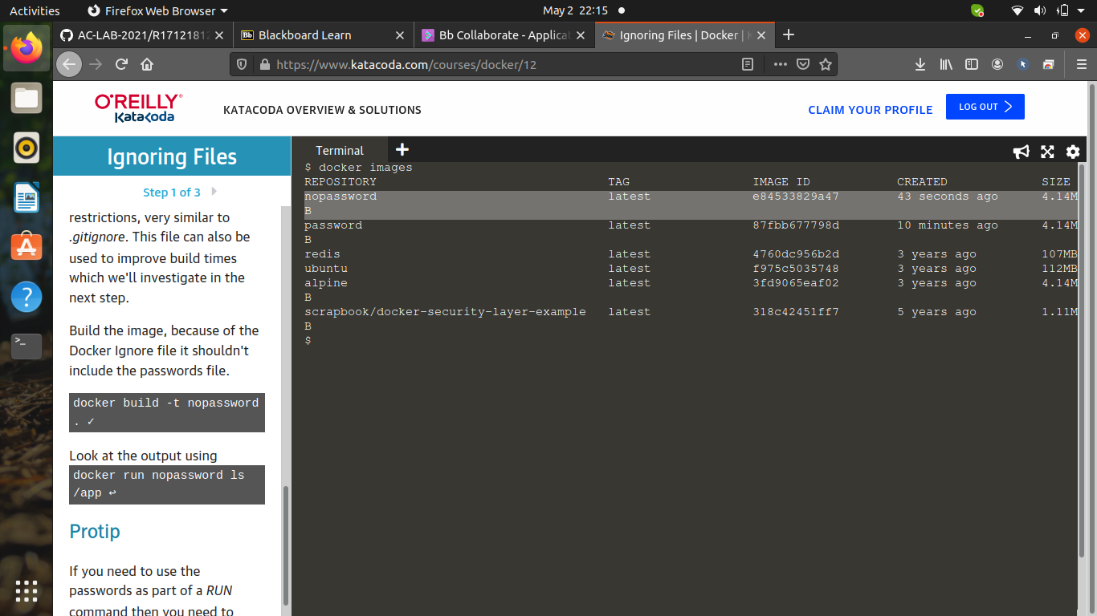

9. Check the output -

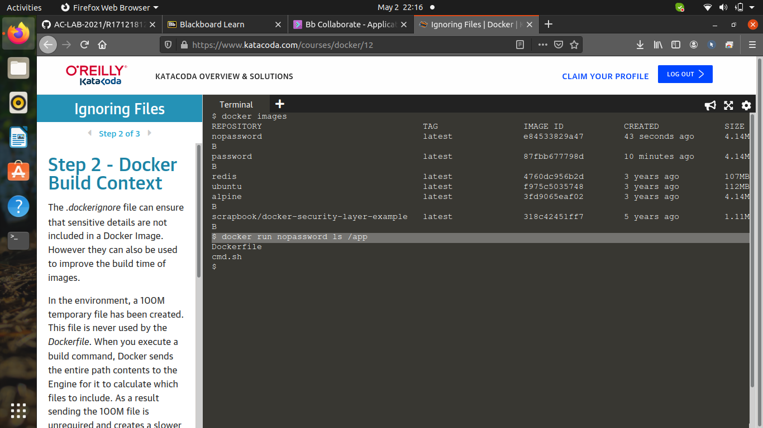

10. To see the 100M impact -

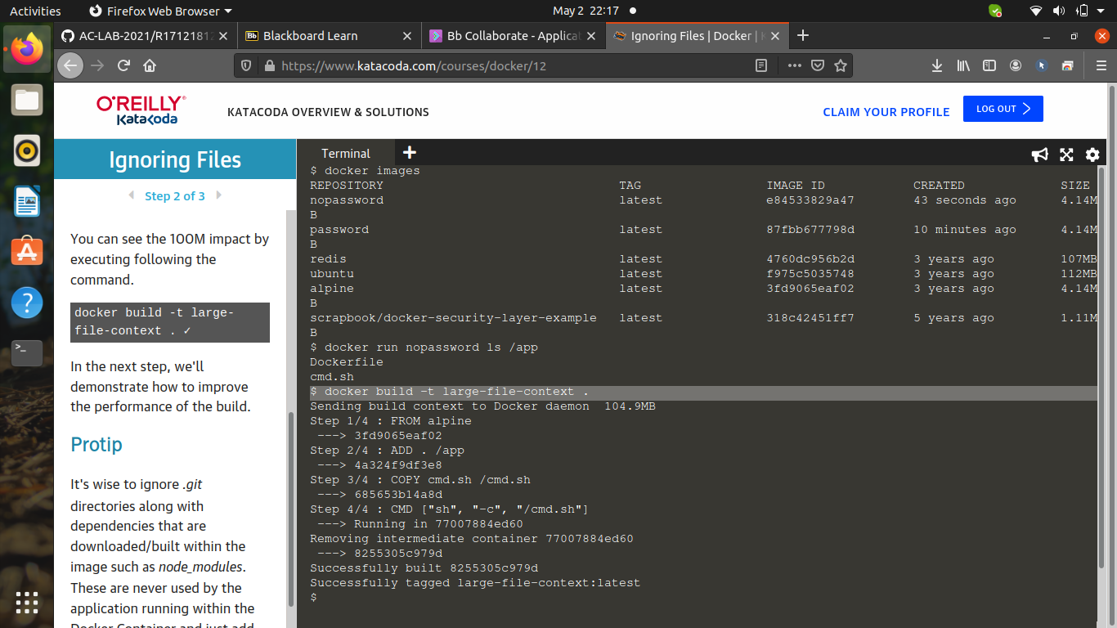

11. To check the dockerfile -

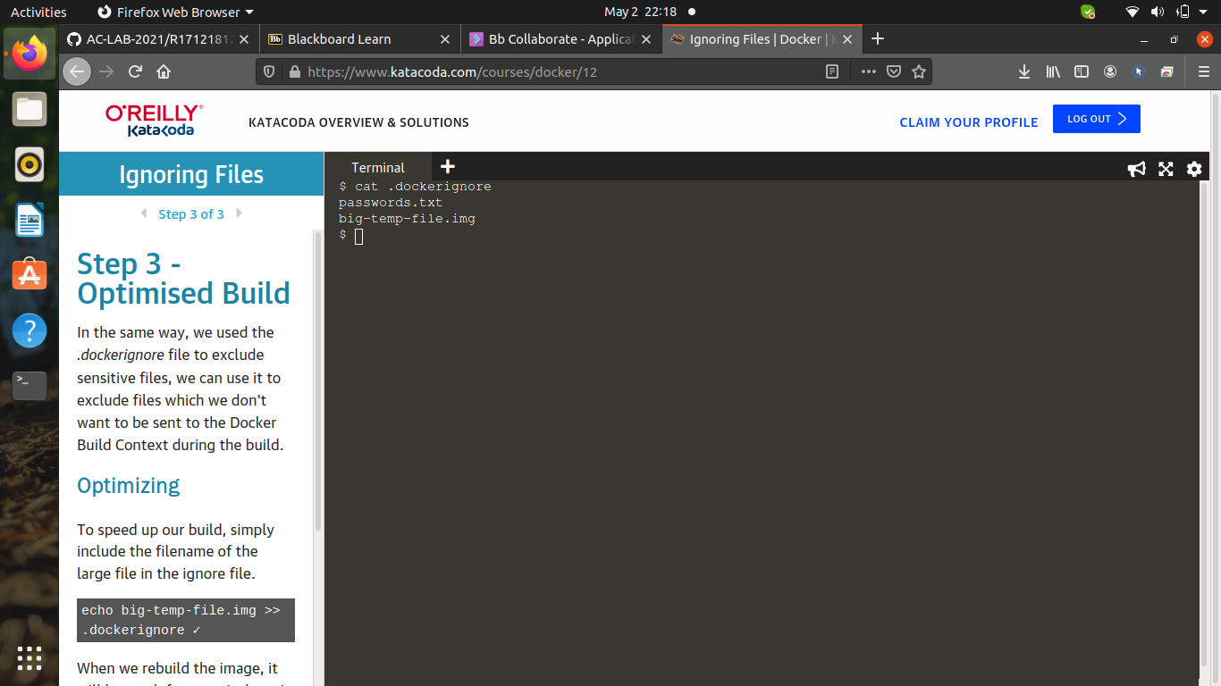

12. The rebuild of the image would be faster -

