Application Containerization

Name – Ishita Bansal
Roll No. - R171218124
Sap Id - 500071818
Course – Devops Batch 2
Submitted To – Mr. Hitesh Kumar Sharma

AIM- Create your own docker image and push on dockerhub.

1) Create a “Dockerfile” and “index.html” file and edit them-
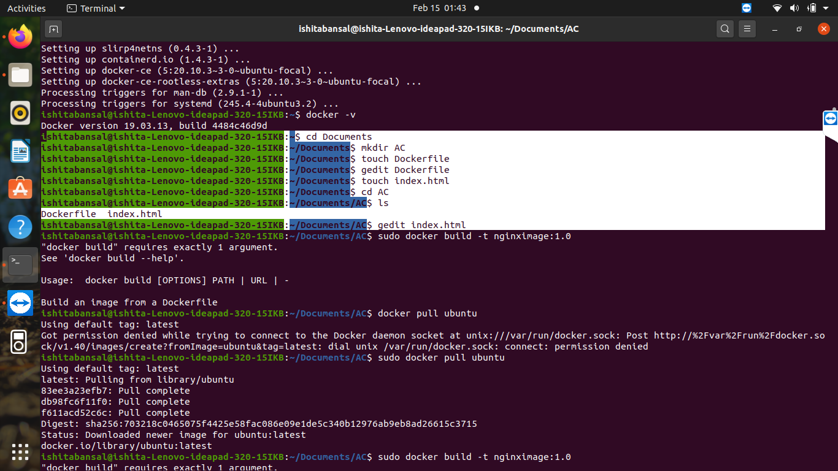

Dockerfile
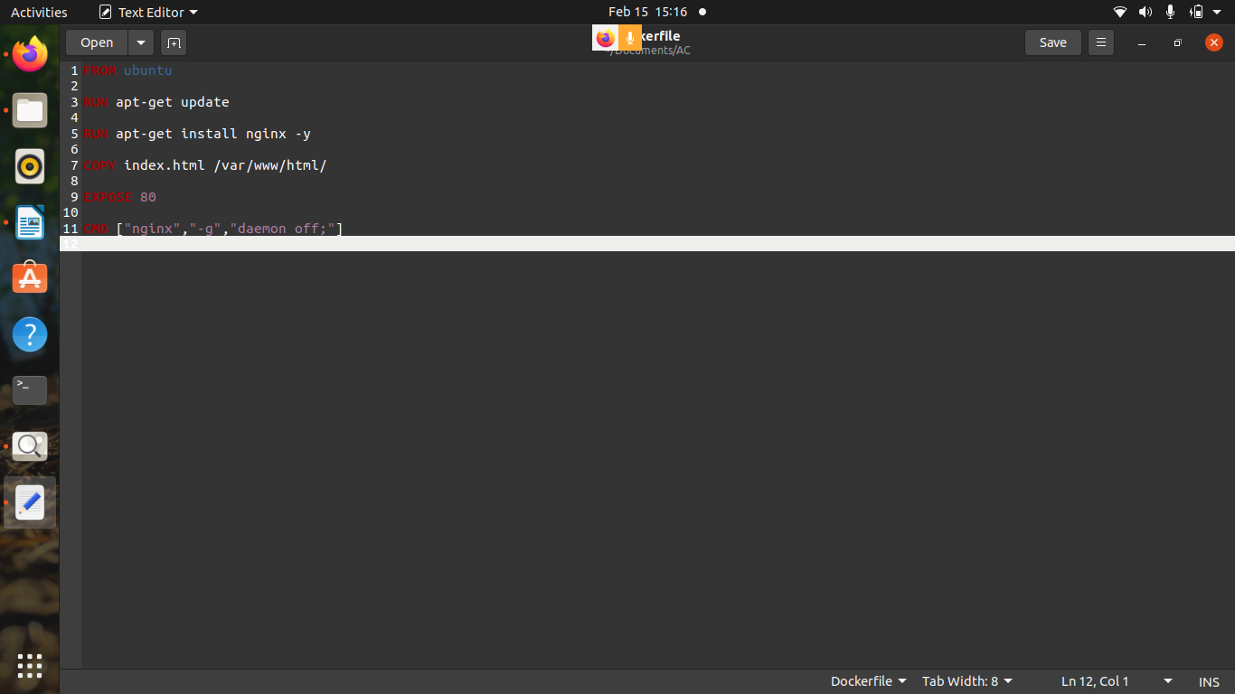
index.html
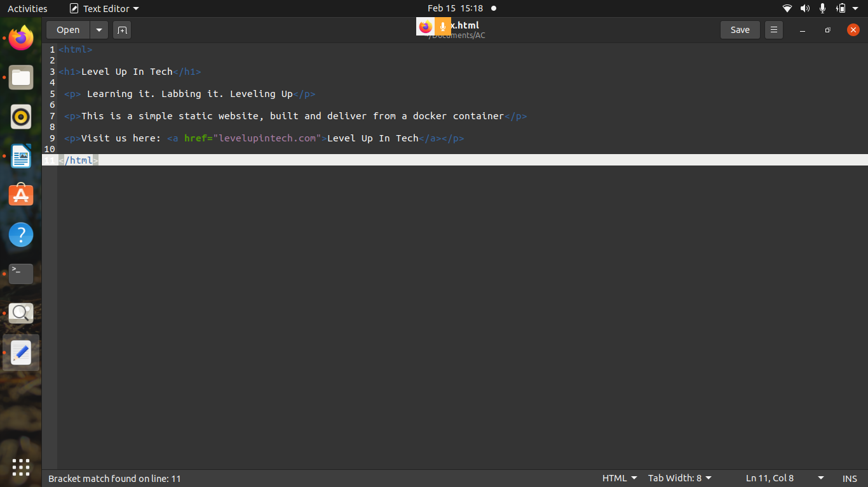

2) allow users to build their images -
sudo docker build -t mynginx:1.0

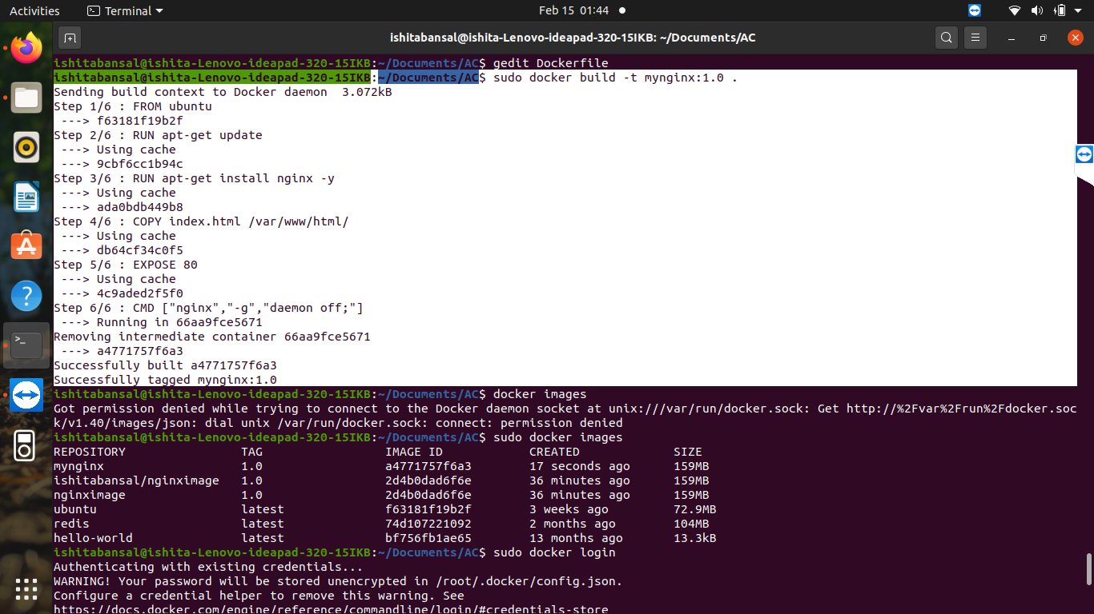

3) create a docker image named “mynginx”-
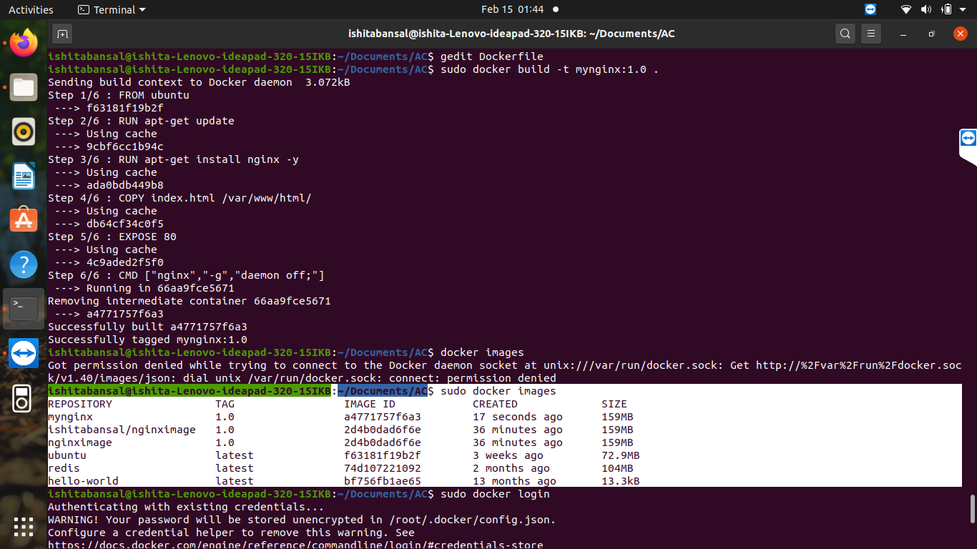

4) create repo on dockerhub-
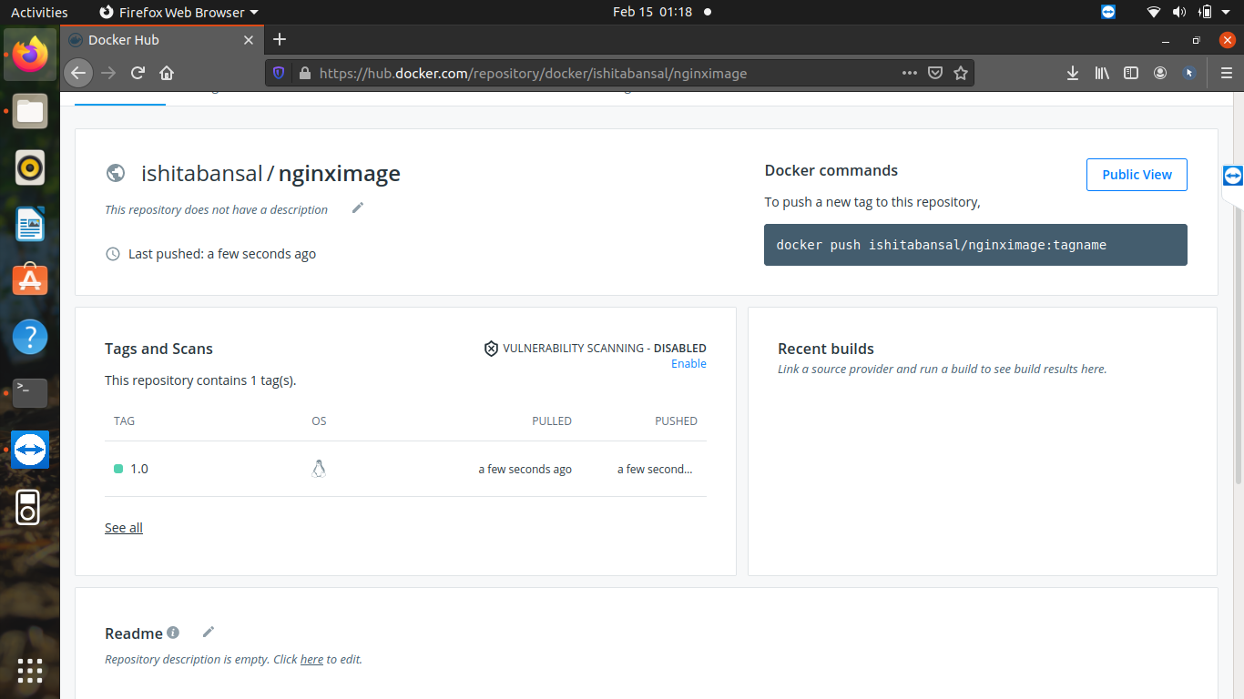

5) connect your machine with dockerhub-
docker login
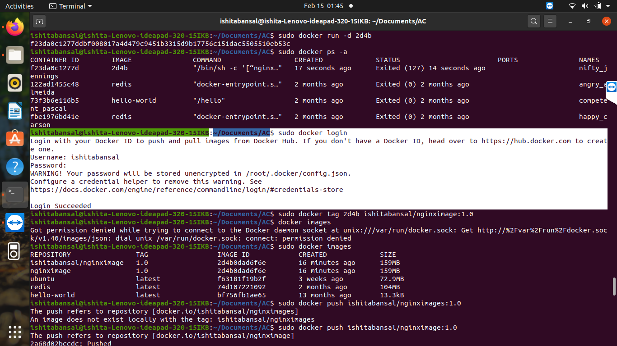

6) change the name of the image using this command-
docker tag “container_id” and “dockerhub_id/image_name”:version
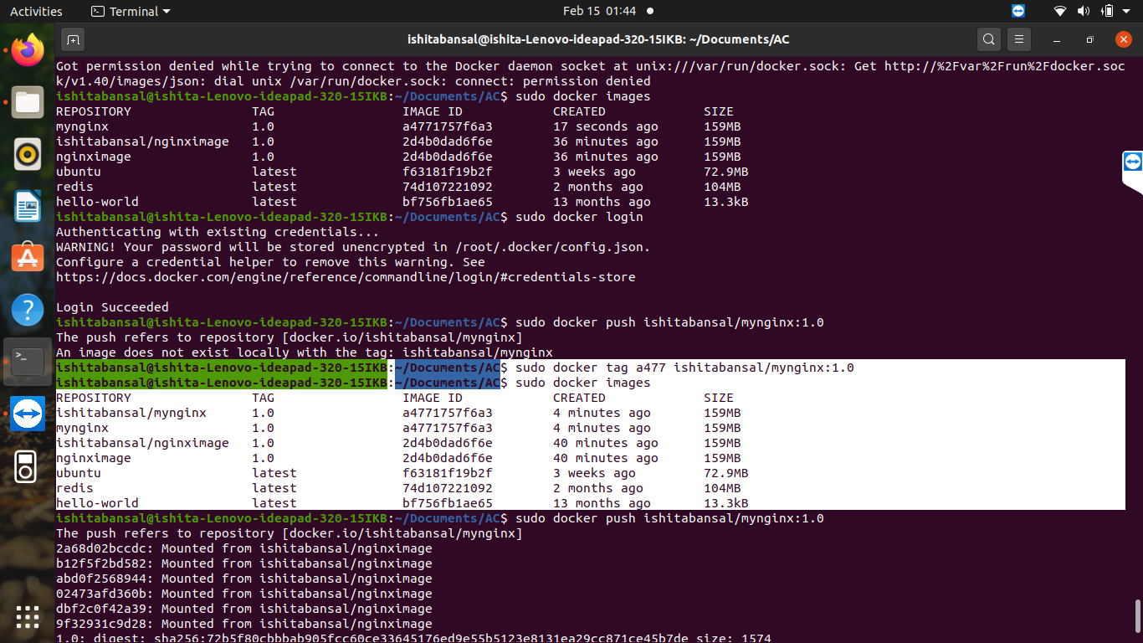

7) now push the image on dockerhub using-
docker push “repository_name”

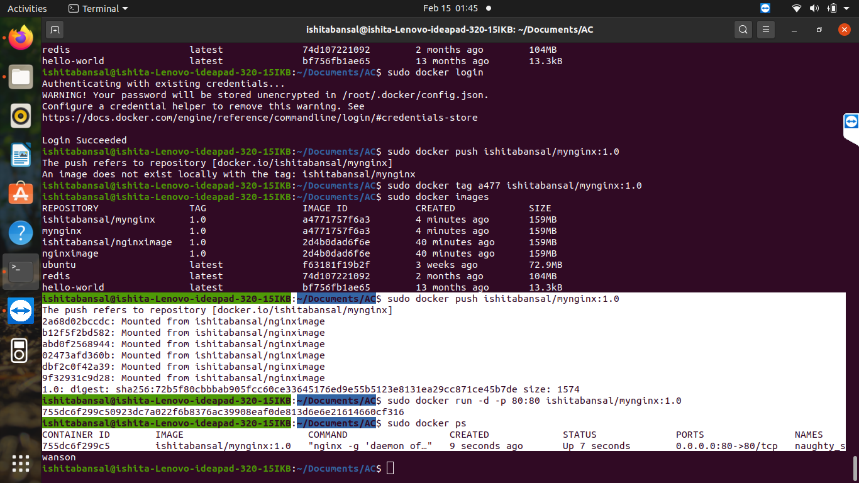

8) the output we will get in our dockerhub will be-
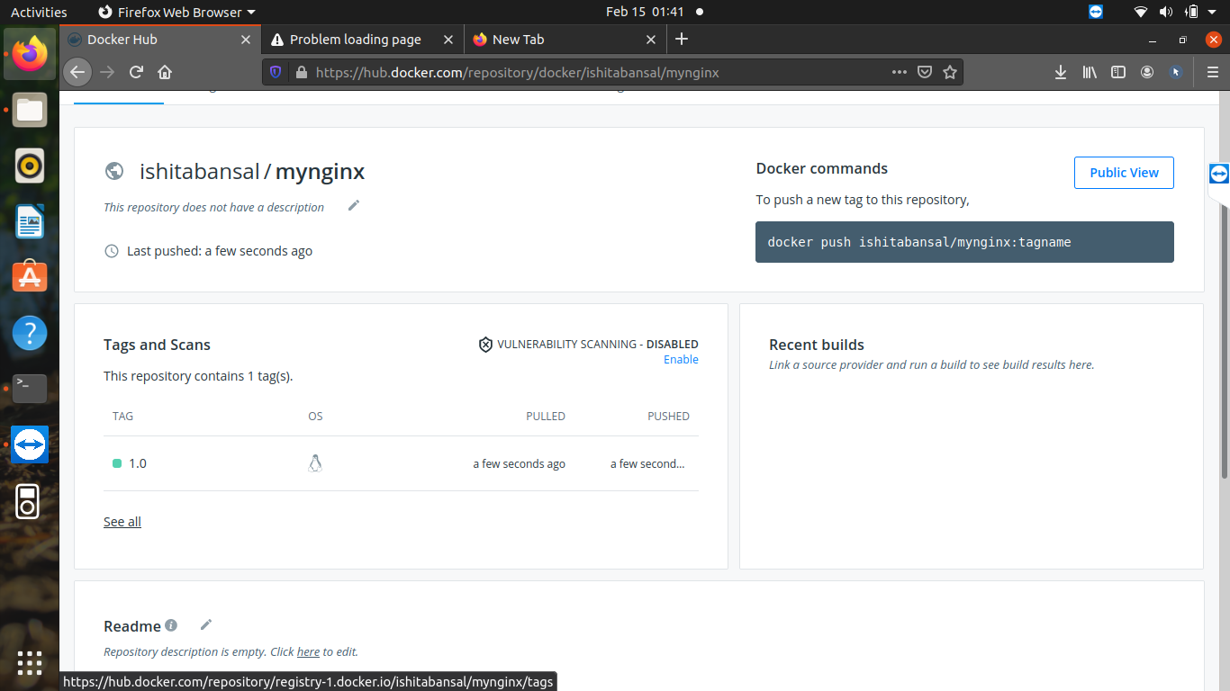
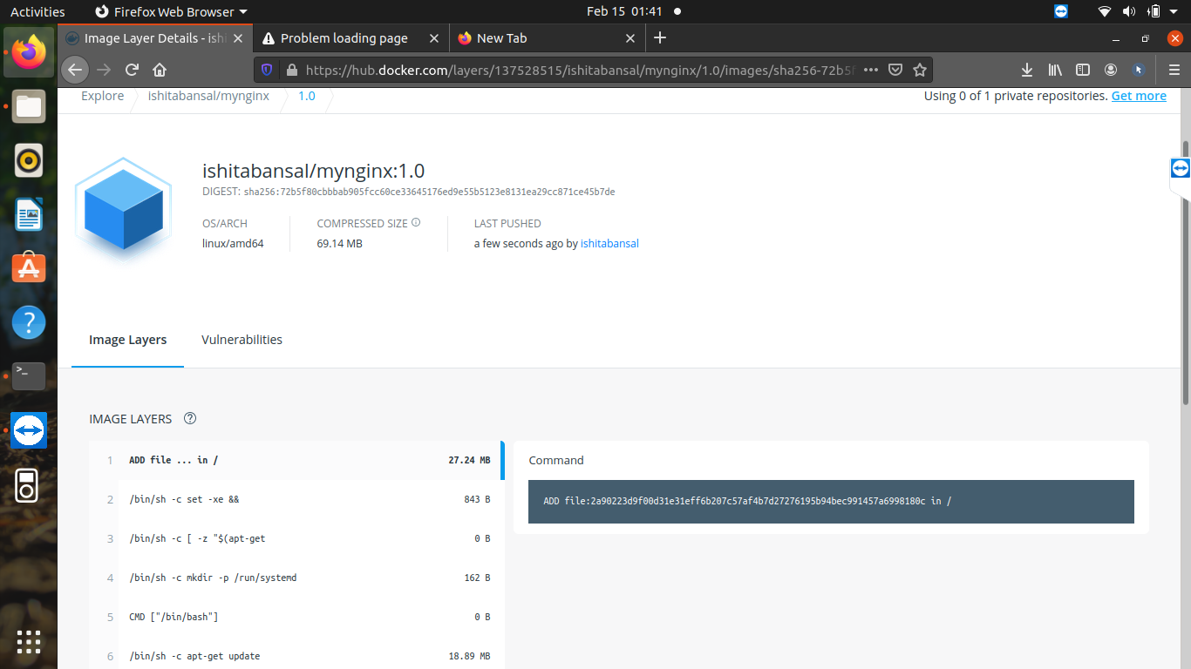

now use this image on our local machine and assign a port number and execute it on browser using-
sudo docker run -d -p 80:80 ishitabansal/mynginx:1.0
