Application Containerization

EXPERIMENT – 11

Name – Ishita Bansal
Roll No - R171218124
Sap id - 500071818
Course – Devops Batch 2
Submitted To – Mr. Hitesh Kumar Sharma

AIM – Working with metadata, log file using docker -

1. Check the log of the server -

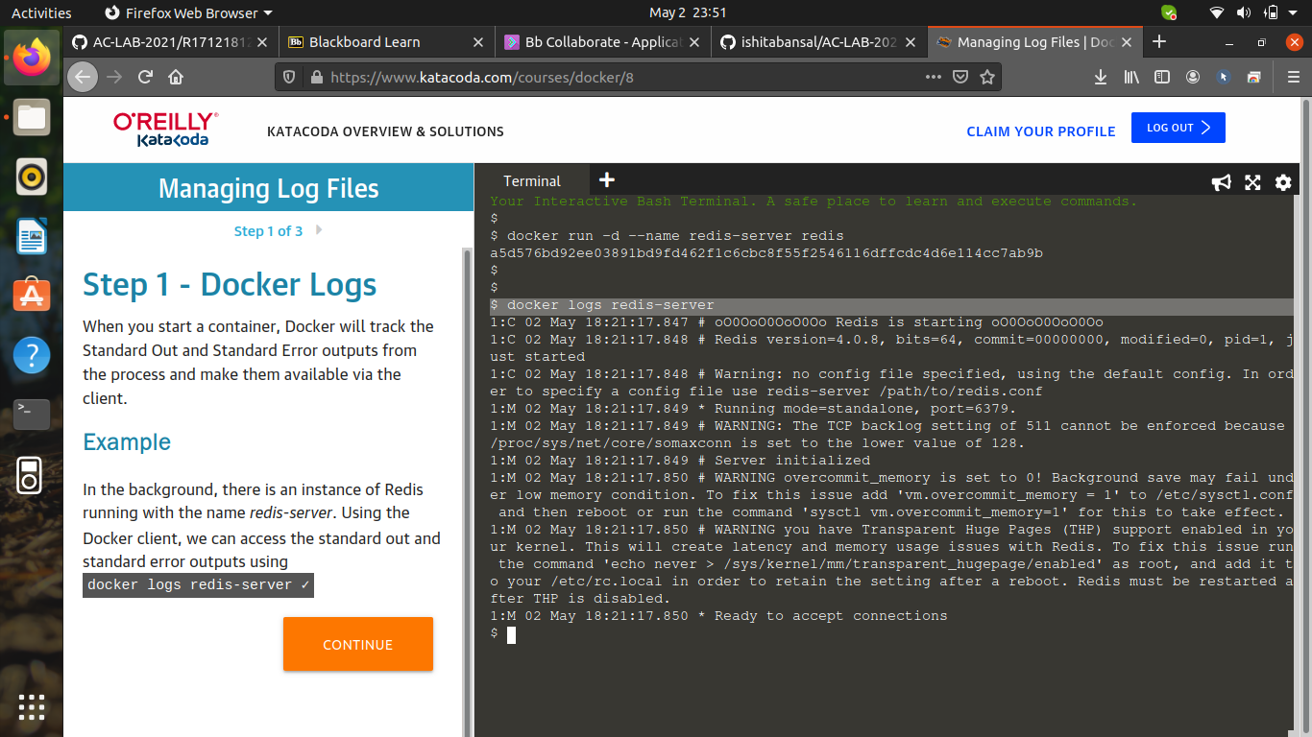
2.Redirect the redis log to syslog -

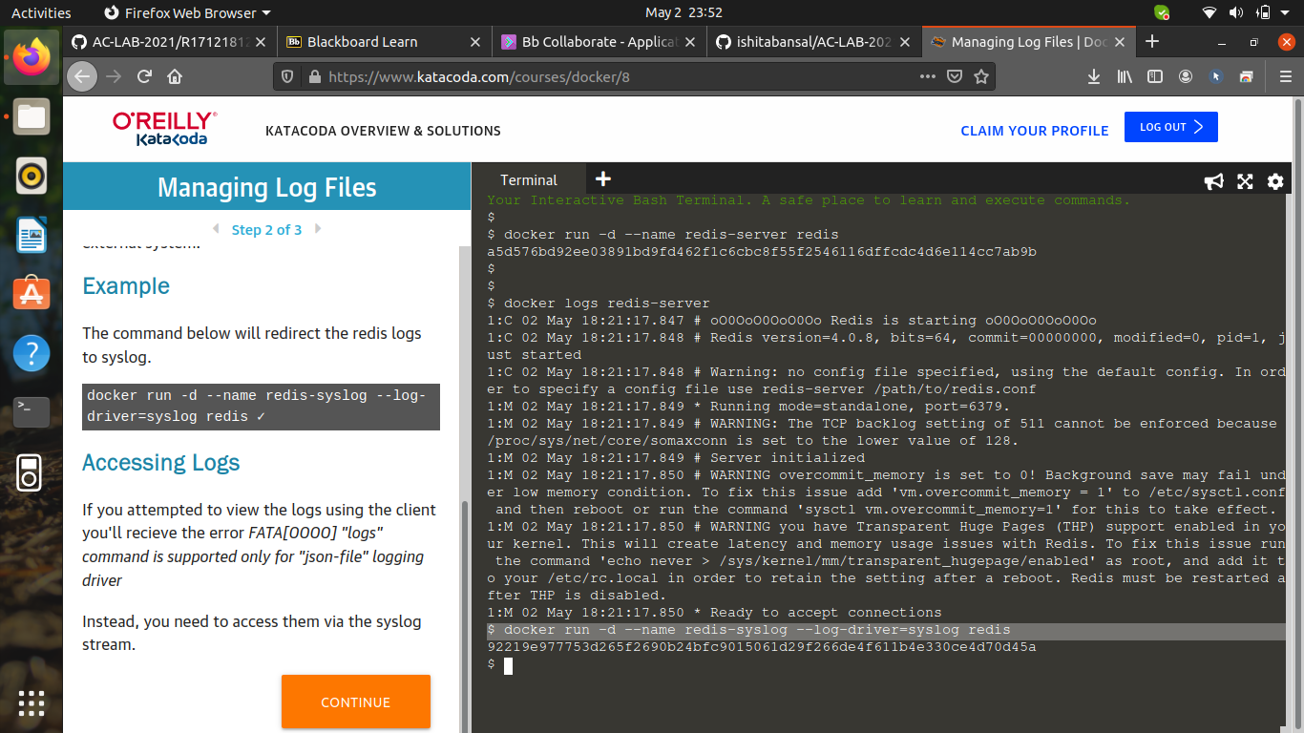

3. To create server -

