Application Containerization

EXPERIMENT-3

Name - Ishita Bansal
Roll No - R171218124
Sap Id - 500071818
Course - Devops Batch 2
Submitted to - Mr. Hitesh Kumar Sharma

Aim – Create the volume

Steps to achieve the task-

1) Start the vagrant using-
vagrant up
vagrant ssh

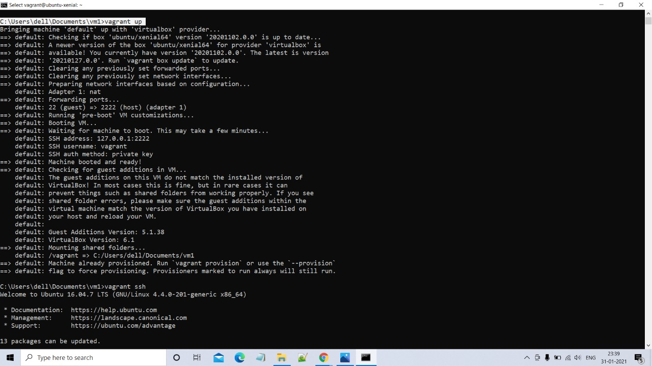

2) We will search for alpine container from docker hub

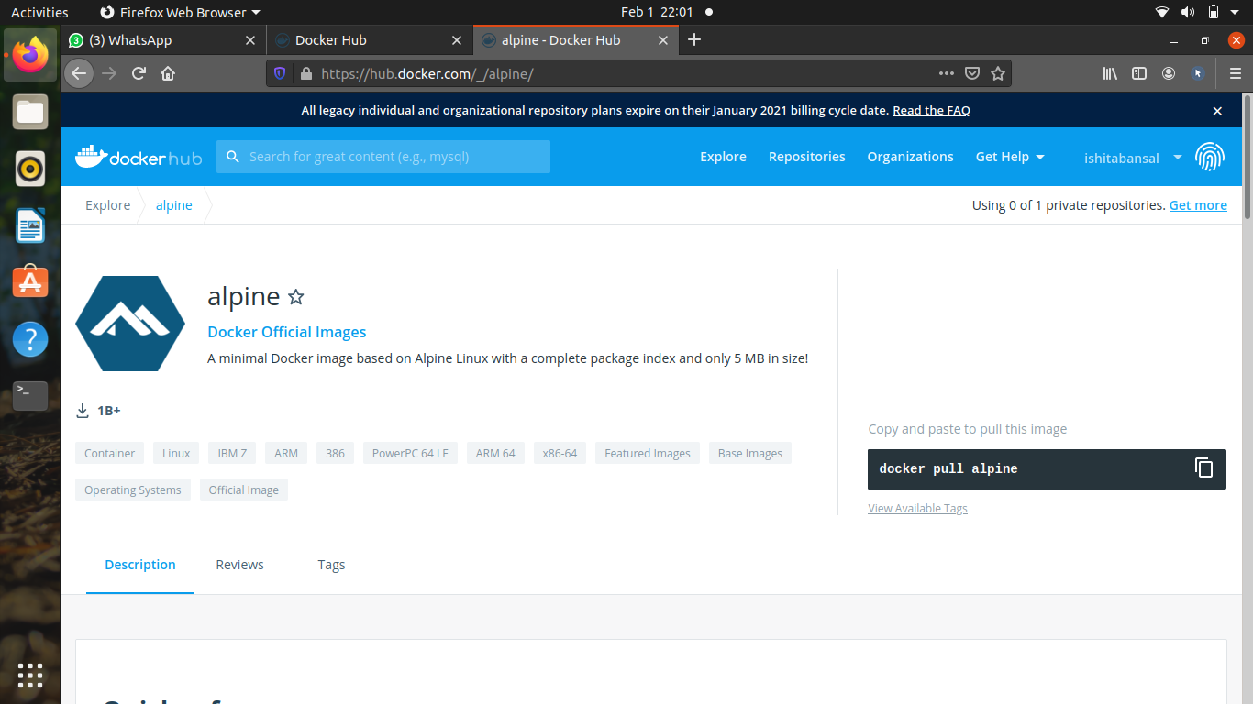

3) run alpine container using sudo docker run -it alpine and then create a file in it using TOUCH command like
touch ishita.txt
touch kashish.txt

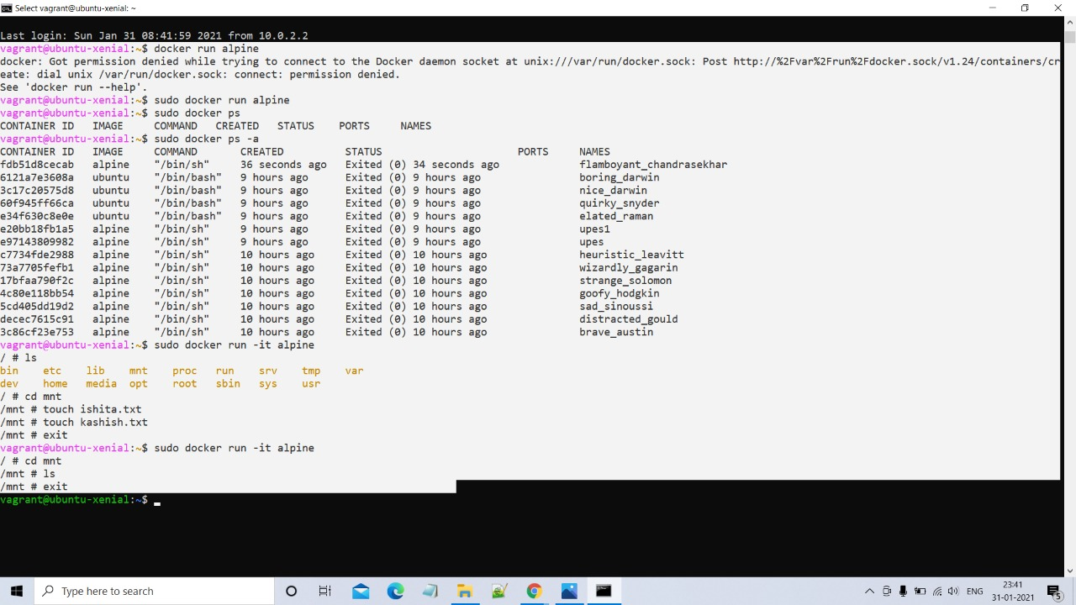

4) Now we run the alpine container using volume and create file using touch command. After we exit the container and enter other container using same volume, the files remain there using the command-
sudo docker run -it -v “volume_name”:/”folder_name” alpine

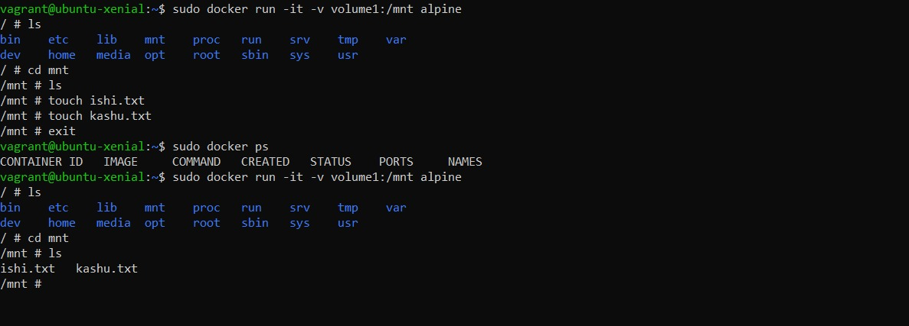
5) To check the path of the volume we will use the command-
sudo docker inspect “volume_name”

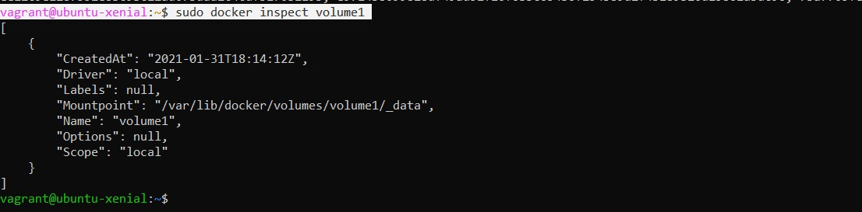
6) To show the location, we will use-

7) Now we will create and run container using-
sudo docker run -it -v “volume_name”:/”folder_name” –name “container_name” alpine

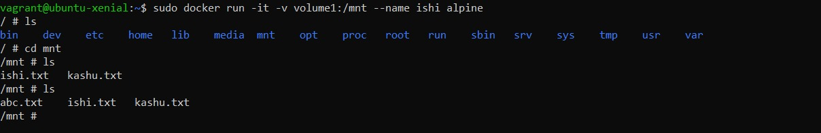
8) Now we will open new terminal and will run the same command and create another container to make the file visible-

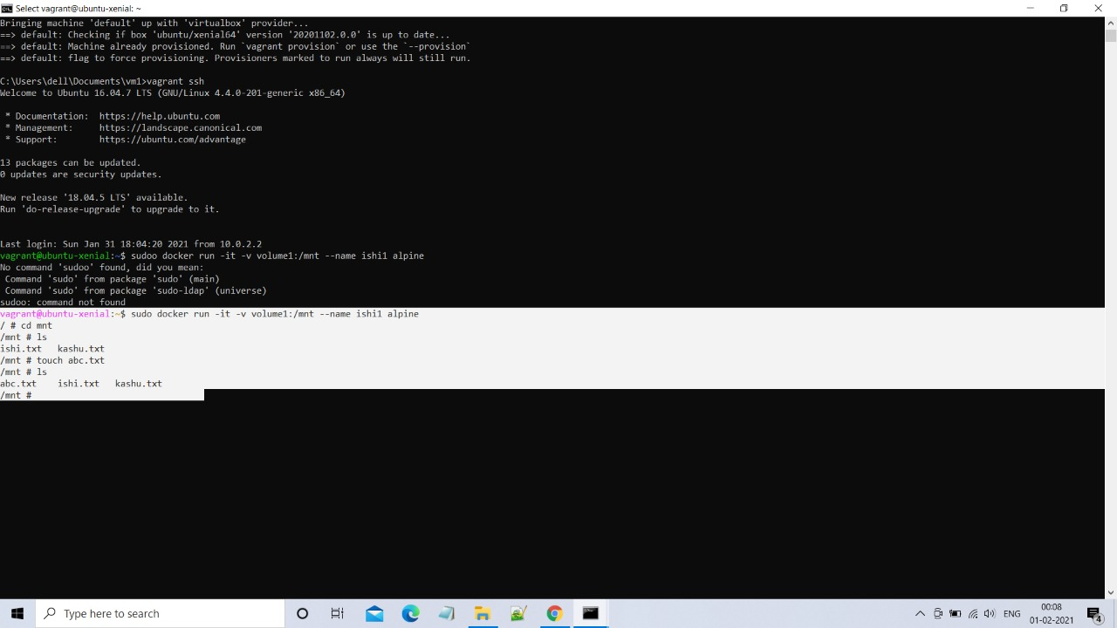

9) Now all the files are visible in the main container-

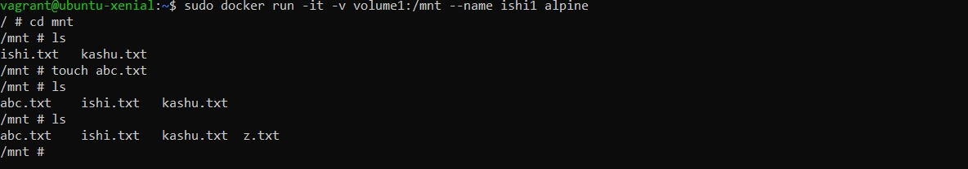

10) Now we will create a new container named ubuntu and make all the visible there-

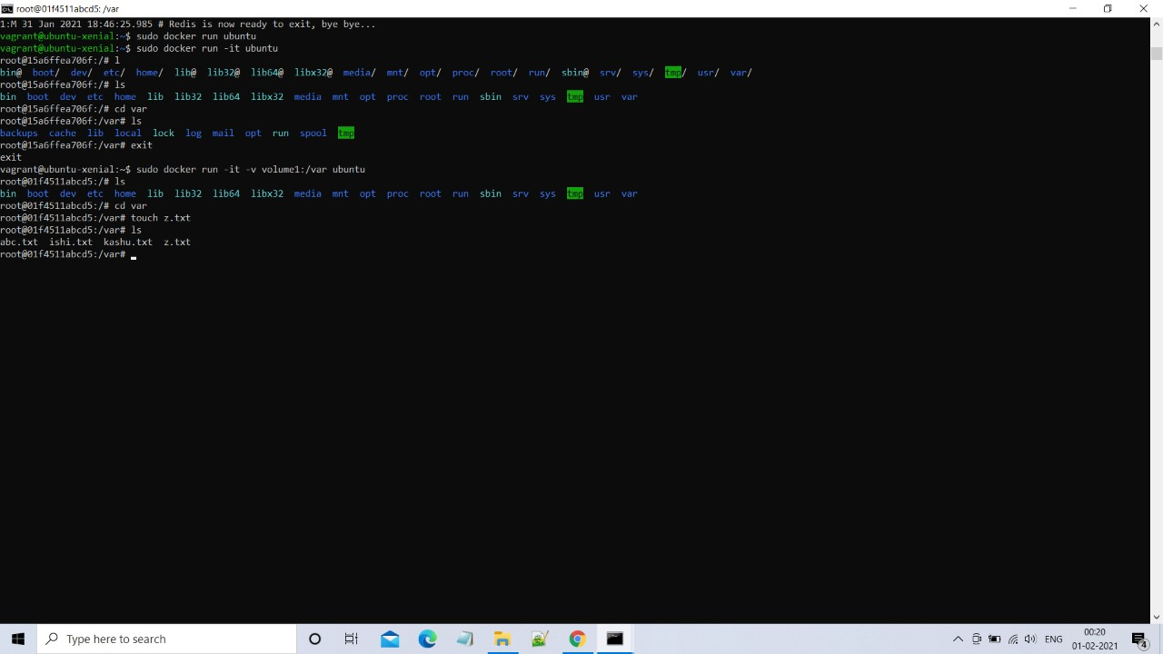
Further, to delete the volume, we will use-
sudo docker volume rm “volume_name”

