Application Containerization

EXPERIMENT – 10

Name – Ishita Bansal
Roll No - R171218124
Sap id - 500071818
Course – Devops Batch 2
Submitted To – Mr. Hitesh Kumar Sharma

AIM – Prepare and implement docker container restart policy.
1. Create a container -

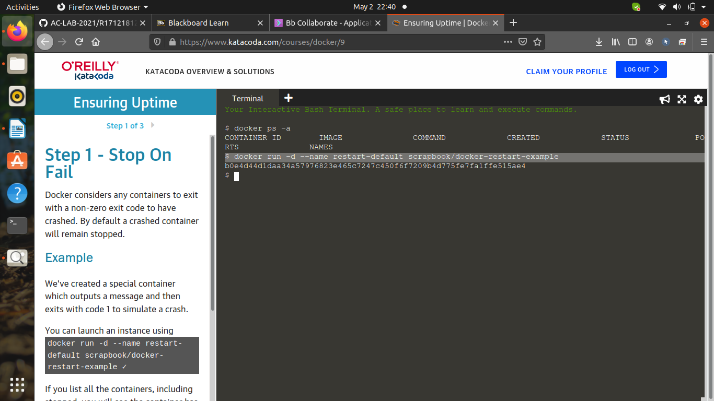
2. check the running containers -
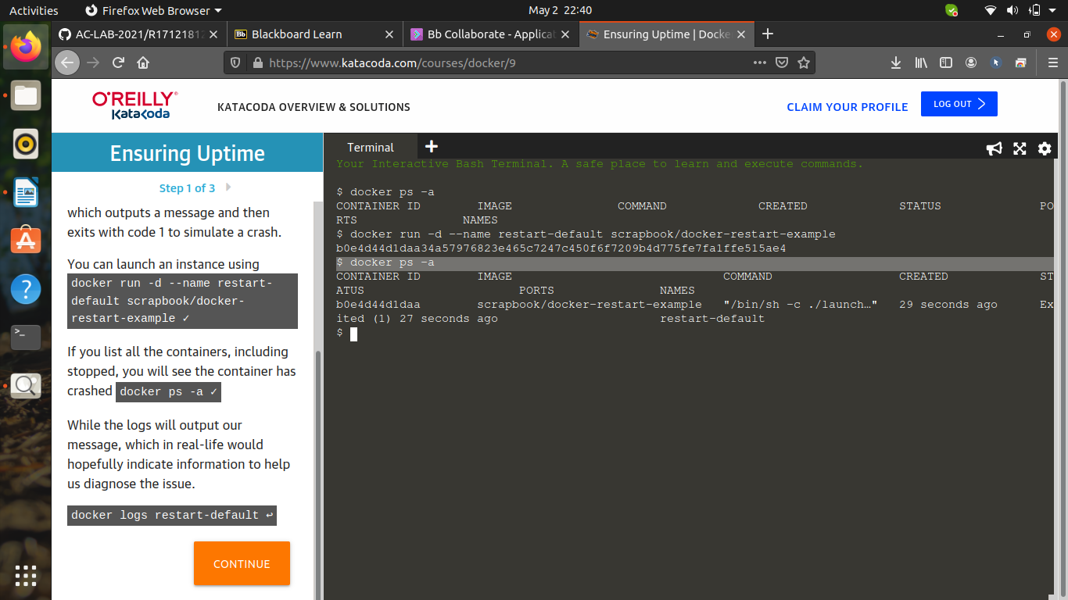

3. To check the log of the container -

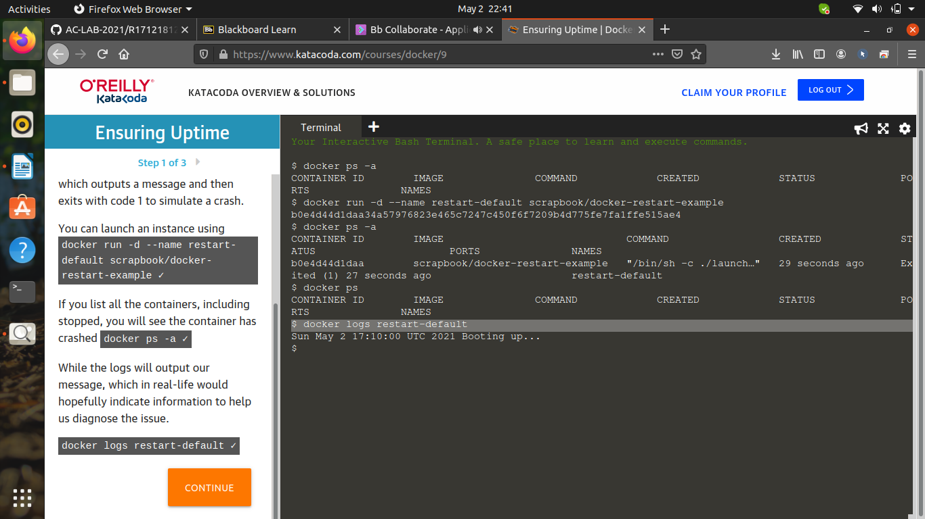

4. Create a container -

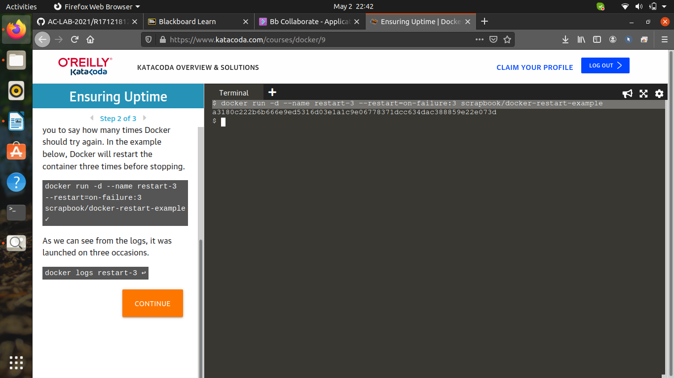

5. Check the running containers -

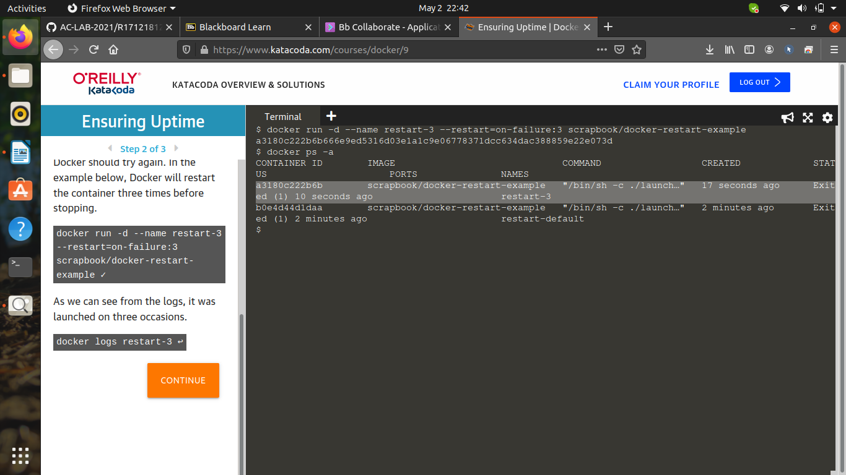

6. Check the logs -

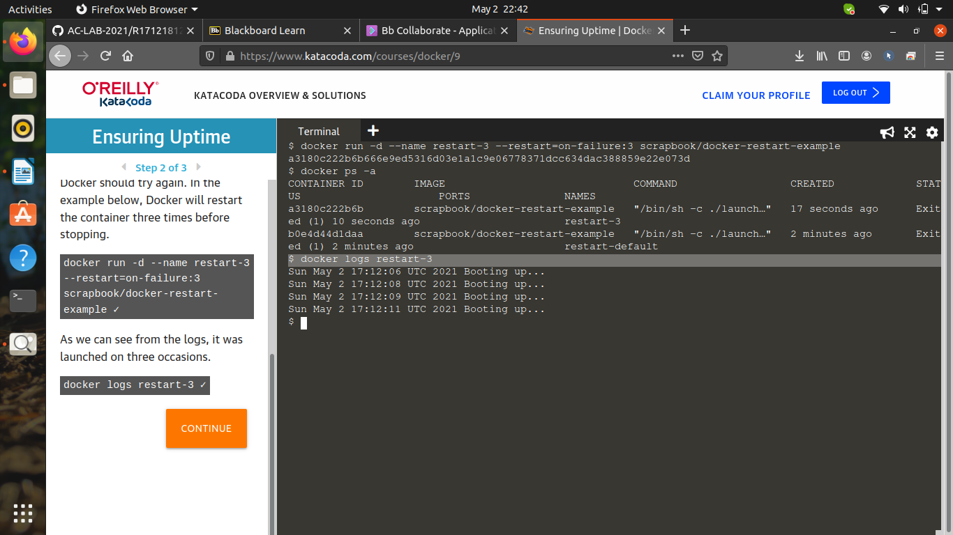

7. Create a container -

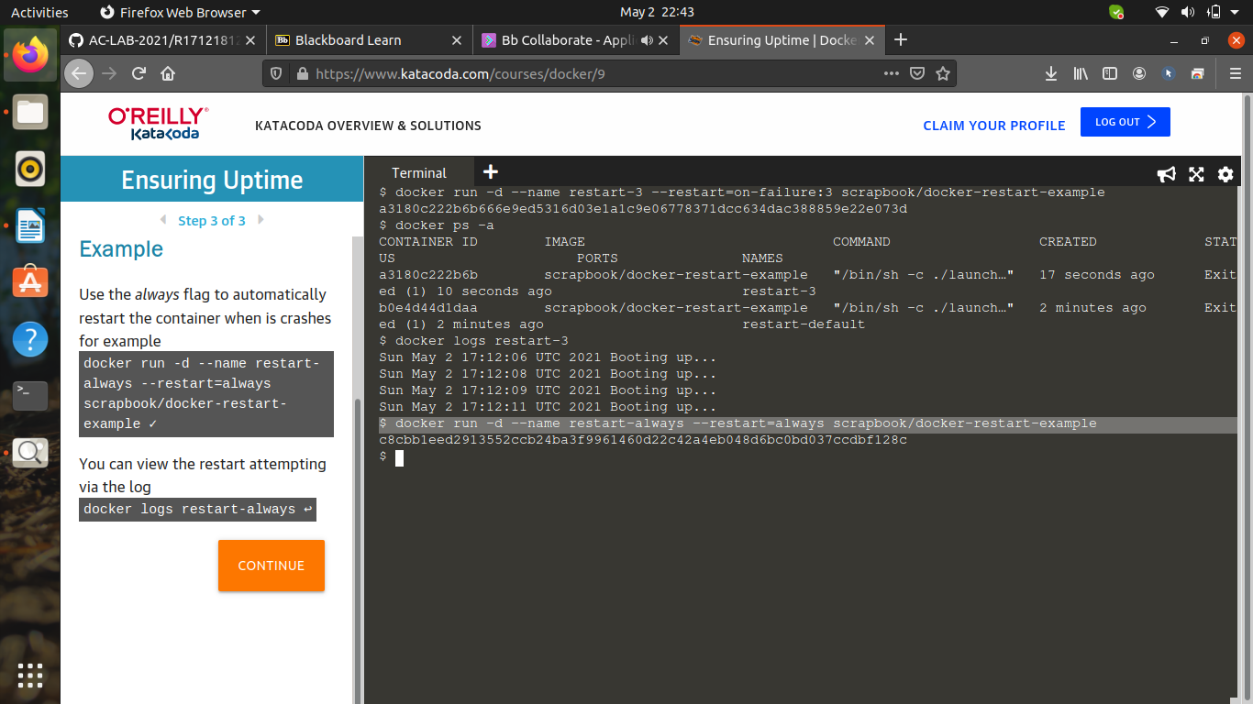

8. Check the logs -

