Application Containerization

Experiment – 6

Name – Ishita Bansal
Roll no – R171218124
Sap id – 500071818
Course – Devops Batch 2
Submitted To – Mr. Hitesh Kumar Sharma

AIM – Linking of two docker contaiers and starting with swarm.

1) Create a container named “db” -

“sudo docker run -it -d –name db training/postgress

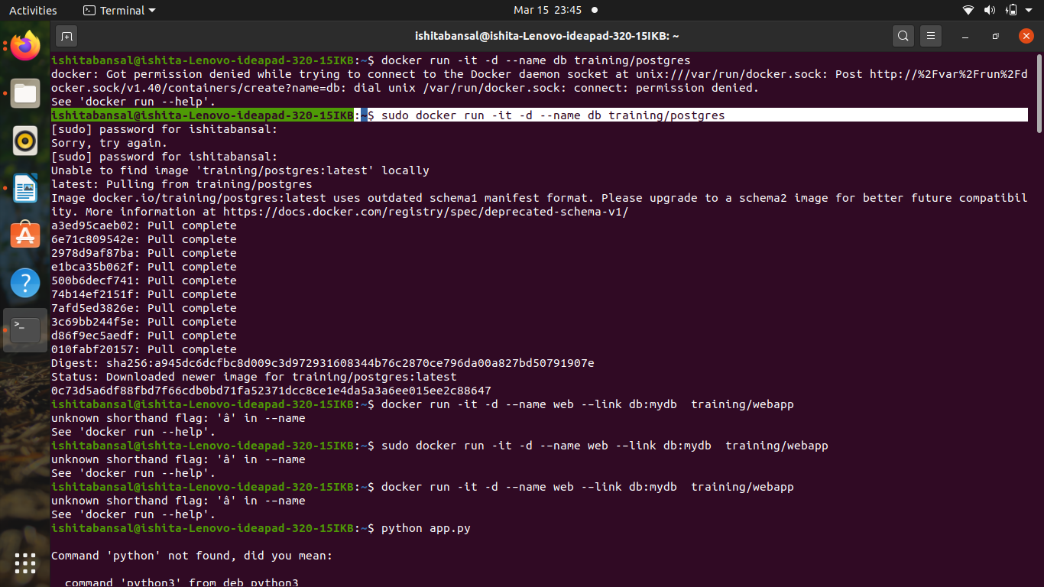

2) List out the running containers using -

“sudo docker ps”

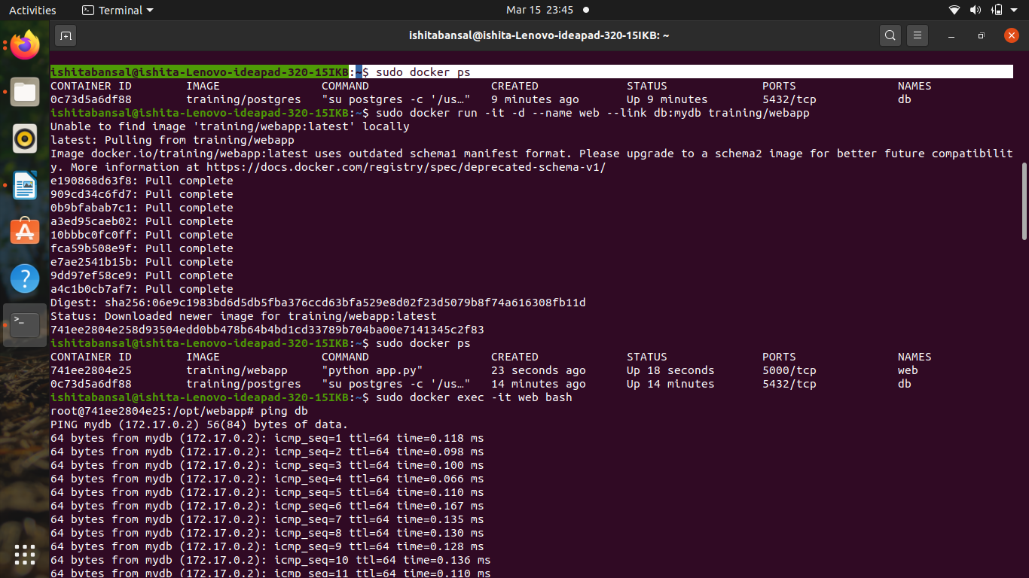

3) create another container linking the previous container -

“sudo docker run -it -d –name web –link db:mydb training/webapp”

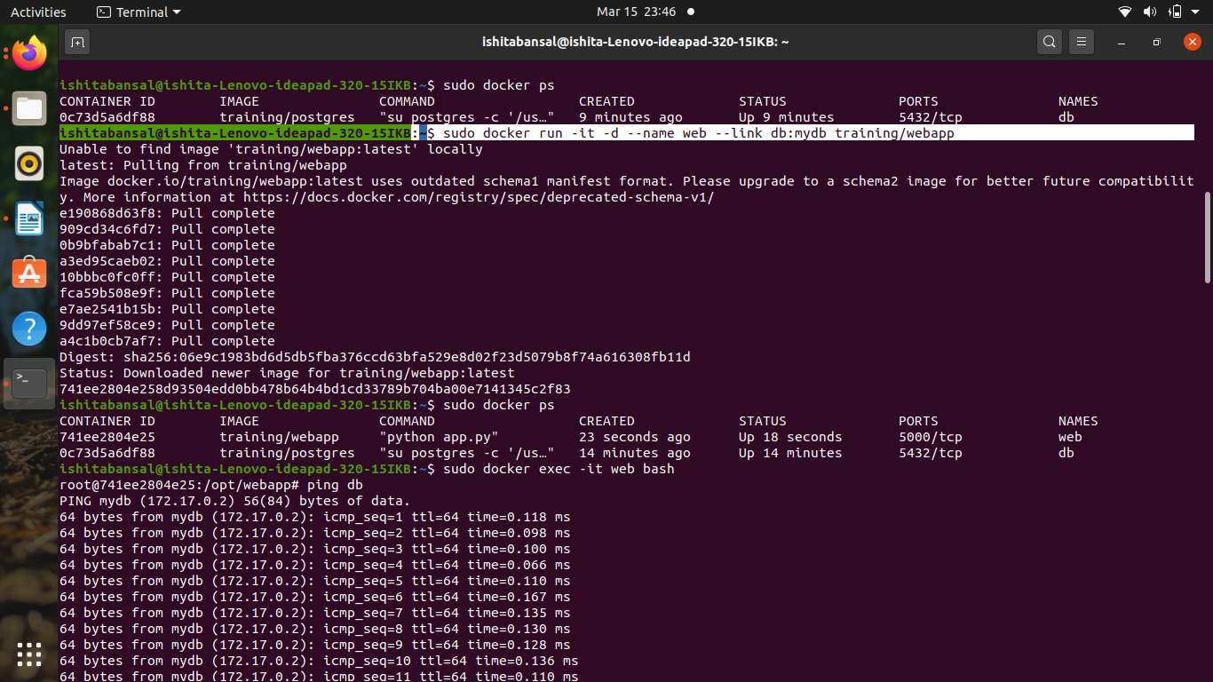

4) Again list out the running containers -

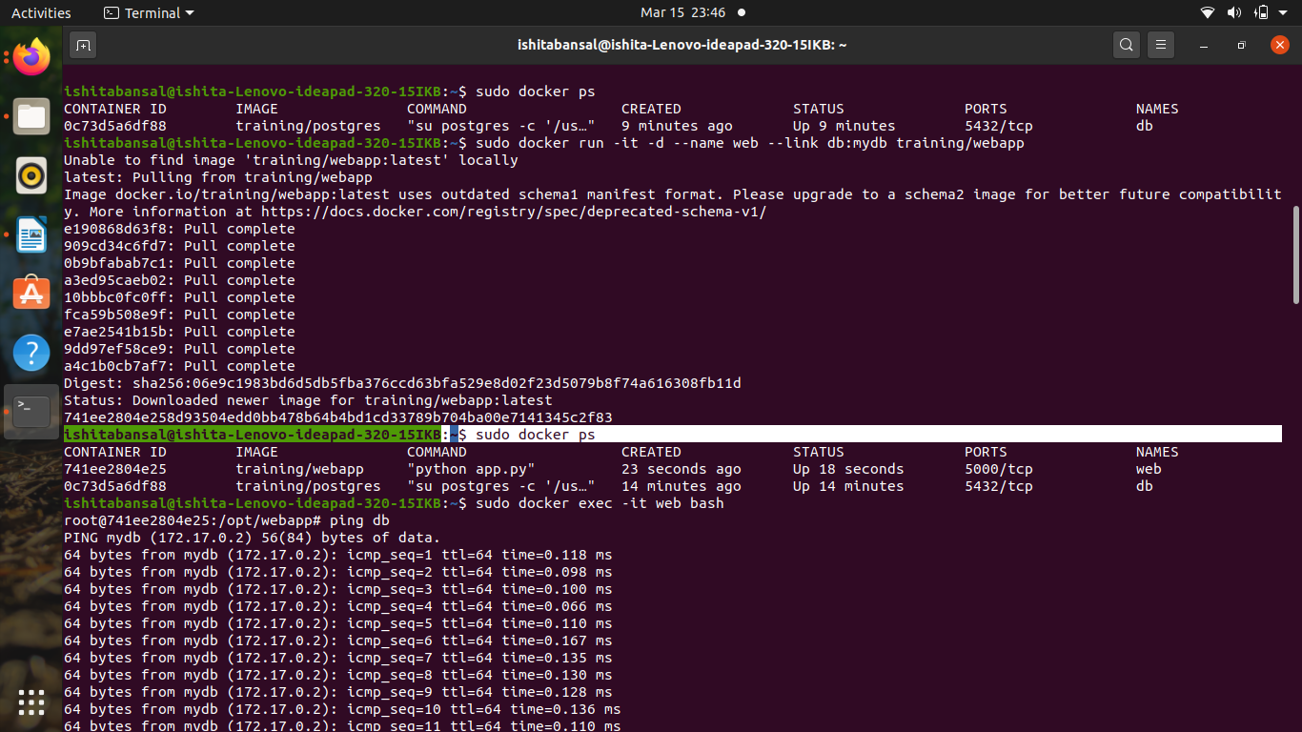

5) Take a bash terminal of webusing and check its linking by using ping command-

“sudo docker exec -it web bash”

“ping db”
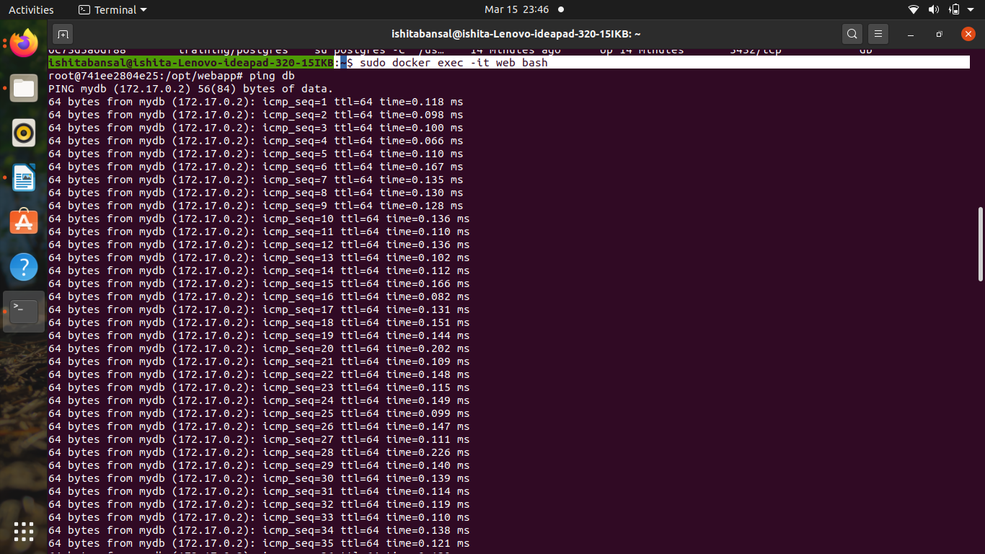

6) Create one more container -

“sudo docker run -it -d –name db1 training/webapp”

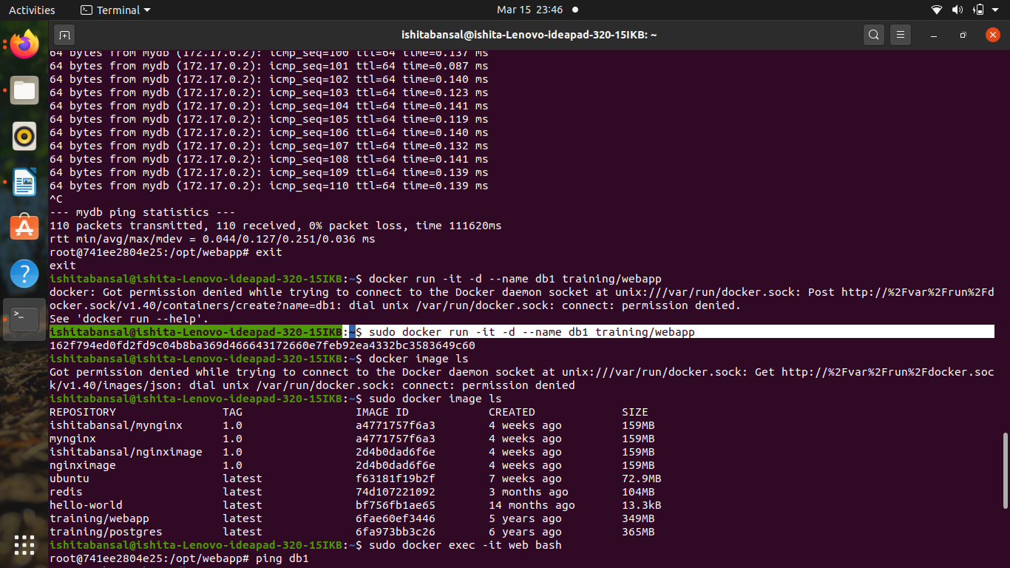

7) Now list out the images in the container -

“sudo docker image ls”

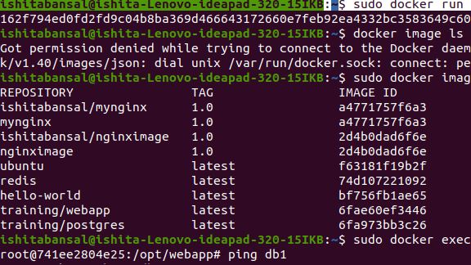

8) Again create a bash terminal of web and ping the new container. This container will not be linked with web container.

“ sudo docker exec -it web bash”

“ping db1”

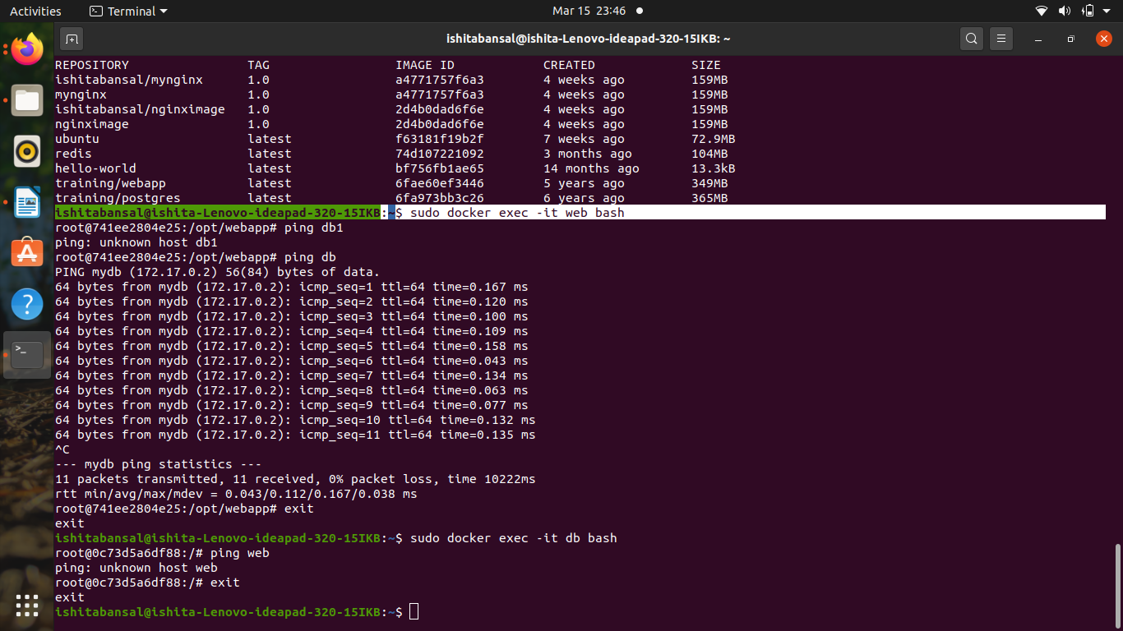

9) Now create a bash terminal of db and check whether it will be linked with web using ping -

“ sudo docker exec -it db bash”
“ping web”

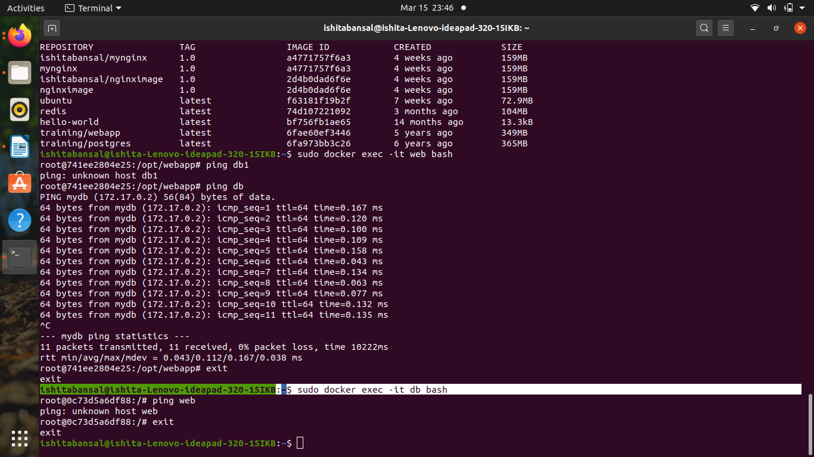

Now we will be starting with basic step of swarm
For this we will need two terminals running simultaneously out of which one will be the slave and other will be the manager.

1) create a swarm on one terminal and join the other terminal with it

“ docker swarm init”

“docker swarm join”

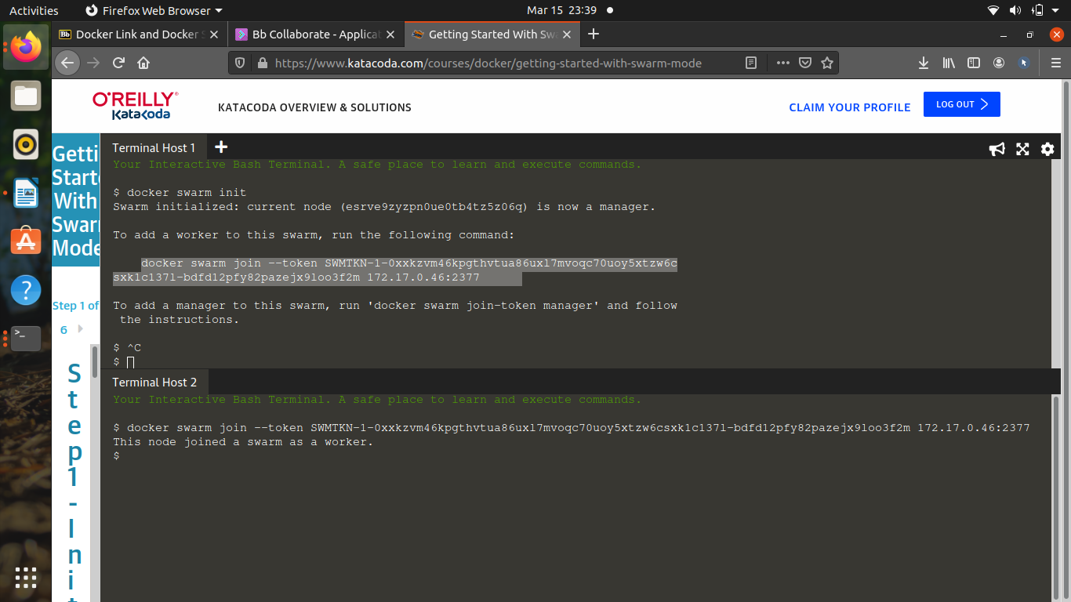

2) Now list out the nodes in both the terminals -

“ docker node ls”

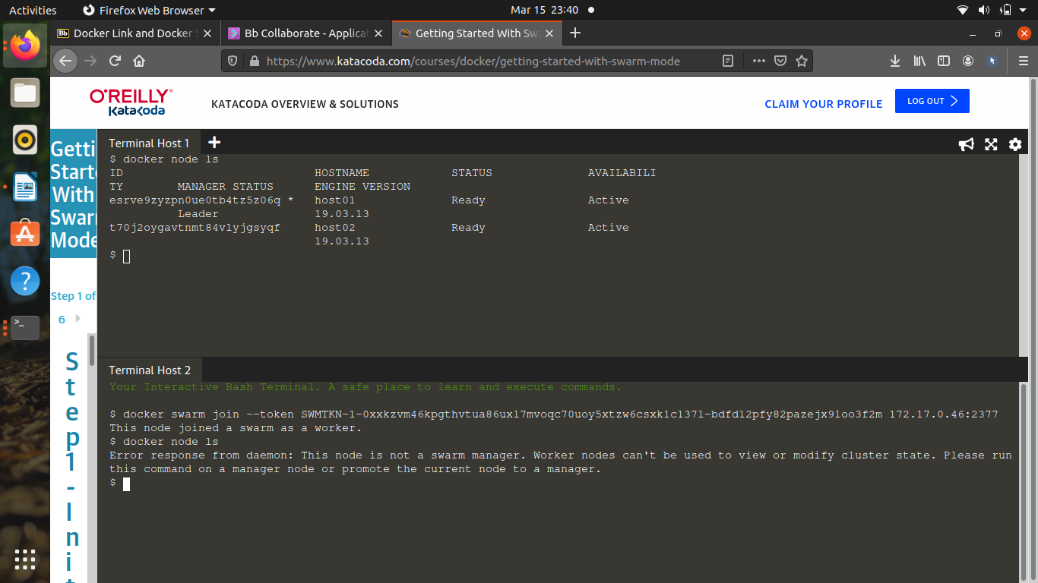

3) now leave the terminal -

“ docker swarm leave –force”

