**Name:** Aayush Kumar

R171218002

500069079

**Experiment 13**

**Aim:** Execution of basic docker commands.

**Commands:**

**1)** docker images: This command will display all the docker images that have been downloaded or created. Eg: **docker images**

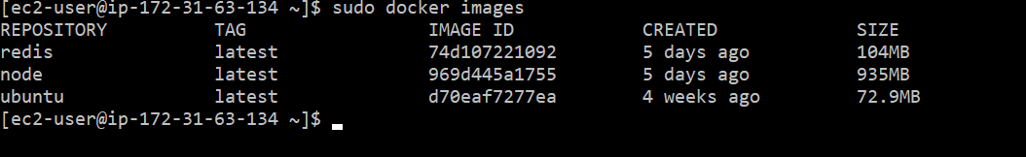

**2)** docker search: This command will search dockerhub for images. Eg: **docker search [image name]**

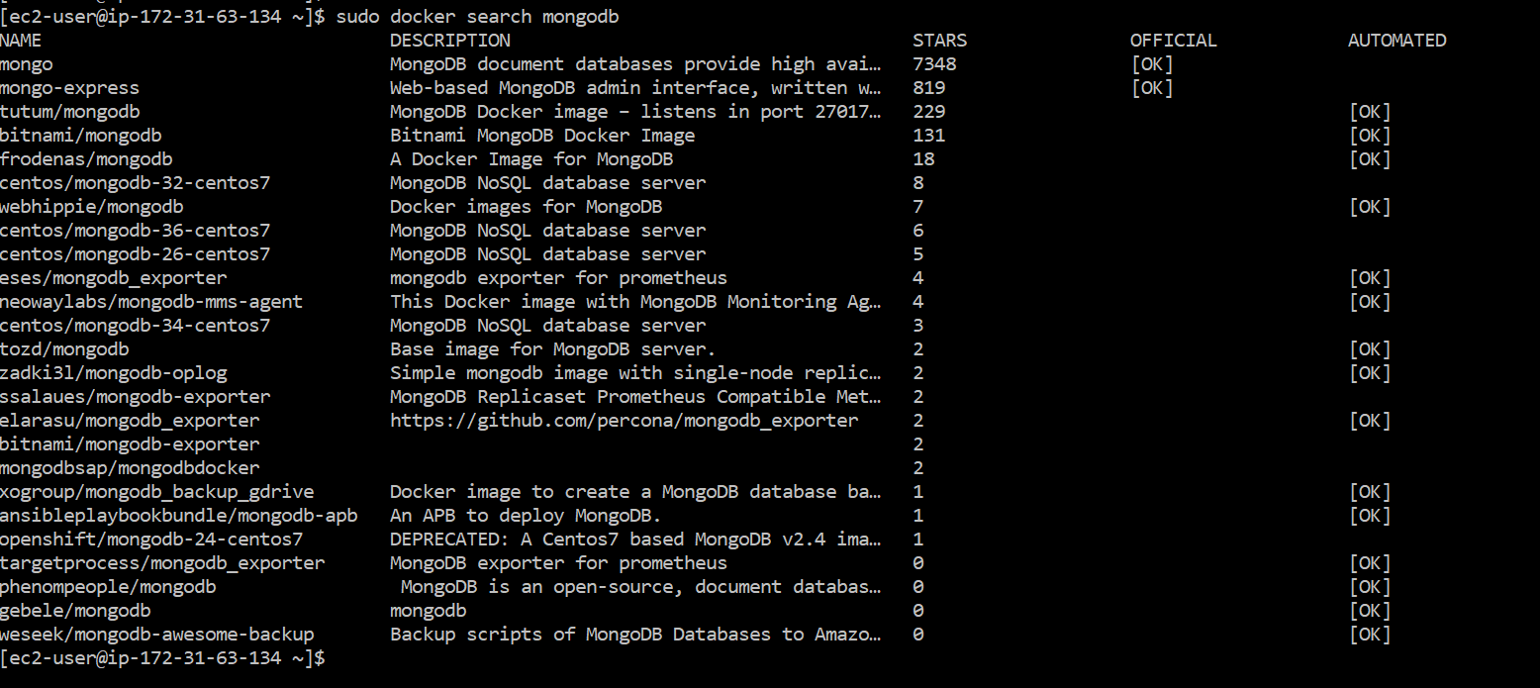

1. docker pull: This command will pull images from dockerhub.

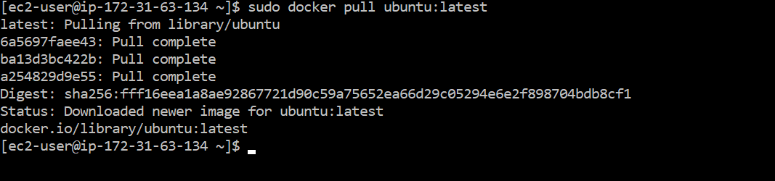

1. docker ps –a: This command will display all the containers created whether running or stopped.

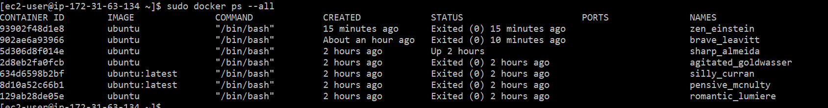

**5)** docker ps: This command will display all the running containers.



6)docker run: This command is used to create containers.

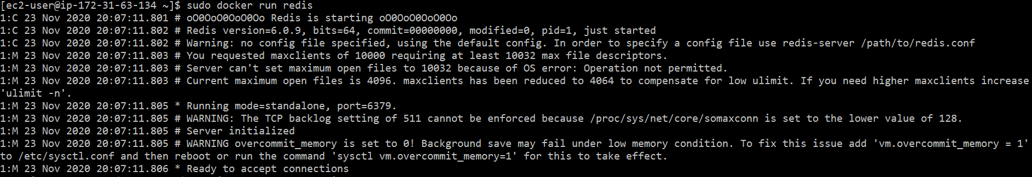

docker run -td [image name]: starts a container and keep it running

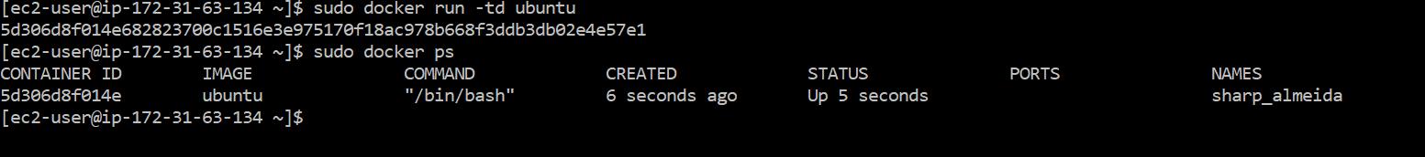

docker run –it [image name]: The –i option is used to make the container interactive and –t is used for attaching the container’s terminal.

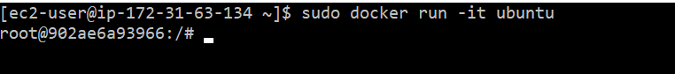

1. docker inspect: The following command is used to inspect the container that has been created.

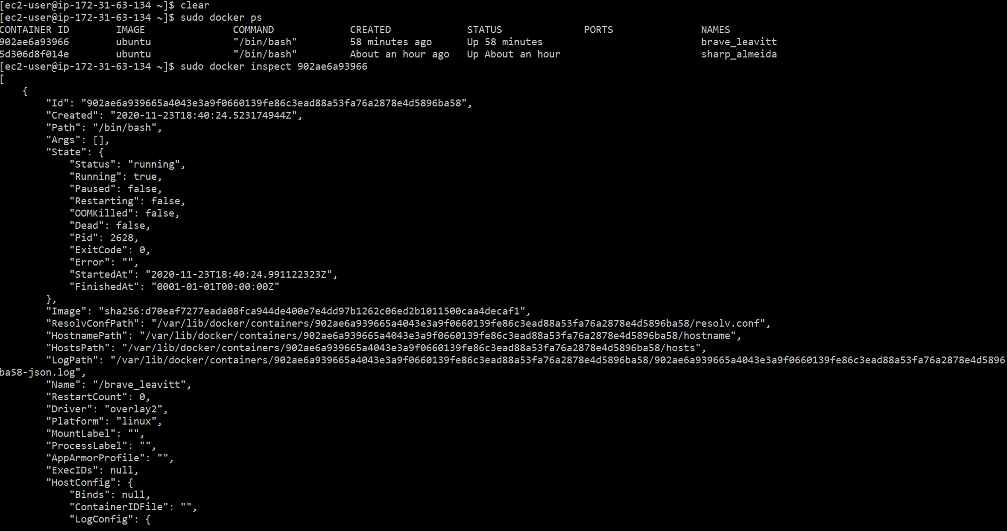

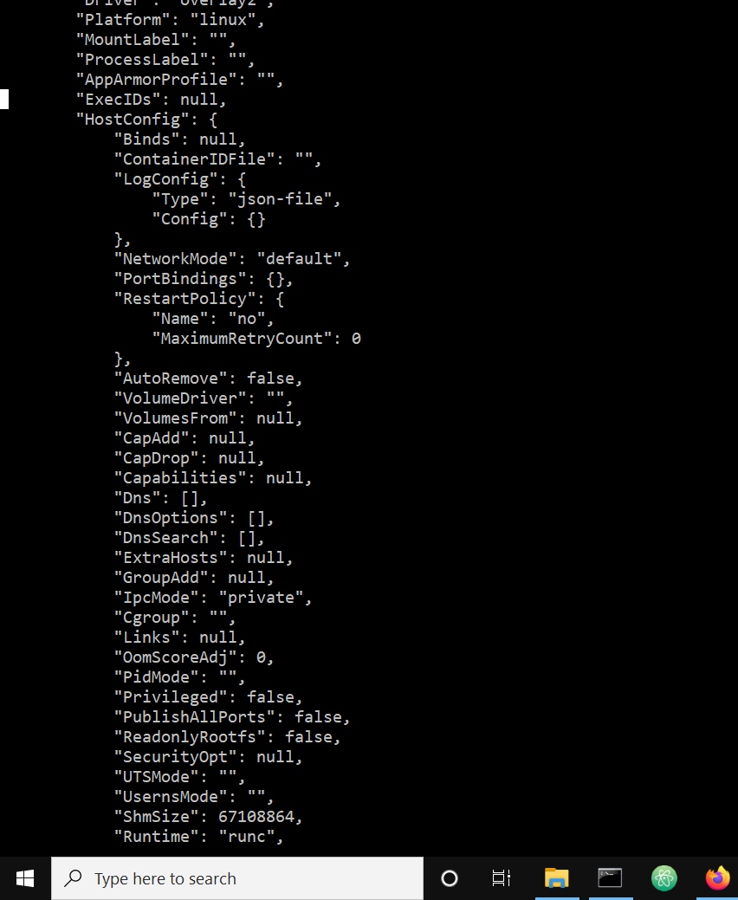

1. docker stop: This command command is used to stop a running container.

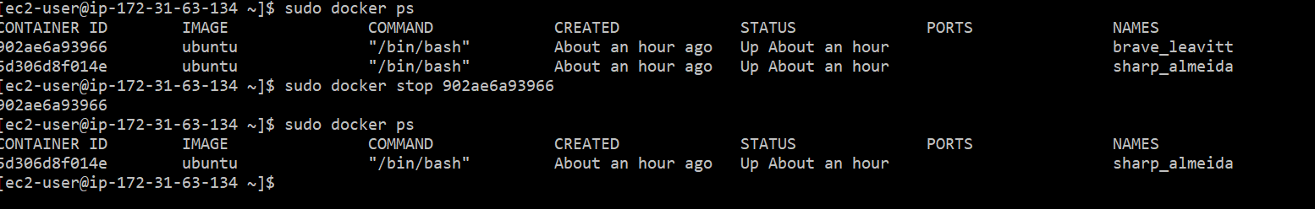

**9)** docker start: This command is used to start a container that has already been created.

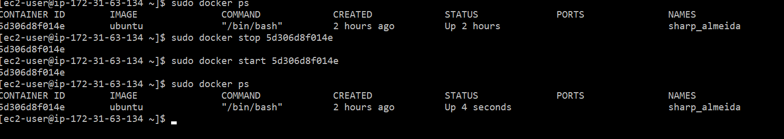

10) docker rm : This command will delete a container if it is not running.

