**EXPERIMENT-13**

Ajay Kumar Tyagi  
500067403  
R171218008

**Aim:** Basic Docker commands.

**Commands:**

**1) docker search <image-name>:** This command will search and display different versions of the image available on dockerhub.  
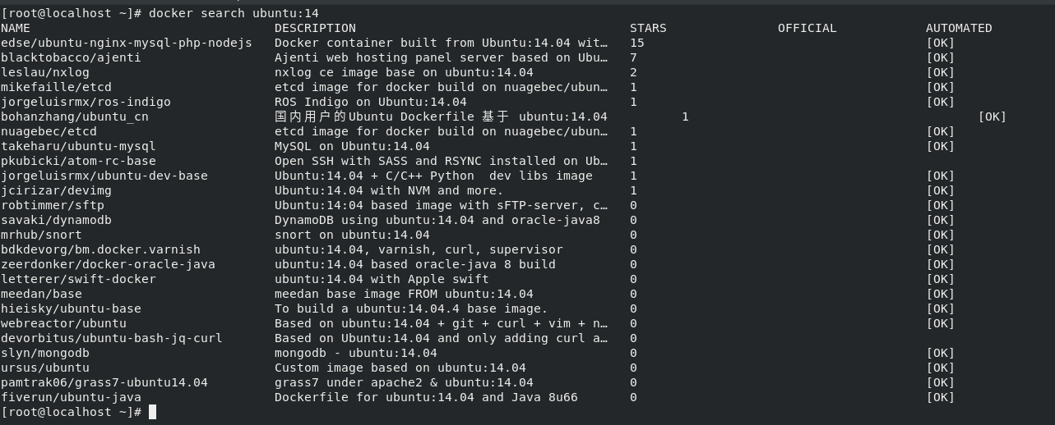

**2) docker pull <image:version>:** This command will download image of the specified version from dockerhub in your local system.  
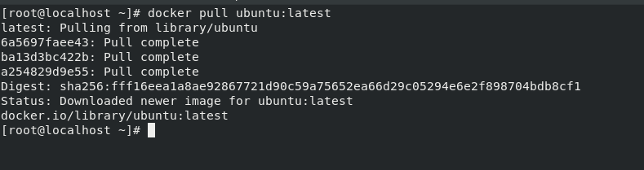

**3) docker image:** This command will show all the images that are available on your local system.  
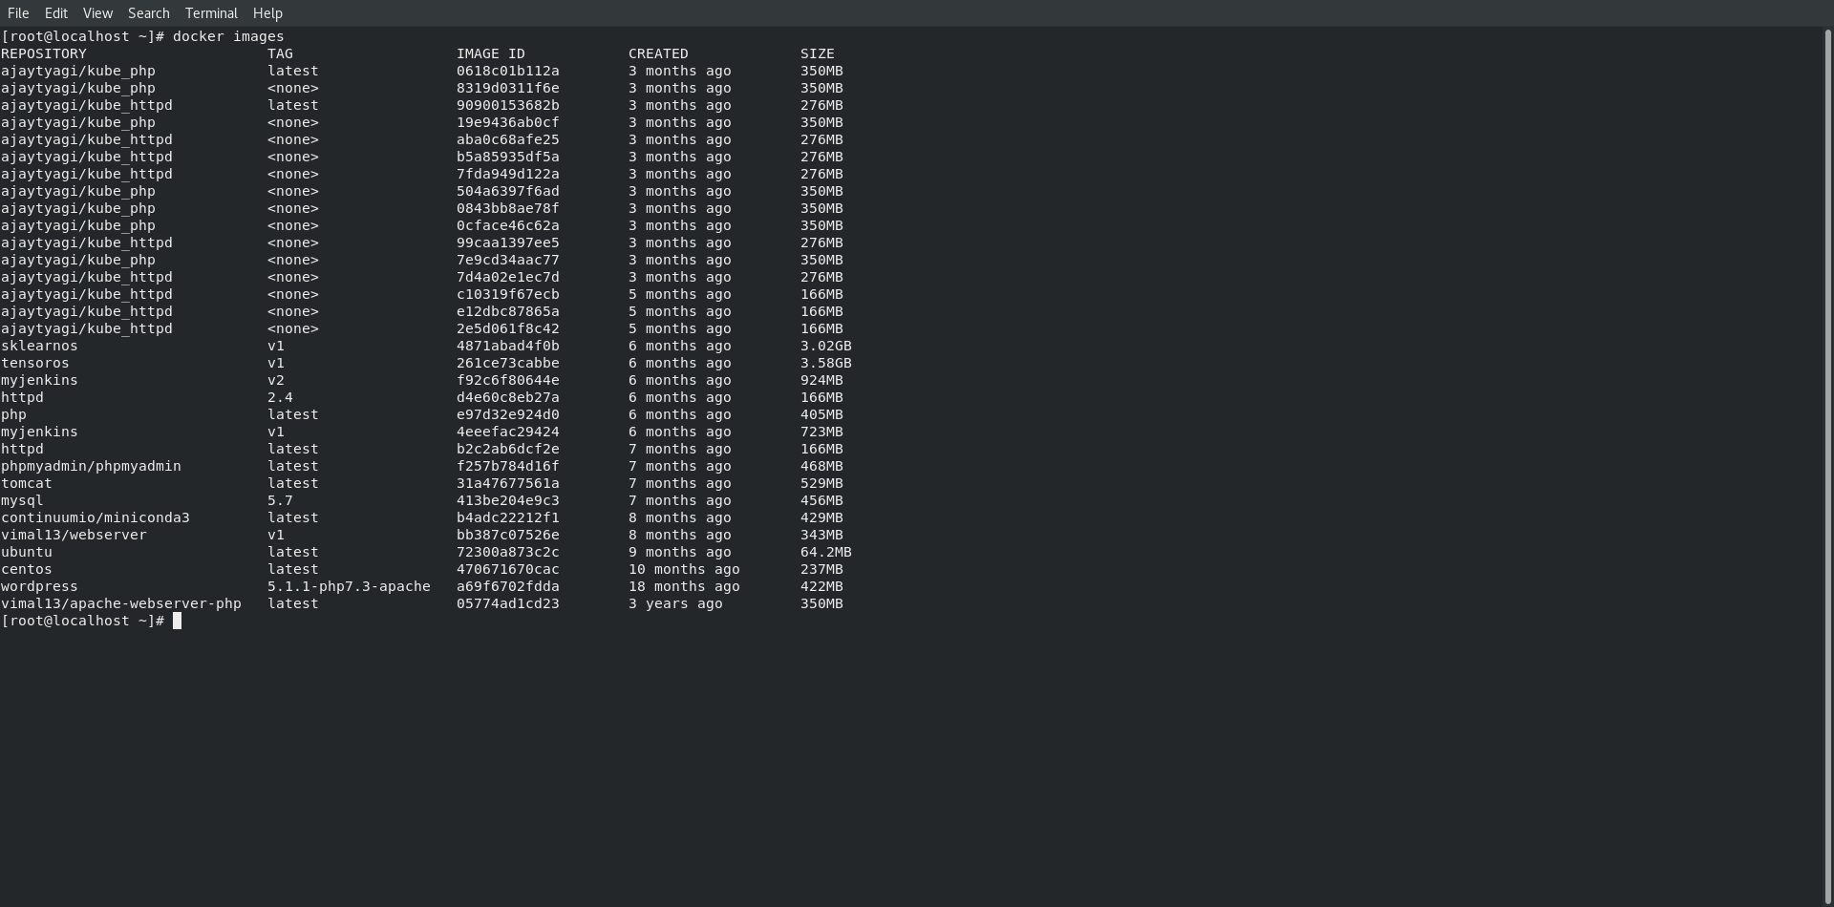

**4) docker ps:** This command will show all containers that are in running state.  
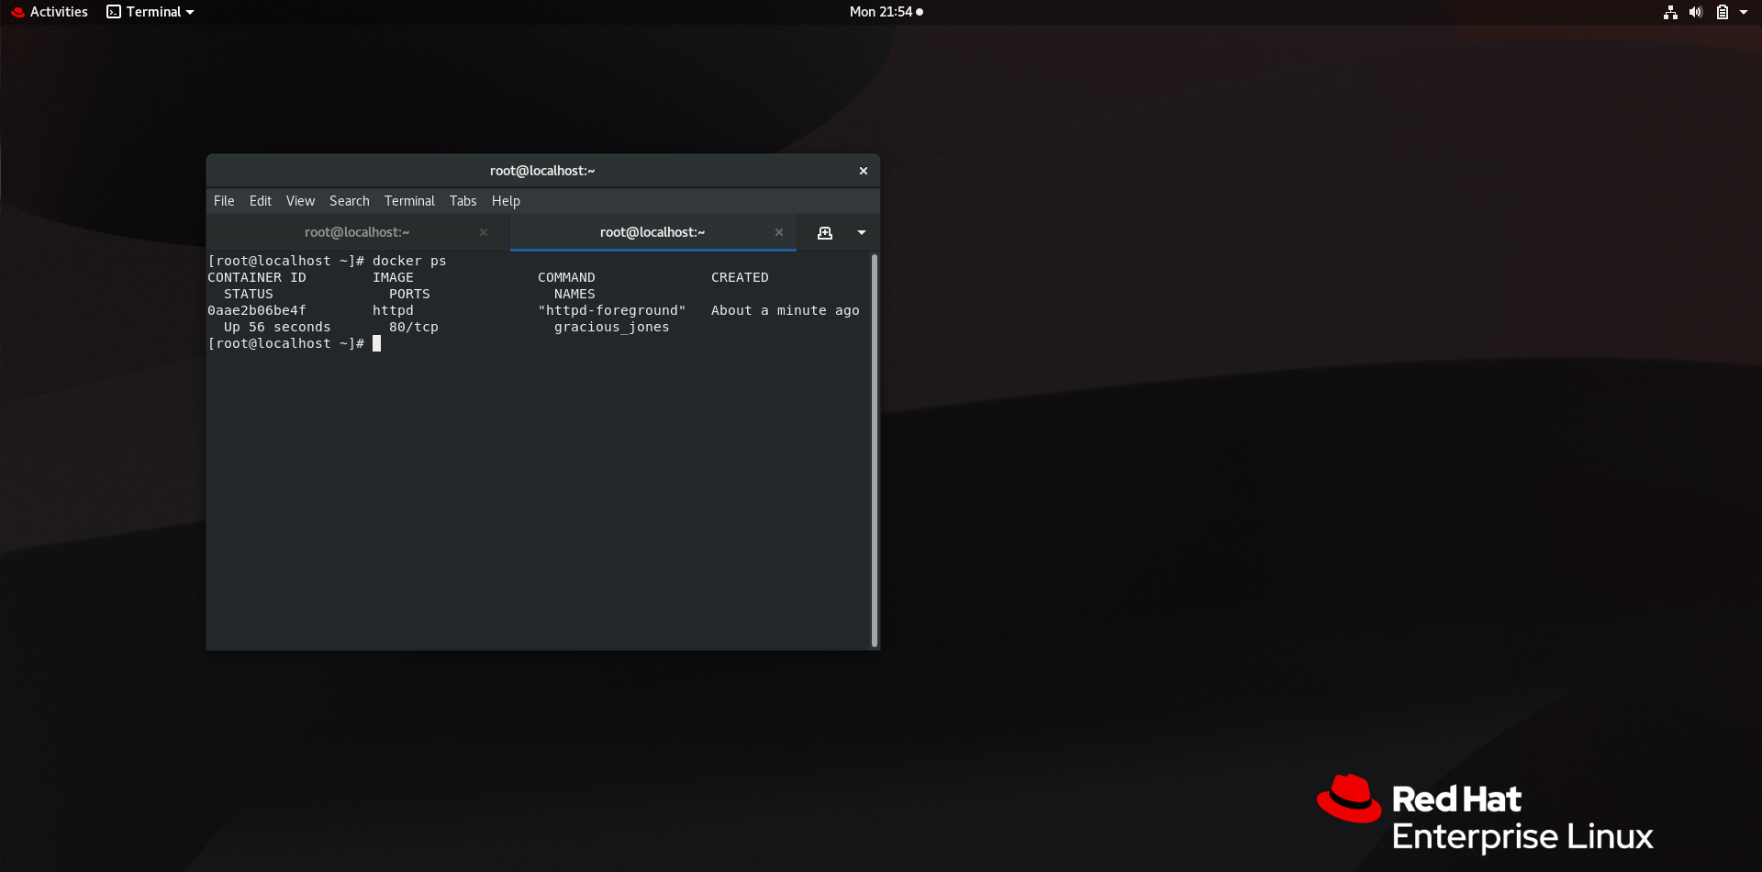

**5) docker ps –a:** This command will show all containers whether they are in running state or stopped.  
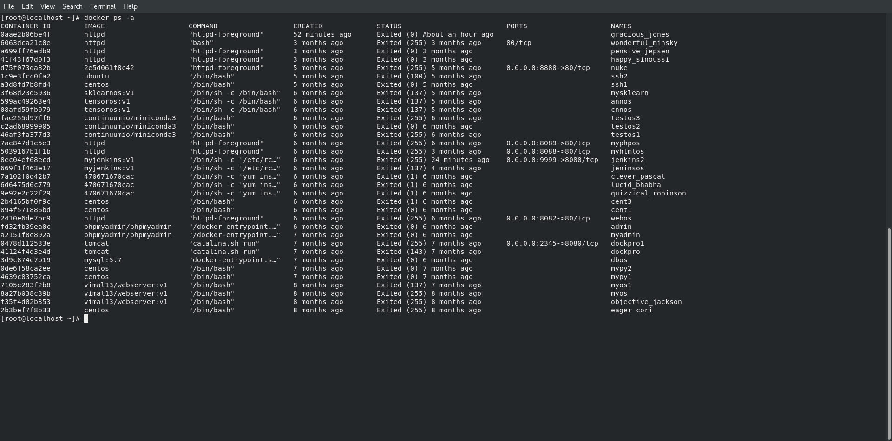

**6) docker run <image-version>:** This command will run the container of the image with the specified version. Container name is given randomly by docker. To give container name use -- name <name> option with docker run command. Use –d option to run container in background.  
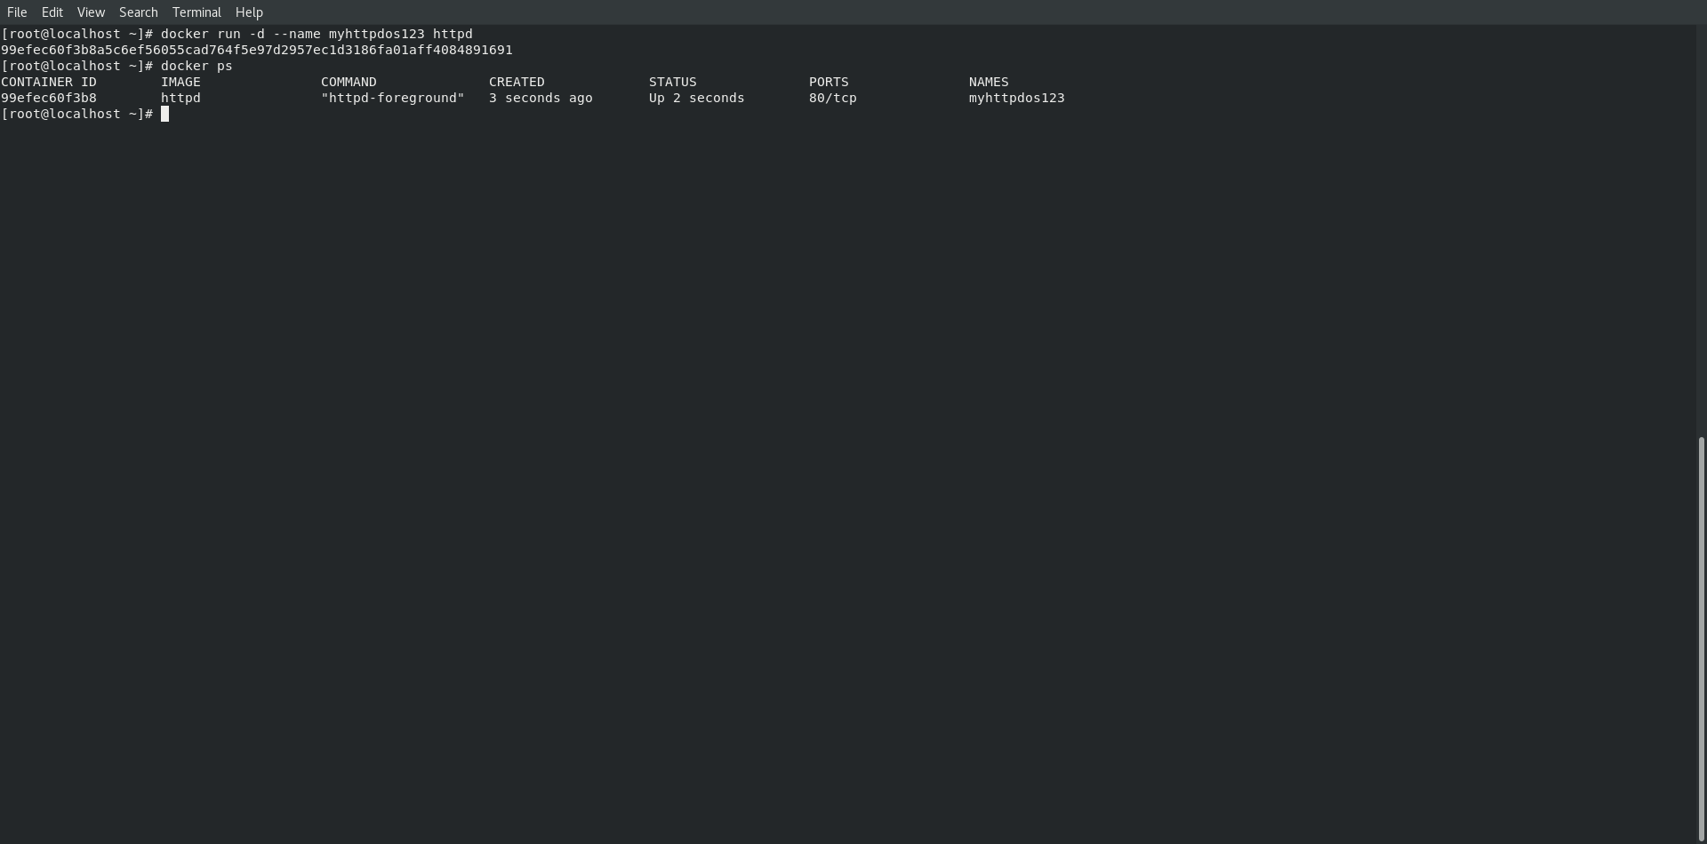

To interact with the container use option –it. It will option interactive terminal of the container.  
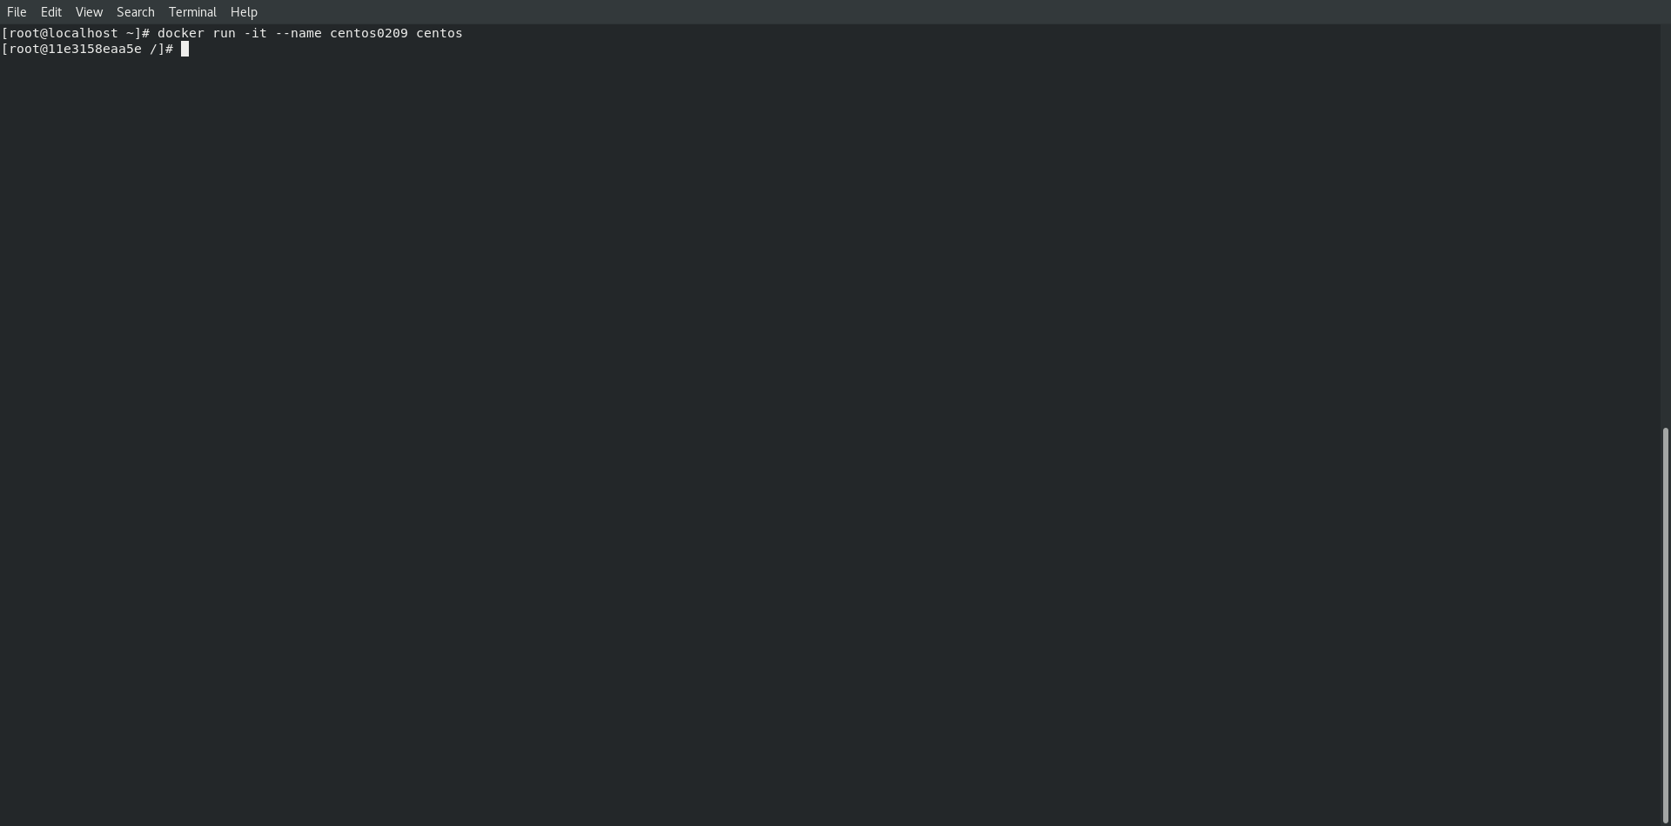

**7) docker run –p[baseOsPort:containerOsPort]:** This command will redirect request from specified port of base OS to the specified port of the container. This is called patting.  
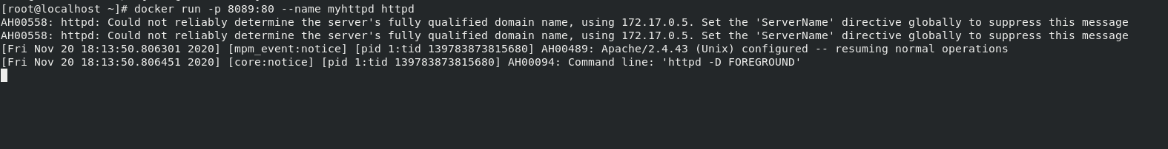

**8) docker inspect <container-name/container-id>:** This command will show all the information about the container or will inspect the container.  
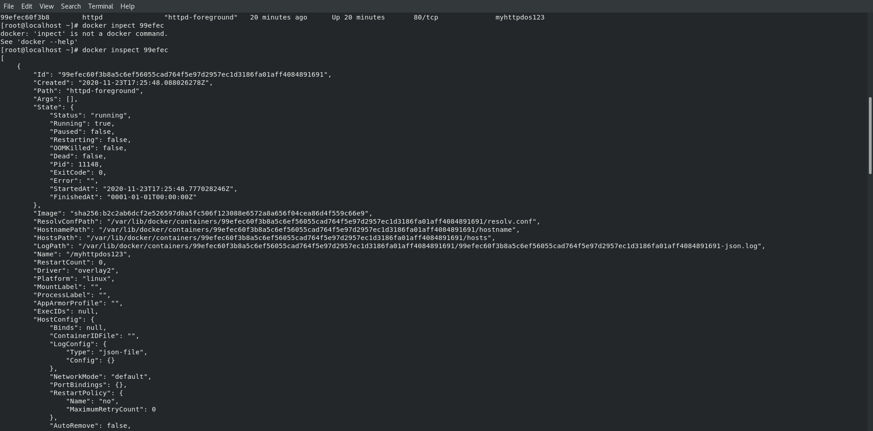

**9) docker start <container-name>:** This command will start the container which is currently stop.  
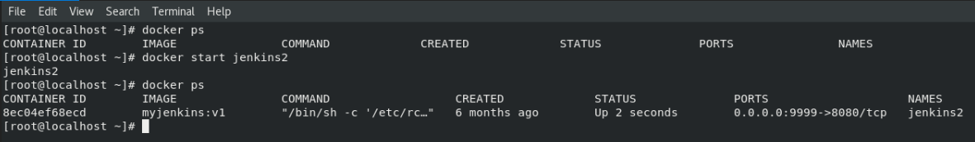

**10) docker stop <container-name>:** This command will stop the container which is currently on running state.  
