**Name: Arnav Ranjan**

**Roll Number: R171218029**

**SAP ID: 500067731**

**Lab: 1**

**Installation of Jenkins and Execution of a simple job in Jenkins**

**Steps**

**1.** Click [here](https://www.jenkins.io/download/%20) and download Jenkins for whatever platform you are working.

**2.** After download open command prompt and go to location where bin is stored for Jenkins.

**3.** Run command java -jar jenkins.war.

**4.** login to jenkins.

**5.** Select “New Item” and select maven project.

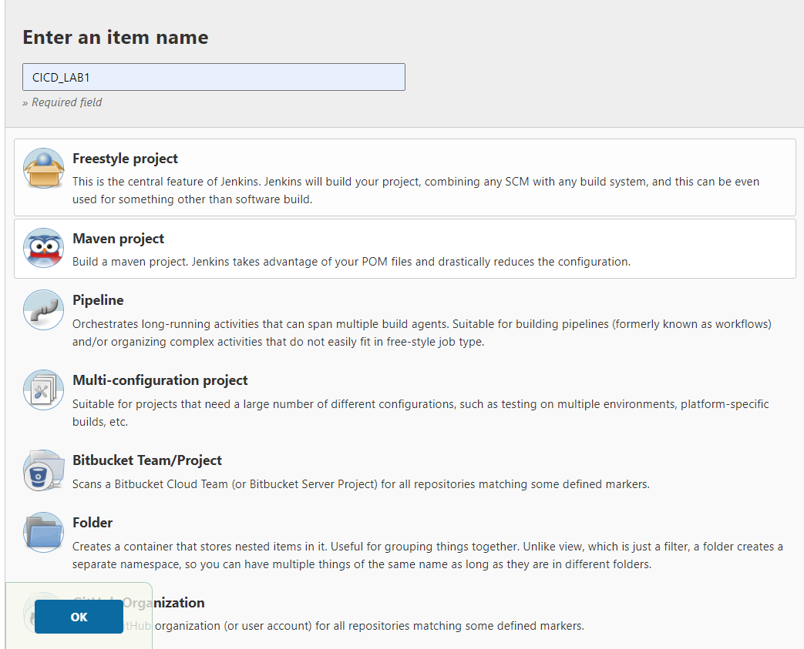

**6.** Run a simple task in jenkins.

**7.** Build the task.

