**Name: Arnav Ranjan**

**Roll Number: R171218029**

**SAP ID: 500067731**

**Lab: 12**

**Running docker in Vagrant**

**Prerequisites**

1.Vagrant should be running in background

**Steps**

1. First, in order to ensure the downloads are valid, add the GPG key for the official Docker repository to your system:  
$ curl –fsSL https://download.docker.com/linux/ubuntu/gpg | sudo apt-key add –

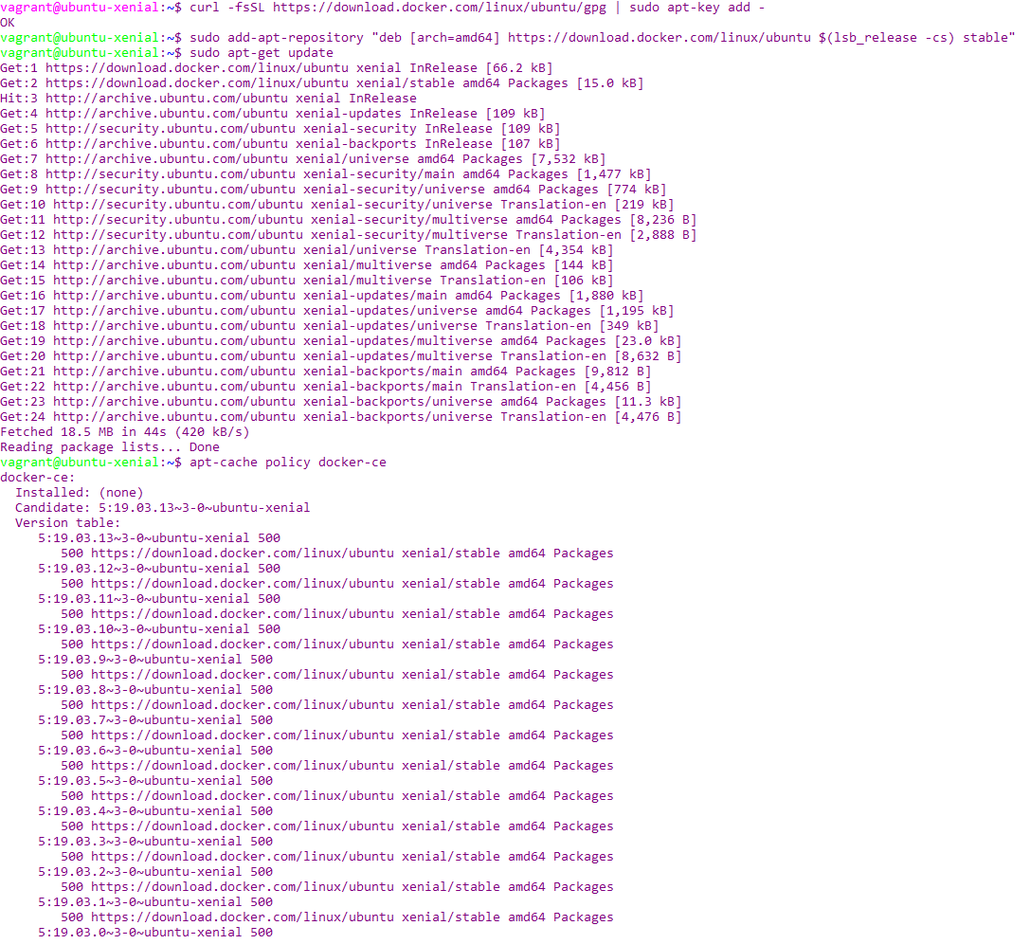

2. Add the Docker repository to APT sources

$ sudo add-apt-repository "deb [arch=amd64] https://download.docker.com/linux/ubuntu $(lsb_release -cs) stable"



3. Next, update the package database with the Docker packages from the newly added repo:

$ sudo apt-get update



4. Make sure you are about to install from the Docker repo instead of the default Ubuntu 16.04 repo:

$ apt-cache policy docker-ce



5. Install docker

$ sudo apt-get install -y docker-ce

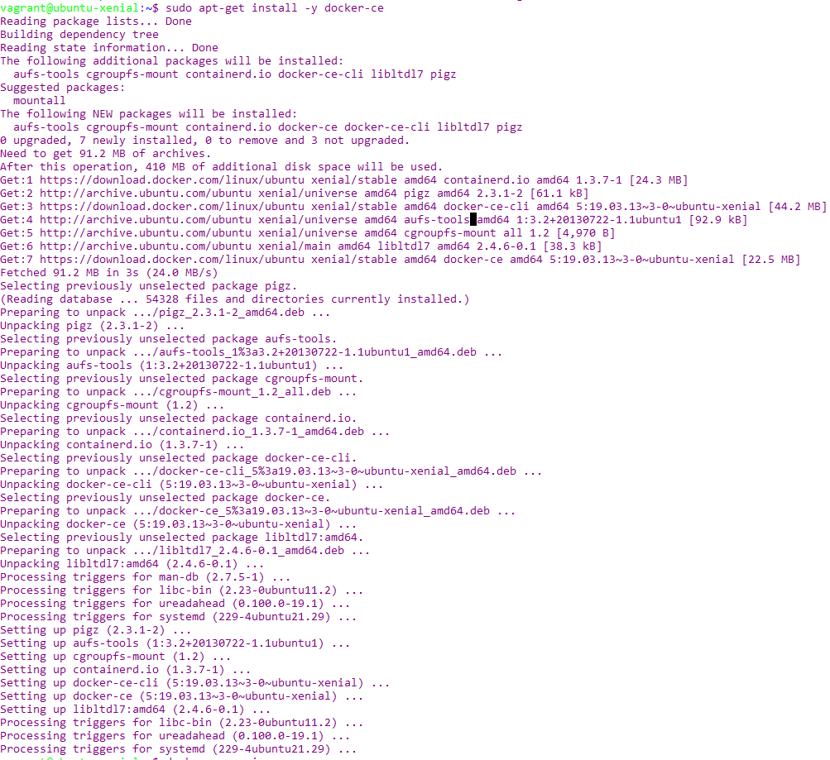

6. Check your docker version

$ docker --version

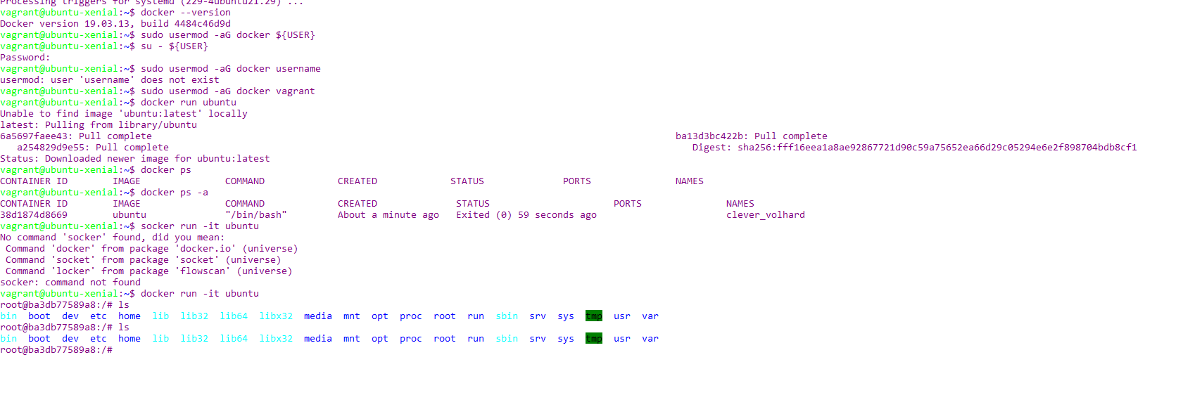

7. Executing the Docker Command Without Sudo

$ sudo usermod -aG docker ${USER}



8. To apply the new group membership, you can log out of the server and back in, or you can type

$ su - ${USER}



Password : vagrant (default)

9. To run Ubuntu

docker run ubuntu



10. To keep ubuntu running this will take you to Ubuntu terminal

docker run -it Ubuntu

