**Name: Arnav Ranjan**

**Roll Number: R171218029**

**SAP ID: 500067731**

**Lab: 2**

**Jenkins integration with Github and Maven**

**Steps**

**1.** Create a repository in github.

**2.** Copy url.

**3.** Go to jenkins click on “**manage jenkins”**.

**4.** Click on “**Manage jenkins**”

**5.** Click on “**Available**”

**6.** Search “**MAVEN INTEGRATION PUGIN**”



**7.** Create a new maven project in jenkins.

**8.** Configure project.

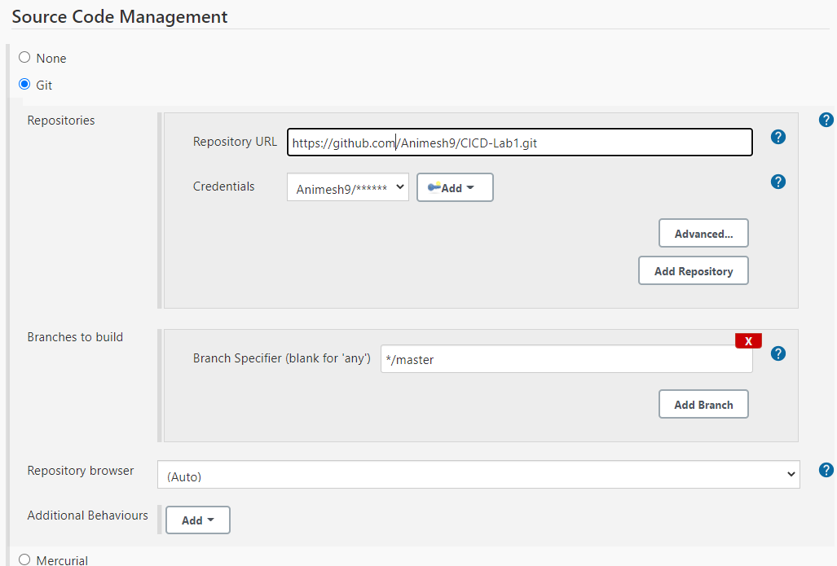

**9.** Upload Project

**10.** Build code

