**Name: Arnav Ranjan**

**Roll Number: R171218029**

**SAP ID: 500067731**

**Lab: 6**

**Create pipelines using JenkinsFile**

**Steps**

**1.** Make a Jenkinsfile and add it to your git repo where your peoject is added

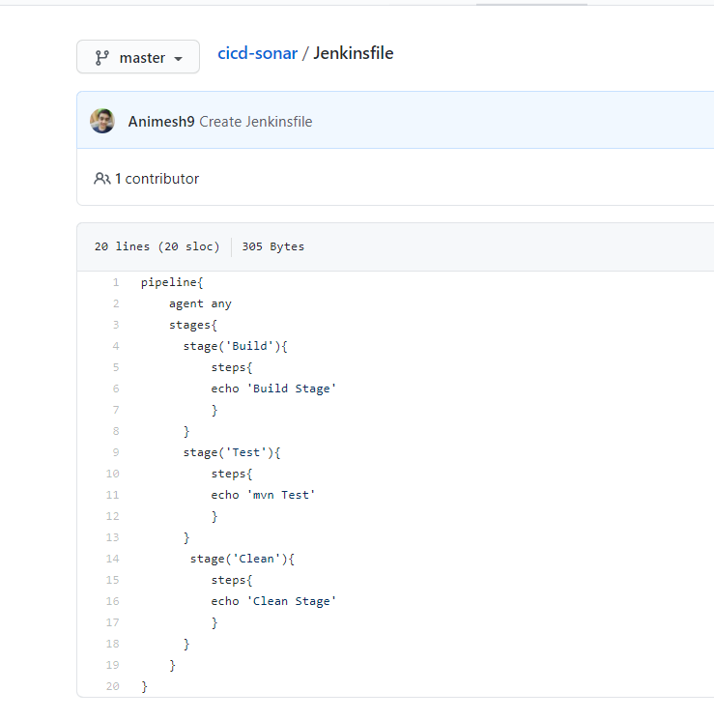

**2.** Create a pipeline

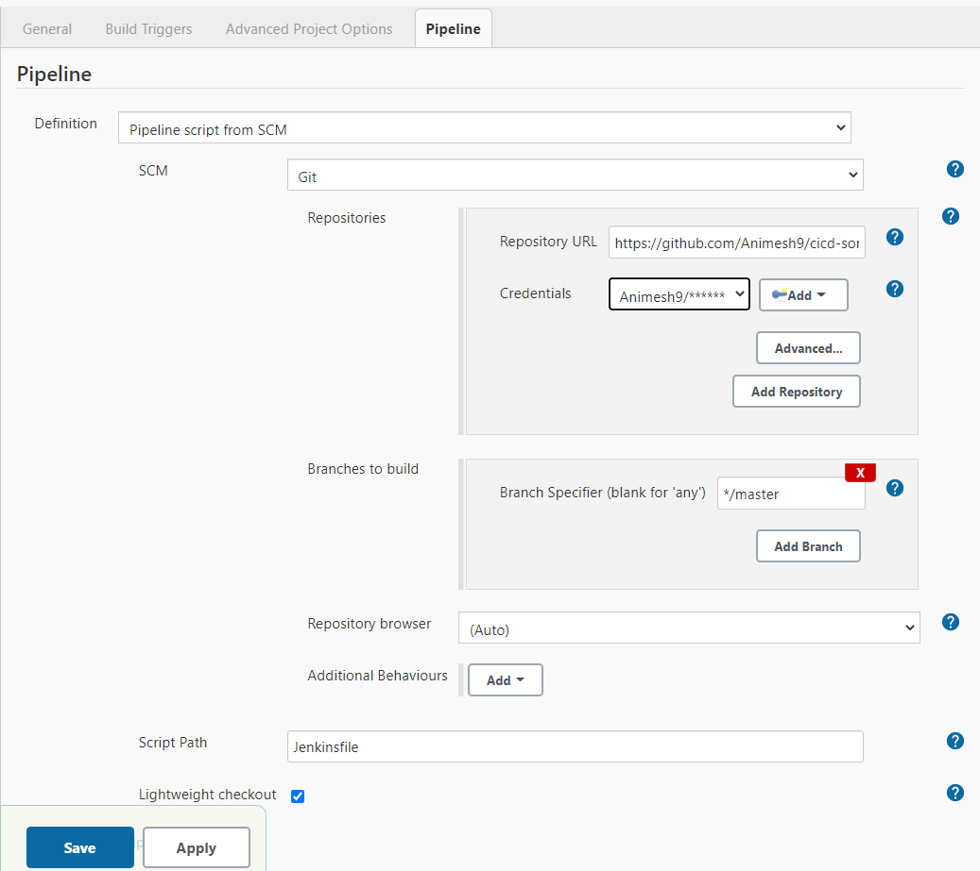

**3.** Save and build.

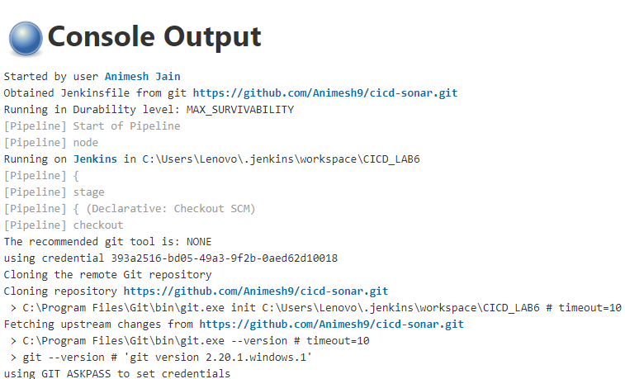

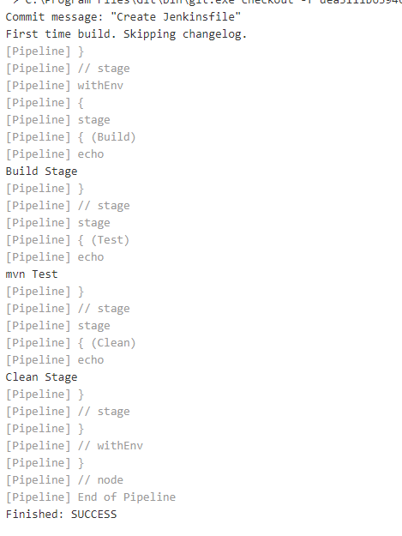

**4.** Stage View

