**Name: Arnav Ranjan**

**Roll Number: R171218029**

**SAP ID: 500067731**

**Lab: 8**

**Implementing Master/Slave Architecture in Jenkins**

**Steps**

**1.** Create Maven project and configure its setting like

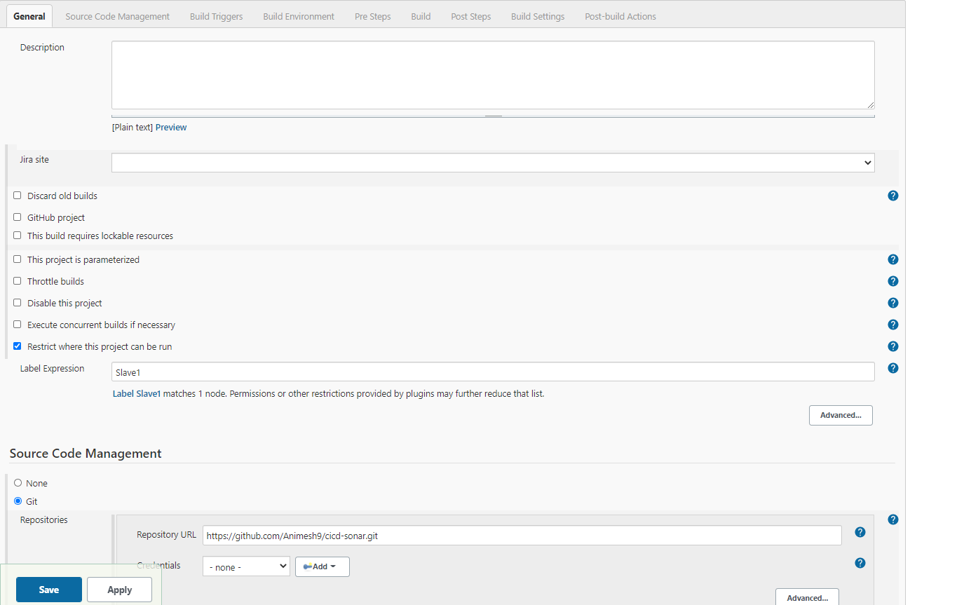

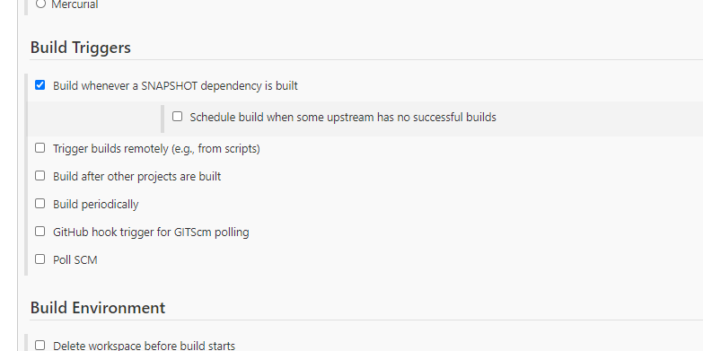

**2.** Save settings and go to slave1 and start it using this command

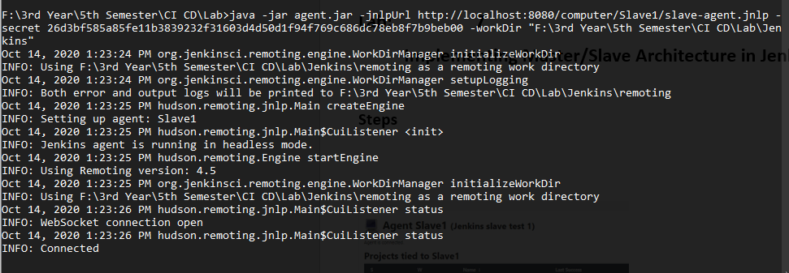

**3.** This will show when you’ll start your slave.

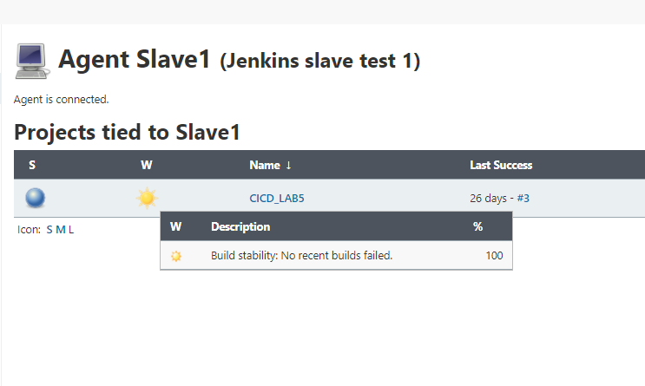

**4.** Build your project.

