**Continuous Integration and Deployment Lab**

**Experiment Number: 13**

**Deploying your first Docker Container**

By :-

Devansh Markan

R171218036

500069794

Batch:- 1

1. Run a container: docker search redis

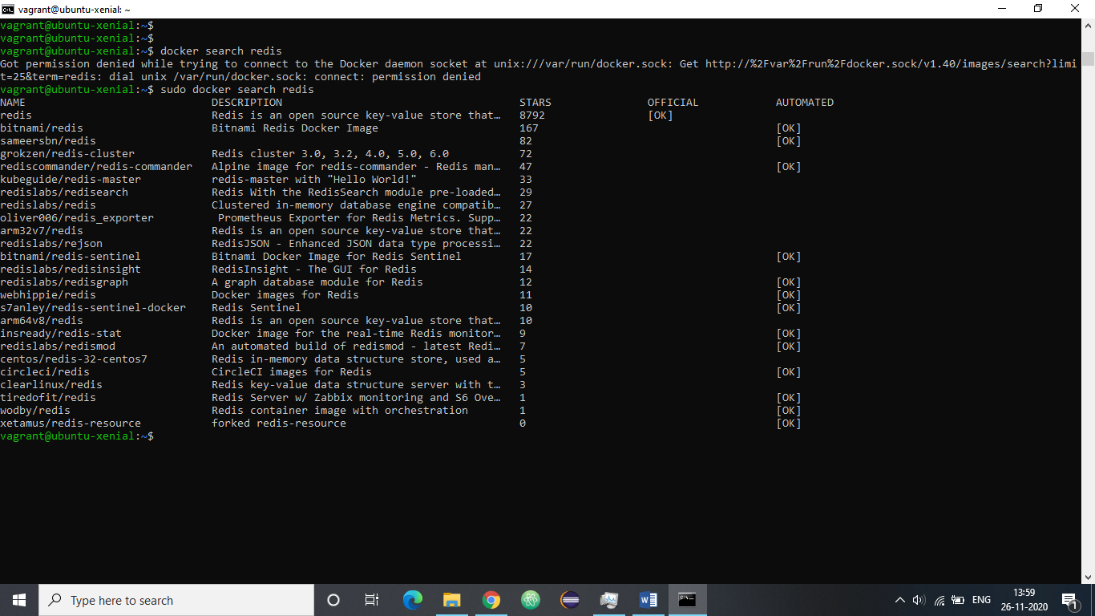

2. docker run <options> <image-name>

Example: docker run -d redis

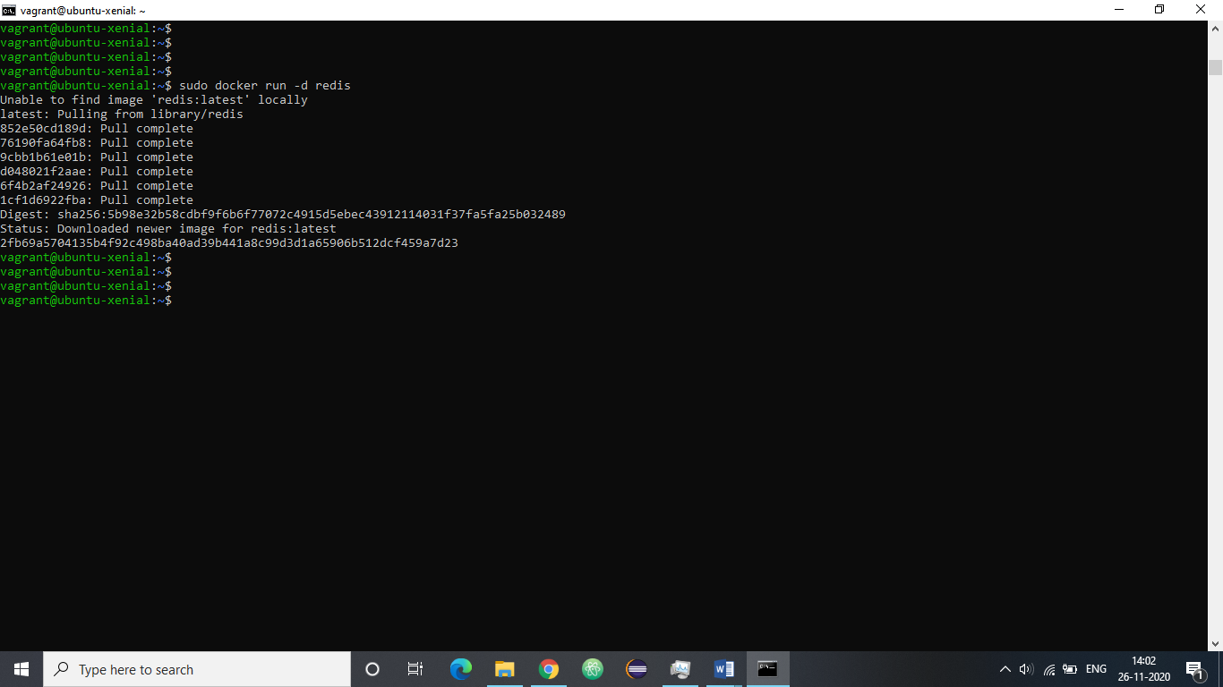

3. Finding Running Containers - docker ps

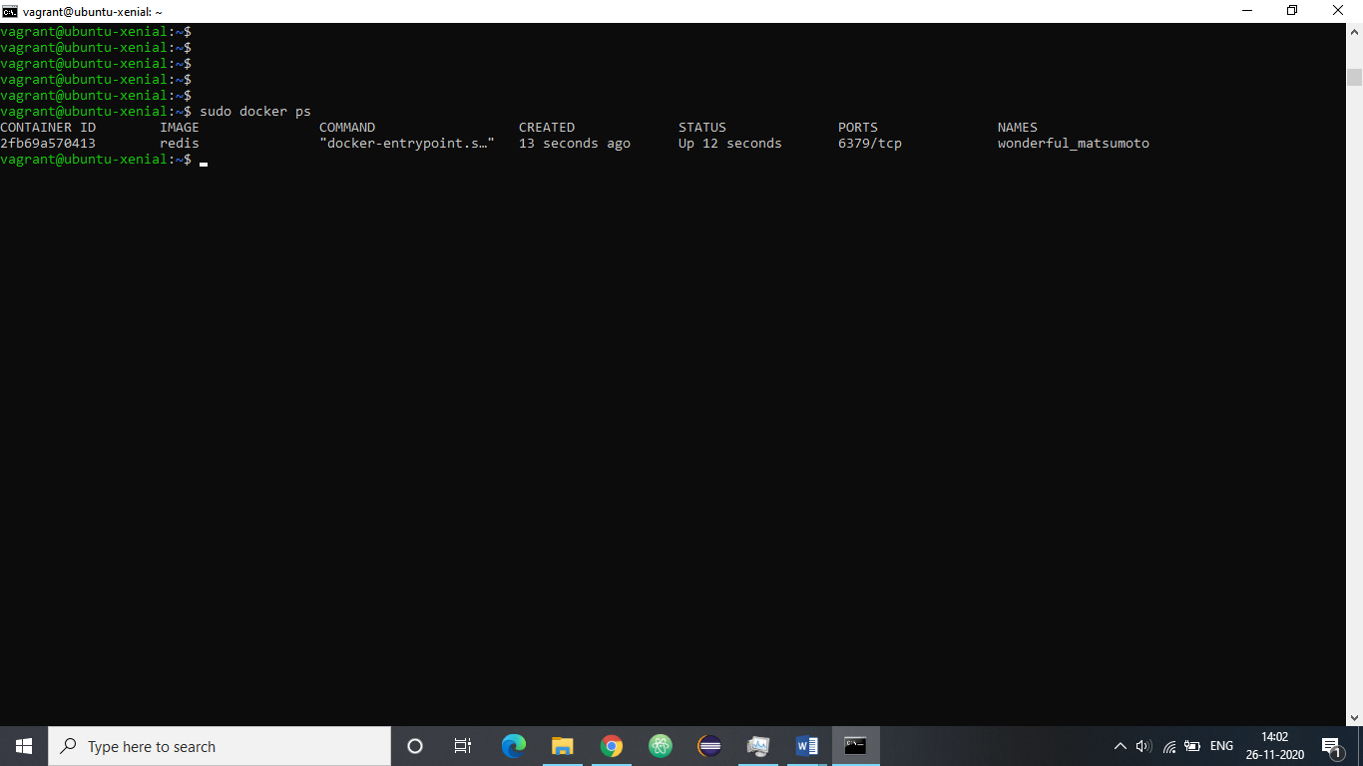

4. Run docker inspect <friendly-name|container-id>

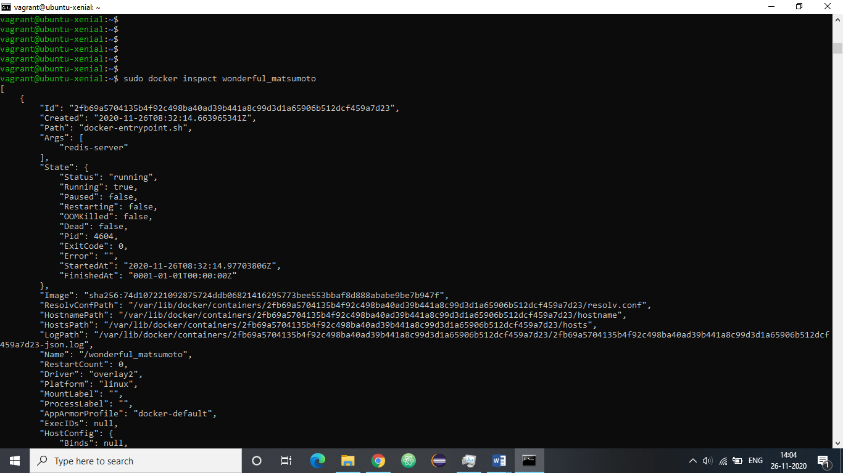

5. Run docker logs <friendly-name|container-id>

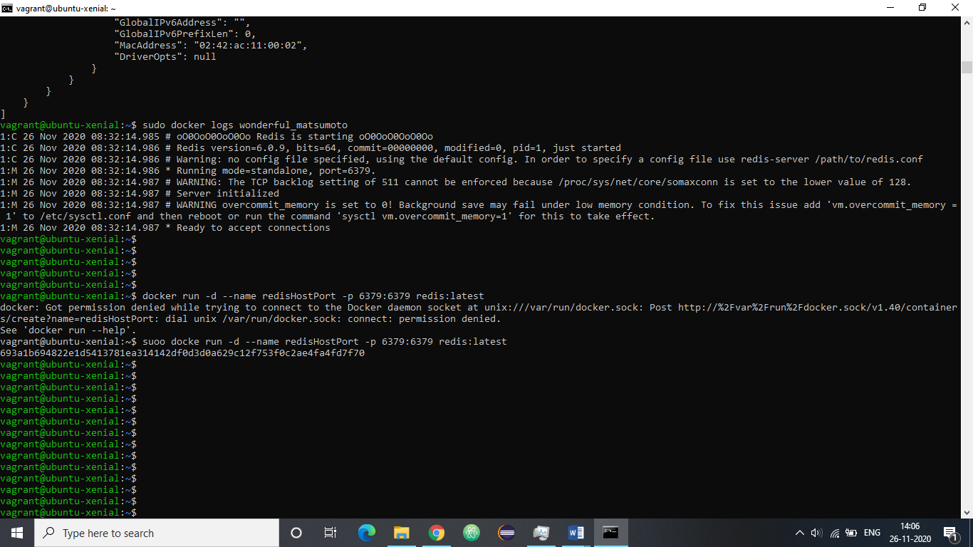

6. Accessing Redis -:

a) docker run -d --name redisHostPort -p 6379:6379 redis:latest

Accessing Redis -:

b) docker run -d --name redisDynamic -p 6379 redis:latest

c) docker port redisDynamic 6379

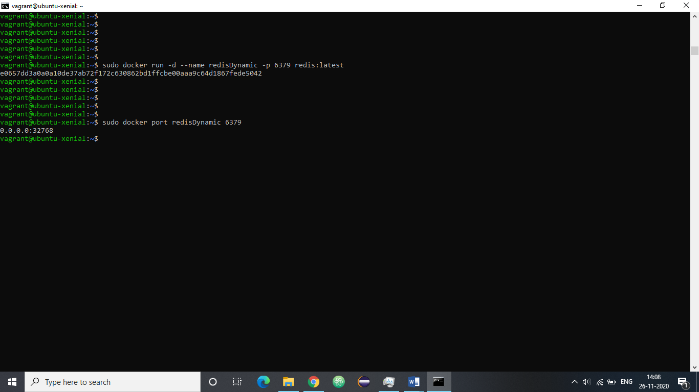

7. Checking docker images :- docker ps

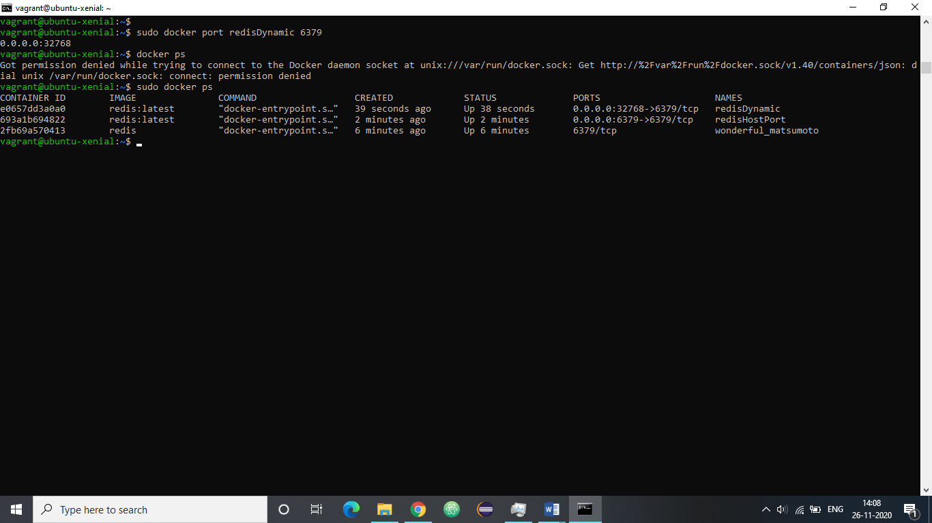

8. Persisting Data :-

docker run -d --name redisMapped -v /opt/docker/data/redis:/data redis

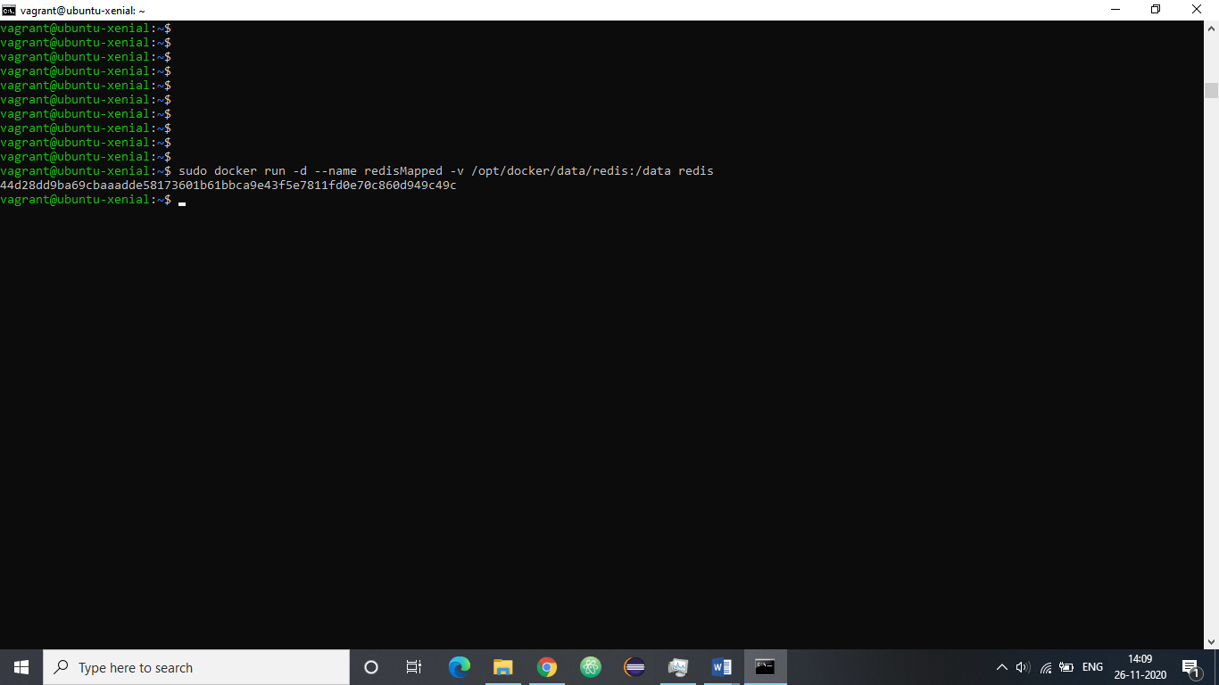

9. Running A Container In The Foreground -:

docker run -it ubuntu bash

Now, making a directory and verifying it.

