**Continuous Integration and Deployment Lab**

**Experiment Number: 12**

**Getting started with Docker**

By :-

Devansh Markan

R171218036

500069794

Batch:- 1

In this experiment, we have to install Docker on Ubuntu-xenial and getting started with it.

Do follow the steps below:

1. Copy these 2 commands :-

a) curl -fsSL https://download.docker.com/linux/ubuntu/gpg | sudo apt-key add -

b) sudo add-apt-repository "deb [arch=amd64] https://download.docker.com/linux/ubuntu $(lsb_release -cs) stable"

This will Add Docker repository to your APT resources.

c) Update the system using - sudo apt-get update

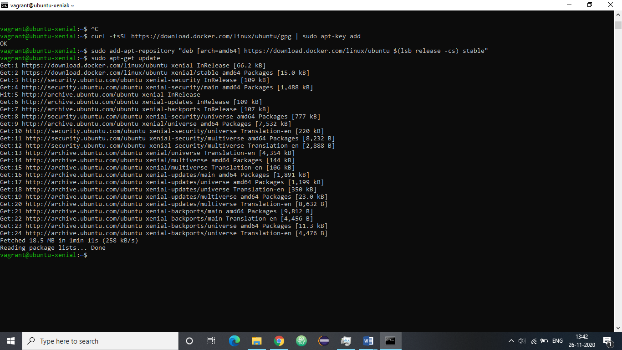

2. Use this command : apt-cache policy docker-ce for downloading Docker.

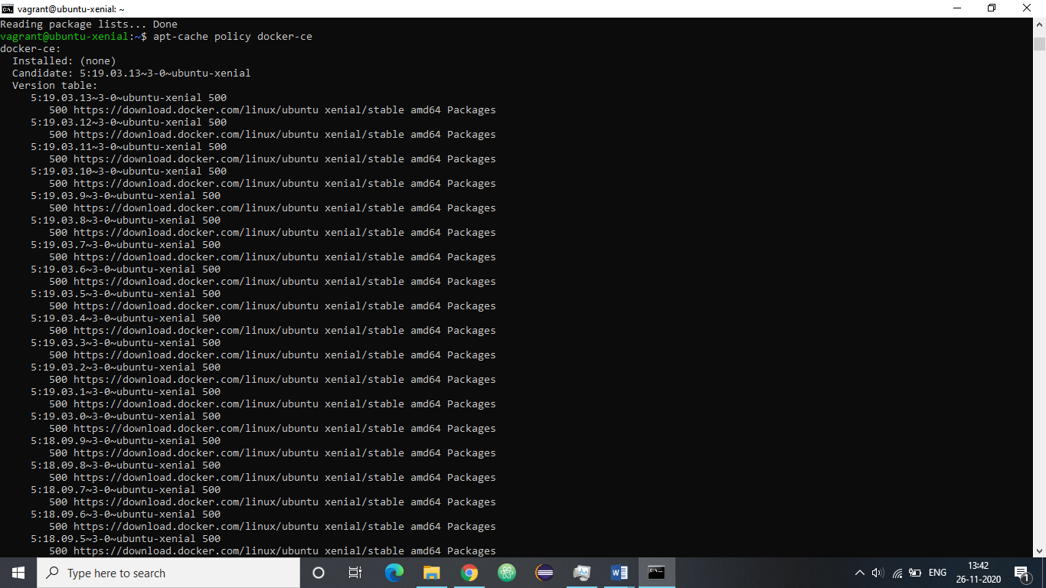

3. Now we are ready to install Docker. Run the following command to install Docker.

Command: sudo apt-get install -y docker-ce

In the next step we will verify that its running.

Verify that Docker is in the running state.

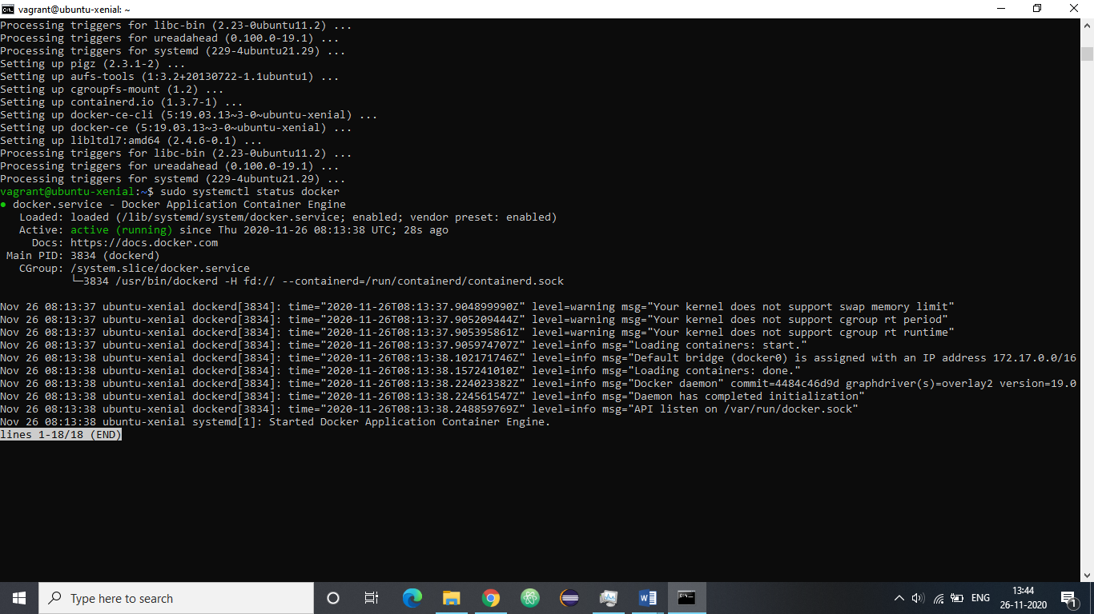

4. Use the following command to verify the creation of container.

Command: docker ps –a

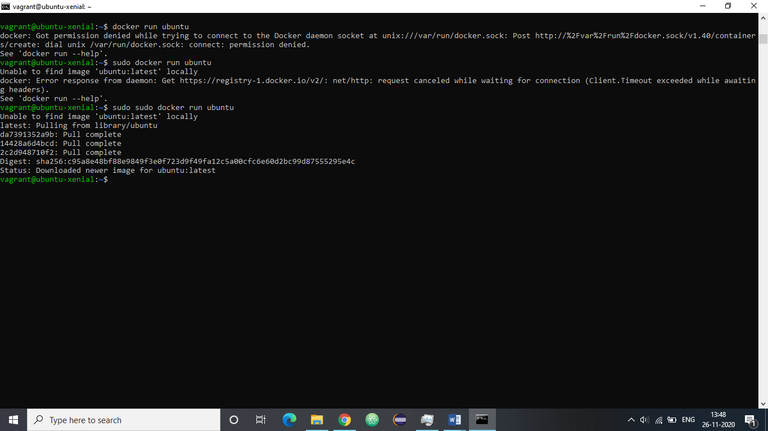

5. Run the following command to open the interactive terminal of the newly created Ubuntu container that will let you work on it.

Command: docker run –it Ubuntu

Create a new directory and verify that it is created.

