**Continuous Integration and Deployment Lab**

**Experiment Number: 11**

**Creation of Virtual Machine in Virtual Box using Vagrant.**

By :-

Devansh Markan

R171218036

500069794

Batch:- 1

Vagrant is a tool provided by HashiCorp. It is used for building and managing virtual machines environments.

This experiment is about creating a virtual machine in Virtual Box using Vagrant.

**Steps to perform this experiment:**

1. Download Vagrant : <https://www.vagrantup.com/downloads.html>

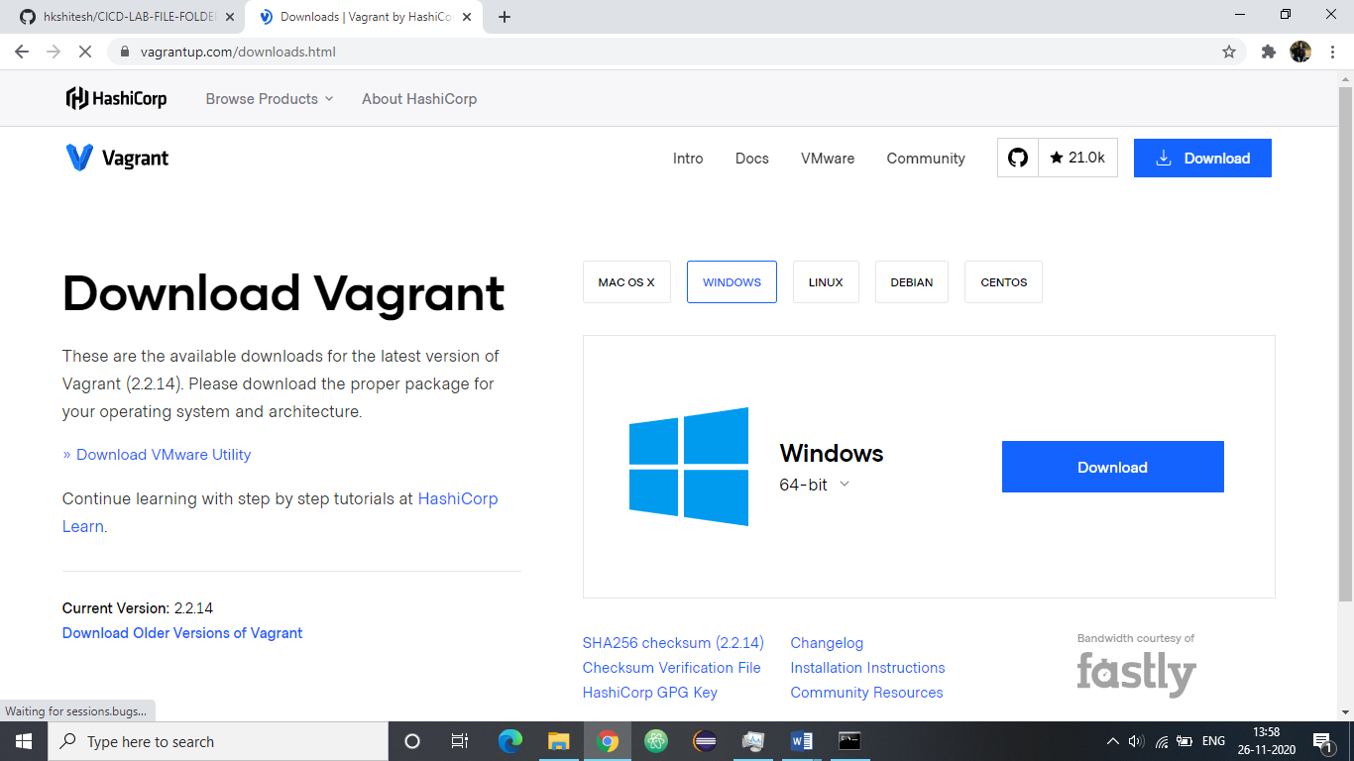

2. Finish the installation and then restart the computer to apply the changes.

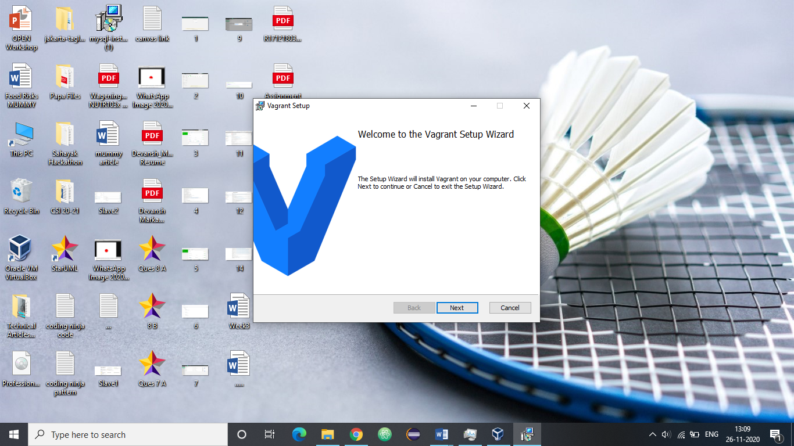

3. Verify that Vagrant is successfully installed on your computer.

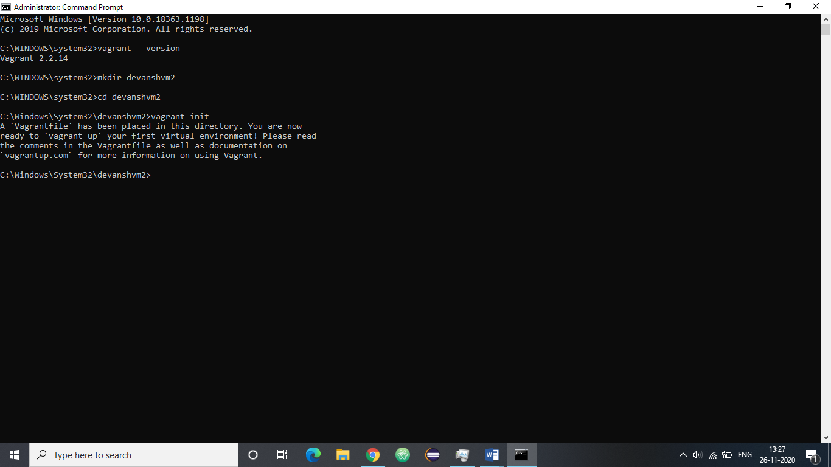

4. You can observe that a file named Vagrantfile is created in your folder after the execution of above command.

Create a new folder and switch to that folder.

Initialize this folder for Vagrant.

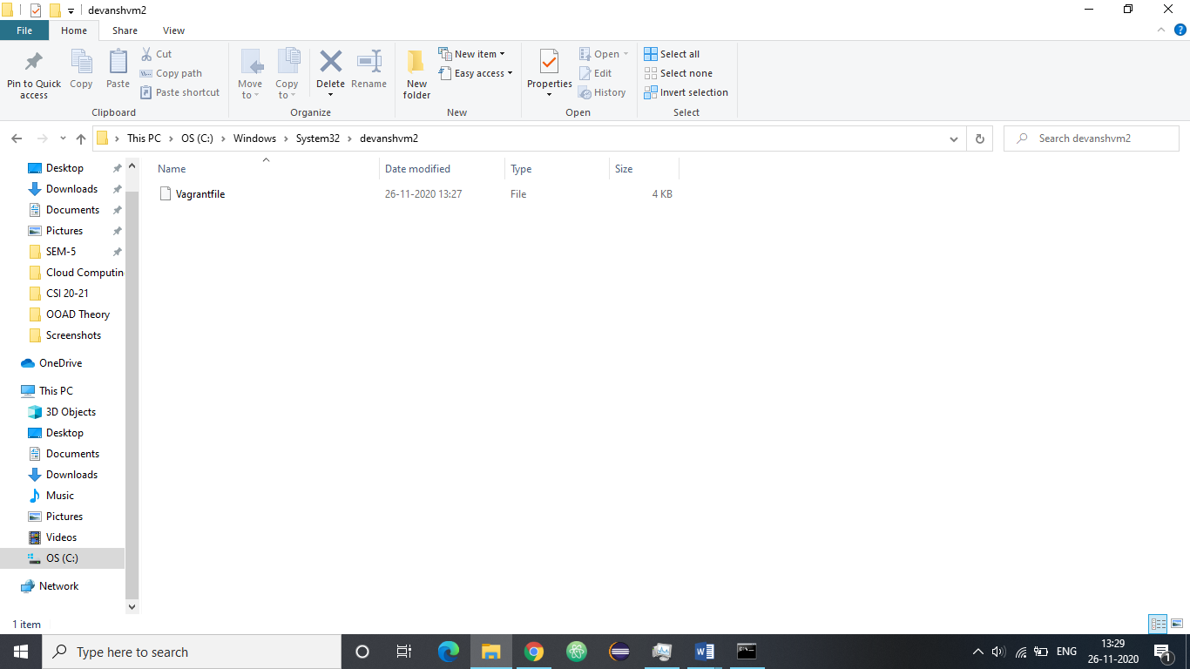

5. Open the Vagrantfile for editing and specify the image.

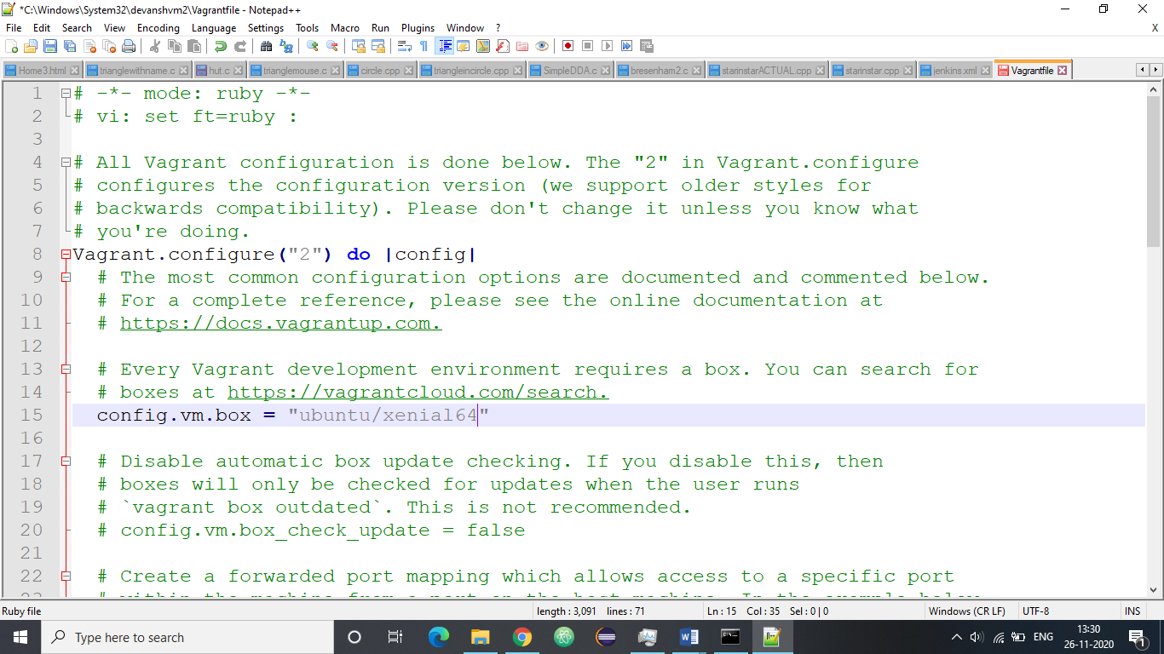

6. Create the virtual machine as per the specified configuration. The command for the same is “vagrant up”.

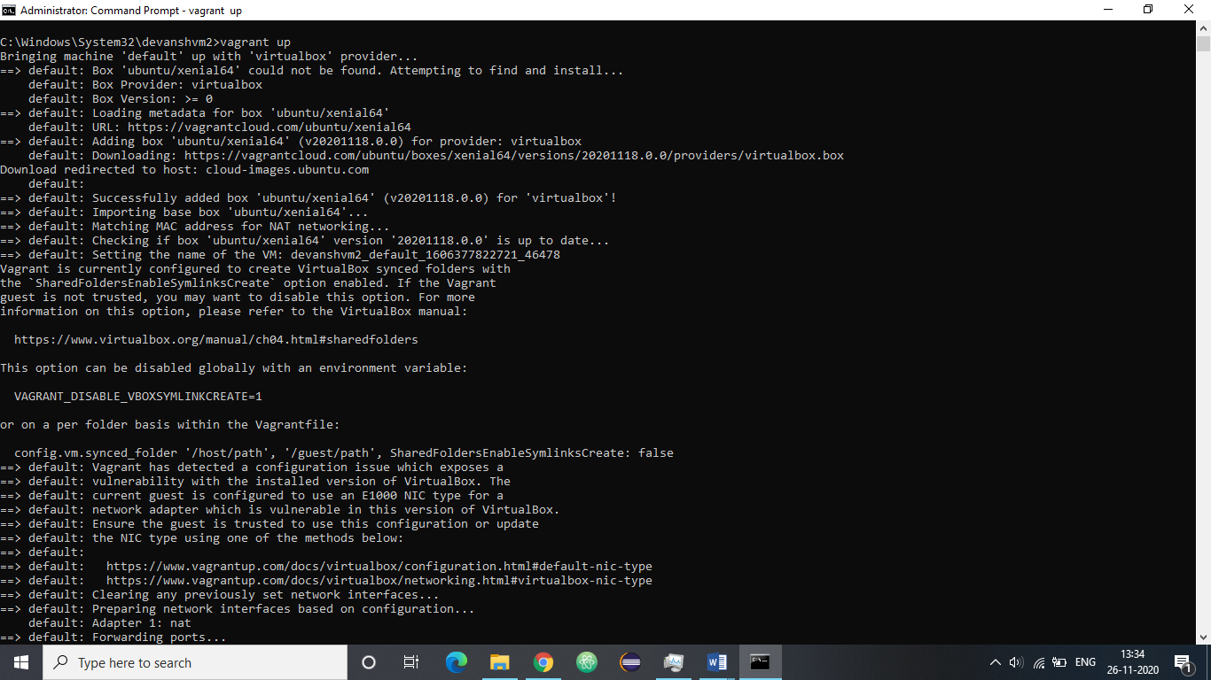

7. This command will create a new virtual machine in the virtual box.

You will see a virtual machine listed with the specified name in the virtual box.

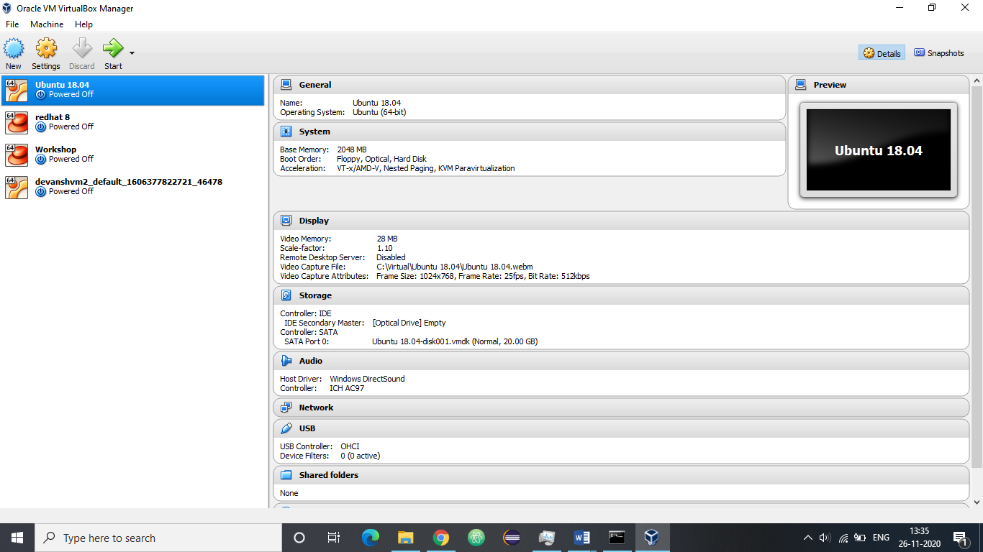

8. Vagrant ssh will get into the newly created virtual machine.

