* **Getting familiar with Docker Commands.**

**1. docker search:** This command helps to search available docker images.

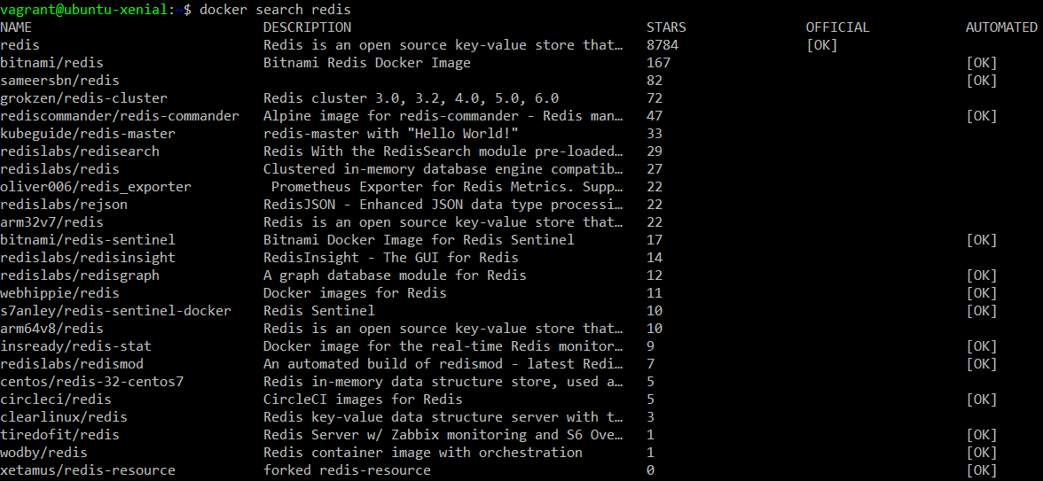

**2. docker images:** This command lets you see which images are present on your machine.



**3. docker pull <image-name>:** This command pulls the specified image from the docker hub

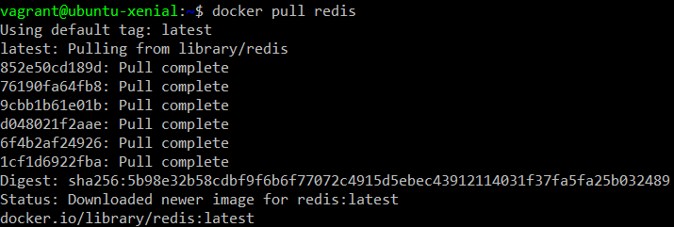

After successful execution of docker pull command, the specified image will be pulled. This can be verified using docker images command.

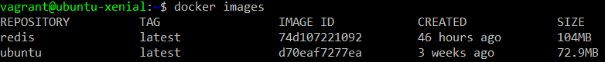

**4. docker ps:** This is process status command which gives information about the containers. By default, it only lists the running containers when no option is specified.



The above output shows no running container because we have just pulled the container image and the image is not run yet.

**5. docker run <image>:** This command is used to run the specified container image. When this command is used with –d option, the container is kept running in the background.



If no option is specified, the container exits after running.

The running container can be seen with the docker ps command.



Another variant of docker run command is with the option –it. This option let you open the terminal of the specified container image.

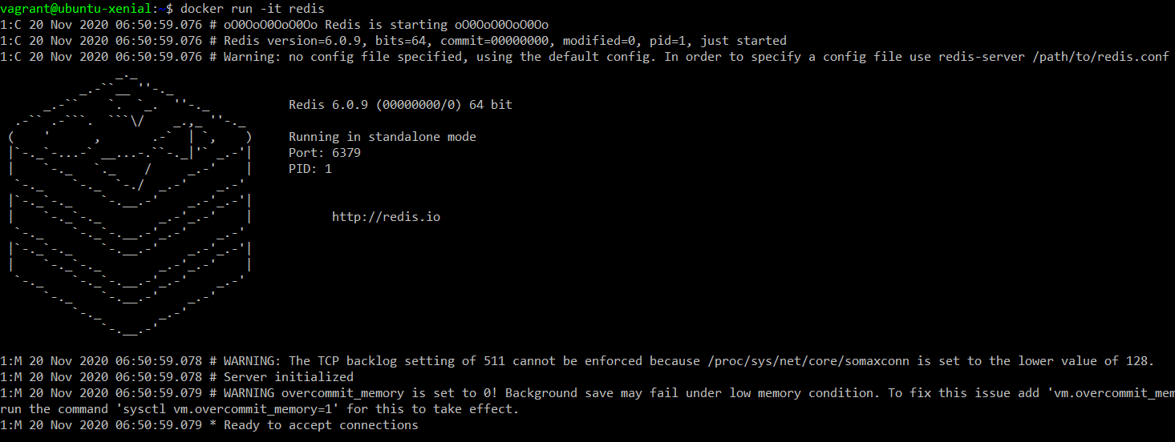

**6. docker inspect <container id>:** This command shows the configuration of the specified docker container.

Let us first create another container with redis image.



We can see that the container is created.



Now we will run the inspect command to view the configuration of any one of these containers.

We can specify a a few unique characters of the container id to run the inspect command.

The output of the inspect command will be as follows:

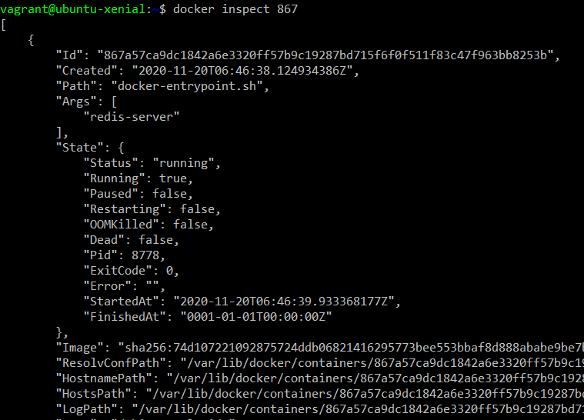

Another variant of docker run command lets you bind the container to a particular port.



To verify the port use docker ps command.



If we do not specify the port then container will be bind to a random port.



**7. docker port <containername>:** To view the port that a container is bind to run this command.



Another method to verify the port is to use the docker ps command.



**Note:** There can be scenarios where you want the work you do on a container to remain safe. In such cases, you can run the below command.



**8. docker stop <container-id>:** This command stops the specified running container.



**9. docker start <container-id>:** This command is used to start the specified stopped container.

As we can see in the below command output, Ubuntu is in the exited state.

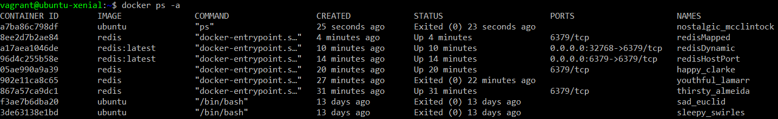

Let’s start Ubuntu image.



We can verify that the Ubuntu is started.

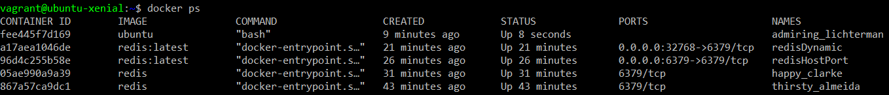

**10. docker attach <container-id>:** This command attachs the input, output and error buffers of the current terminal with the terminal of the specified container image. In simple words, it opens the terminal of the specified container image.

