Experiment-16

Step 1> Create the docker file for building the image

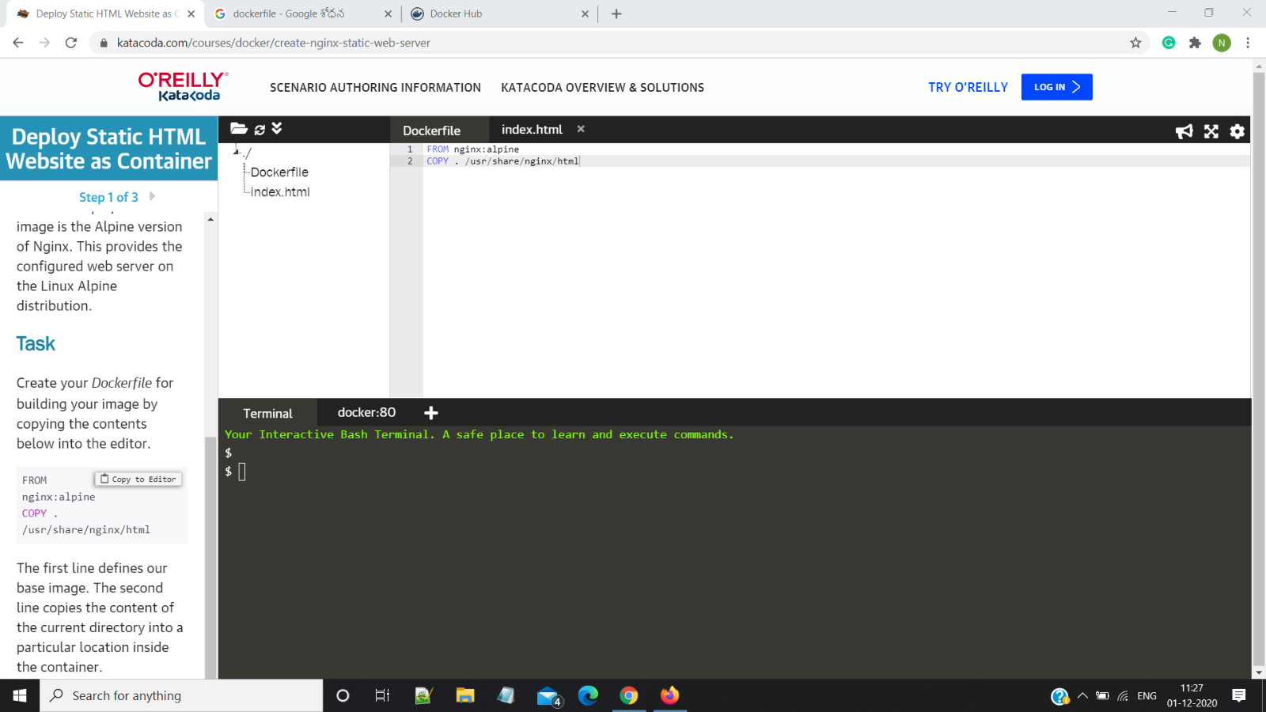

Step 2:Build the Static HTML image

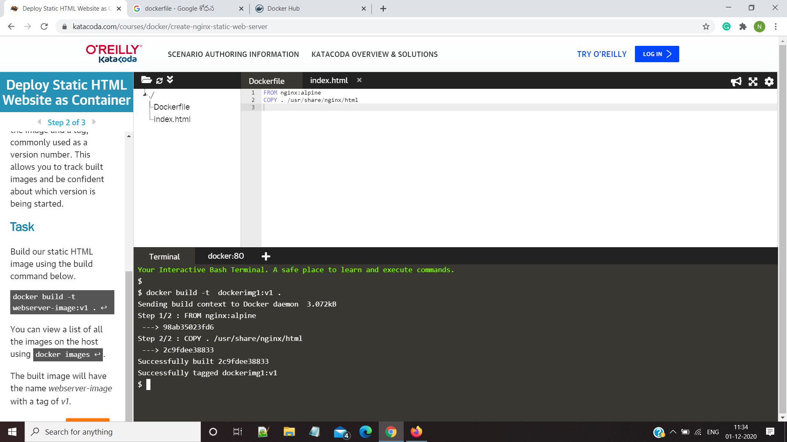

Step 3:Run the command Docker images to view all the local images

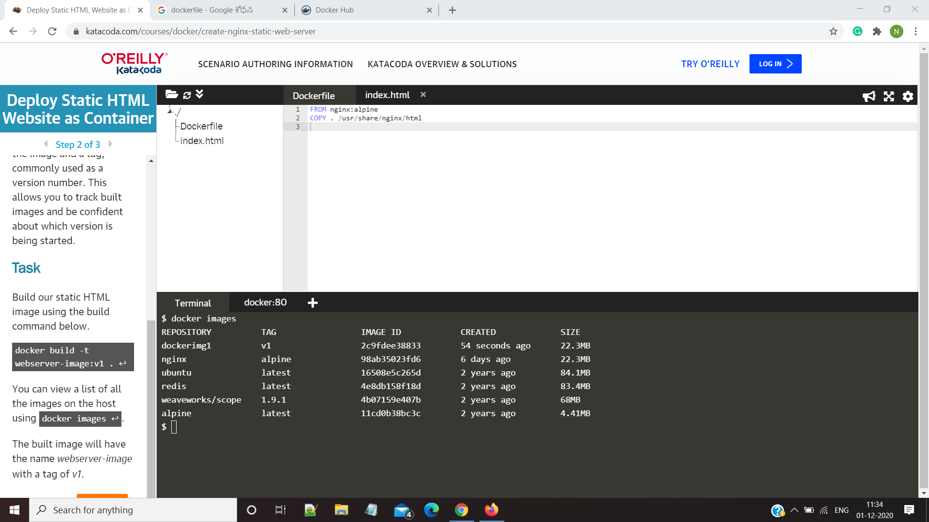

Step 4:- Run the image by using docker run -d -p 80:80 image_name

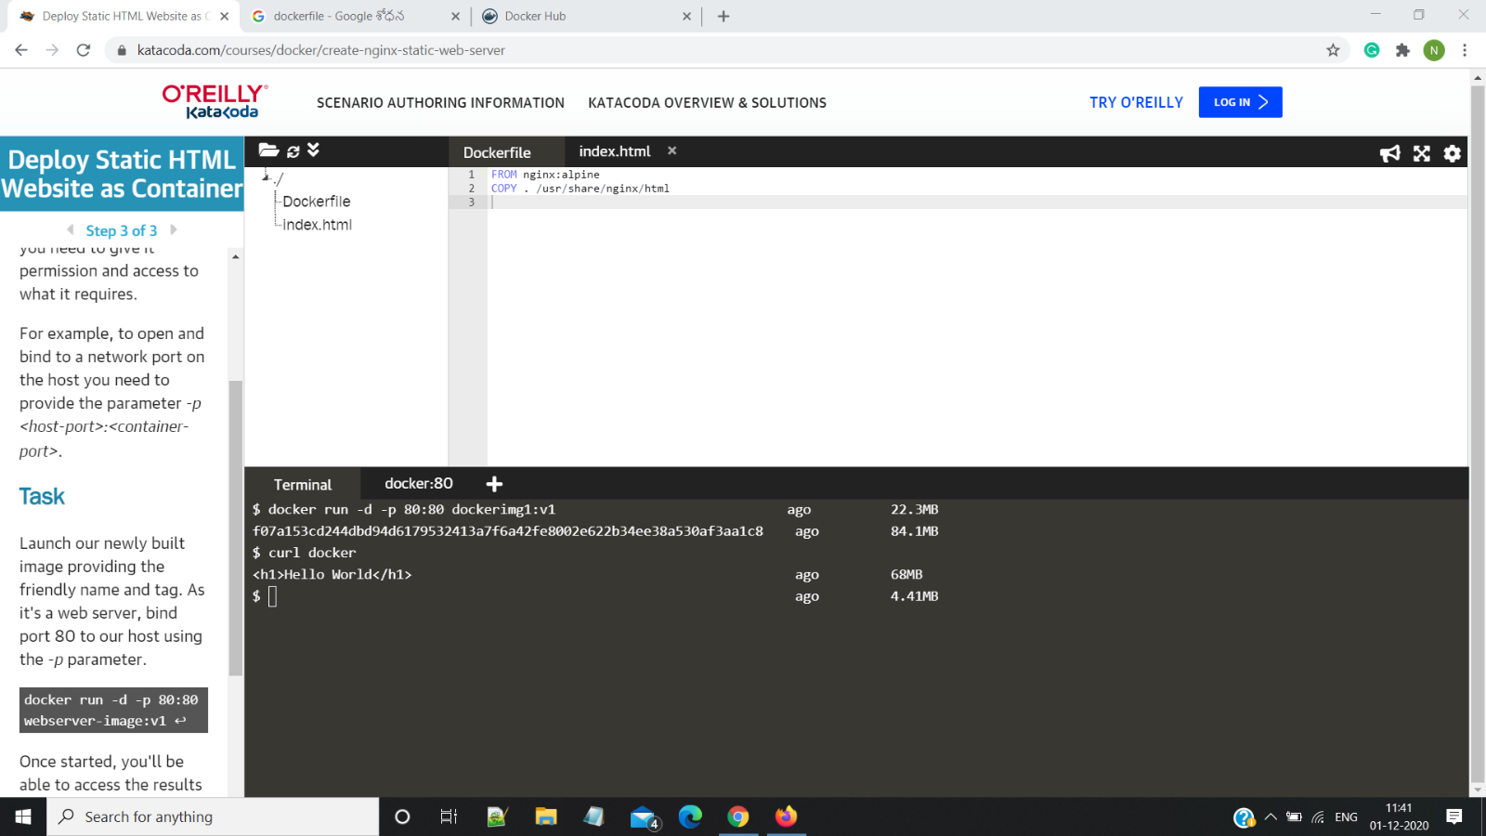

Step 5:- login into your dockerhub account using docker login –username

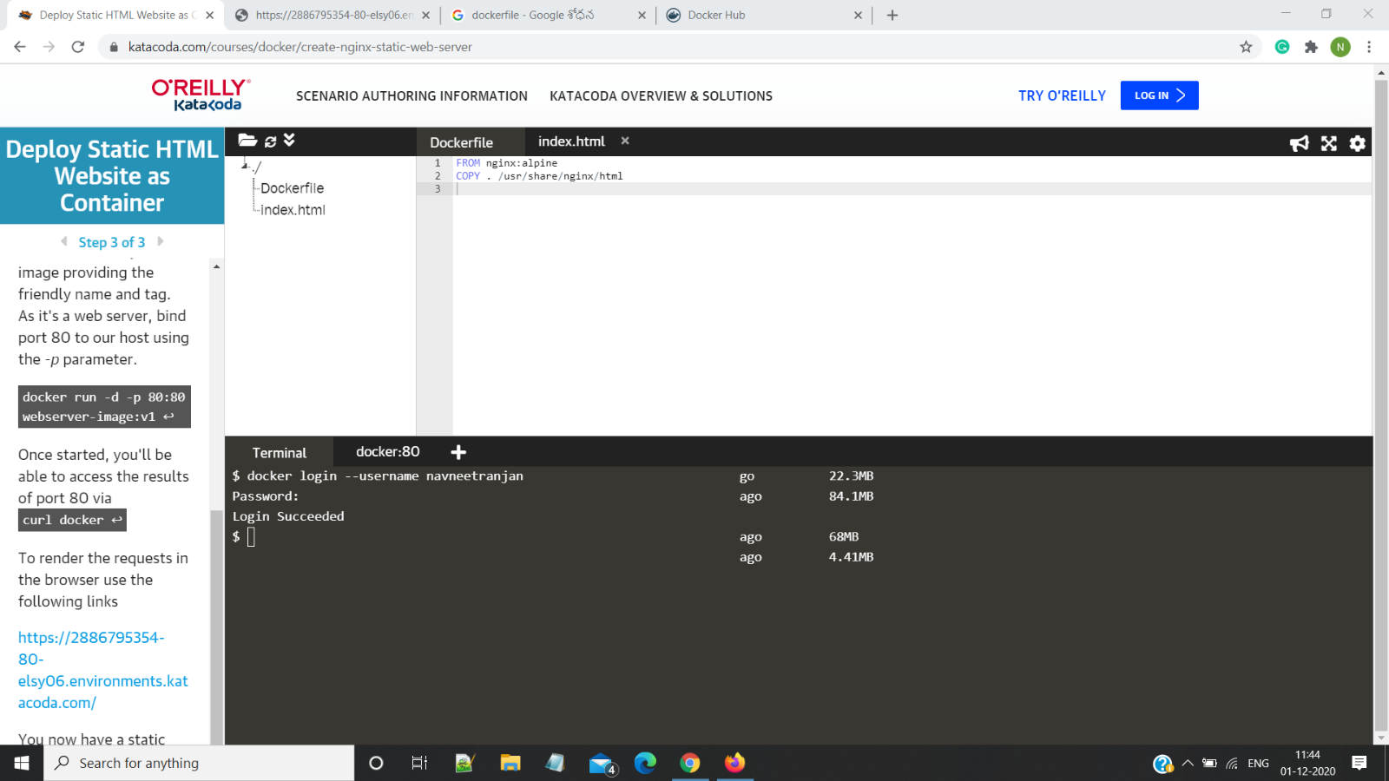

Step 6:-

Tag & push the image to docker hub using the commands

i>Docker tag image_name user_name/image_name(to be hosted)

ii> Docker push image_name

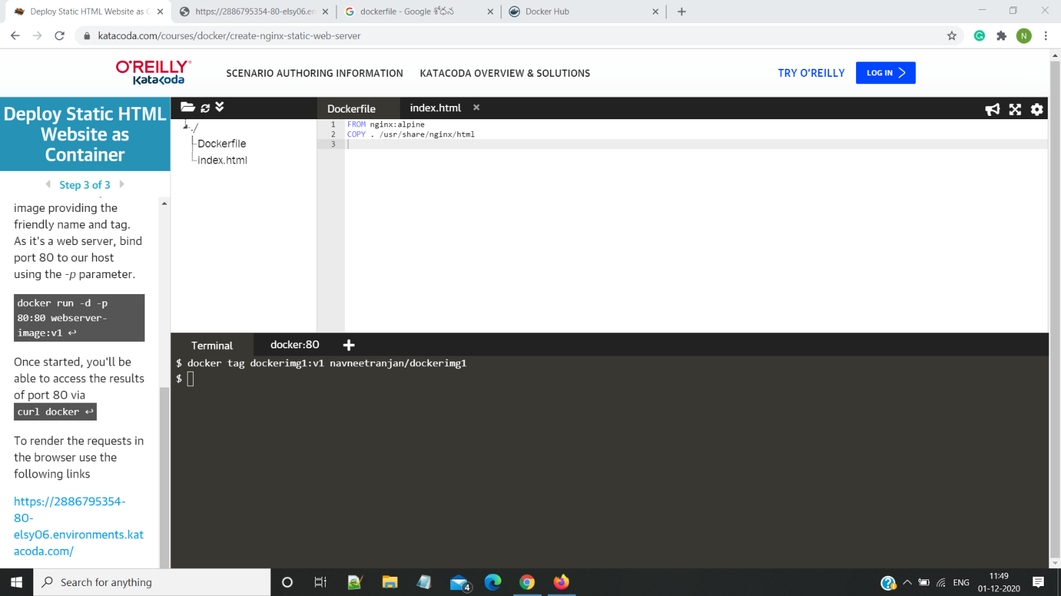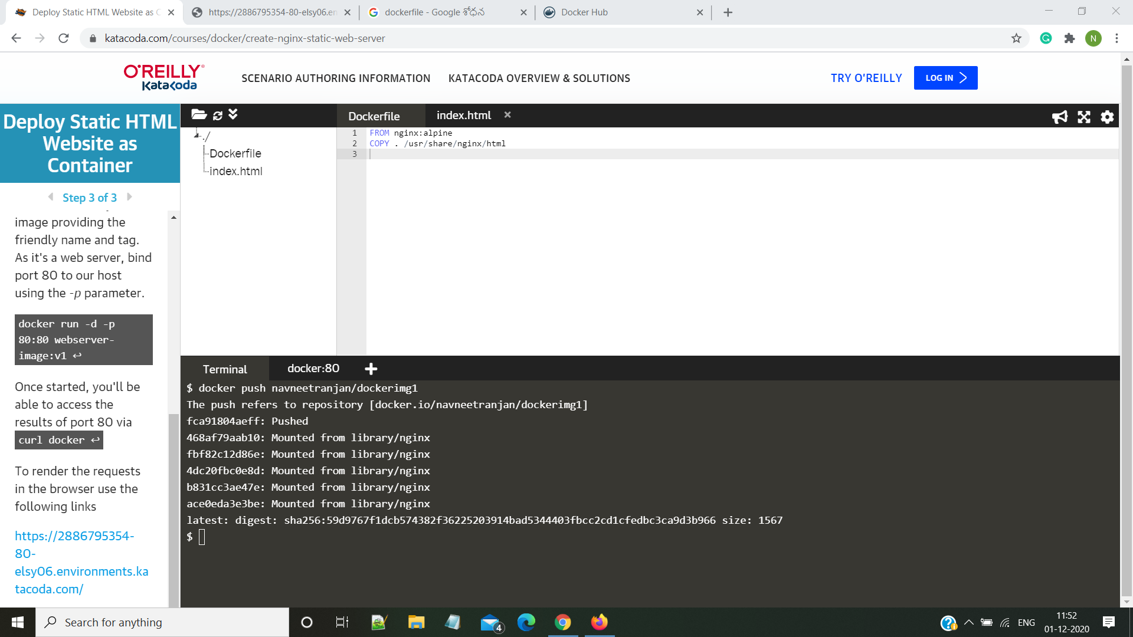

Step 7: Browse the docker hub account the image would be hosted there

