

**UNIVERSITY OF PETROLEUM & ENERGY STUDIES**

**Dehradun**

**CONTINOUS INTEGRATION AND**

**CONTINOUS DELIVERY**

# Assignment-2

**Name: Piyush Vishnoi**

**Course: B. TECH CSE DevOps (2018-22)**

**Roll no.: R171218071**

**Sapid: 500067083**

# Assignment

Step 1: Create a maven project using Eclipse

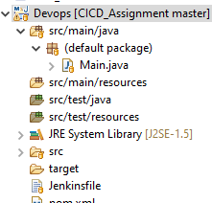

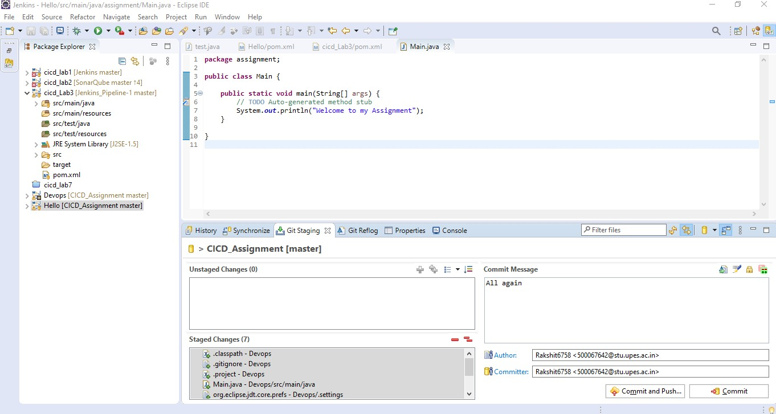

Step 2: Push the project to GitHub using eclipse.

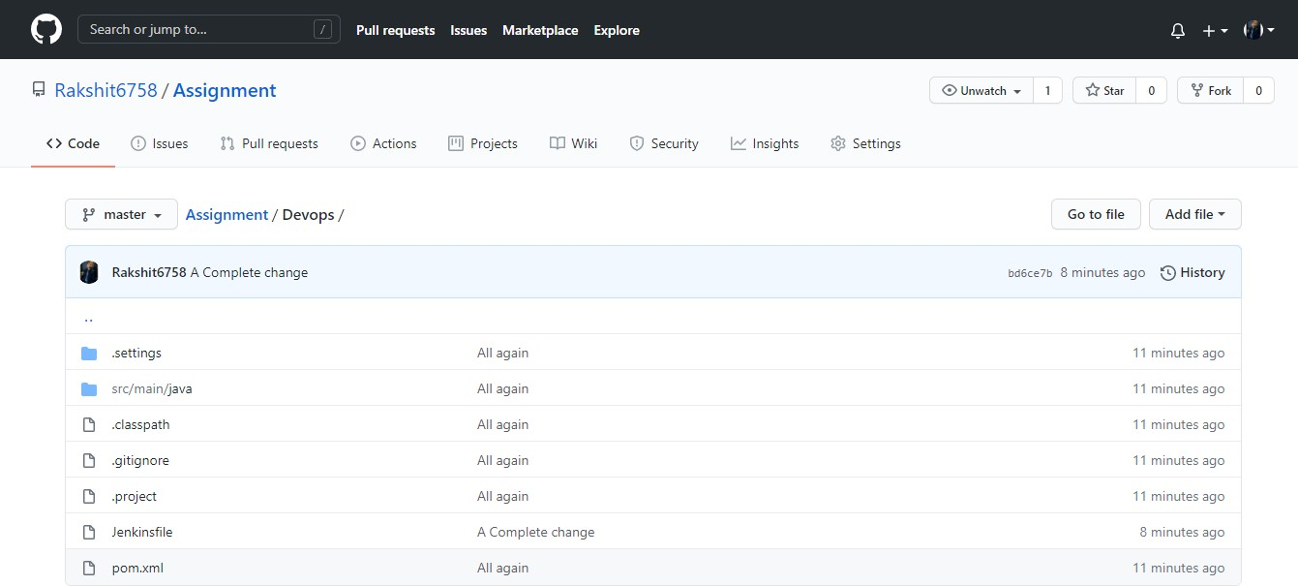

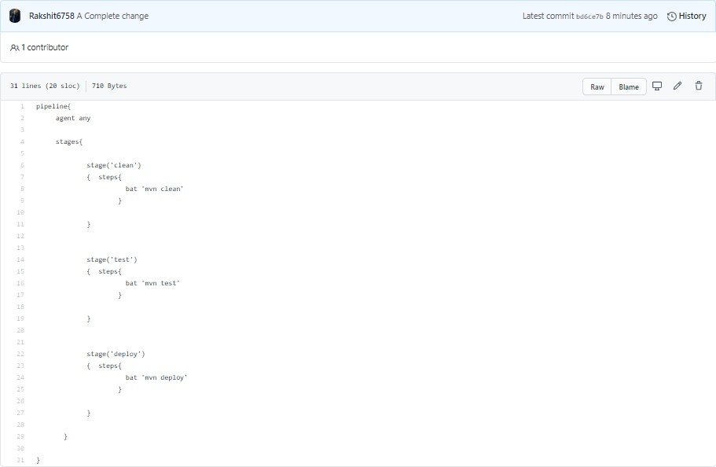Step 3: Create a Jenkinsfile on GitHub and make changes to pom.xml file.

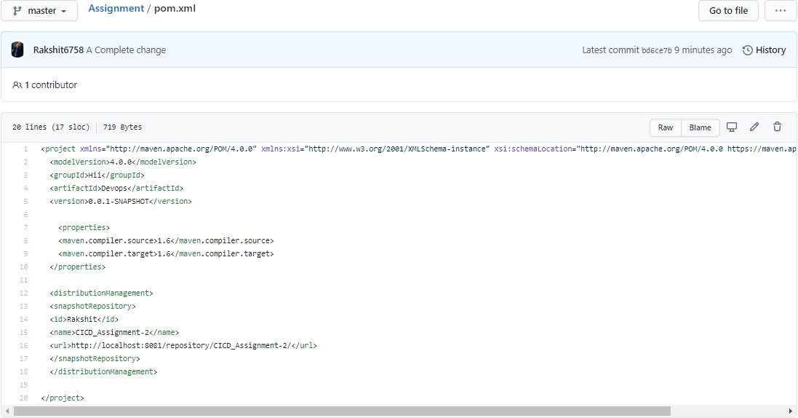

Step 4: Start Jenkins server using **java -jar Jenkins.war** on command line and type **localhost:8080** on the browser to start Jenkins server.

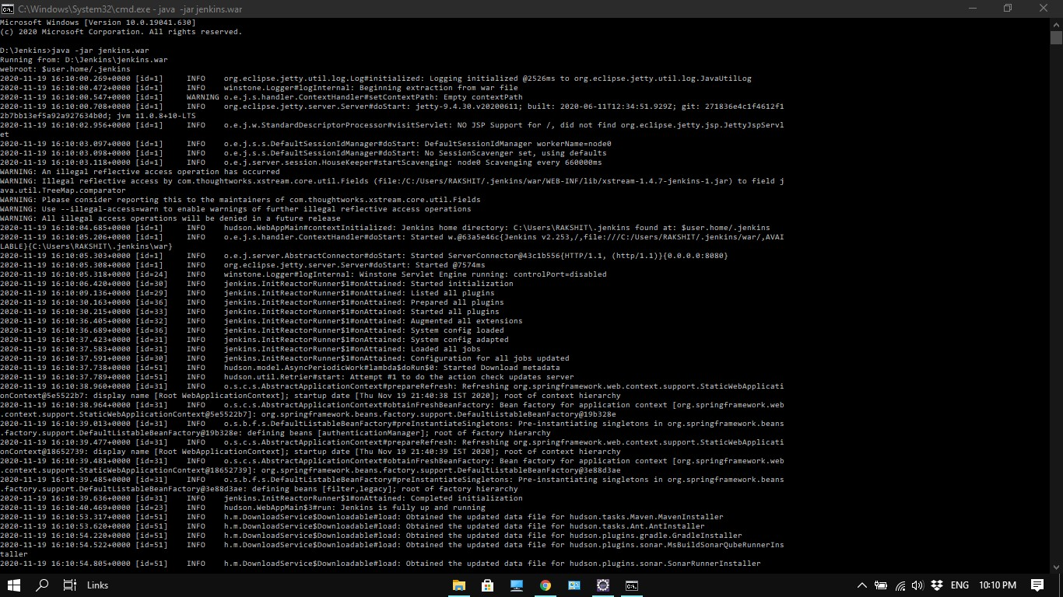

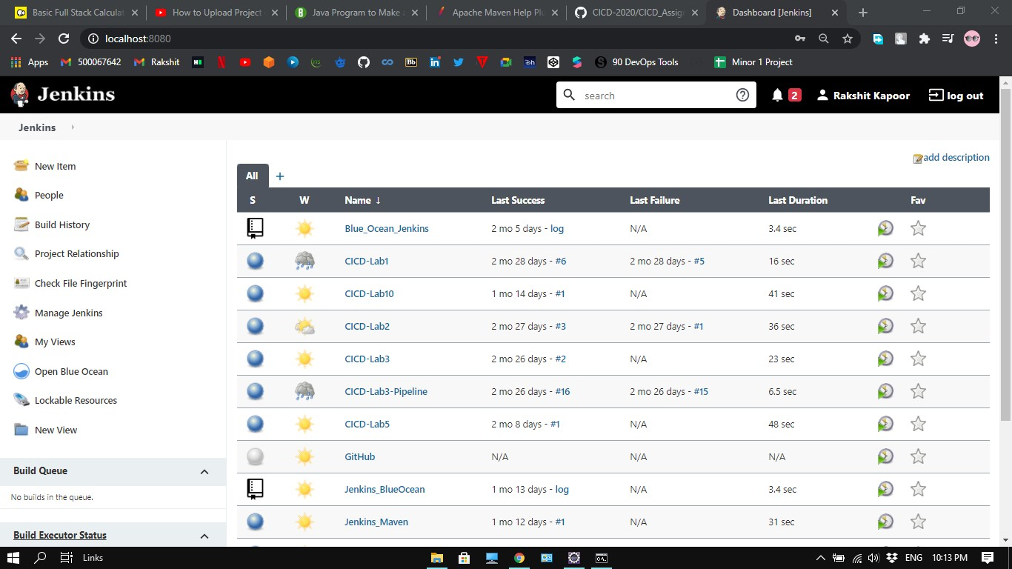

Step 5: Start Nexus server using **nexus.exe /run** on command line and type **localhost:8081** on the browser to start Jenkins server.

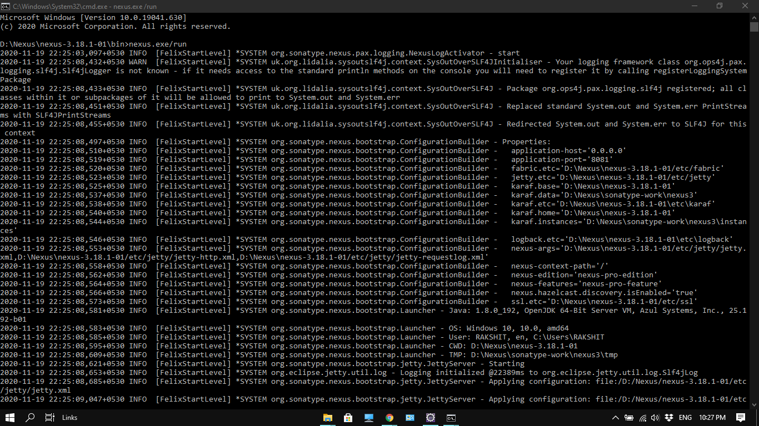

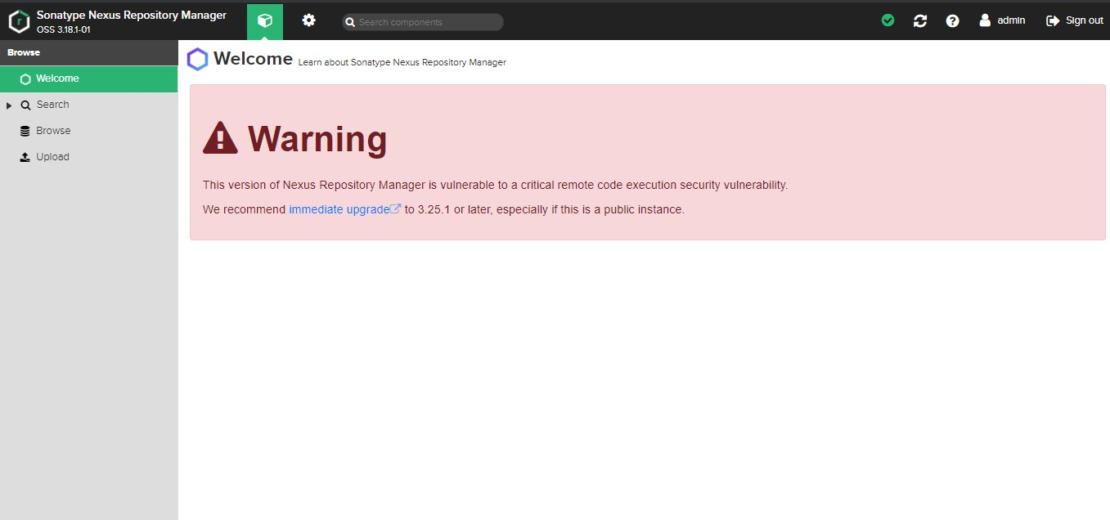

Step 6: Click on new item and provide the name and select pipeline

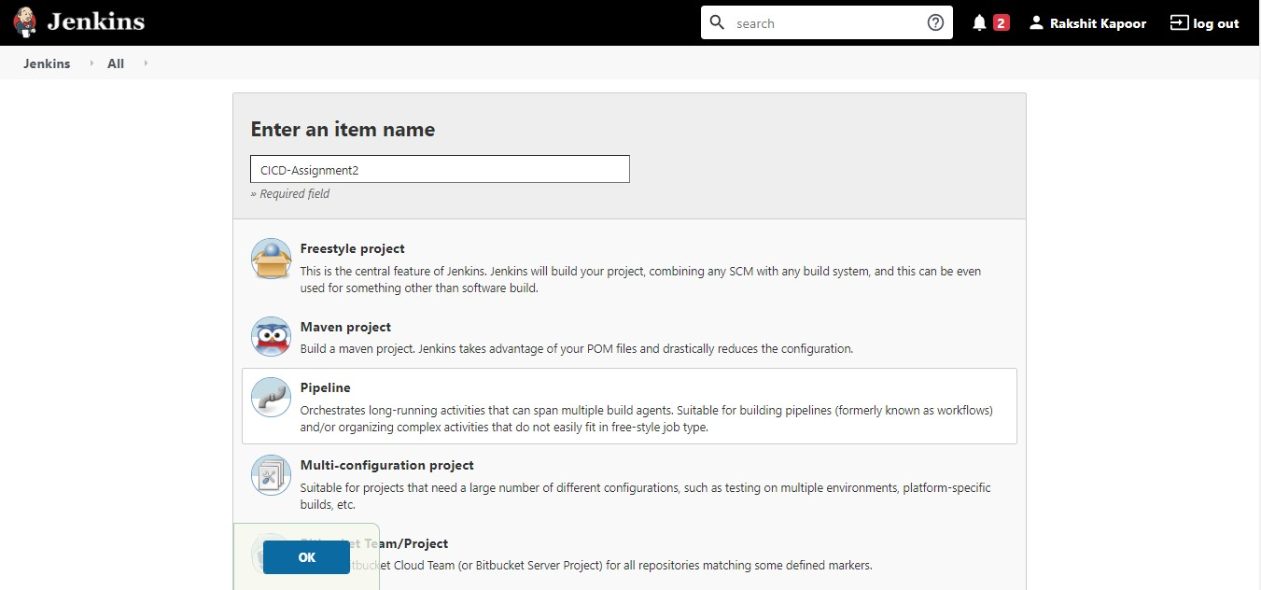

Step 7: Provide the path of the repository and Jenkinsfile as well

and click on save.

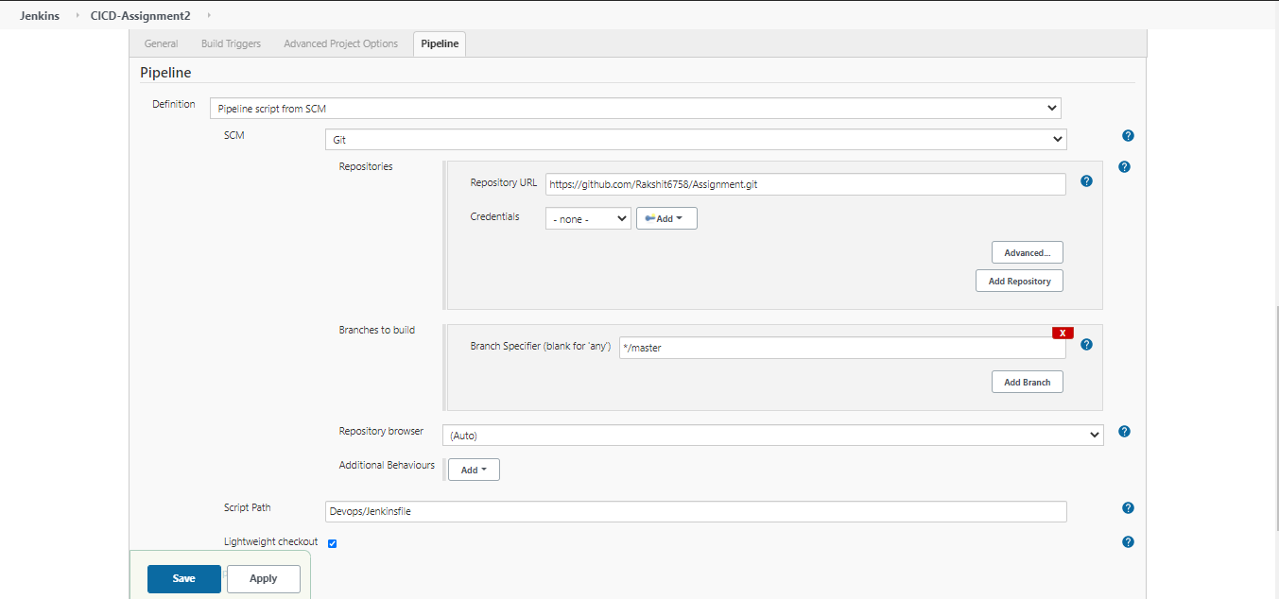

Step 8: Click on build now and see the results at console output.

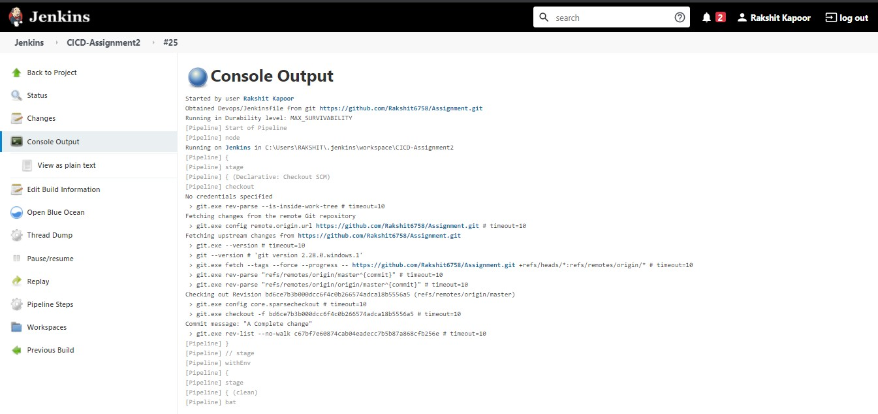

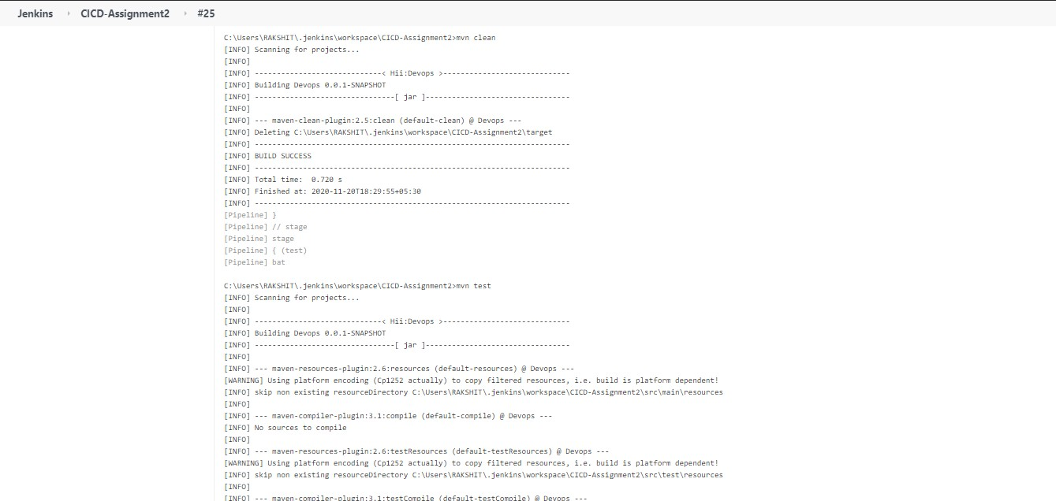

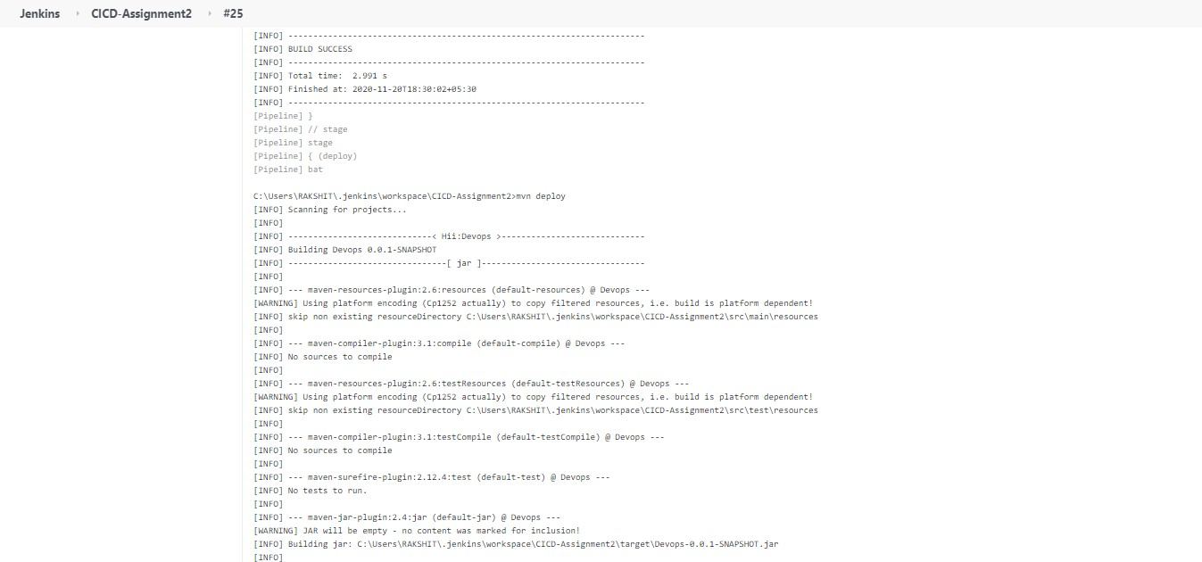

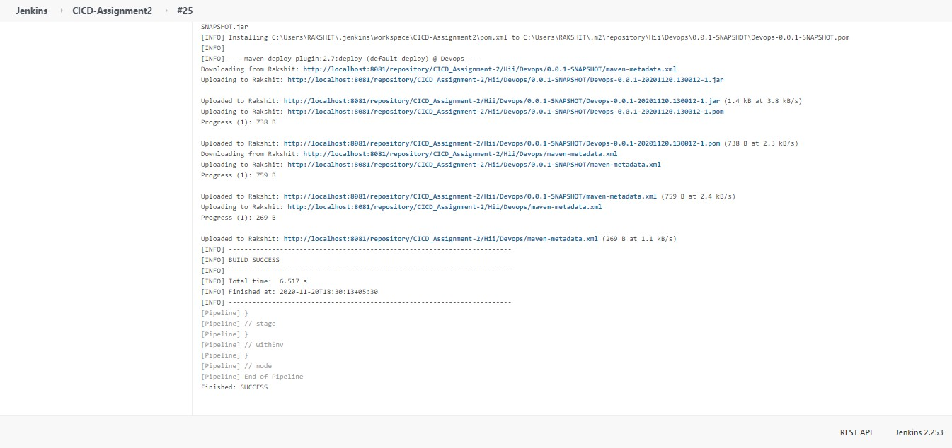

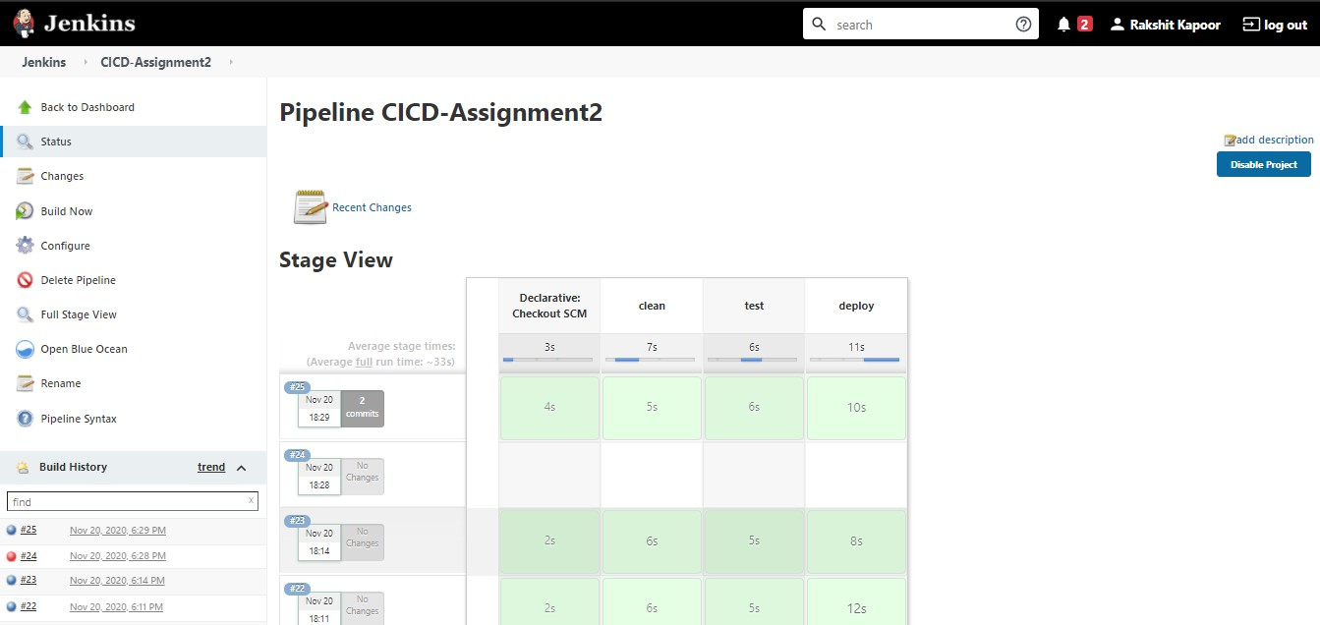

Step 9: The generated build gets pushed on the nexus server as

well as.

