Name: Prashasti Gupta

Roll No: R171218077

SAP ID: 500068493

**EXPERIMENT -11**

**Vagrant**

1. Download vagrant from <https://www.vagrantup.com/downloads.html>.

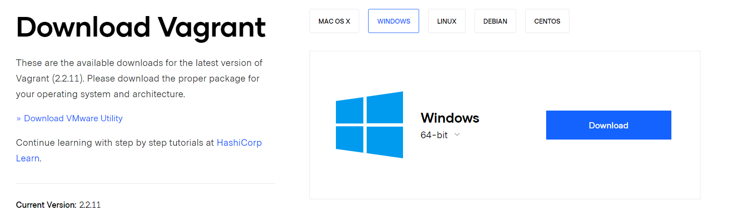

1. Install vagrant on your system. After that restart your system.

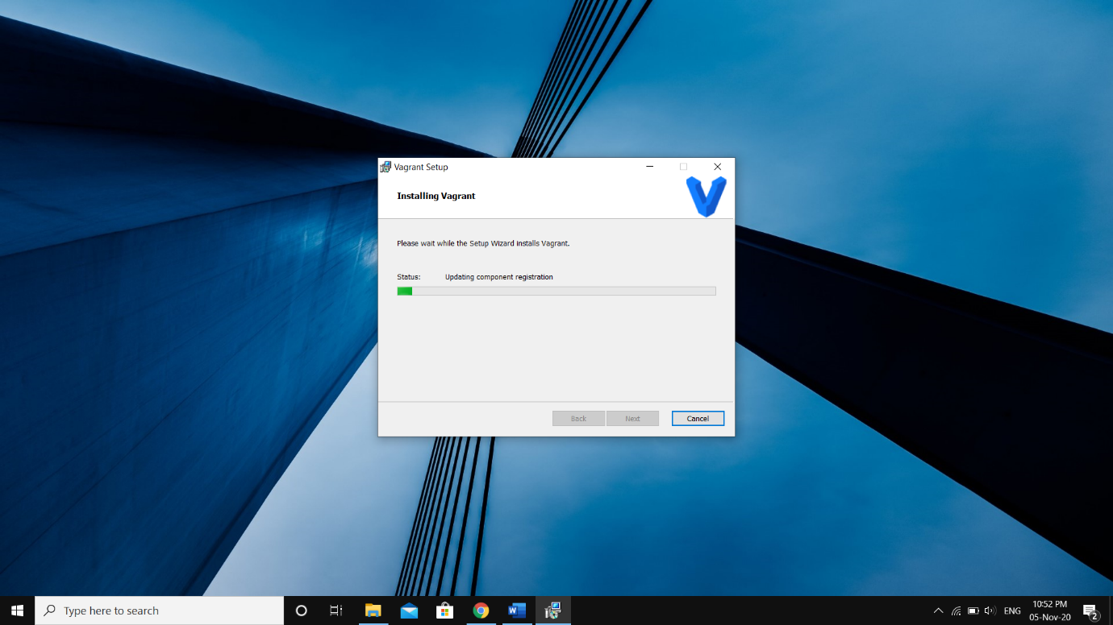

1. Open Command Prompt, make a new folder and initialize vagrant in it.

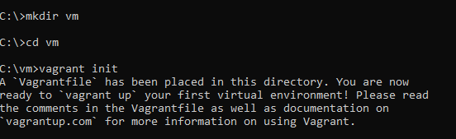

1. After Vagrantfile is created, we will make some changes in this file. 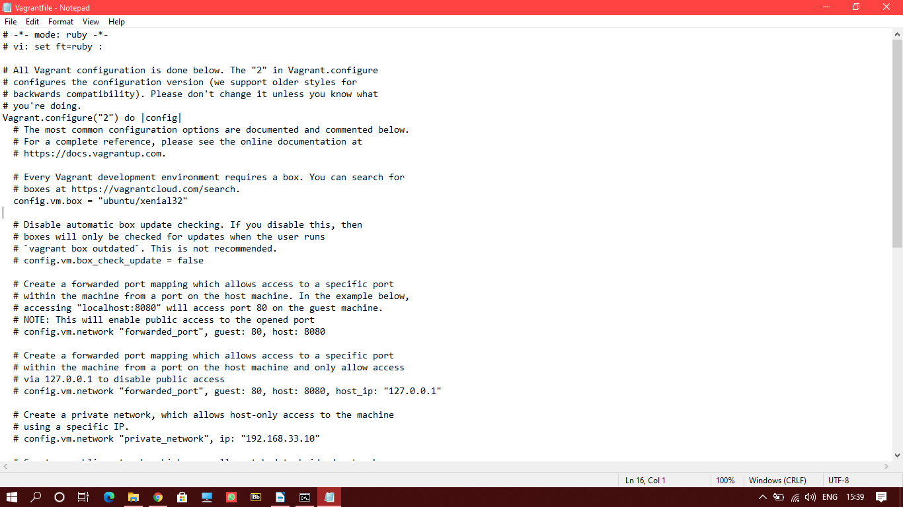
2. Run the ‘**vagrant up’** command to create the virtual machine.

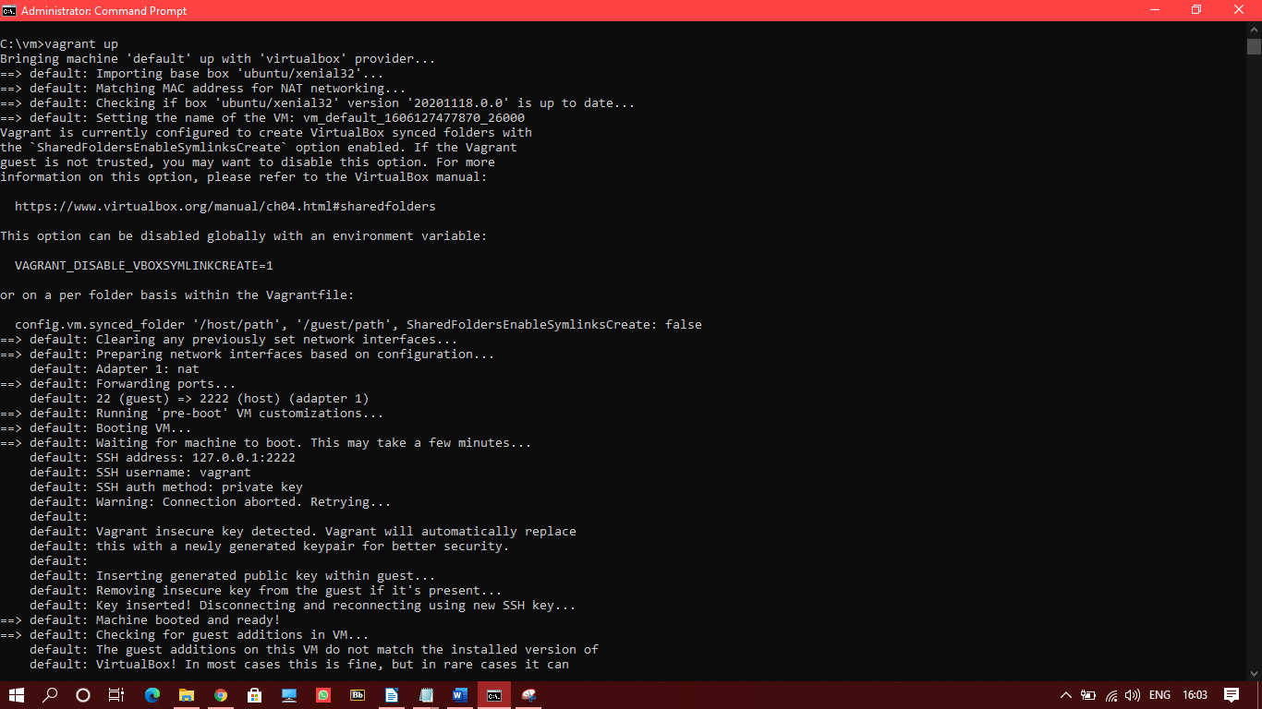

1. Run the ‘**vagrant ssh**’ command to attach the virtual machine created to the windows command line.

