Name: Prashasti Gupta

Roll No: R171218077

SAP ID: 500068493

**EXPERIMENT – 12**

**Docker and Vagrant**

1. Add the GPG key for the official Docker repository to your system.
2. Add the Docker repository to APT sources.
3. Next, update the package database with the Docker packages from the newly added repository.

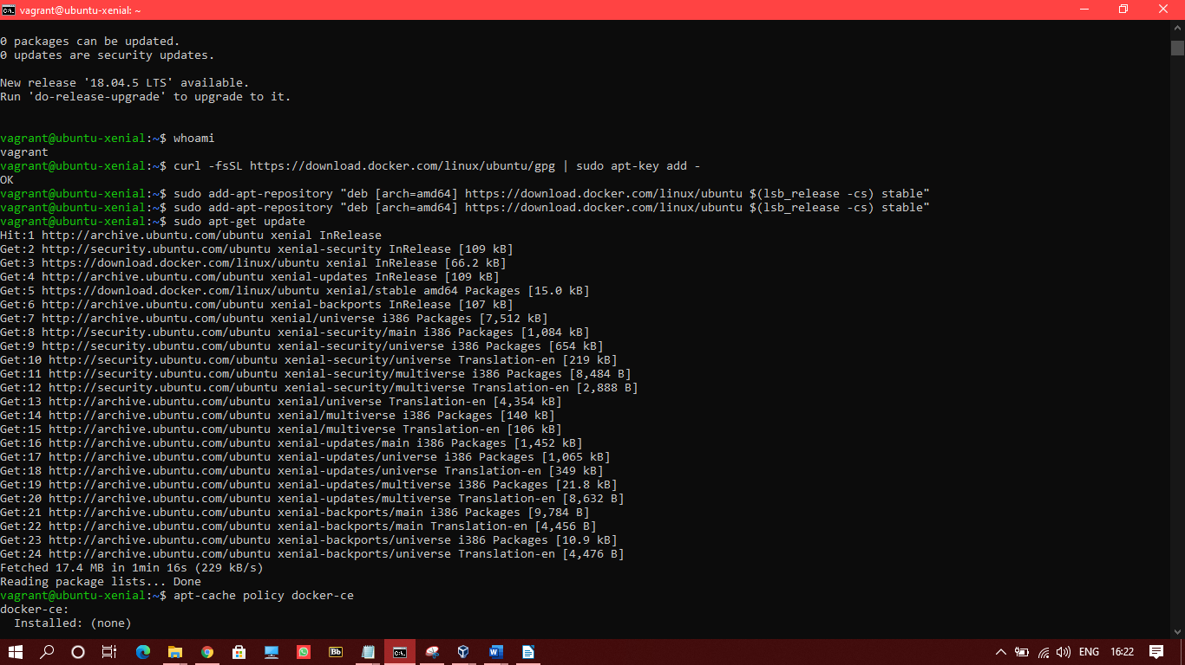

1. Install Docker.

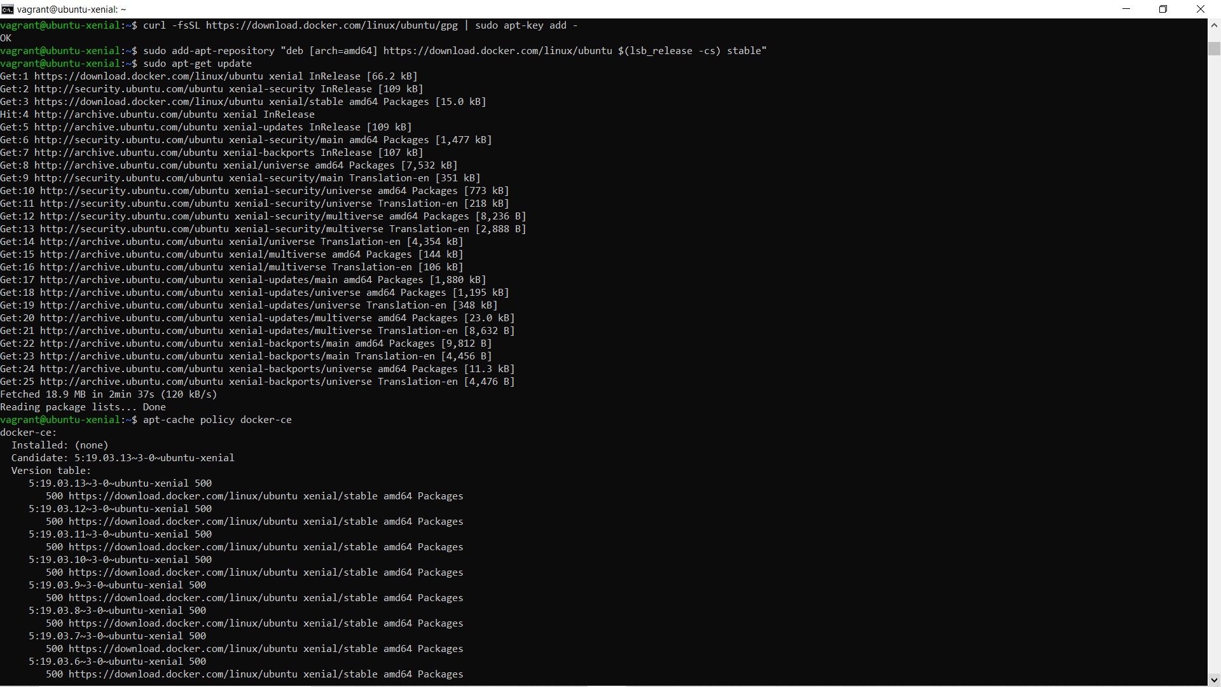

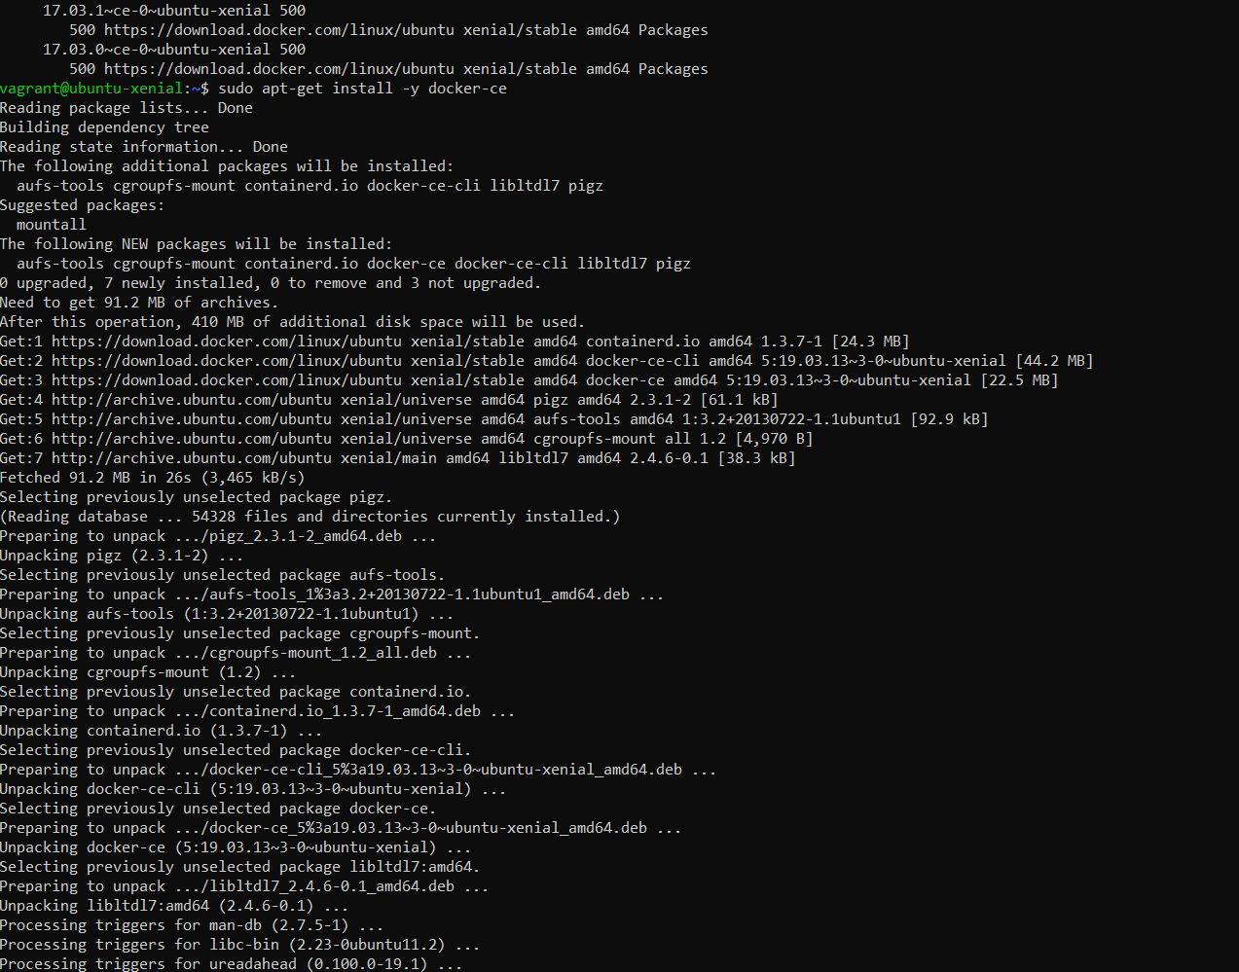

1. Check if docker is running or not.

