**CI/CD**

**LAB EXPERIMENT 9**

**SUBMITTED BY:**

NITISH KUMAR SINGLA

500071913

R171218126

**SUBMITTED TO:**

HITESH KUMAR SHARMA SIR

**Nexus Integration with Jenkins**

Deploying the Build Artifact to Nexus Repository using Jenkins

Go to Jenkins and then Configuration. Add Java JDK path installed in your sytem.

Nexus is only applicable with Java JDK 8.

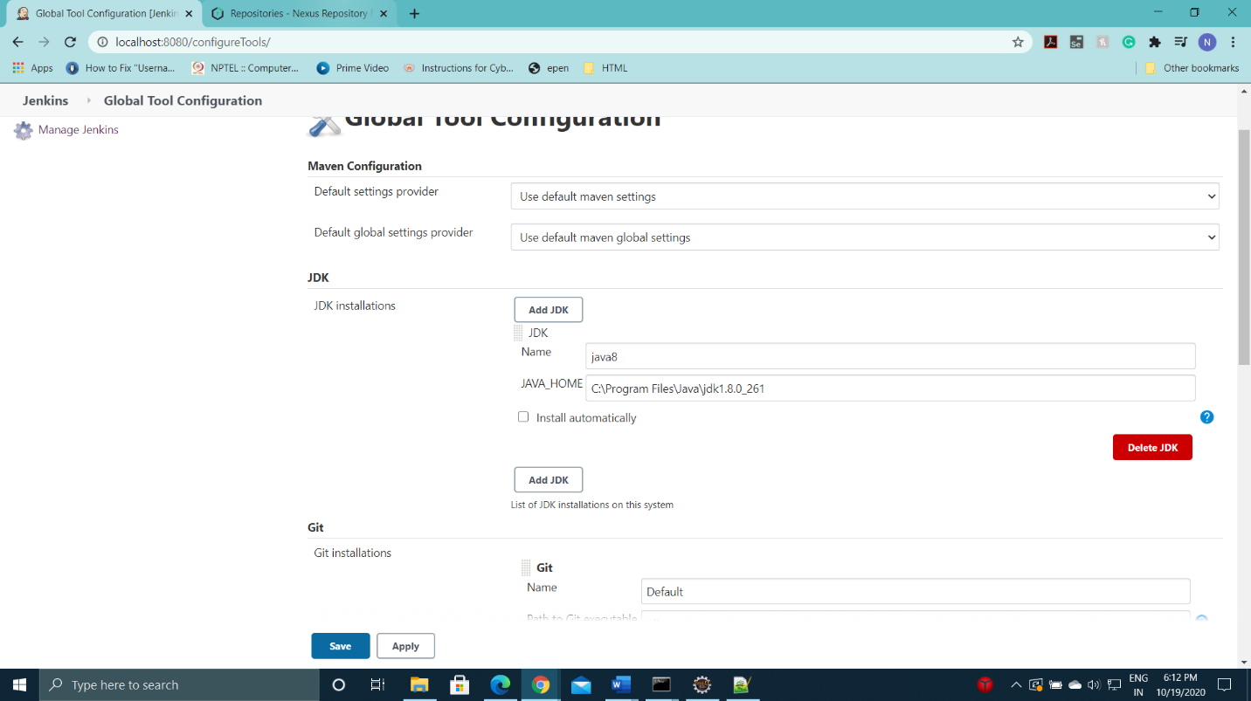

Install Nexus Plugin in Jenkins



Then, again go to Jenkins Configuration and Create a Nexus Server. Add Server URL as <https://localhost:8081>

Then, Test the connection. If it displayed “succedded” then the Nexus Server is established.

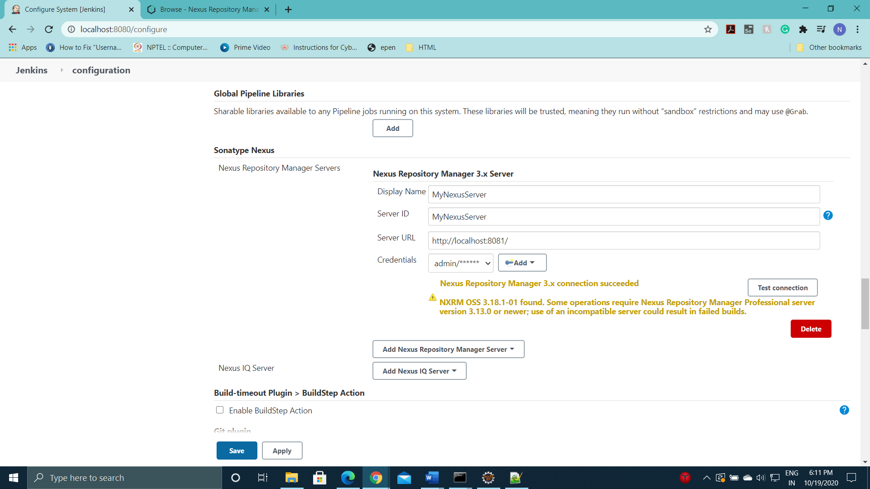

Now go to Nexus Dashboard <https://localhost:8081> and Create a Repository.

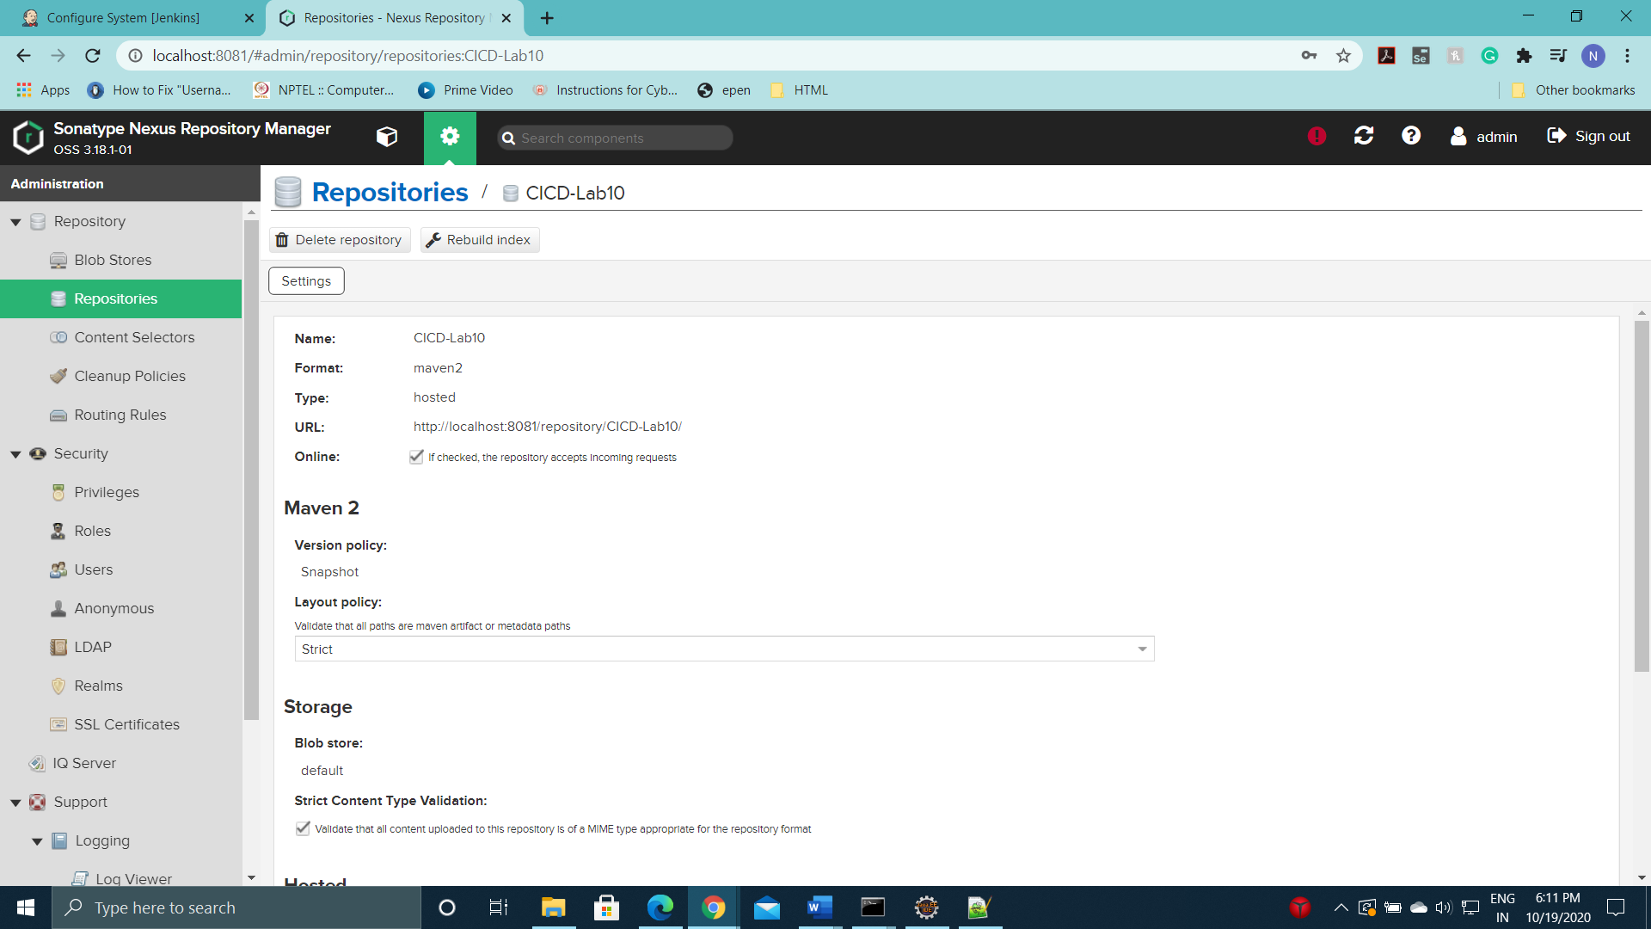

Enter the Github which contains the Maven Project.

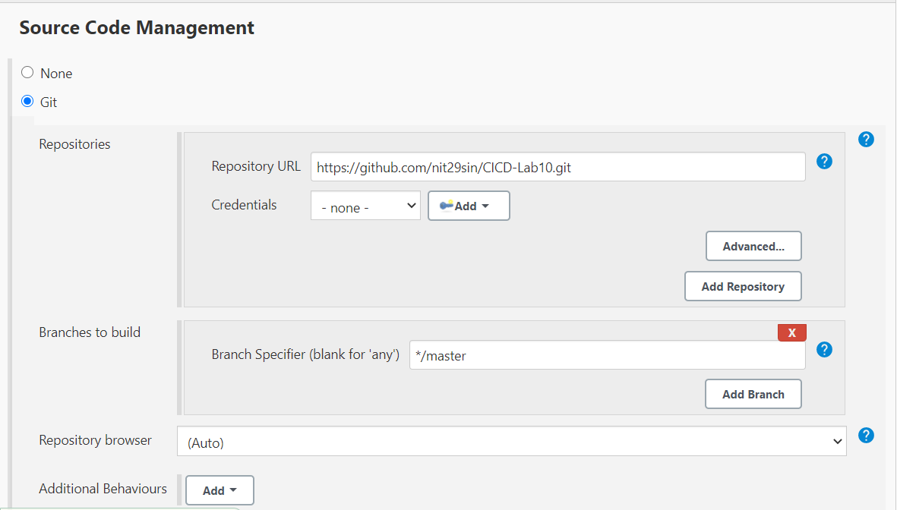

Mention deploy in Goals and options to deploy the build artifact to the Nexus Repository CICD-Lab10.

Click on Build Now to run deploy command and finally the build artifact will be deployed to the Nexus Repository CICD-Lab 10.

