Integration of GitHub and Jenkins - Report

# 1. Application Code

The application code is maintained in a GitHub repository named 'GitTesting'. It includes:  
- README.md – A markdown file for project documentation.  
- vvce.py – Python source code file.

# 2. GitHub Repository

Repository Name: GitTesting

GitHub URL: https://github.com/ArjunSadananda/GitTesting

Branch: main

Screenshot of the GitHub repository:

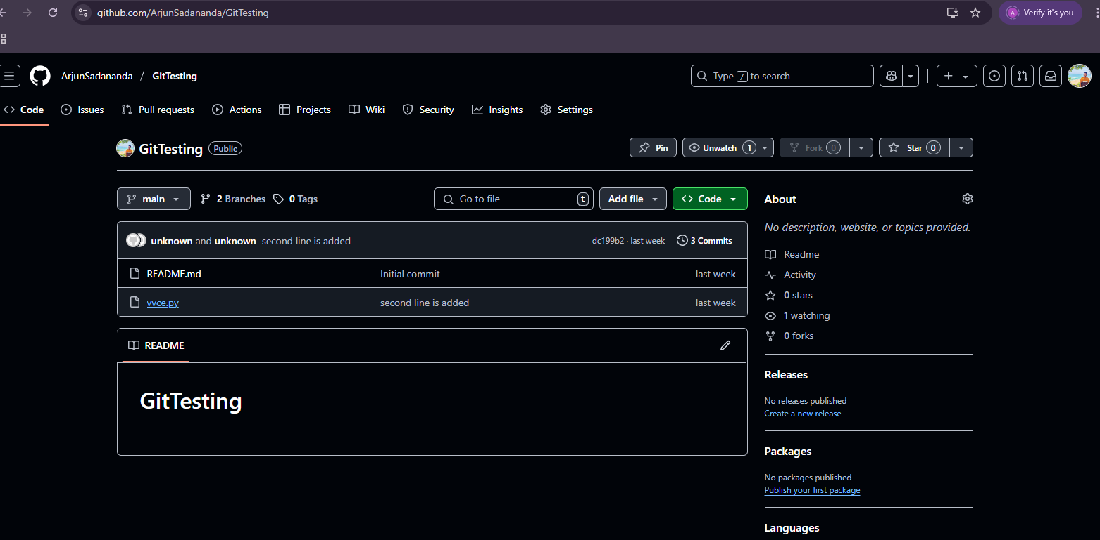

# 3. Jenkins Project Configuration

## General

Project Name: GitTesting-CI

Build Triggers: GitHub hook trigger for GITScm polling

## Source Code Management

Repository URL: https://github.com/ArjunSadananda/GitTesting.git

Branch to build: */main

## Build Steps

Windows Batch Command:

echo "Building the Python project..."  
python vvce.py

## Post-build Actions

Action: Archive the artifacts or email notification (commonly used options).

Example: Send email on build failure or success using Email Extension Plugin.