CYBERSECURITY 60-DAY CHALLENGE
Task 2 — Network Security & Scanning
Days 13–24 | Practical Lab Report

1. Objective
The objective of Task 2 is to learn reconnaissance, network scanning, vulnerability scanning, packet analysis and basic firewall controls in an isolated cybersecurity training environment.

2. Lab Scope and Target
Testing machine | Kali Linux
Target | Metasploitable2
Target IP | 192.168.56.102
Network | VirtualBox Host-Only isolated lab
Vulnerability scanner | OpenVAS / OpenVAS Default

3. Required Activities
- Reconnaissance: Whois, Nslookup, Google Dorking, Shodan, ping sweep and banner grabbing.
- Nmap TCP/UDP scanning, service detection, OS detection and scan reporting.
- OpenVAS or Nessus vulnerability scanning and severity analysis.
- Wireshark packet analysis for HTTP, FTP and DNS traffic, including unencrypted FTP credential observation and SYN-flood analysis in the lab.
- Basic iptables allow/deny rules and a demonstration of blocking a scan.

4. Nmap Scan Results
The verified lab service scan identified 23 open TCP services on Metasploitable2. The following table records the observed service surface.
Port | Service
21/tcp | FTP
22/tcp | SSH
23/tcp | Telnet
25/tcp | SMTP
53/tcp | DNS
80/tcp | HTTP
111/tcp | RPCbind
139/tcp | NetBIOS-SSN
445/tcp | Microsoft-DS/SMB
512/tcp | exec
513/tcp | login
514/tcp | shell
1099/tcp | Java RMI
1524/tcp | Ingreslock
2049/tcp | NFS
2121/tcp | FTP proxy
3306/tcp | MySQL
5432/tcp | PostgreSQL
5900/tcp | VNC
6000/tcp | X11
6667/tcp | IRC
8009/tcp | AJP13
8180/tcp | HTTP/unknown
The exposed services include legacy protocols and multiple application/database services. In a real environment, unnecessary services should be disabled and exposed services should be restricted and patched.

5. OpenVAS Vulnerability Assessment
A completed OpenVAS full scan was performed against the Metasploitable2 target. The supplied report screenshots provide the following summary:
Metric | Observed result
Hosts scanned | 1
Ports | 20 of 23
Applications | 20 of 20
CVEs | 36 of 36
Results | 69 of 635
TLS certificates | 2 of 2
Critical | 13
High | 10
Medium | 40
Low | 6
Highest reported CVSS | 10.0 (Critical)
Scan duration | 1:11 h
The severity counts total 69 findings. The screenshots do not show the full individual vulnerability list, so this report does not invent CVE names, package names or remediation steps.

6. OpenVAS Evidence
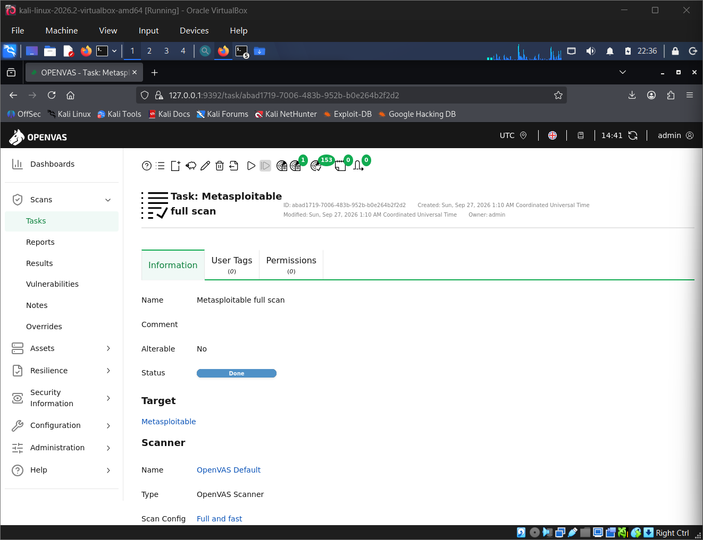
Figure 1. Completed OpenVAS task for the Metasploitable target.
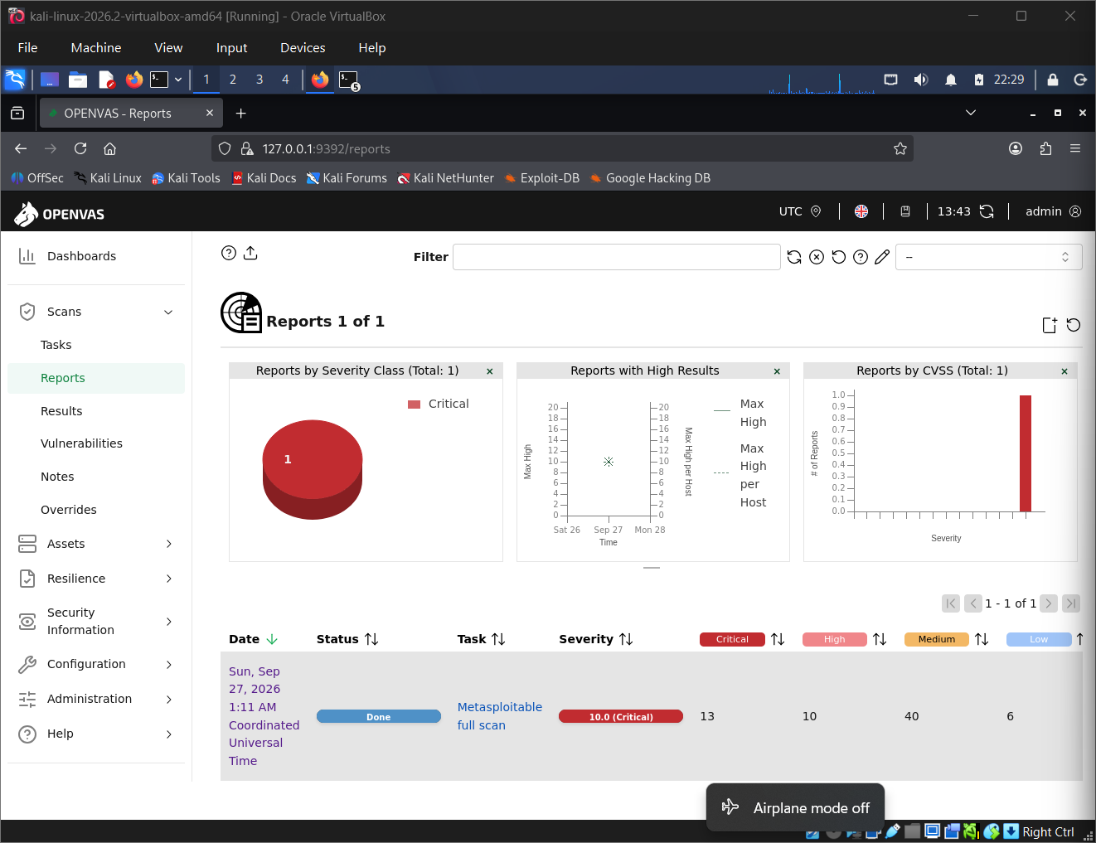
Figure 2. OpenVAS report summary showing the severity distribution.
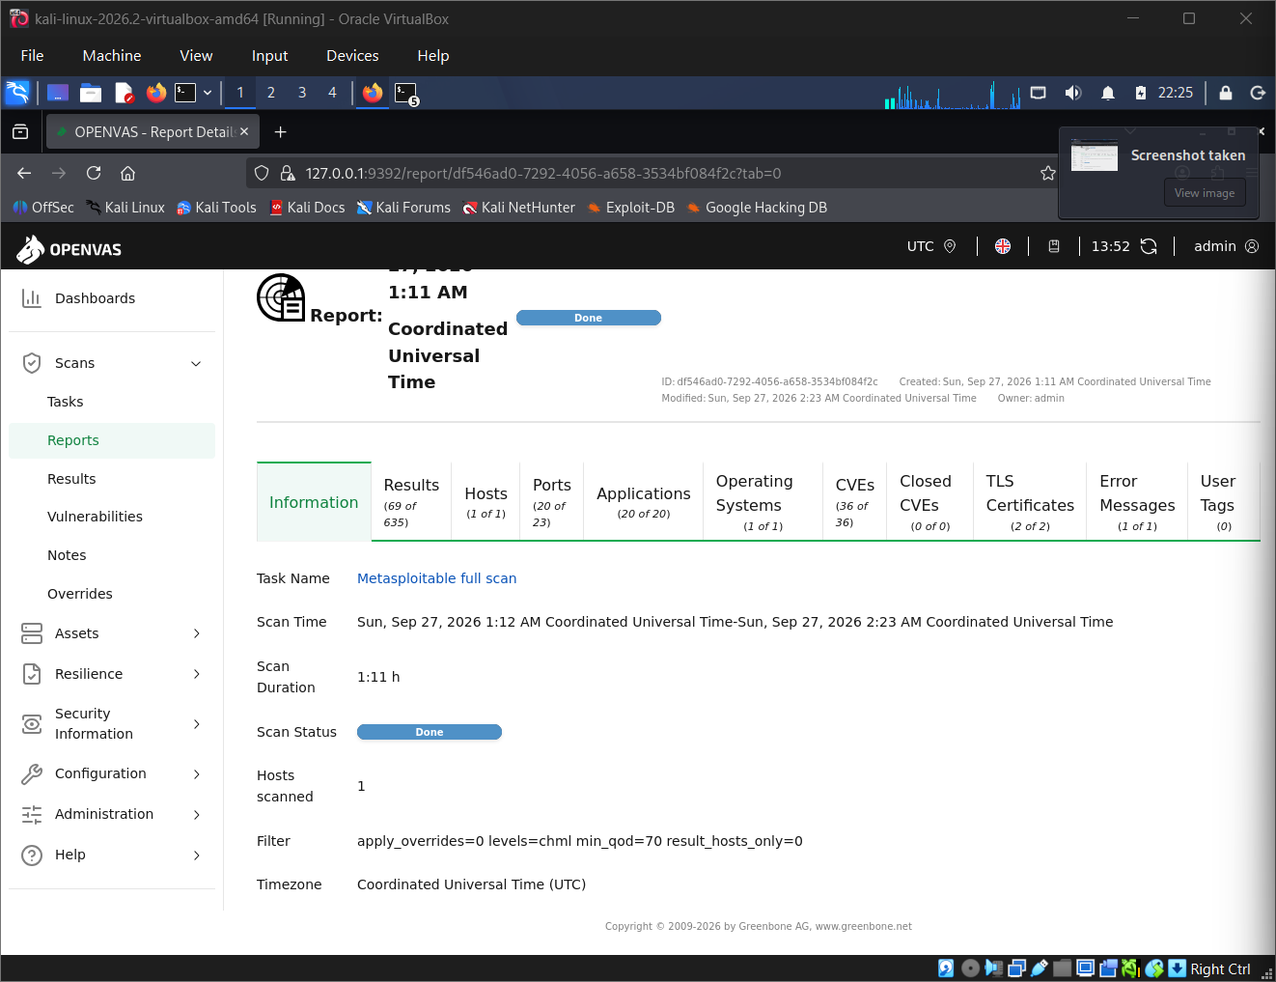
Figure 3. OpenVAS report details showing hosts, ports, applications, CVEs and scan duration.

7. Findings and Defensive Interpretation
- The target exposes a large service surface, including legacy and unencrypted protocols.
- OpenVAS identified 69 results, including 13 Critical and 10 High findings.
- The highest reported CVSS score is 10.0 (Critical).
- Nmap establishes the exposed attack surface, while OpenVAS adds vulnerability assessment context.
- For a real system, remediation should include validation, patching, disabling unnecessary services, access restriction and a follow-up scan.

8. Evidence and Submission Notes
The supplied screenshots include the official Task 2 requirements and OpenVAS evidence. The uploaded set does not include visual screenshots of every Nmap variant, Wireshark analysis, reconnaissance activity or firewall demonstration. Those screenshots should be added to the GitHub repository if the evaluator explicitly requires screenshot evidence for each sub-task.

9. Safety and Scope
Testing was performed against the intentionally vulnerable Metasploitable2 VM in an isolated VirtualBox Host-Only environment. The activities are intended for authorized cybersecurity training.

