# Project Overview:

This project is used to create and maintain employee records. The user will be able to create, update, search and delete the employee records.

# Project Setup:

1. In MySql database create a database named **“EmployeeManagementApp”**.
2. And do the following changed in the **“Application.properties”** file
   1. spring.datasource.url=jdbc:mysql://localhost/EmployeeManagementApp
   2. spring.datasource.username=root
   3. spring.datasource.password=enter your database password

### Sample properties file:

After updating the application.properties file in the project, the script will look like the below given image.

spring.application.name=employeeManagementApplicationFrontEnd

spring.datasource.url=jdbc:mysql://localhost/EmployeeManagementApp

spring.datasource.username=root

spring.datasource.password=password

spring.jpa.properties.hibernate.dialect=org.hibernate.dialect.MySQLDialect

spring.jpa.hibernate.ddl-auto=update

spring.jpa.show-sql=true

# 

# Screen Screenshots:

## Screen 1: Index Screen

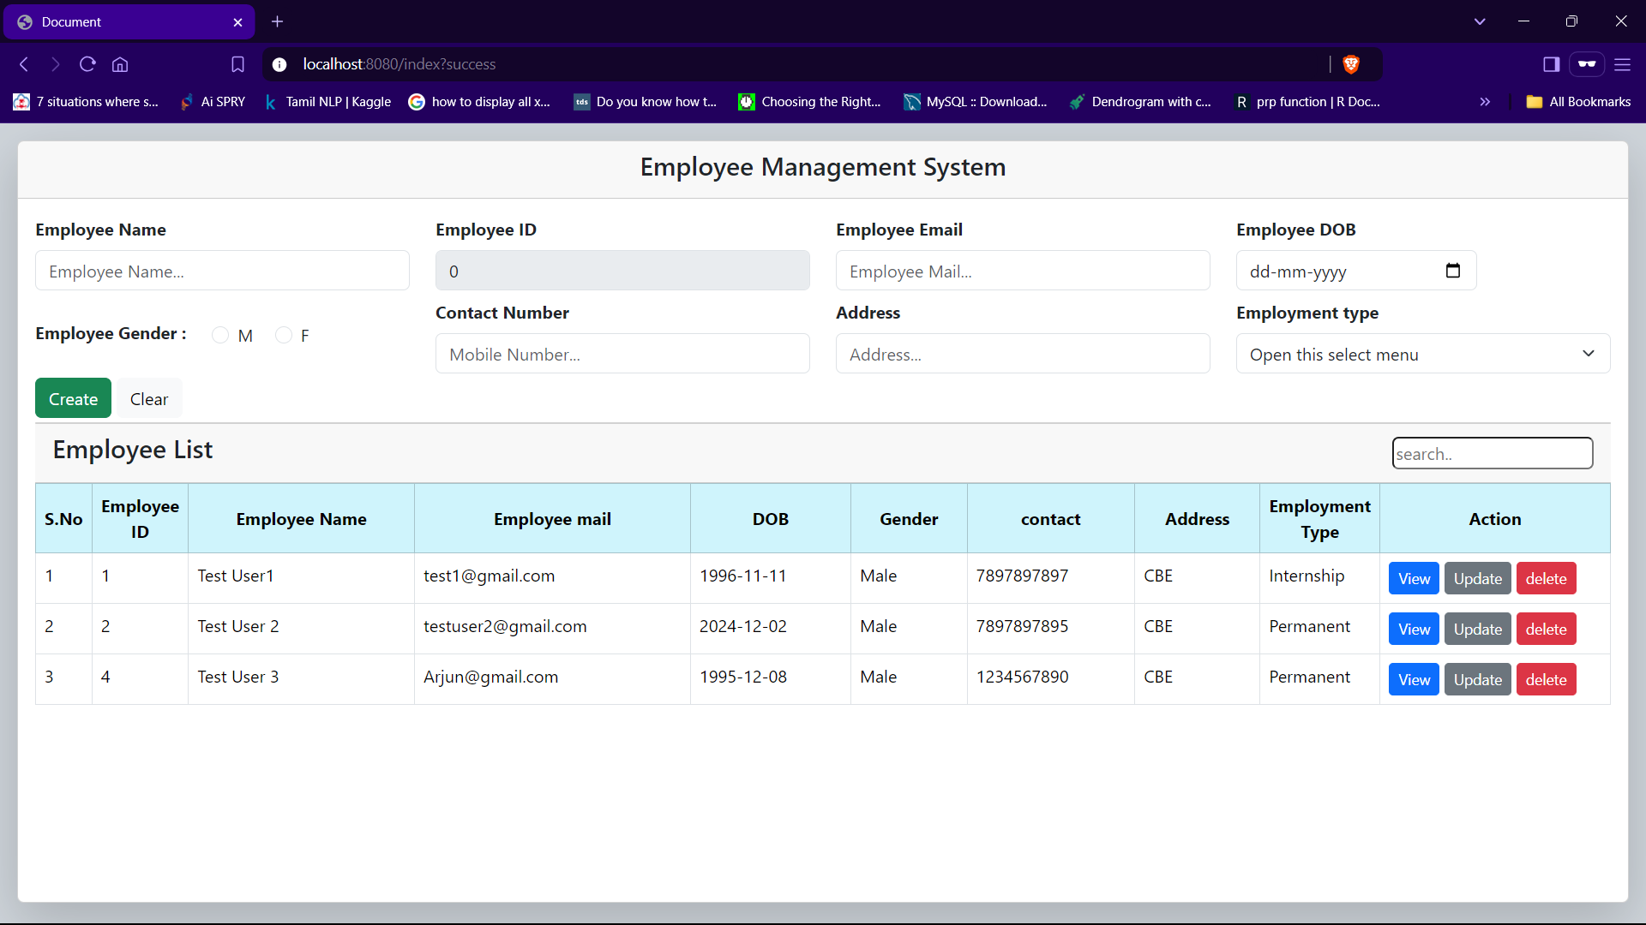

## Screen 1: Index Screen - with validations

#### Field Validations:

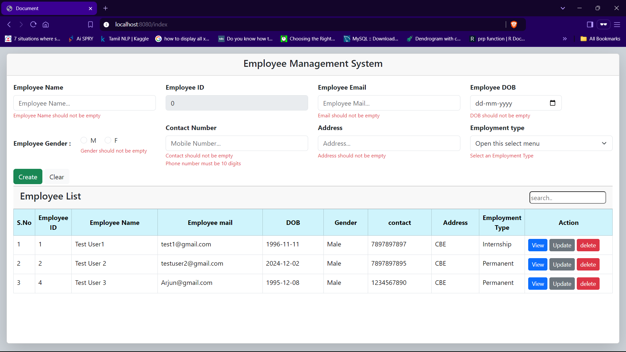

#### Duplicate MailID validation:

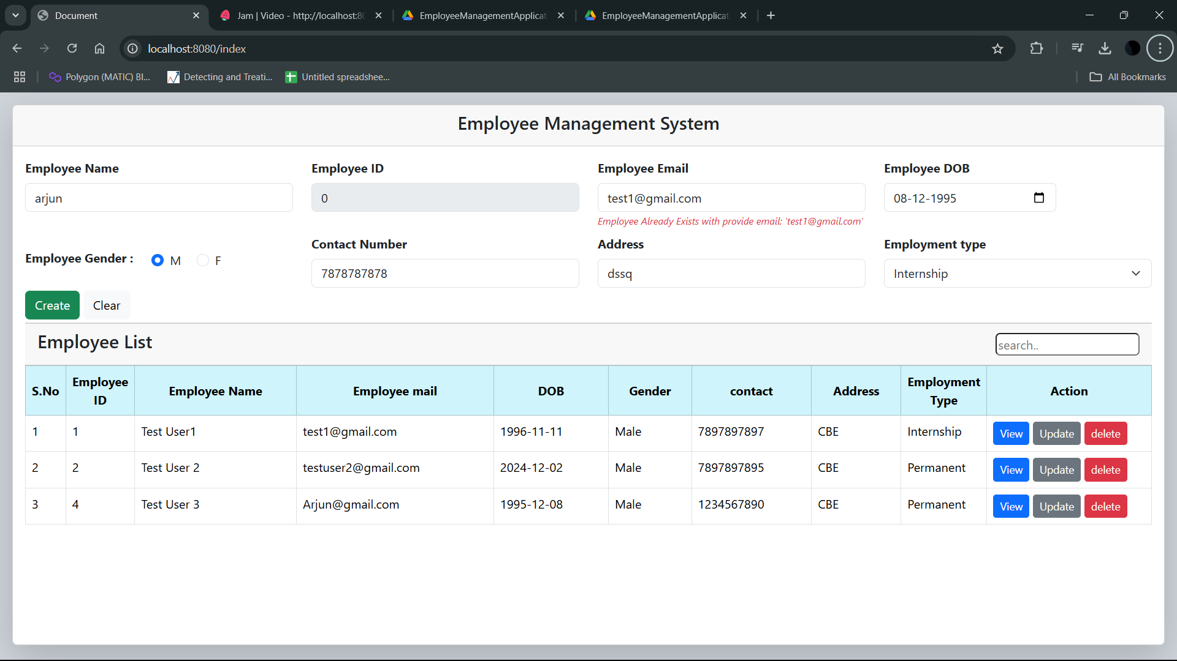

## Screen 2: Employee View Screen

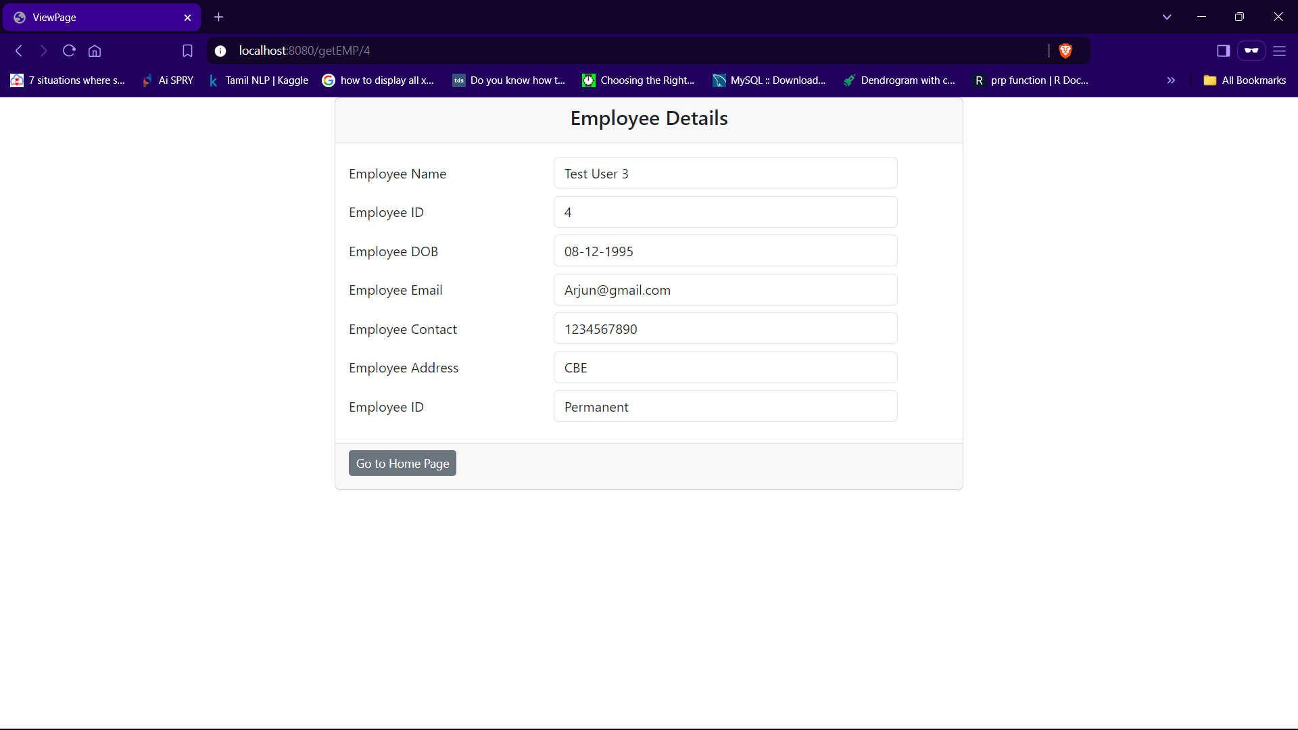

## Screen 3: Employee Update Screen

## 

# Project Demo:

## Demo Link:

The screen demo for this project is given in the below given drive link.

<https://drive.google.com/file/d/1j0c_PBEZkYpOow7BNdpSyilXIVgr7dar/view?usp=sharing>