AI-BASED CAMPUS ENERGY CONSUMPTION
AND ANOMALY DETECTION SYSTEM

SUBJECT : MACHINE LEARINING LABORATORY

SUBJECT CODE : 20MSSL12

TEAM MEMBERS :

ARJUN BALAJI S – 2403717672621008
SHIVESH S – 2403717672621048

DATE : 16-10-2026

1. Project Overview
Educational institutions use electricity in classrooms, laboratories, libraries, offices, and other facilities. Consumption changes with time, occupancy, weather, and building activity. This project estimates expected energy consumption and identifies unusual readings so that campus staff can investigate potential inefficiencies.

Objectives
- Predict expected energy consumption (kWh) from time and contextual features.
- Flag unusual consumption using prediction deviations and an anomaly-detection algorithm.
- Show anomaly category, severity, and useful context in a dashboard.
- Support data-driven investigation; an alert is not proof of a fault or energy waste.

2. Modules and Algorithms

Module 1 — Data Generation / Collection
Load historical or synthetic building-energy observations containing timestamps, building details, energy readings, and available environmental or occupancy variables. Pandas is used for tabular data ingestion and validation. No machine-learning algorithm is required in this module.

Module 2 — Preprocessing and Feature Engineering
Check missing values, duplicates, data types, invalid readings, and timestamp consistency. Derive hour, day of week, weekend indicator, and other fields where available. Use descriptive statistics and plots for exploratory data analysis.
Techniques: missing-value handling, duplicate removal, categorical encoding when needed, feature creation, and a chronological train/test split for time-dependent data.

Module 3 — Energy Consumption Prediction
Train a regression model to estimate expected energy consumption for a building and time period. The main algorithm is Random Forest Regressor, an ensemble of decision trees that can learn nonlinear relationships between input features and energy use.
Evaluation: Mean Absolute Error (MAE) and Root Mean Squared Error (RMSE) on held-out test data.

Module 4 — Anomaly Detection
Compare actual consumption with predicted consumption. The residual is calculated as actual minus predicted usage. Large deviations can be flagged using a documented threshold. Isolation Forest provides an additional unsupervised method for identifying observations that differ from common patterns.
Algorithms: residual-based deviation analysis and Isolation Forest. In scikit-learn, Isolation Forest typically returns 1 for an inlier and -1 for an outlier. The contamination setting is an estimate used by the model, not a verified ground-truth rate.

Module 5 — Explanation and Dashboard
Display energy trends, actual-versus-predicted values, anomaly alerts, timestamp, building, deviation percentage, severity, anomaly type, and environmental context when available. Deviation percentage may be calculated as |actual − predicted| / |predicted| × 100, with a safe rule for zero predicted values.
Techniques: aggregation, rule-based severity labels, and charts. A dashboard supports investigation but cannot determine the true cause of an anomaly without further checks.

Main Technology Stack
Technology | Use
Python | Core implementation and model pipeline
Pandas / NumPy | Data cleaning, transformation, numerical operations
Scikit-learn | Random Forest Regressor, Isolation Forest, metrics
Matplotlib / Plotly / Streamlit (if used) | Charts and dashboard presentation

3. Dataset Description
This report describes the synthetic dataset design discussed for the project. Synthetic records simulate campus energy patterns and anomaly scenarios; they must not be presented as measured readings from a real campus. If a public dataset is used in the final implementation instead, update this section with its exact name, version, source, date range, and record count.
Field / label | Description
timestamp | Date and time of the simulated observation
building_id / building_type | Building identifier or category, if generated
temperature / humidity | Environmental context variables, if included
occupancy | Estimated or simulated number/level of occupants
hour / day_of_week / is_weekend | Time-derived features
energy_kwh | Regression target: energy consumed in kilowatt-hours
is_anomaly | Binary anomaly indicator: normal (0) or anomaly (1), according to the dataset's encoding
anomaly_type | Category describing the simulated scenario

Example anomaly categories
- normal — usage follows the expected pattern.
- weekend_hvac_surge — unusually high HVAC-related usage during a weekend.
- night_standby_machinery — excess usage during nighttime standby.
- meter_failure_drop — an abnormal drop in recorded usage caused by a simulated meter issue.
- extreme_thermal_surge — a large consumption increase associated with extreme temperature.
The exact columns and category names must match the generated CSV or code. If anomaly_type is not present in the file, do not claim it as an existing column. Likewise, record count, date range, and measured scores should be filled from the actual run.

Evaluation Metrics
Metric | Purpose
MAE = average(|actual − predicted|) | Average absolute prediction error in the target's units
RMSE = sqrt(average((actual − predicted)²)) | Penalizes larger prediction errors more strongly
Anomaly count / rate | Summarizes the number or proportion of flagged records

4. Project Workflow and Figure
The figure below summarizes the proposed software workflow from synthetic data generation through prediction, anomaly detection, explanation, and dashboard presentation.
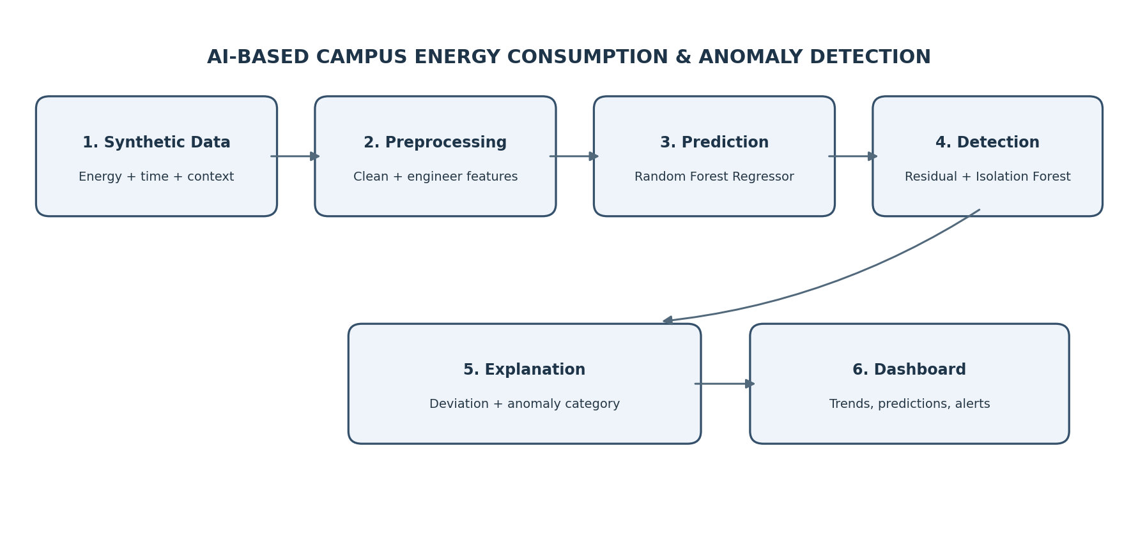
Figure 1. Project workflow diagram (illustrative architecture; not a screenshot of a running application).

Screenshots :
- Dashboard home: summary cards and energy-consumption trend.
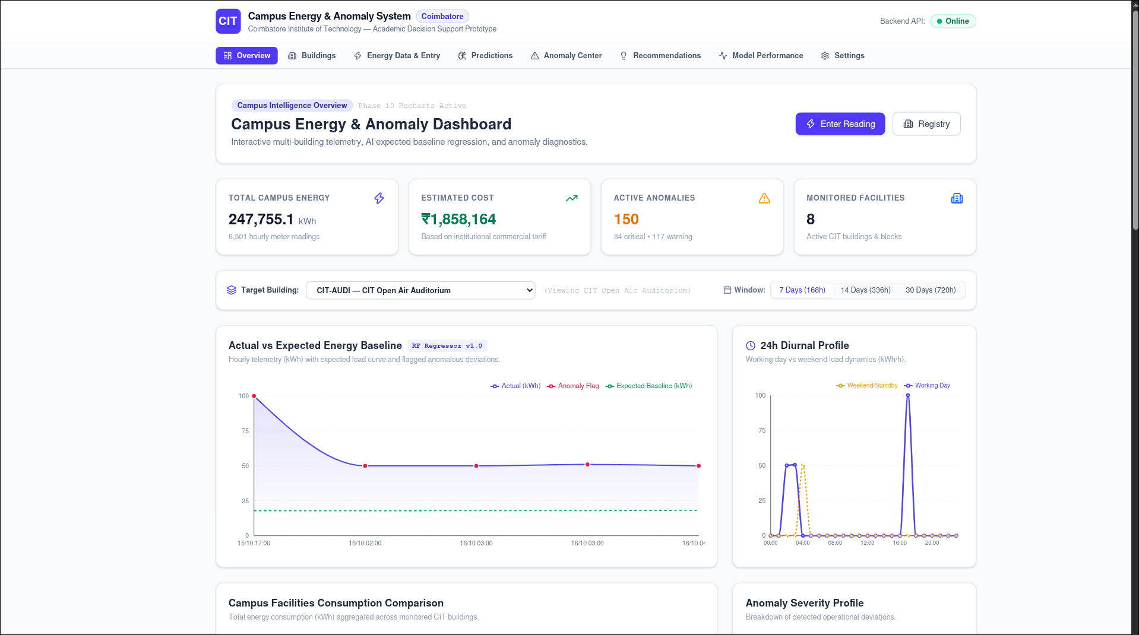

- Prediction page: actual versus predicted consumption.
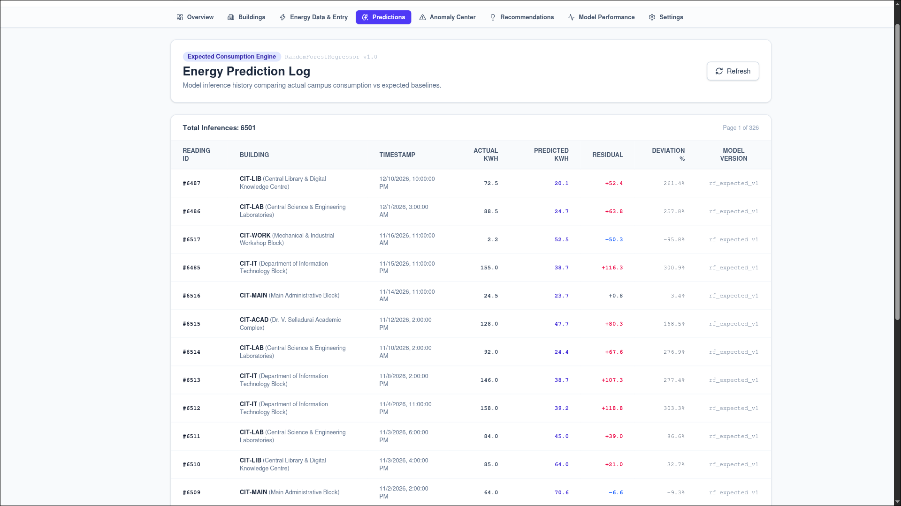
- Anomaly view: flagged record, deviation, severity, and anomaly category.

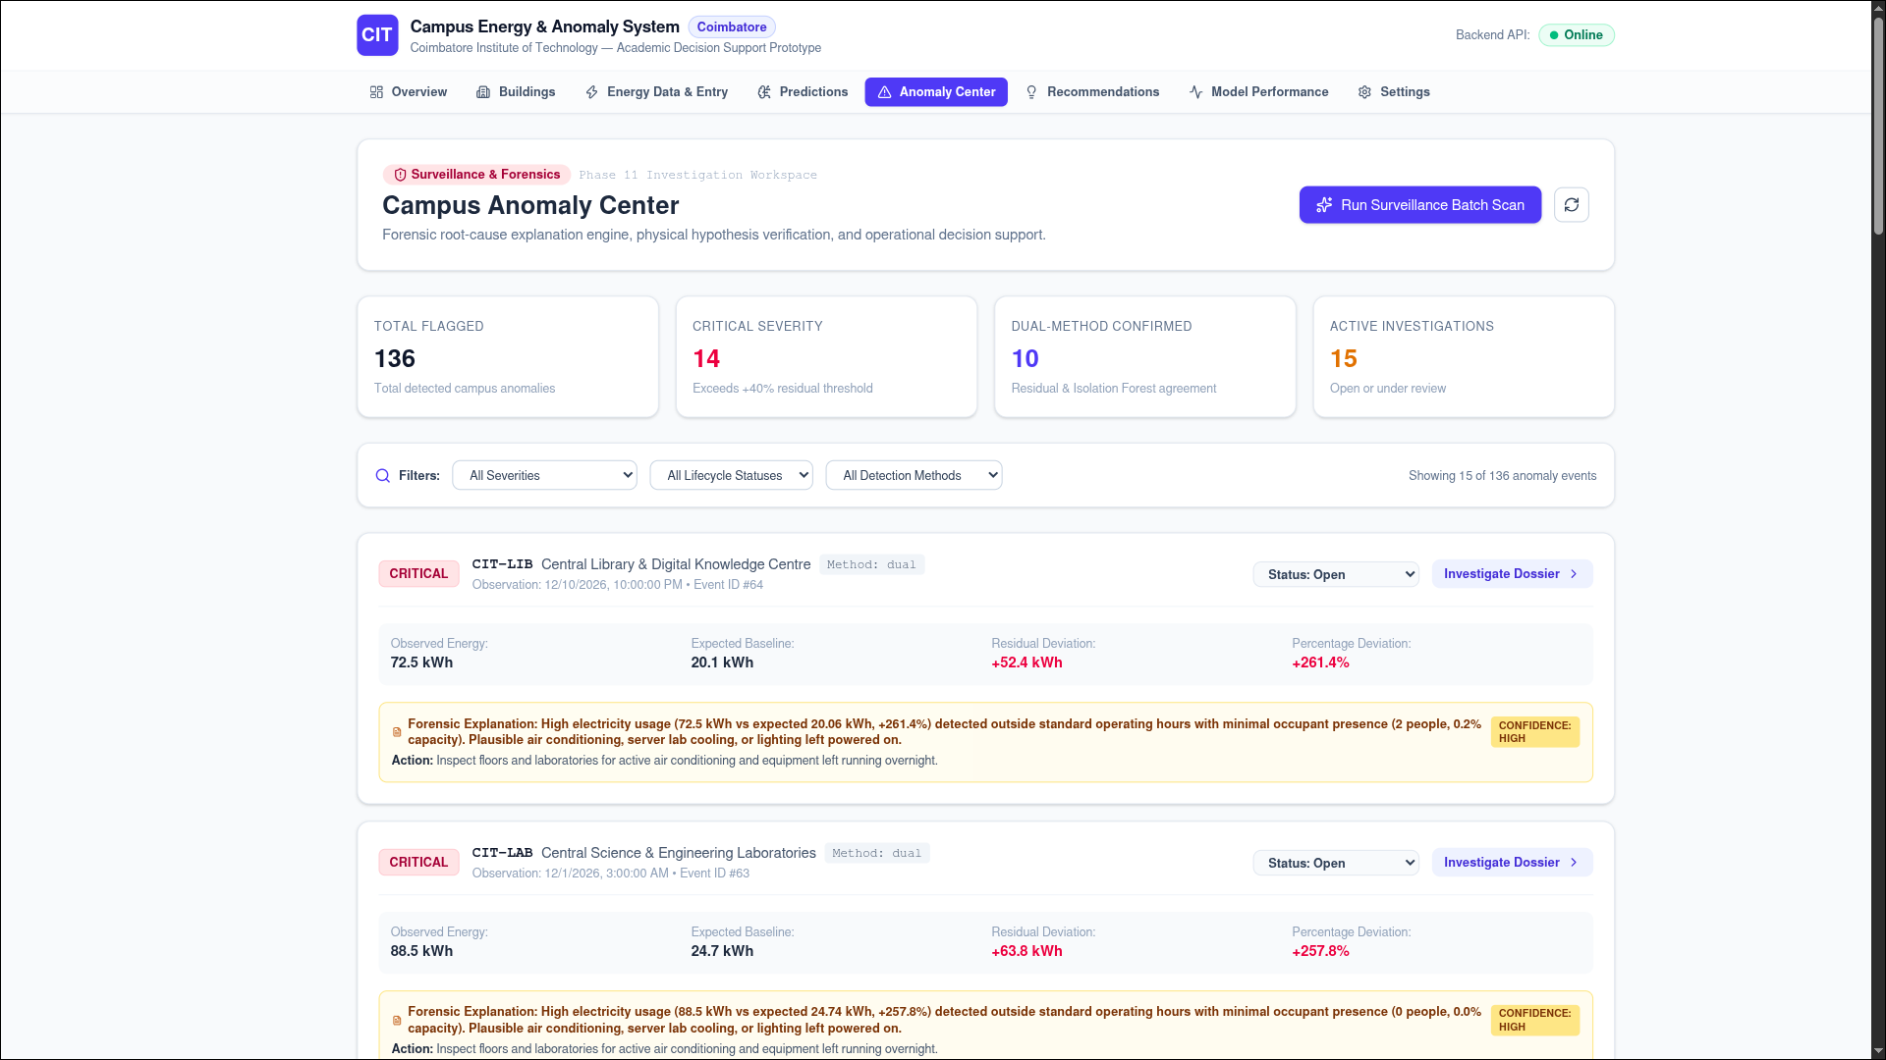



Conclusion
The proposed system combines Random Forest Regression for expected energy estimation with residual analysis and Isolation Forest for unusual-pattern detection. Its dashboard organizes predictions and alerts to help users investigate possible energy inefficiencies. Future work may include real smart-meter integration and sequence models such as LSTM or GRU.

