AI-BASED CAMPUS ENERGY CONSUMPTION
AND ANOMALY DETECTION SYSTEM
Project Report
Academic Research Prototype | Coimbatore Institute of Technology (CIT), Coimbatore

Abstract
Campus buildings use electricity for lighting, computers, air conditioning, laboratories, and other daily activities. When consumption rises unexpectedly, it can be difficult for facilities teams to identify the building, time, or operating condition responsible. This project presents an AI-based campus energy monitoring prototype that brings building information, meter readings, expected-consumption predictions, anomaly alerts, and operational recommendations into one dashboard.
The prototype uses a synthetic dataset created for this project containing 6,480 records. The dataset was designed to represent campus energy behaviour and related contextual factors so that the models could learn patterns from the generated examples. A 70:10:20 train-validation-test split was used. Random Forest is used to estimate expected energy consumption from tabular features, an LSTM model is used to model sequential or time-series patterns, and Isolation Forest is used to identify unusual observations. The results are displayed through a web interface that supports review of buildings, readings, predictions, anomalies, recommendations, model metrics, and detection thresholds.

1. Introduction
Energy consumption changes with building purpose, occupancy, time of day, equipment use, weather conditions, and operating schedules. A single high meter reading does not automatically mean that energy is being wasted; it may reflect a busy laboratory, a special event, or equipment operating outside its normal schedule. For this reason, the system compares observed readings with an expected baseline and uses contextual information to help explain unusual differences.
The project is intended as an academic decision-support prototype. It demonstrates how machine learning can support energy monitoring and help campus staff decide which readings may need further investigation. The generated data and displayed results should not be treated as verified measurements from live campus meters unless they are later connected to validated real-world data.

2. Objectives
- Maintain a registry of campus buildings and their operating characteristics.
- Record energy readings alongside time, occupancy, environmental conditions, and operating status.
- Estimate expected energy consumption using a supervised regression model.
- Use a sequence model to learn temporal patterns in energy readings.
- Flag unusual readings using an unsupervised anomaly-detection method.
- Present alerts, model performance indicators, and practical follow-up recommendations in one interface.
- Allow users to configure warning and critical deviation thresholds.

3. Dataset and Preparation
Dataset type: Synthetic dataset created for this project.
Number of records: 6,480.
Split: 70% training, 10% validation, and 20% testing.
The synthetic records represent energy observations across campus buildings and time periods. The interface shows fields such as building, timestamp, energy consumed (kWh), meter interval, outdoor and indoor temperature, relative humidity, occupancy headcount, day type, operating status, HVAC runtime status, tariff, and observation notes. These are the contextual variables visible in the energy-entry screen; the exact feature list used by each trained model should be confirmed against the project’s preprocessing and training code.
The training portion is used to fit model parameters, the validation portion can support model selection and tuning, and the test portion is held back for a final performance check. Keeping the test split separate helps provide a more realistic estimate of how the models perform on records they did not use during training. For time-series experiments, the split should preserve chronological order to reduce the risk of future information leaking into the training data.

4. System Architecture and Modules
The application is organised as a web dashboard connected to a FastAPI backend. The frontend provides the user-facing pages, while API routes handle requests for building records, observations, predictions, anomaly events, recommendations, model metrics, and configuration. The supplied architecture diagram also shows persistence components for energy records, database sessions, and runtime settings, along with a dataset/training seeder and the machine-learning modules.
Overview dashboard: Summarises campus energy consumption, estimated cost, active anomalies, monitored facilities, and charts comparing actual readings with expected baselines.
Building registry: Stores and displays building codes, names, categories, floor area, capacity, HVAC status, operating hours, and meter identifiers.
Energy data entry: Allows a user to submit a meter observation with timestamp and contextual operating variables. A searchable records view supports reviewing existing readings.
Prediction log: Lists actual and predicted energy values, residuals, percentage deviations, timestamps, and model versions.
Anomaly Center: Displays flagged events, severity, detection method, lifecycle status, and supporting context for investigation.
Recommendations workspace: Turns selected anomaly evidence into suggested checks, verification steps, responsible campus roles, and estimated savings.
Model performance: Compares Random Forest and LSTM metrics and provides a place to inspect error and training-time indicators.
Settings: Allows configuration of warning and critical deviation percentages used by the residual-based alert logic.

5. Machine-Learning Methods

5.1 Random Forest Regression
Random Forest is the main tabular prediction model shown in the dashboard. It combines the outputs of multiple decision trees and averages their predictions for a regression task. In this project, it estimates the expected energy consumption for an observation using the selected input features. The system can then compare the measured value with this expected baseline. A large difference may indicate an event that deserves review, but it does not by itself prove a fault or energy waste.

5.2 Long Short-Term Memory (LSTM)
LSTM stands for Long Short-Term Memory. It is a recurrent neural-network architecture designed to learn relationships across ordered sequences. For energy data, a sequence can represent readings over a time window, allowing the model to learn recurring patterns such as daily changes and short-term trends. The dashboard identifies the LSTM model as a 24-hour sliding-sequence benchmark and reports its training duration and regression metrics. The LSTM is presented as a comparison model rather than the active production baseline in the supplied screenshot.

5.3 Isolation Forest
Isolation Forest is an unsupervised anomaly-detection algorithm. It repeatedly partitions the feature space; observations that are isolated with relatively few splits are treated as more unusual. In this project, it provides a second method for finding readings that differ from typical patterns. The anomaly workflow can compare model residuals with Isolation Forest results, and the interface reports events identified by a dual-method approach. Final labels still need to be checked against operational context.

6. Evaluation Metrics
The Model Performance screen displays the coefficient of determination (R²), Mean Absolute Error (MAE), Root Mean Squared Error (RMSE), Random Forest inference latency, and LSTM training duration. R² describes how much variation in the target is explained by the model relative to a baseline; values closer to 1 generally indicate a better fit on the evaluated data. MAE is the average absolute difference between actual and predicted values. RMSE is the square root of the mean squared prediction error and gives larger errors more influence. Inference latency measures prediction time for the reported operation, while training duration measures the time needed for the stated training run.
The supplied performance screenshot reports a Random Forest R² of 0.9754 and an LSTM sequence R² of 0.928 in the headline cards. It also shows a Random Forest inference latency of 0.08 ms and an LSTM training duration of 9.54 seconds. The detailed model cards display slightly different rounded or run-specific values (Random Forest R² 0.9720; LSTM R² 0.9304, with MAE/RMSE values shown in the cards). These values should be reconciled with the evaluation output before being quoted as a single definitive result in a final submission. Report metrics from the same held-out test split and the same model run for a fair comparison.

7. Anomaly Detection and Recommendations
The system compares actual energy consumption with the Random Forest expected baseline. The residual is the difference between the observed value and the prediction. The interface presents the residual in kWh and a percentage deviation, then classifies the event using configurable warning and critical thresholds. The Settings screen shows a warning threshold of 20% and a critical threshold of 40%.
The Anomaly Center includes severity, status, detection method, and an explanation based on information such as energy usage, expected consumption, operating hours, and occupancy. The Recommendations workspace suggests follow-up actions, for example checking HVAC or equipment operation outside normal hours and verifying later readings. These recommendations are decision support, not automatic proof of the root cause; a campus staff member should verify the event before taking operational action.

8. Technology and Application Flow
The screenshots identify a React frontend and a FastAPI backend, with machine-learning components based on PyTorch and scikit-learn. The architecture diagram shows frontend route components calling an API client, which sends requests to FastAPI routes. Those routes connect to prediction, anomaly, building, overview, analytics, telemetry-explorer, metrics, and pipeline modules. Persistence components support energy records, database sessions, and runtime configuration.
A typical workflow is: (1) register or select a building; (2) enter or retrieve an energy observation; (3) generate an expected baseline; (4) compare the actual reading with the prediction; (5) run anomaly checks; (6) review the event and its context; and (7) follow the suggested verification steps. The dashboard then presents summary indicators and model performance information to help users review the results.

9. Results and Discussion
The screenshots show a complete prototype workflow across eight screens: overview, buildings, energy entry, prediction log, anomaly investigation, recommendations, model comparison, and threshold settings. The dashboard is designed to make energy readings easier to review by bringing prediction results and anomaly evidence together rather than requiring users to inspect separate files or model outputs.
The reported Random Forest R² is higher than the LSTM headline R² in the supplied screenshot, suggesting that Random Forest performed better on the particular evaluation shown. However, the displayed MAE values and detailed model-card values are not fully consistent across the same screen. The result should therefore be described as a prototype evaluation, with a recommendation to regenerate a single metric summary from one saved test run. Because the dataset is synthetic, strong scores show that the models learned patterns in the generated data; they do not yet establish performance on real campus meter readings.

10. Limitations and Future Improvements
- Validate the pipeline using real meter data, with suitable permissions and data-quality checks.
- Document the exact feature columns, target variable, missing-value handling, scaling, and sequence-window construction used by each model.
- Use a chronological train-validation-test split for forecasting and prevent future observations from leaking into training.
- Recalculate and display all model metrics from the same held-out test set; include the test-set size and evaluation date.
- Check for duplicate recommendations and ensure that estimated savings are calculated consistently from the tariff and expected avoidable energy.
- Evaluate anomaly thresholds with labelled or expert-reviewed events and track false positives and false negatives.
- Add monitoring for model drift, data gaps, sensor errors, and changing building schedules.
- Treat AI-generated explanations as hypotheses and keep a human verification step before changing building operations.

11. Conclusion
This project demonstrates an end-to-end approach to campus energy monitoring using synthetic data and machine-learning methods. Random Forest provides an expected consumption baseline, LSTM explores time-series forecasting, and Isolation Forest helps identify unusual observations. The dashboard connects these results with building details, investigation workflows, recommendations, and configurable thresholds. The prototype provides a useful foundation for academic demonstration and further testing. Its next important step is to validate the data pipeline and model performance against reliable real-world readings before using the outputs for operational decisions.

Appendix A. Application Screenshots
The following figures were supplied as evidence of the prototype interface. They are included to document the main pages and workflows.
Figure 1. Campus energy dashboard and overall campus indicators.
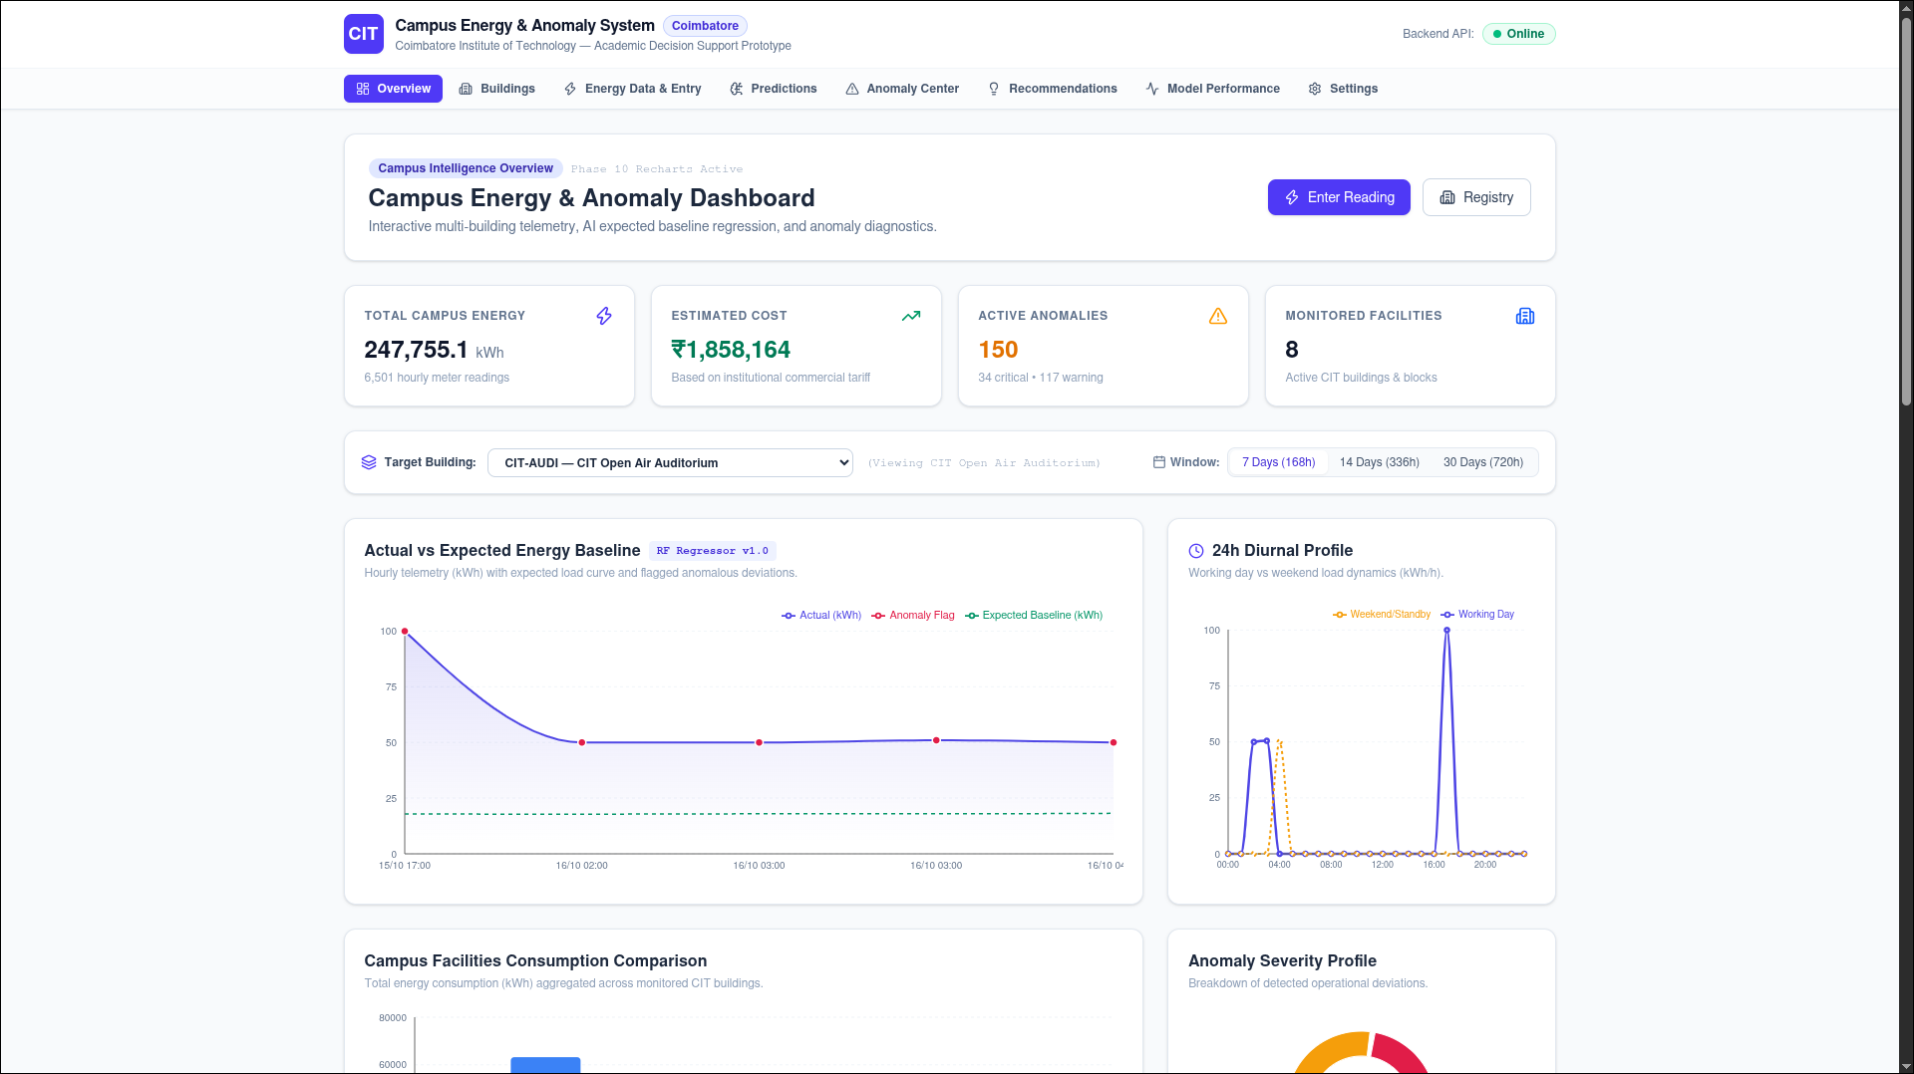

Figure 2. Building registry with facility details and monitoring status.
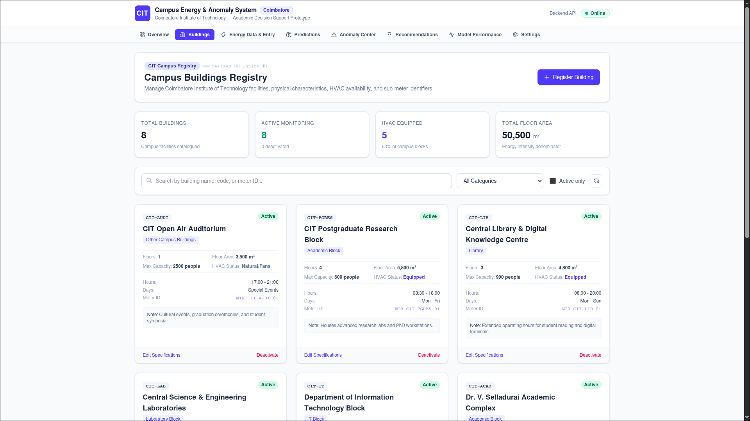

Figure 3. Energy observation entry form and contextual operating variables.
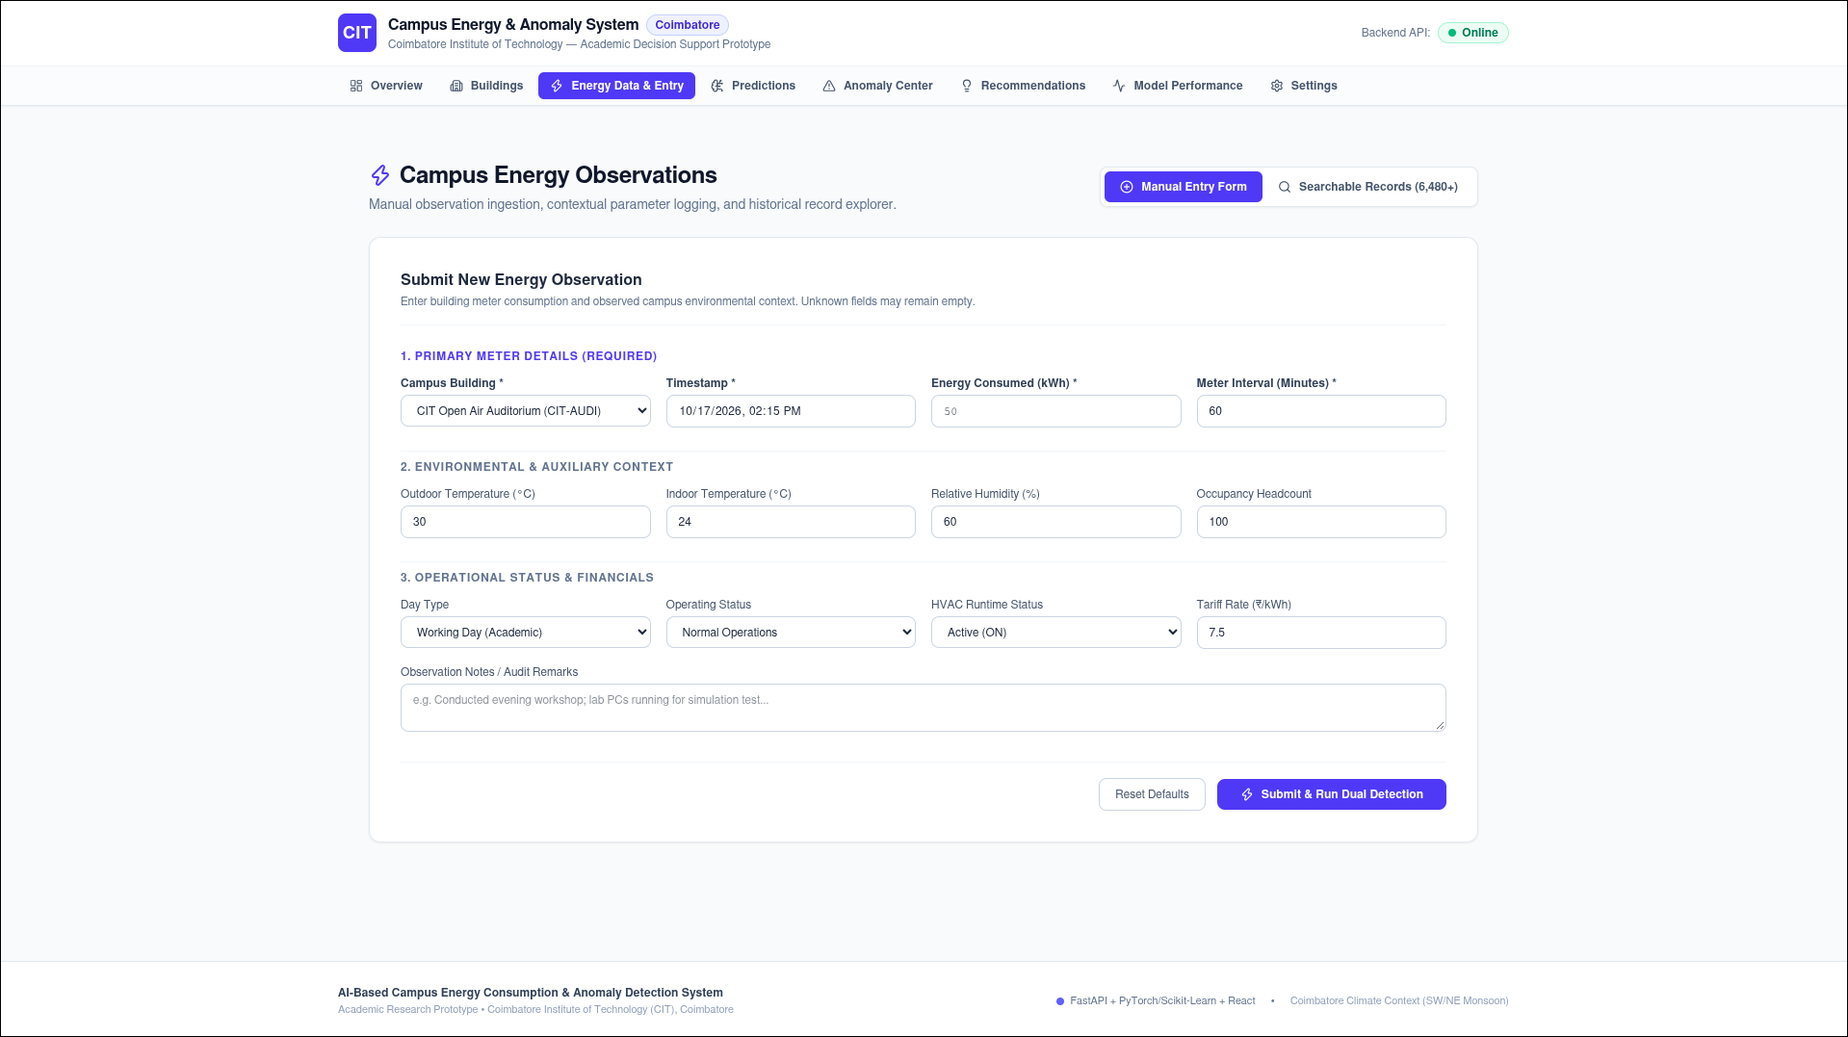

Figure 4. Energy prediction log comparing actual and predicted readings.
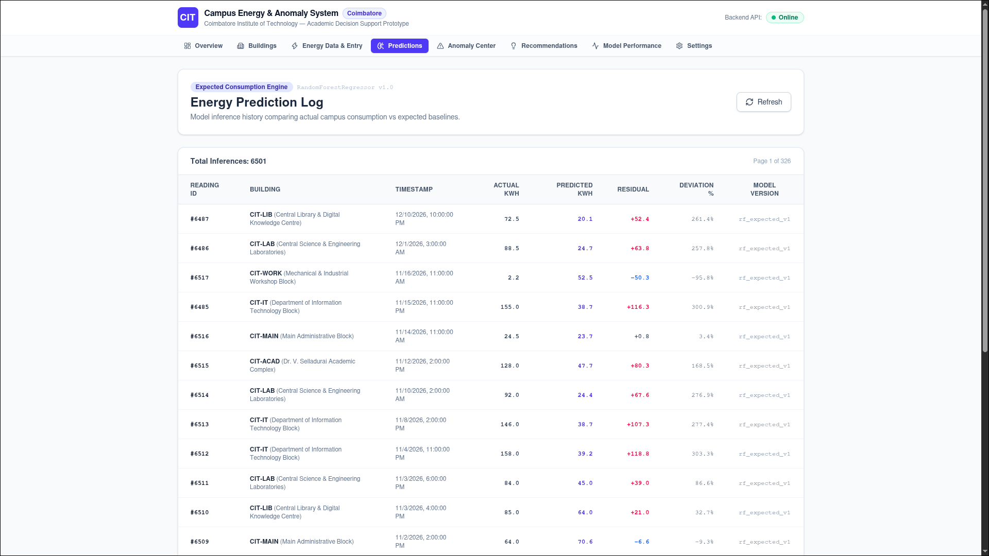

Figure 5. Anomaly Center showing flagged events, deviations, and investigation details.
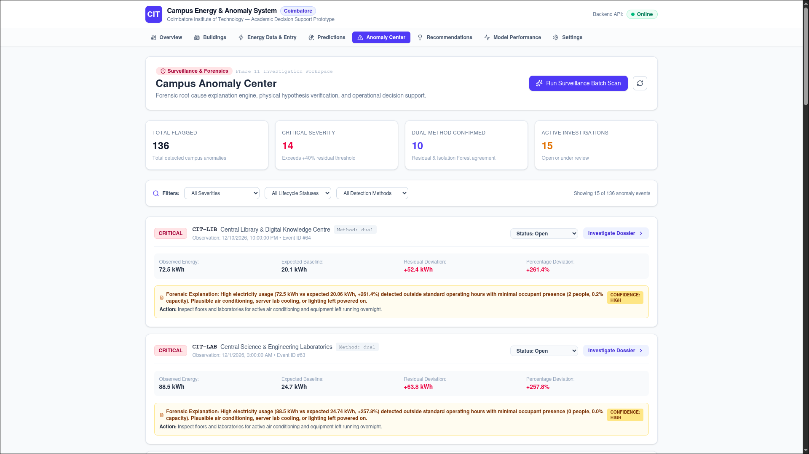

Figure 6. Recommendations workspace with suggested operational actions.


Figure 7. Model performance comparison for Random Forest and LSTM.
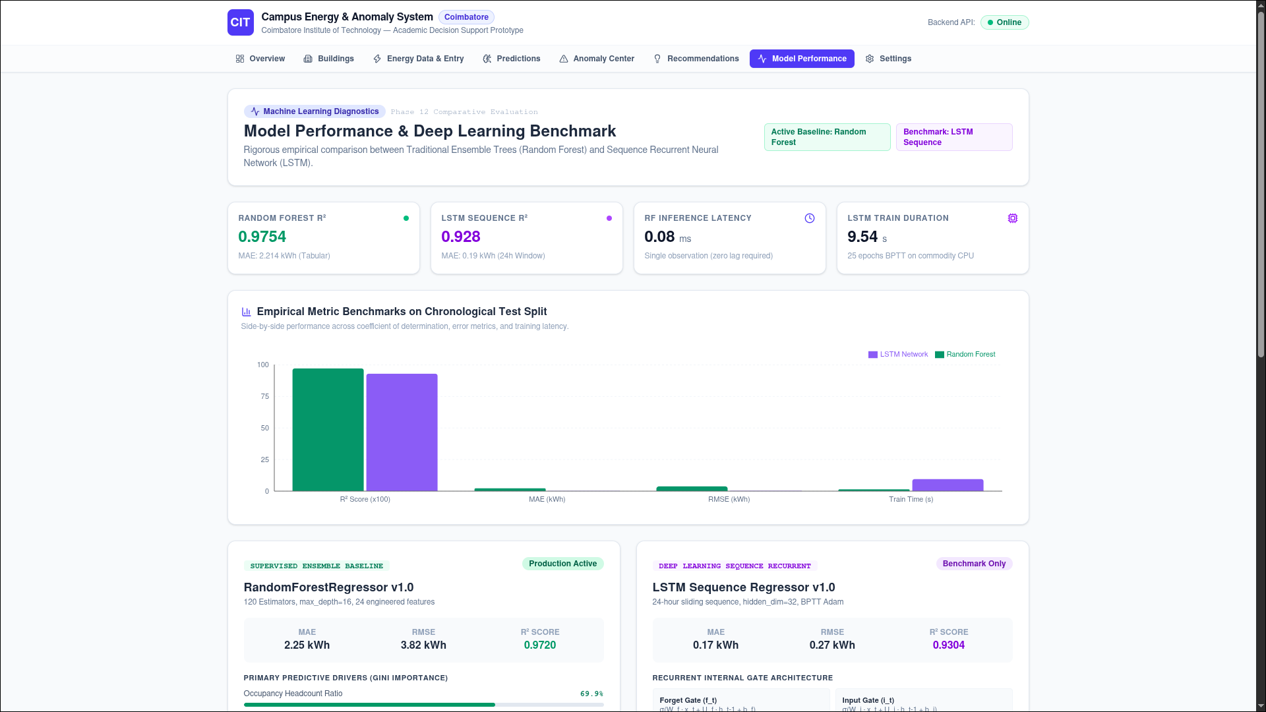

Figure 8. System settings for warning and critical anomaly thresholds.
