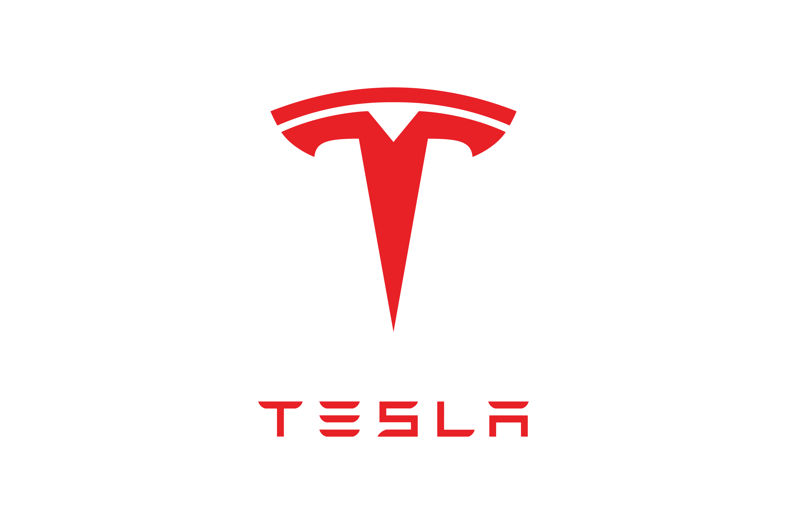

**INDIA’S ELECTRIC VEHICLE EXPO 2022**

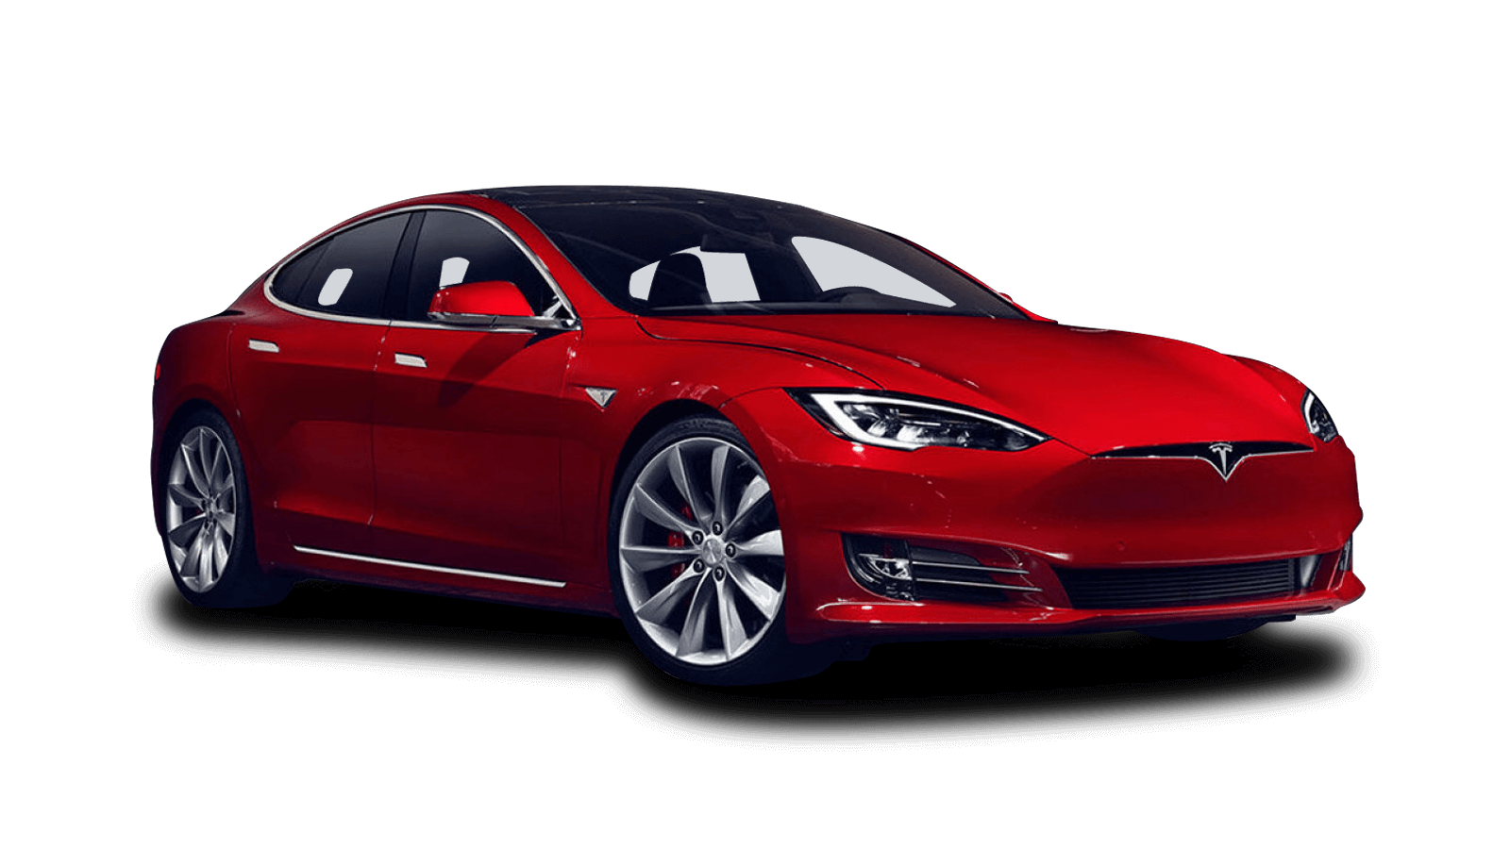

**THE FUTURE OF TRANSPORT IS HERE!**

**Sunday Jan 9th, 10am – 4pm**

**Delhi international exhibition centre** @ Tumkur Main Road, Madavara Post Dasanapura, Hobli, New Delhi, 110018

**Electric cars are really very cool**

India’s Premier EV Event

Test Ride electric bikes & cars

Tech Talks by industry experts

Charging infrastructure display

EV Show ‘N Shine Competition

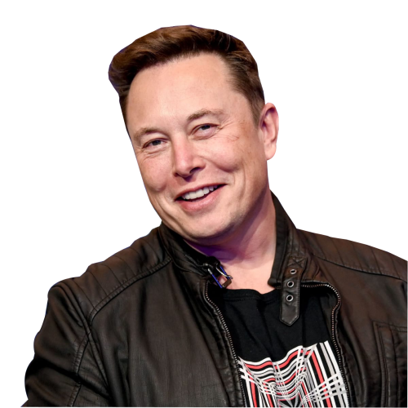

**100+ vehicles on show, a solution for every budget!**

**FREE ENTRY**