A Report on

**DBMS Project**

Submitted By

**Arjun Mehta (K036)**

**SAP ID:70102300018**

Under The Guidance Of

**Ma’am Bhavna Bose**



**Mukesh Patel School of Technology & Management Engineering**

**Department of B.Tech CSE (Cybersecurity)**

**Vile Parle (w), Mumbai- 400056**

**TABLE OF CONTENTS:**

|  |  |  |
| --- | --- | --- |
| **Chapter** | **Title** | **Page No** |
| 1 | Problem Statement | 3 |
| 2 | ER Diagram | 4 |
| 3 | ER Diagram to Schema | 5 |
| 4 | Deliverables | 6 |
| 5 | Functional Dependencies | 7 |
| 6 | Normalisation | 8 |
| 7 | Creation of Tables | 9-14 |
| 8 | Inserting Values in Tables | 15-21 |
| 9 | Creating View of Each deliverable and displaying the values | 22-28 |
| 10 | Conclusion | 29 |

**Chapter-1: Problem Statement**

An e-commerce company wants to develop a comprehensive database to better manage its online store's operations. The company sells products like electronics, food items, and clothing. Each product has unique attributes. The database must track products, suppliers, orders, and customers efficiently.

**Requirements:**

1. **Product Management**
   * Each product is identified by a unique item_id and includes attributes like name, brand, price, and type_name.
   * Categories:
     1. **Electronics**: Has attributes for warranty and power usage.
     2. **Food**: Includes an expiry date.
     3. **Clothing**: Includes size, color, and material.
2. **Supplier Management**
   * Each supplier is identified by a unique supplier_id and includes name, phone number, etc.
   * Tracks products supplied by each supplier with attributes like quantity and status.
3. **Order Processing**
   * Orders are identified by order_id and include order date, total amount, etc.
   * Orders contain multiple products and are linked to customers.
4. **Customer Management**
   * Customers are identified by customer_id and include personal details like name, phone number, email, etc.

**Chapter-2:** **ER Diagram**

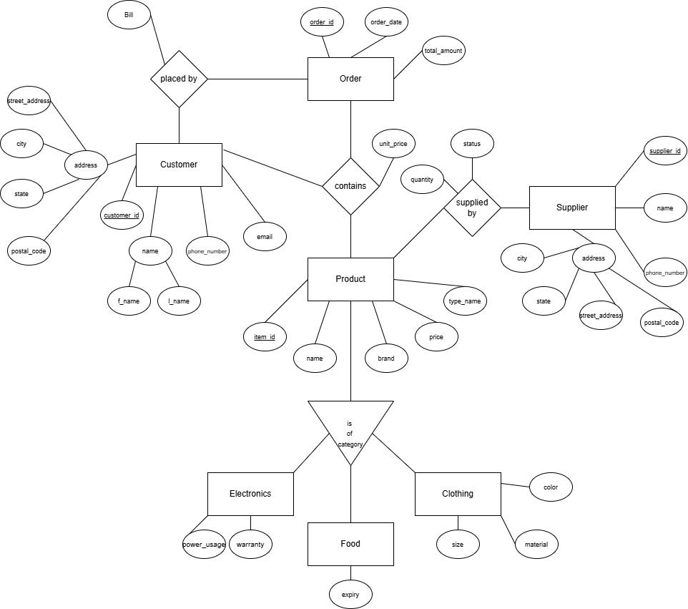

**Chapter-3: Er diagram to Schema**

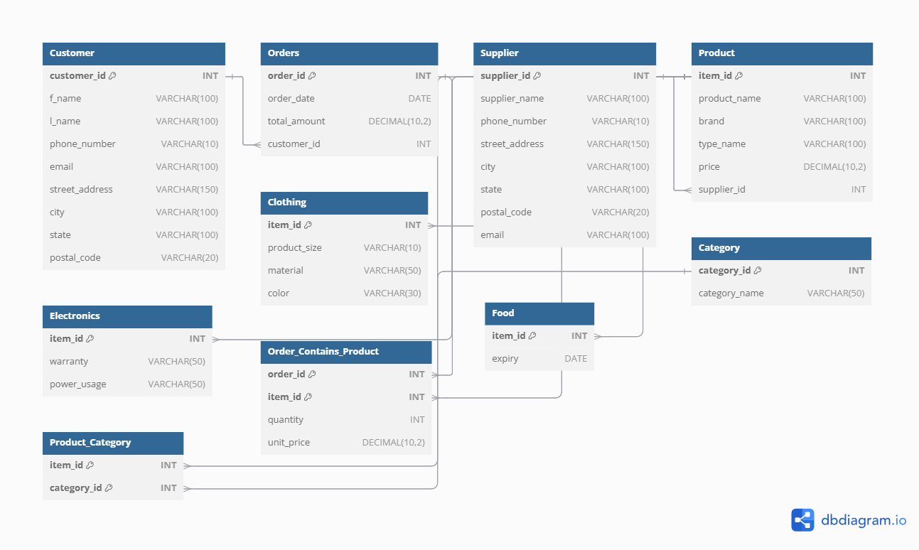

**Chapter-4: Deliverables**

* **Customer Demographics and Contact Information:**  
  Report on customer details like contact information and demographics for CRM.
* **Order and Sales Analysis:**  
  Report on orders, order dates, total amounts, and customer purchasing behavior.
* **Supplier Performance Report:**  
  Details on suppliers, including the products they supply, and their contact/location info.
* **Product Inventory and Category Insights:**  
  Breakdown of available products by category, including attributes like price, color, etc.
* **Revenue and Product Sales Tracking:**  
  Report tracking revenue by product and category for sales forecasting.

**Chapter-5: Functional Dependencies**

1. **Customer Table**  
   customer_id → f_name, l_name, phone_number, email, street_address, city, state, postal_code
2. **Orders Table**  
   order_id → order_date, total_amount, customer_id
3. **Supplier Table**  
   supplier_id → supplier_name, phone_number, street_address, city, state, postal_code, email
4. **Product Table**  
   item_id → product_name, brand, type_name, price, supplier_id
5. **Electronics Table**  
   item_id → warranty, power_usage
6. **Clothing Table**  
   item_id → product_size, material, color
7. **Food Table**  
   item_id → expiry
8. **Category Table**  
   category_id → category_name
9. **Product_Category Table**  
   (item_id, category_id) → item_id, category_id
10. **Order_Contains_Product Table**  
    (order_id, item_id) → quantity, unit_price

**Chapter-6: Normalization of the Database Schema**

**1NF (First Normal Form):**  
The schema is in 1NF as each table contains only atomic values, with no repeating groups or arrays. Every field contains indivisible values, ensuring compliance with the first normal form.

**2NF (Second Normal Form):**  
The schema adheres to 2NF. All non-primary key attributes are fully functionally dependent on the primary key. For example, in the Product table, attributes such as brand, type_name, and price depend solely on the item_id, the table's primary key.

**3NF (Third Normal Form):**  
The schema is in 3NF since there are no transitive dependencies. Non-key attributes depend only on the primary key and not on other non-key attributes. For instance, in the Customer table, fields like phone_number and email depend only on the customer_id.

**BCNF (Boyce-Codd Normal Form):**  
The schema satisfies BCNF, as every determinant is a candidate key. For example, in the Orders table, order_id determines all other attributes, and no anomalies exist with functional dependencies.

**4NF (Fourth Normal Form):**  
The schema is in 4NF as there are no multi-valued dependencies. Each table represents a single relationship, ensuring there are no redundancies or anomalies related to multiple independent attributes.

**5NF (Fifth Normal Form):**  
The schema complies with 5NF. It cannot be further decomposed without losing information or causing redundancy. All possible join dependencies are properly handled.

**Chapter-7: Table Creation**

CREATE TABLE Customer (

customer_id INT PRIMARY KEY,

f_name VARCHAR(100) NOT NULL,

l_name VARCHAR(100) NOT NULL,

phone_number VARCHAR(10) UNIQUE,

email VARCHAR(100) NOT NULL UNIQUE,

street_address VARCHAR(150) NOT NULL,

city VARCHAR(100) NOT NULL,

state VARCHAR(100) NOT NULL,

postal_code VARCHAR(20) NOT NULL

);

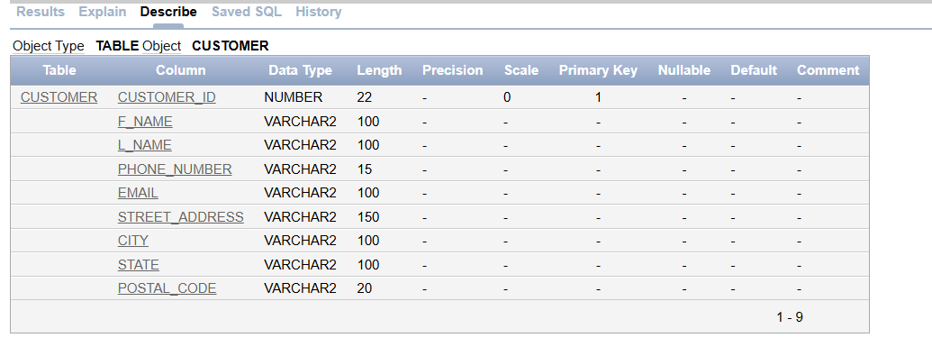

CREATE TABLE Orders (

order_id INT PRIMARY KEY,

order_date DATE NOT NULL,

total_amount DECIMAL(10, 2) NOT NULL,

customer_id INT CONSTRAINT FK_Orders_Customer REFERENCES Customer(customer_id)

NOT NULL

);

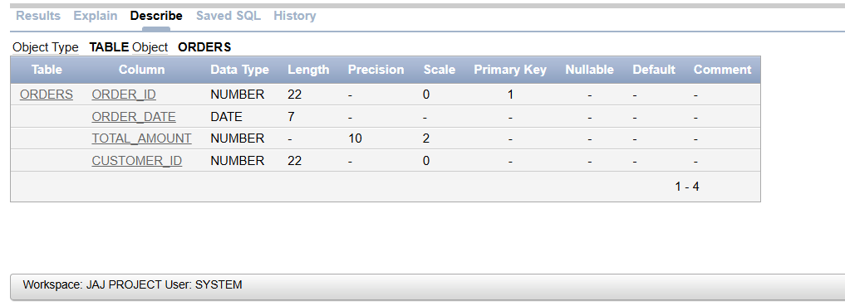

CREATE TABLE Supplier (

supplier_id INT PRIMARY KEY,

supplier_name VARCHAR(100) NOT NULL,

phone_number VARCHAR(10) UNIQUE,

street_address VARCHAR(150) NOT NULL,

city VARCHAR(100) NOT NULL,

state VARCHAR(100) NOT NULL,

postal_code VARCHAR(20) NOT NULL,

email VARCHAR(100) NOT NULL UNIQUE

);

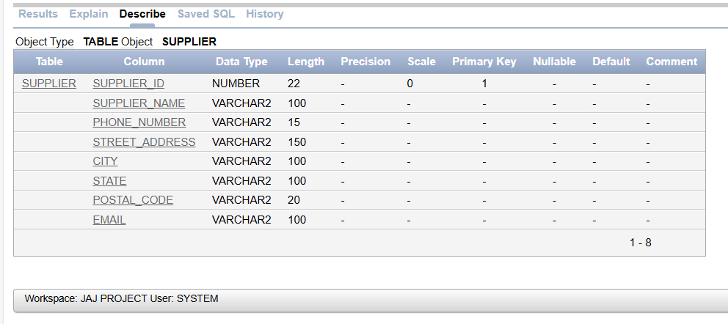

CREATE TABLE Product (

item_id INT PRIMARY KEY,

product_name VARCHAR(100) NOT NULL,

brand VARCHAR(100) NOT NULL,

type_name VARCHAR(100) NOT NULL,

price DECIMAL(10, 2) NOT NULL,

supplier_id INT CONSTRAINT FK_Product_Supplier REFERENCES Supplier(supplier_id)

NOT NULL

);

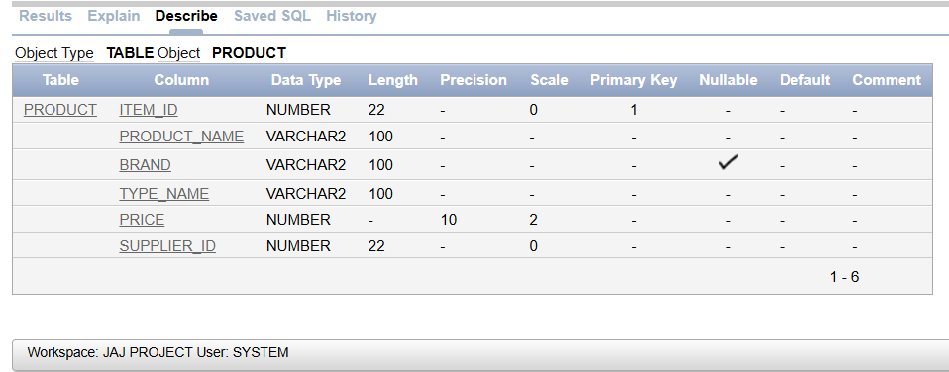

CREATE TABLE Electronics (

item_id INT NOT NULL CONSTRAINT FK_Electronics_Product REFERENCES Product(item_id),

warranty VARCHAR(50) NOT NULL,

power_usage VARCHAR(50) NOT NULL,

PRIMARY KEY(item_id)

);

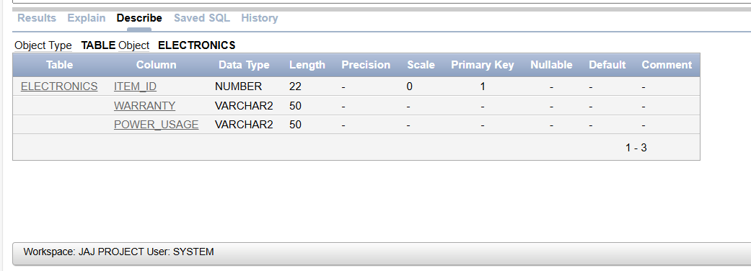

CREATE TABLE Clothing (

item_id INT NOT NULL CONSTRAINT FK_Clothing_Product REFERENCES Product(item_id),

product_size VARCHAR(10) NOT NULL,

material VARCHAR(50) NOT NULL,

color VARCHAR(30) NOT NULL,

PRIMARY KEY (item_id)

);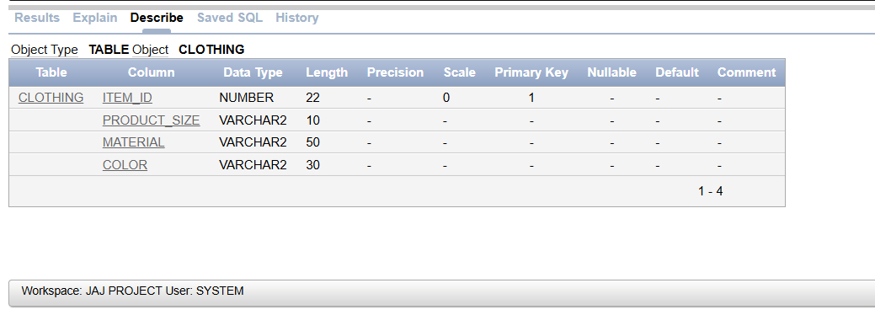

CREATE TABLE Food (

item_id INT NOT NULL CONSTRAINT FK_Food_Product REFERENCES Product(item_id),

expiry DATE NOT NULL,

PRIMARY KEY (item_id)

);

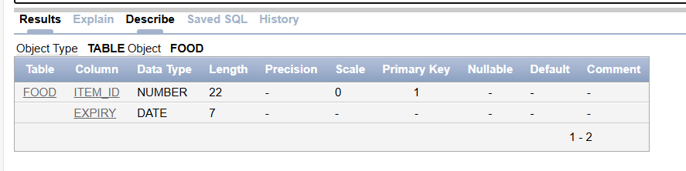

CREATE TABLE Category (

category_id INT PRIMARY KEY,

category_name VARCHAR(50) NOT NULL UNIQUE

);

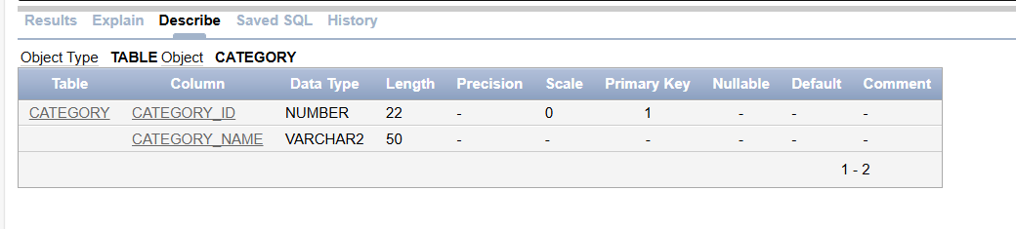

CREATE TABLE Product_Category (

item_id INT NOT NULL CONSTRAINT FK_Product_Category_Product FOREIGN KEY REFERENCES Product(item_id),

category_id INT NOT NULL CONSTRAINT FK_Product_Category_Category FOREIGN KEY REFERENCES Category(category_id),

PRIMARY KEY (item_id, category_id)

);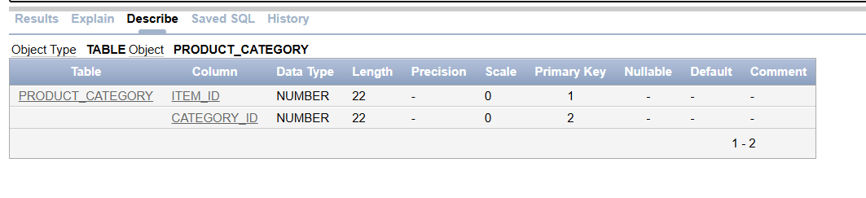CREATE TABLE Order_Contains_Product (

order_id INT NOT NULL CONSTRAINT FK_Order_Contains_Product_Order FOREIGN KEY REFERENCES Orders(order_id),

item_id INT NOT NULL CONSTRAINT FK_Order_Contains_Product_Product FOREIGN KEY REFERENCES Product(item_id),

quantity INT NOT NULL CHECK (quantity > 0),

unit_price DECIMAL(10, 2) NOT NULL,

PRIMARY KEY (order_id, item_id)

);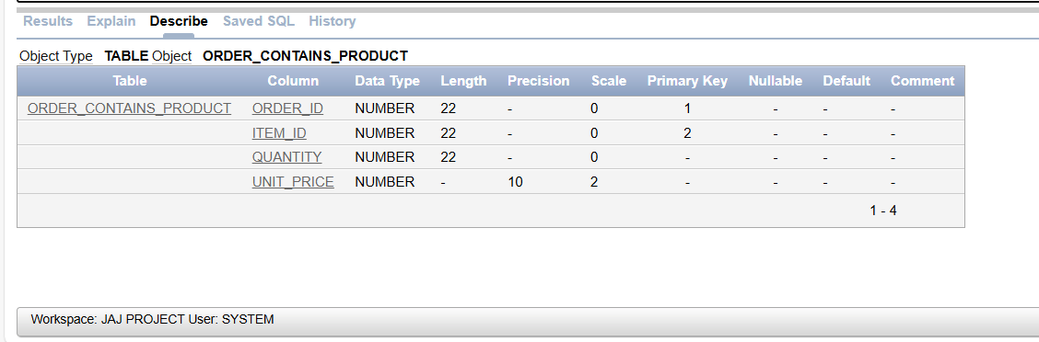

**Chapter-8: Inserting Values**

1.) Inserting values in the Customer table:

CODE:

INSERT INTO CUSTOMER VALUES ('1', 'Raj', 'Kumar', '9876543210', 'raj.kumar@example.com', '1234 Elm St', 'Mumbai', 'Maharashtra', '400001');

INSERT INTO CUSTOMER VALUES ('2', 'Priya', 'Sharma', '8765432109', 'priya.sharma@example.com', '5678 Oak St', 'Delhi', 'Delhi', '110001');

INSERT INTO CUSTOMER VALUES ('3', 'Amit', 'Patel', '7654321098', 'amit.patel@example.com', '9101 Maple St', 'Bangalore', 'Karnataka', '560001');

INSERT INTO CUSTOMER VALUES ('4', 'Sita', 'Verma', '6543210987', 'sita.verma@example.com', '2345 Pine St', 'Chennai', 'Tamil Nadu', '600001');

INSERT INTO CUSTOMER VALUES ('5', 'Vikram', 'Singh', '5432109876', 'vikram.singh@example.com', '6789 Cedar St', 'Hyderabad', 'Telangana', '500001');

INSERT INTO CUSTOMER VALUES ('6', 'Neha', 'Iyer', '4321098765', 'neha.iyer@example.com', '1357 Birch St', 'Pune', 'Maharashtra', '411001');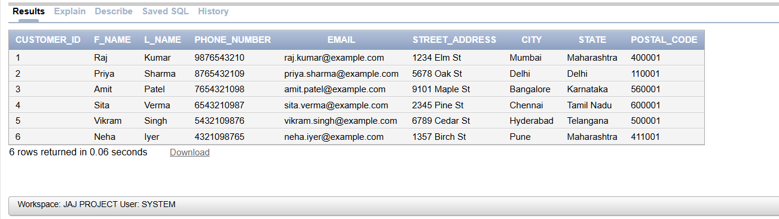

2.) Inserting Values in the Orders Table:

CODE:

INSERT INTO ORDERS VALUES ('1', TO_DATE('01/10/2024', 'MM/DD/YYYY'), '141000', '1');

INSERT INTO ORDERS VALUES ('2', TO_DATE('06/15/2024', 'MM/DD/YYYY'), '13500', '2');

INSERT INTO ORDERS VALUES ('3', TO_DATE('10/05/2024', 'MM/DD/YYYY'), '24000', '1');

INSERT INTO ORDERS VALUES ('4', TO_DATE('01/10/2024', 'MM/DD/YYYY'), '176000', '3');

INSERT INTO ORDERS VALUES ('5', TO_DATE('09/15/2024', 'MM/DD/YYYY'), '61204', '2');

INSERT INTO ORDERS VALUES ('6', TO_DATE('10/20/2024', 'MM/DD/YYYY'), '2500', '4');

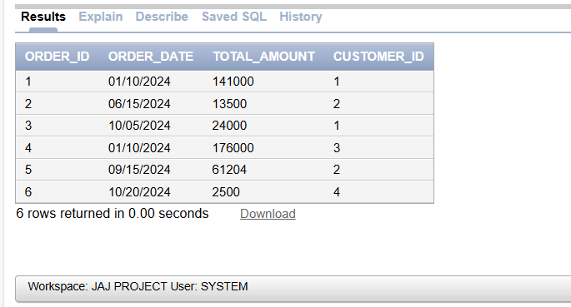

3.) Inserting Values in Supplier table:

CODE:

INSERT INTO SUPPLIER VALUES ('1', 'ABC Electronics', '9988776655', '4567 Tech Ave', 'Mumbai', 'Maharashtra', '400002', 'contact@abcelectronics.com');

INSERT INTO SUPPLIER VALUES ('2', 'Fashion Hub', '8899776655', '7890 Fashion St', 'Delhi', 'Delhi', '110002', 'support@fashionhub.com');

INSERT INTO SUPPLIER VALUES ('3', 'Fresh Foods', '7788996655', '123 Food St', 'Bangalore', 'Karnataka', '560002', 'info@freshfoods.com');

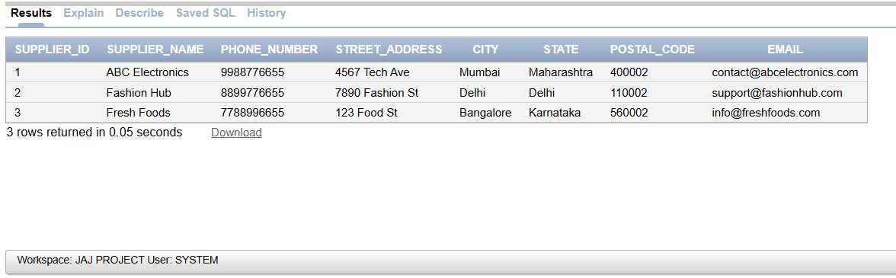

4.) Inserting Values in Product Table:

CODE:

INSERT INTO PRODUCT VALUES (1, 'Laptop', 'Brand A', 'Electronics', 45000, 1);

INSERT INTO PRODUCT VALUES (2, 'T-shirt', 'Brand B', 'Clothing', 500, 2);

INSERT INTO PRODUCT VALUES (3, 'Smartphone', 'Brand A', 'Electronics', 30000, 1);

INSERT INTO PRODUCT VALUES (4, 'Jeans', 'Brand C', 'Clothing', 1200, 2);

INSERT INTO PRODUCT VALUES (5, 'Apple', 'Fresh', 'Food', 100, 3);

INSERT INTO PRODUCT VALUES (6, 'Orange', 'Fresh', 'Food', 80, 3);

INSERT INTO PRODUCT VALUES (7, 'Blender', 'Brand D', 'Electronics', 2000, 1);

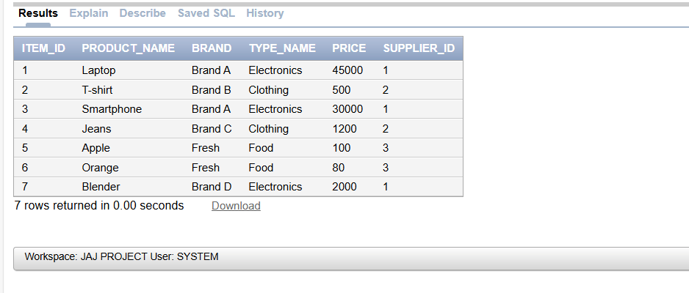

5.) Inserting Values in Electronics Table:

CODE:

INSERT INTO ELECTRONICS VALUES (1, '1 Year', 50);

INSERT INTO ELECTRONICS VALUES (3, '2 Years', 20);

INSERT INTO ELECTRONICS VALUES (7, '1 Year', 150);

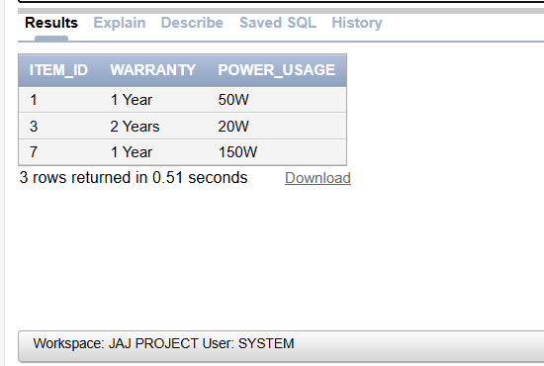

6.) Inserting Values in Clothing Table:

CODE:

INSERT INTO CLOTHING VALUES (2, 'M', 'Cotton', 'Blue');

INSERT INTO CLOTHING VALUES (4, 'L', 'Denim', 'Black');

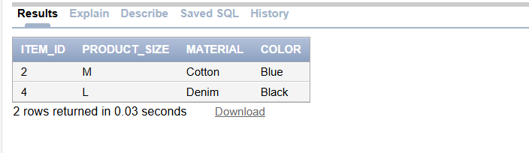

7.) Inserting Values in Food Table:

CODE:

INSERT INTO FOOD VALUES (5, '12/01/2024');

INSERT INTO FOOD VALUES (6, '11/15/2024');

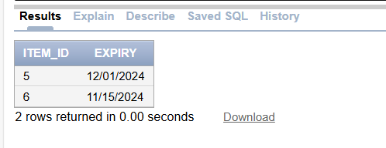

8.) Inserting Values Category Table:

CODE:

INSERT INTO CATEGORY VALUES (2, 'Clothing');

INSERT INTO CATEGORY VALUES (1, 'Electronics');

INSERT INTO CATEGORY VALUES (3, 'Food');

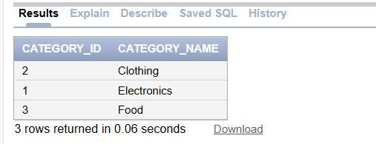

9.) Inserting Values in Product_Category Table:

CODE:

INSERT INTO PRODUCT_CATEGORY VALUES (1, 1);

INSERT INTO PRODUCT_CATEGORY VALUES (2, 2);

INSERT INTO PRODUCT_CATEGORY VALUES (3, 1);

INSERT INTO PRODUCT_CATEGORY VALUES (4, 2);

INSERT INTO PRODUCT_CATEGORY VALUES (5, 3);

INSERT INTO PRODUCT_CATEGORY VALUES (6, 3);

INSERT INTO PRODUCT_CATEGORY VALUES (7, 1);

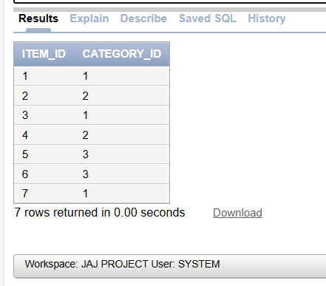

10.) Inserting Values in order_contains_product Table:

CODE:

INSERT INTO ORDER_CONTAINS_PRODUCT VALUES (1, 1, 2, 52000);

INSERT INTO ORDER_CONTAINS_PRODUCT VALUES (1, 2, 1, 32000);

INSERT INTO ORDER_CONTAINS_PRODUCT VALUES (2, 5, 15, 100);

INSERT INTO ORDER_CONTAINS_PRODUCT VALUES (3, 4, 10, 1800);

INSERT INTO ORDER_CONTAINS_PRODUCT VALUES (4, 2, 5, 35000);

INSERT INTO ORDER_CONTAINS_PRODUCT VALUES (5, 6, 8, 150.5);

INSERT INTO ORDER_CONTAINS_PRODUCT VALUES (6, 7, 1, 2500);

INSERT INTO ORDER_CONTAINS_PRODUCT VALUES (1, 3, 5, 1000);

INSERT INTO ORDER_CONTAINS_PRODUCT VALUES (2, 4, 3, 4000);

INSERT INTO ORDER_CONTAINS_PRODUCT VALUES (3, 5, 20, 300);

INSERT INTO ORDER_CONTAINS_PRODUCT VALUES (4, 6, 10, 100);

INSERT INTO ORDER_CONTAINS_PRODUCT VALUES (5, 1, 1, 60000);

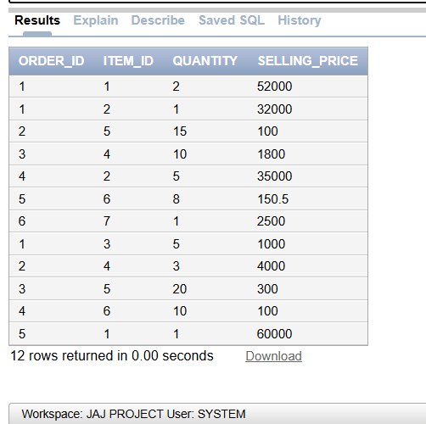

**Chapter-9: Creating View for Each deliverable**

1. Retrieve all customers whose last name ends with 'ar' and whose phone number starts with '98'.

CODE:

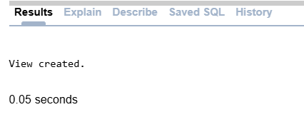CREATE VIEW nameendsar AS

SELECT * FROM Customer

WHERE l_name LIKE '%ar'

AND phone_number LIKE '98%';

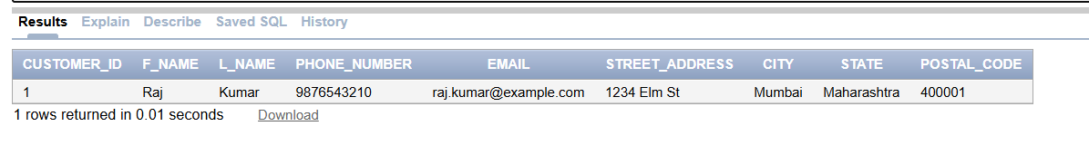

1. Retrieve all customers whose email contains 'example' and live in 'Mumbai' or 'Delhi'.

CODE:

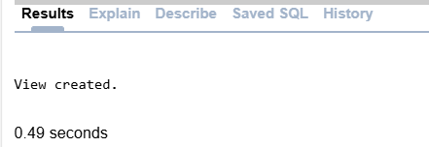CREATE VIEW emailcity AS

SELECT * FROM Customer

WHERE email LIKE '%example%'

AND (city = 'Mumbai' OR city = 'Delhi');

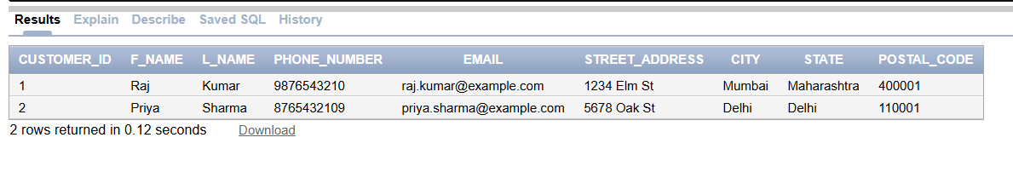

1. Find the top 3 customers based on their total purchase amount.

CODE:

CREATE VIEW Top3CustomersBySpending AS

SELECT c.customer_id, c.f_name, c.l_name, SUM(o.total_amount) AS total_spent

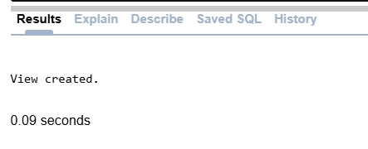FROM Orders o

JOIN Customer c ON o.customer_id = c.customer_id

GROUP BY c.customer_id, c.f_name, c.l_name

ORDER BY total_spent DESC

FETCH FIRST 3 ROWS ONLY;

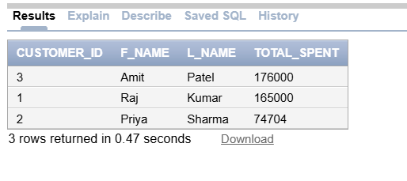

1. Retrieve the total sales amount for each order, along with the order date and customer details..

CODE:

CREATE VIEW OrderCustomerDetails AS

SELECT o.order_id, o.order_date, o.total_amount, c.f_name, c.l_name, c.city, c.state

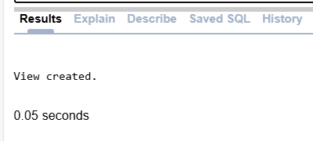FROM Orders o

JOIN Customer c ON o.customer_id = c.customer_id;

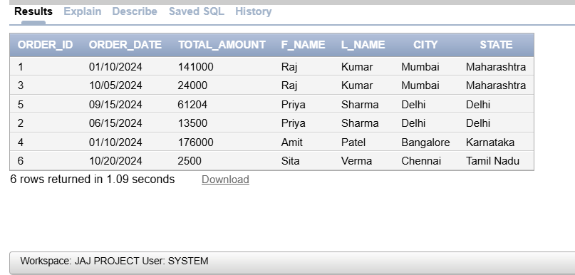

1. Find the number of products supplied by each supplier.

CODE:

CREATE VIEW Productsupplies AS

SELECT s.supplier_name, COUNT(p.item_id) AS product_count

FROM Supplier s

JOIN Product p ON s.supplier_id = p.supplier_id

GROUP BY s.supplier_name

ORDER BY product_count DESC;

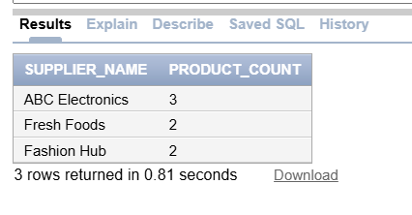

1. List all products by category, including their price and supplier.

CODE:

CREATE VIEW Categorypricesupplier AS

SELECT c.category_name, p.product_name, p.price, s.supplier_name

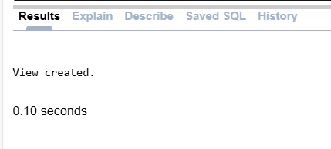FROM Product p

JOIN Product_Category pc ON p.item_id = pc.item_id

JOIN Category c ON pc.category_id = c.category_id

JOIN Supplier s ON p.supplier_id = s.supplier_id

ORDER BY c.category_name;

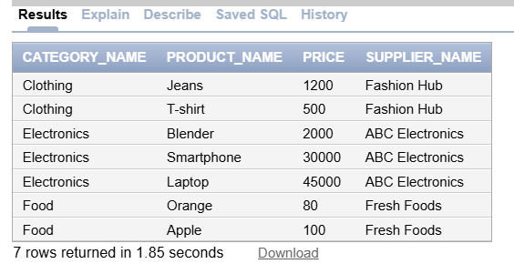

1. Find the average price of products in each category.

CODE:

CREATE VIEW AveragePriceofproduct AS

SELECT c.category_name, AVG(p.price) AS avg_price

FROM Product p

JOIN Product_Category pc ON p.item_id = pc.item_id

JOIN Category c ON pc.category_id = c.category_id

WHERE c.category_name IN ('Clothing', 'Food')

GROUP BY c.category_name

ORDER BY avg_price DESC;

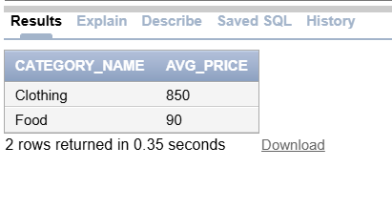

1. Calculate the total revenue generated from each product category.

CODE:

CREATE VIEW Revenueofeachproduct AS

SELECT c.category_name, SUM(op.quantity * p.price) AS total_revenue

FROM Order_Contains_Product op

JOIN Product p ON op.item_id = p.item_id

JOIN Product_Category pc ON op.item_id = pc.item_id

JOIN Category c ON pc.category_id = c.category_id

GROUP BY c.category_name

ORDER BY total_revenue DESC;

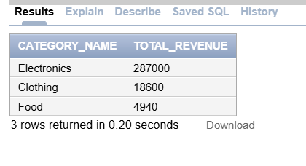

1. Find the 3 most frequently ordered products (by total quantity ordered).

CODE:

CREATE VIEW threemostordereditems AS

SELECT p.product_name, SUM(op.quantity) AS total_quantity_ordered

FROM Order_Contains_Product op

JOIN Product p ON op.item_id = p.item_id

GROUP BY p.product_name

ORDER BY total_quantity_ordered DESC

FETCH FIRST 3 ROWS ONLY;

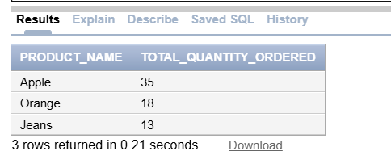

1. Retrieve all orders placed on date 15 and the associated customer details, and order them by the total amount in descending order.

CODE:

CREATE VIEW Orderon15 AS

SELECT o.order_id, o.order_date, o.total_amount, c.f_name, c.l_name

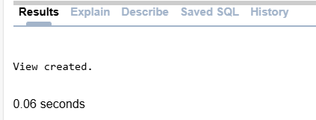FROM Orders o

INNER JOIN Customer c ON o.customer_id = c.customer_id

WHERE EXTRACT(DAY FROM o.order_date) = 15

ORDER BY o.total_amount DESC;

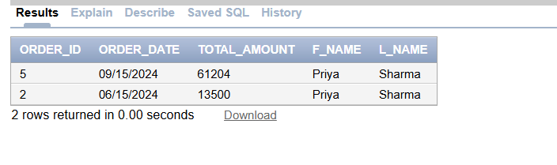

1. Retrieve all clothing items that are blue in color and made of cotton, along with the product name.

CODE:

CREATE VIEW clothlbluecotton AS

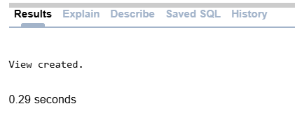SELECT p.product_name, cl.product_size, cl.material, cl.color

FROM Clothing cl

INNER JOIN Product p ON cl.item_id = p.item_id

WHERE cl.color = 'Blue'

AND cl.material = 'Cotton';

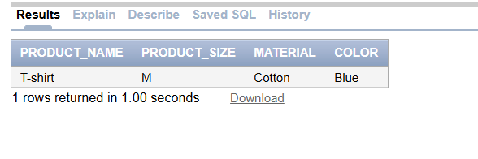

**Chapter-10: Conclusion**

In conclusion, this database management project effectively fulfils the e-commerce company’s requirements by establishing a structured and efficient database for managing products, orders, customers, and suppliers. The project began with a comprehensive ER diagram that captured essential relationships, followed by a relational schema translated into an optimized database structure. Through normalization to the Fifth Normal Form (5NF), data redundancy and anomalies were minimized, ensuring data integrity across all tables. Functional dependencies were thoroughly examined to uphold normalization standards, strengthening the consistency and reliability of the database. Additionally, tailored SQL queries provide valuable insights into customer demographics, purchasing trends, inventory details, and supplier performance, supporting the company in data-driven decision-making. This well-rounded database solution enables streamlined operations and enhances the company’s ability to maintain high standards in customer satisfaction and operational efficiency.