Experiment – 5
Dashboard
Building an Analytics Dashboard in Zoho Creator
Department of Computer Science and Engineering
Student Name: Arjunraj M
Roll No: 240701049
Application Name: College Library Management System

Objective
To design and configure a Dashboard page in Zoho Creator for the College Library Management System, using Panel, Chart, and Report elements to present summary figures, a fine-analysis chart, a member-wise distribution chart, and the underlying transaction records on a single page.

Introduction
A Dashboard in Zoho Creator is a separate page, built with the built-in Dashboard Builder, that combines multiple visual elements — panels, charts, gauges, and embedded reports — drawn from one or more forms. Each element is dragged onto the canvas and configured independently, without writing code, so that key figures and trends can be viewed at a glance instead of opening each report separately.

Dashboard Elements Used
Element | Configuration | Purpose
Panel (summary tile) | Display data: Sum, Form: Issue Transaction, Field: Fine Amount | Shows the Total Fine Amount as a single aggregated figure
Panel (summary tile group) | Four tiles: Total Fine Amounts, and three further aggregate totals | Quick-glance totals shown at the top of the dashboard
Chart (bar) | Form: Issue Transaction, X-axis: Member ID (label Member), Y-axis: Sum of Fine Amount | Visualises fine amount by member as a horizontal bar chart
Chart (bar) | X-axis: Member, Y-axis: Count of Member | Shows the distribution of issue transactions across members
Report (embedded) | Report: All Issue Transactions, Add/Edit/Delete/Duplicate actions shown, Search enabled | Displays the underlying transaction records below the charts
Panel (Fine Type / Quick Links) | Count aggregates for Lost, Overdue, Damages, Total; shortcut links to add records | Breaks down fines by type and gives one-click record creation
Table 5.1: Elements configured on the College Library Management System dashboard.

Screenshot-based lab record
The following pages contain the actual Zoho Creator screenshots of the Dashboard Builder configuration and the resulting live dashboard.

Screenshots 1 – Dashboard Builder – Layout
The Dashboard Builder canvas with the element palette on the left. A panel titled Distribution by Member was configured with a bar chart on Issue Transaction and an embedded All Issue Transactions report below it.
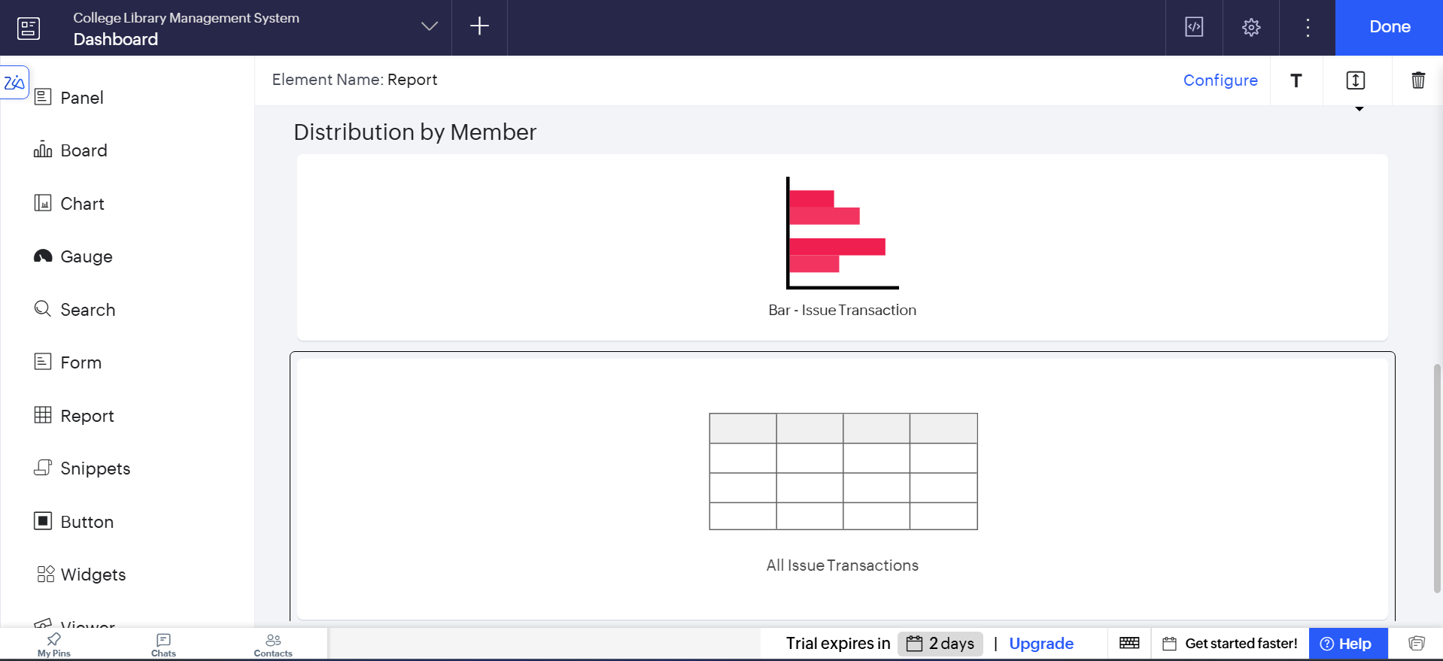
Figure 1.1: Dashboard Builder canvas showing the Distribution by Member panel with its bar chart and embedded report.

Screenshots 2 – Report Embed Configuration
The embedded report element was configured to use the All Issue Transactions report, with the Add, Edit, Delete, and Duplicate actions and the Search option kept visible so that records can be managed directly from the dashboard.
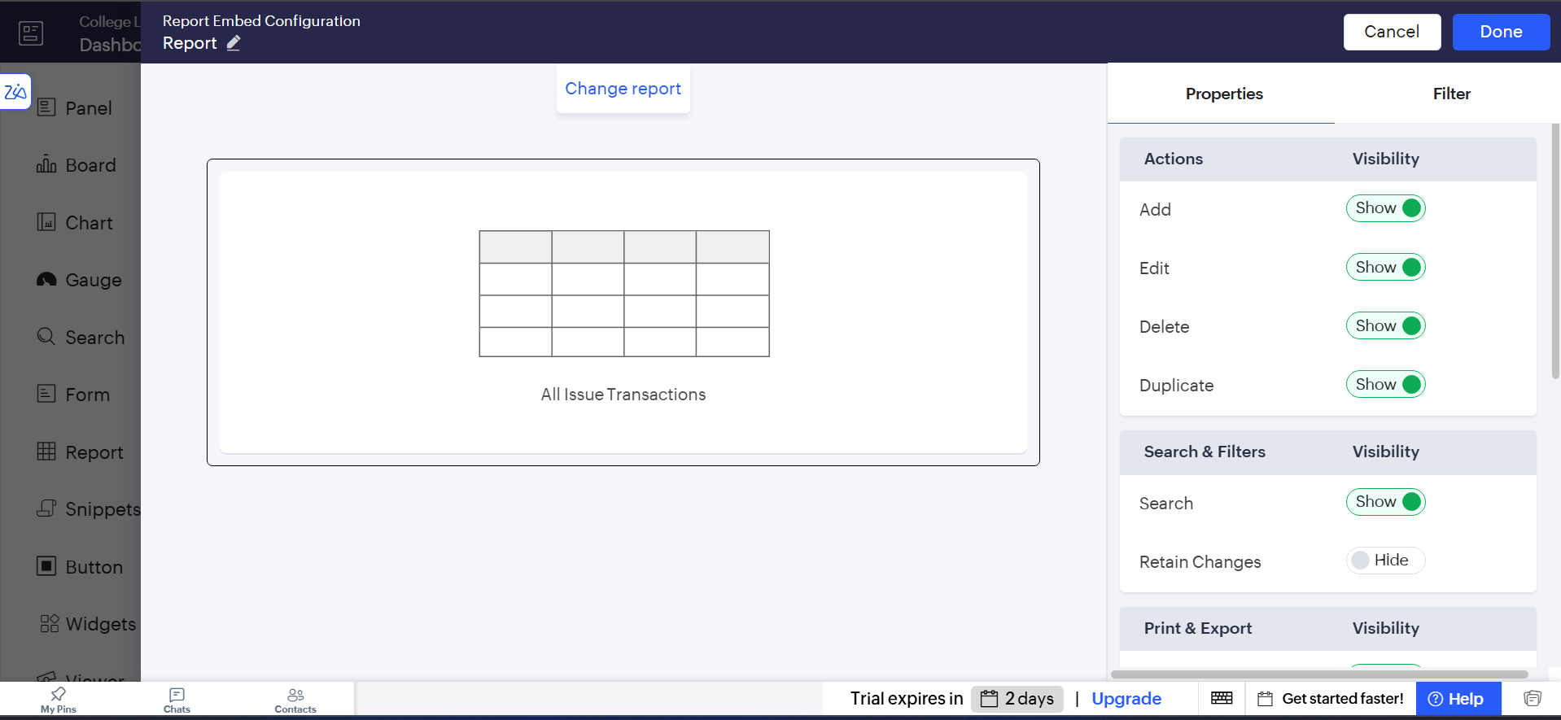
Figure 2: Report Embed Configuration for the All Issue Transactions report, showing action and search visibility settings.

Screenshots 3 – Chart Configuration
The bar chart was configured on the Issue Transaction form, with Member ID set as the X-axis category (labelled Member) and the Sum of Fine Amount set as the aggregated Y-axis value.
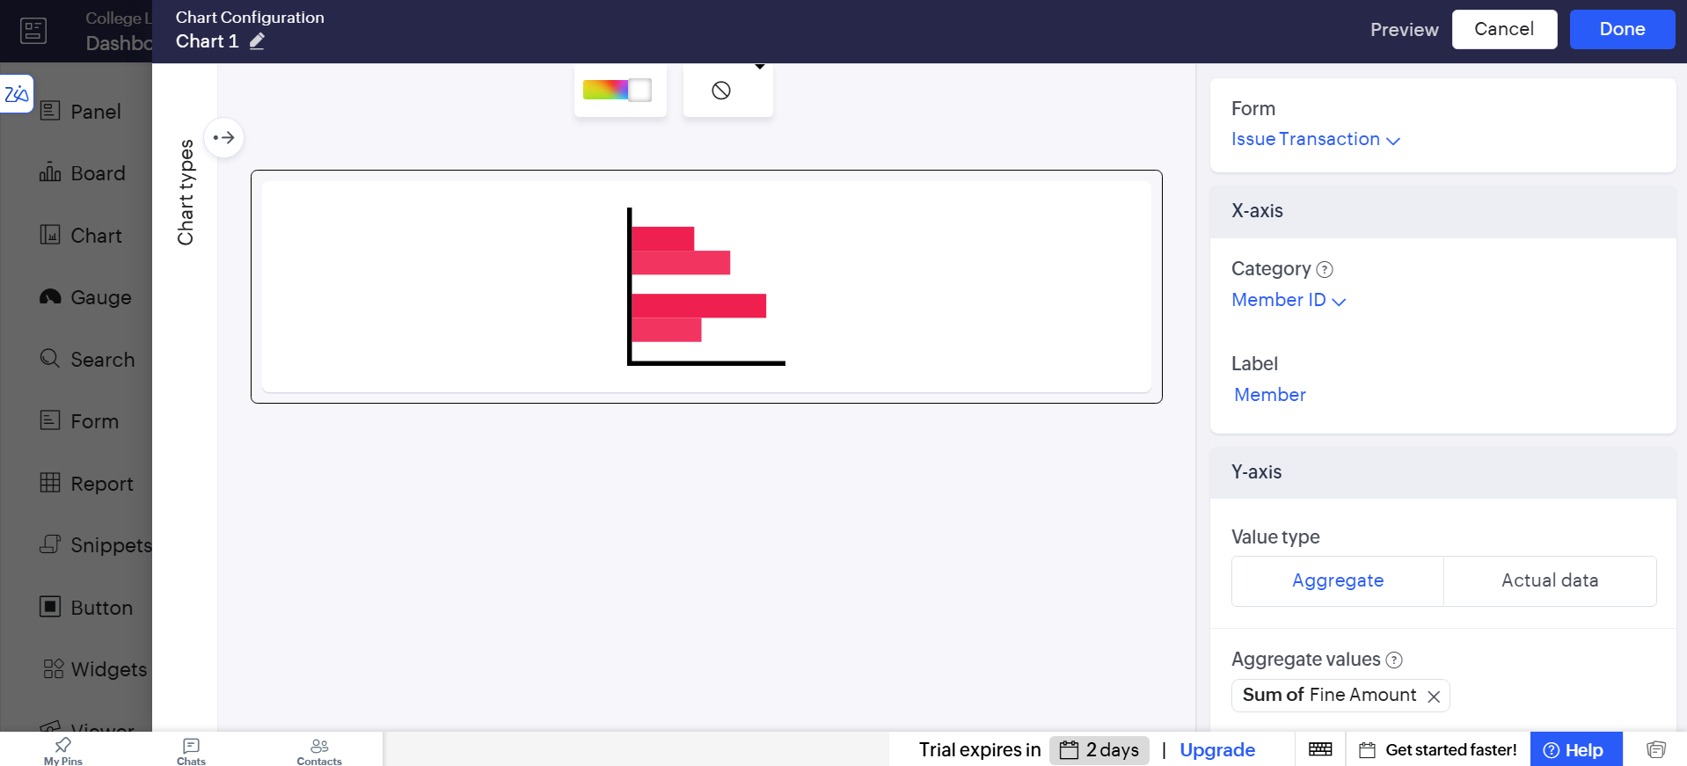
Figure 3: Chart Configuration — Issue Transaction form, X-axis Member ID, Y-axis Sum of Fine Amount.

Screenshots 4 – Panel Configuration
A summary panel was configured to display the Sum of the Fine Amount field from the Issue Transaction form as the Total Fine Amounts tile, with its display data, form, and field settings shown on the Display tab and its font and colour settings on the Style tab.
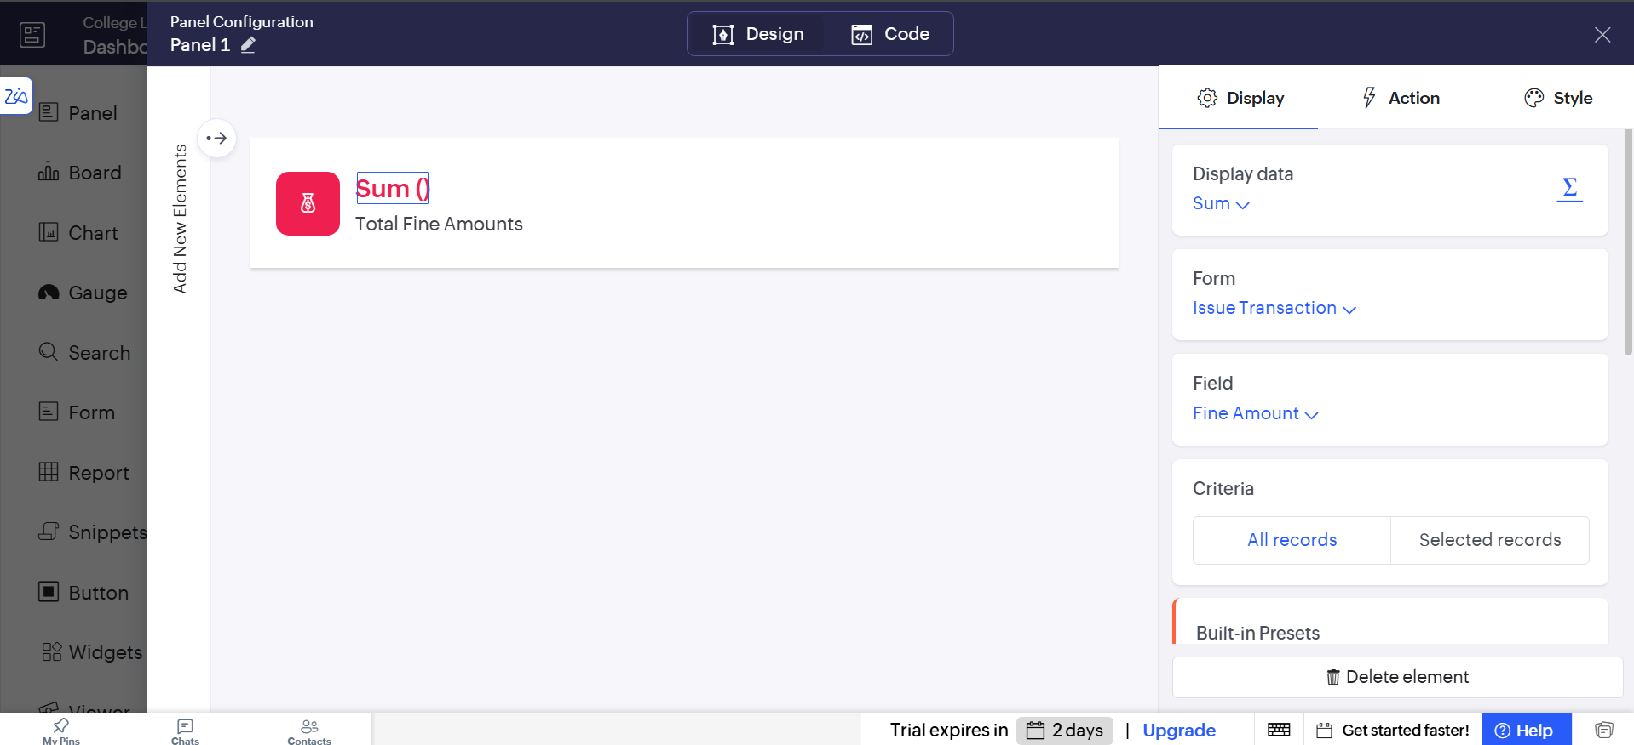
Figure 4.1: Panel Configuration — Display tab, showing Sum aggregate on the Fine Amount field of Issue Transaction.
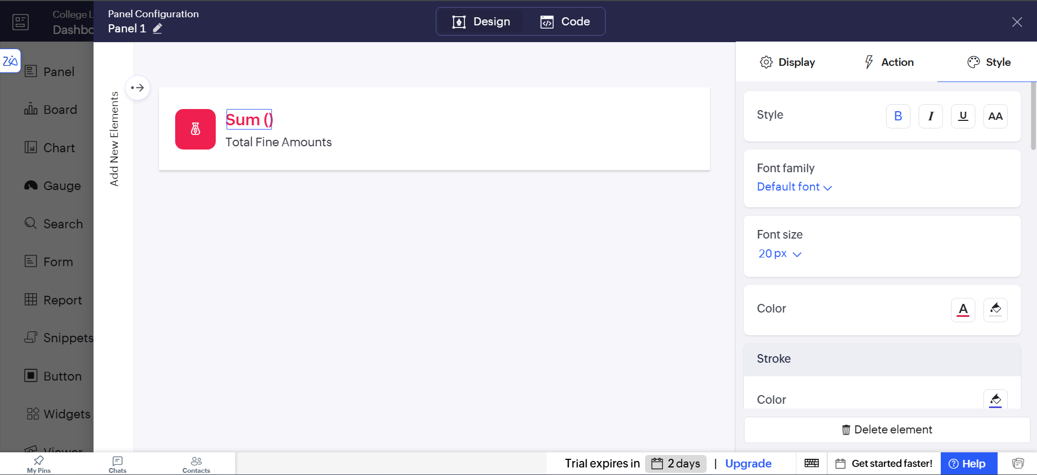
Figure 4.2: Panel Configuration — Style tab, showing font, colour, and stroke settings for the summary tile.
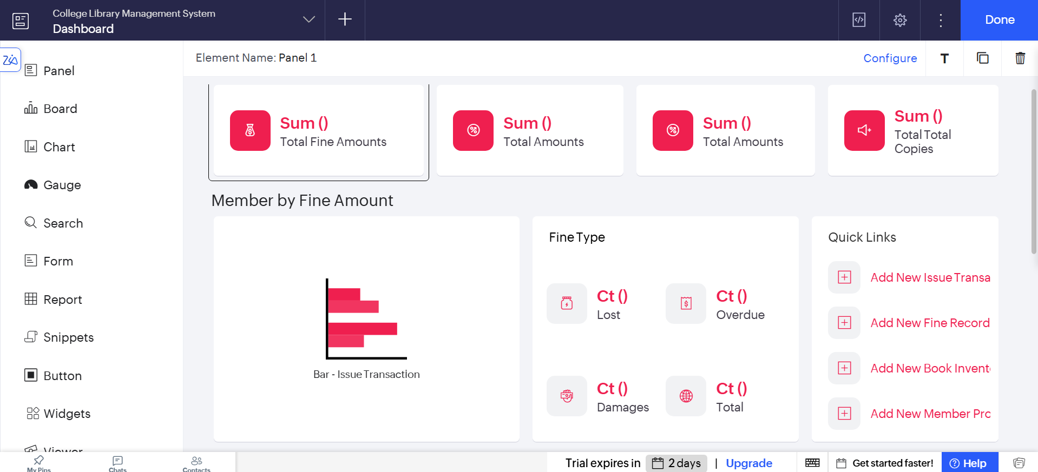
Figure 4.3: Complete summary panel with four aggregate tiles, the Member by Fine Amount chart, Fine Type counts, and Quick Links.

Screenshots 5 – Live Dashboard
The published dashboard, showing the summary tiles, the Member by Fine Amount chart, the Fine Type breakdown, the Quick Links panel, the Distribution by Member chart, and the embedded Issue Transactions report.
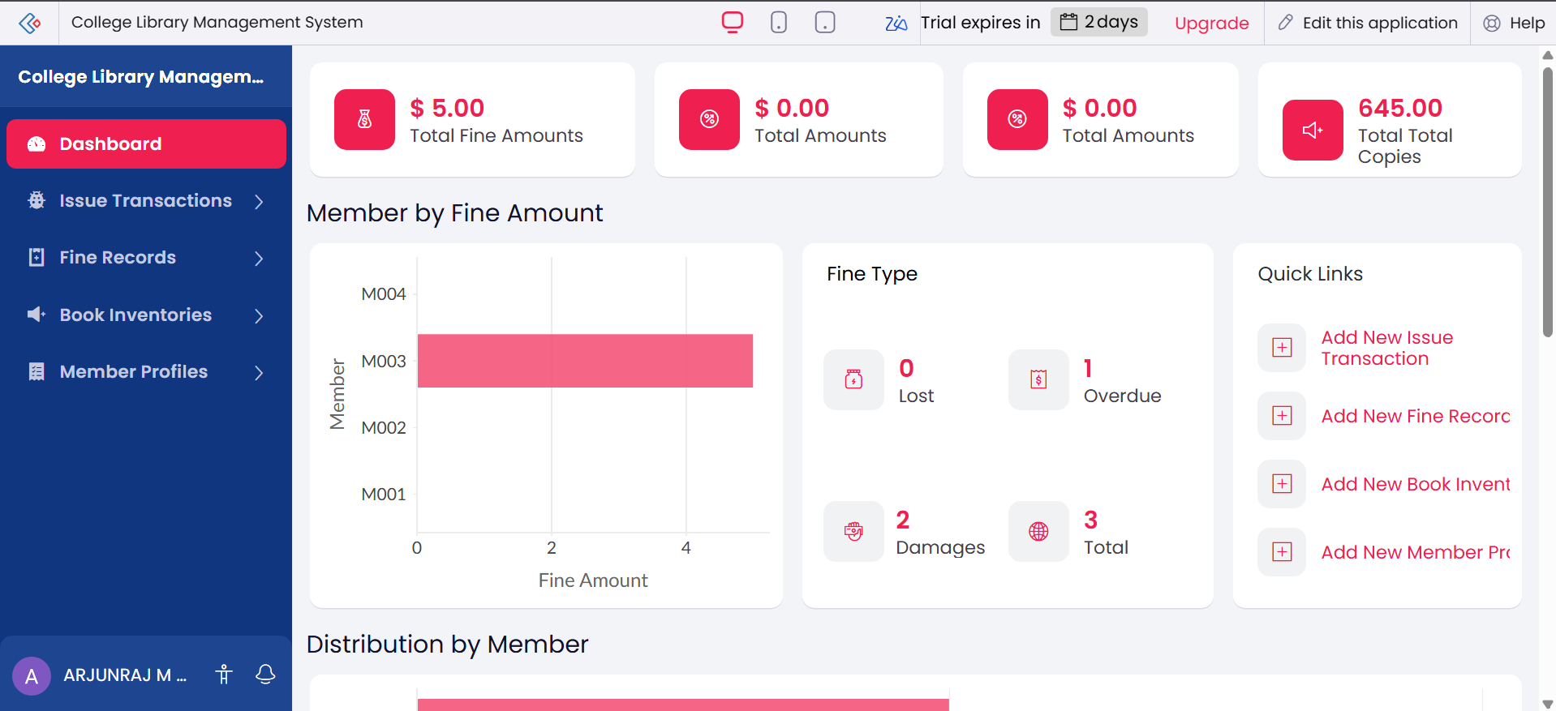
Figure 5.1: Live Dashboard — summary tiles (Total Fine Amounts, Total Amounts, Total Total Copies), Member by Fine Amount chart, Fine Type counts, and Quick Links.
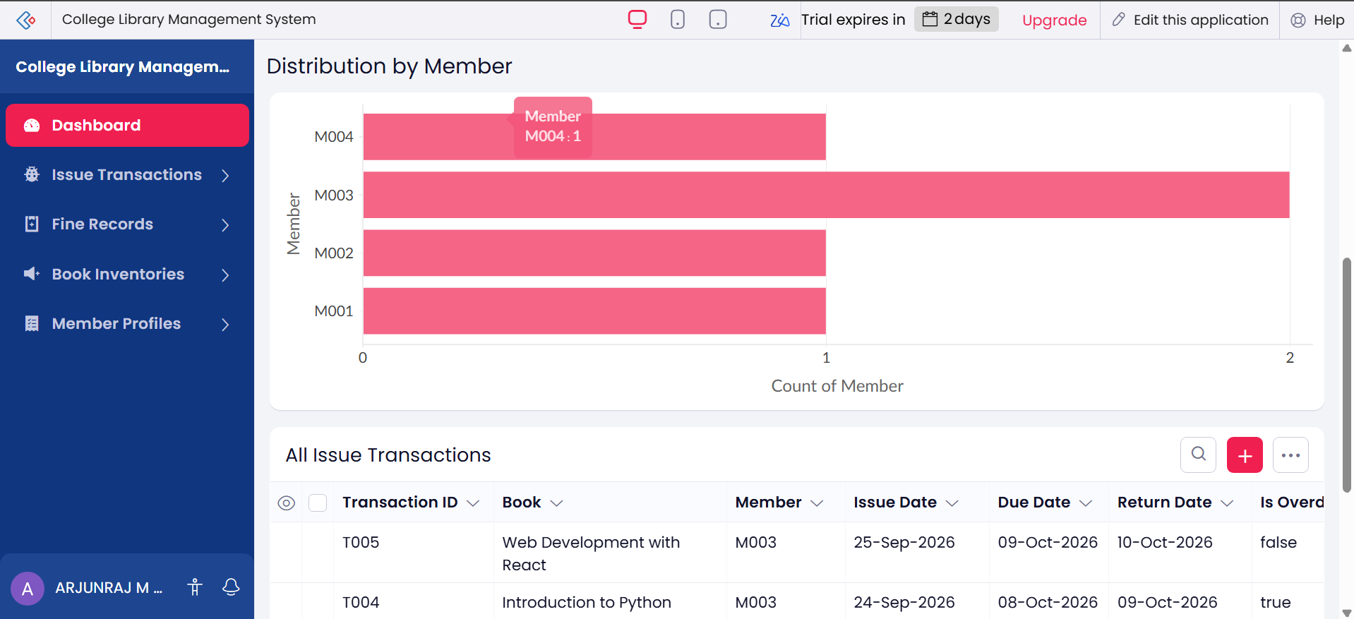
Figure 5.2: Live Dashboard — Distribution by Member chart with a tooltip showing Member M004: 1, above the All Issue Transactions report.
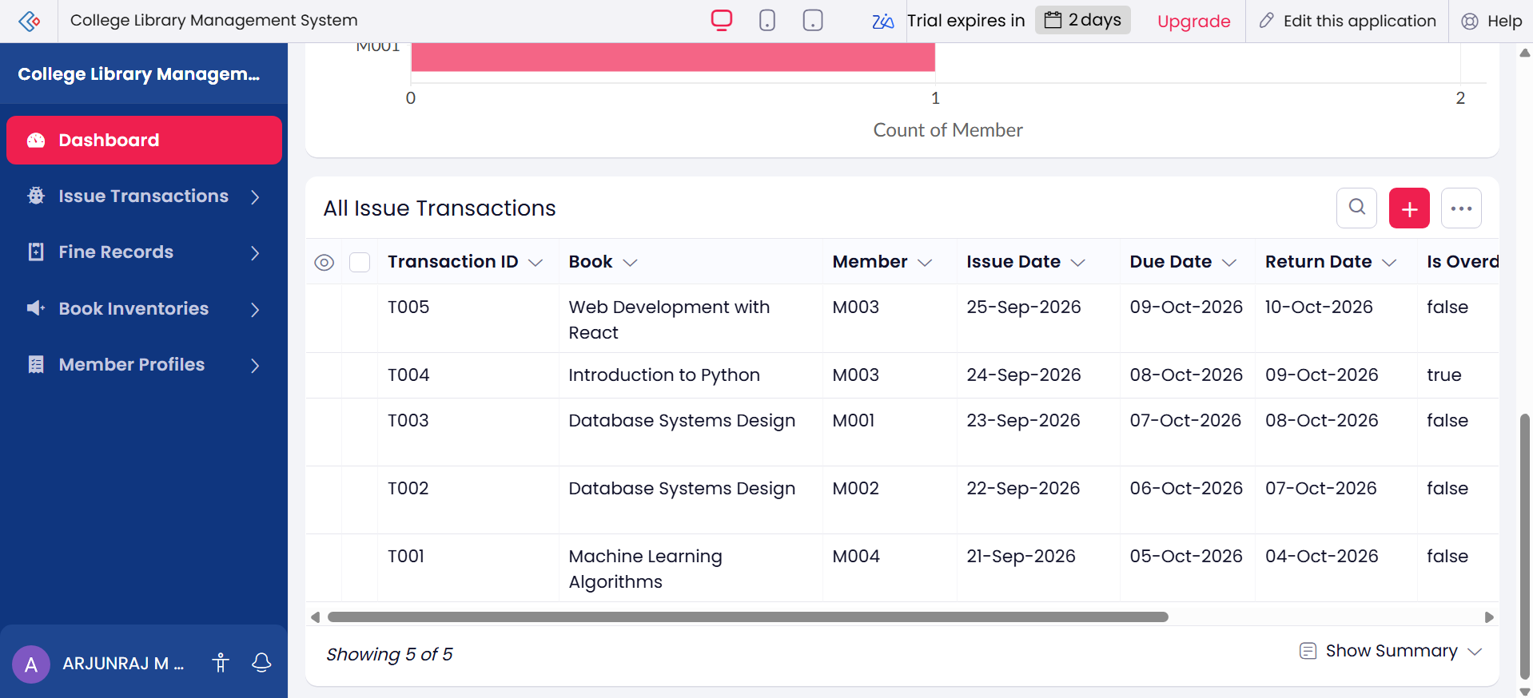
Figure 5.3: Live Dashboard — All Issue Transactions report embedded below the Distribution by Member chart, showing five transaction records.

Observation
The dashboard combined data from the Book Inventory, Member Profile, Issue Transaction, and Fine Record forms into a single page, using only pre-built Panel, Chart, and Report elements configured through their Display, Style, and Action settings. No custom code was required to compute the Total Fine Amounts figure, the member-wise distribution, or the fine-type counts, since each panel and chart derives its value directly from the aggregate settings — Sum, Count — applied to the chosen form and field. This shows that Zoho Creator separates the presentation of aggregated data from its storage and computation, allowing a fully interactive dashboard to be assembled visually.

Result
A Dashboard for the College Library Management System was successfully designed and published in Zoho Creator, incorporating summary panels, a fine-analysis chart, a member-distribution chart, and an embedded transaction report, and all elements were verified to display the correct live data.

