Experiment – 4
Reports
Creating and Viewing Reports in Zoho Creator
Department of Computer Science and Engineering
Student Name: Arjunraj M
Roll No: 240701049
Application Name: College Library Management System

Objective
To study the different report types available in Zoho Creator and to create and view List, Grid, Kanban, and Calendar reports for the College Library Management System, using the Book Inventory and Issue Transaction data.

Introduction
A report in Zoho Creator is a view that displays the records stored through a form. A single form can have any number of reports, each presenting the same data in a different arrangement, with its own columns, filters, grouping, sorting, and permissions. Reports are created without writing code; the required view type is selected and the fields to be displayed are chosen.

Report Types Used
Report Type | Description | Used For
List | Displays records row by row with selected columns, search, sorting, and summary options | All Book Inventories — viewing the complete book collection
Grid | A spreadsheet-like view in which records are numbered and values can be edited inline | All Book Inventories — quick review and correction of book data
Kanban | Groups records into vertical lanes based on a chosen field, shown as cards | Book Inventories grouped by Category
Calendar | Plots records on a calendar using a date field, with Month, Week, and Day views | All Issue Transactions — issue and due dates of borrowed books
Table 4.1: Report types created in the College Library Management System.

Screenshot-based lab record
The following pages contain the actual Zoho Creator screenshots of the List, Grid, Kanban, and Calendar reports created for the application.

Screenshots 1 – List Report
The List report displays the book records row by row with the columns Book Name, ISBN, Author, Publisher, Publication Year, Category, and Total Copies. Search, column-wise sorting, and a record count are available.
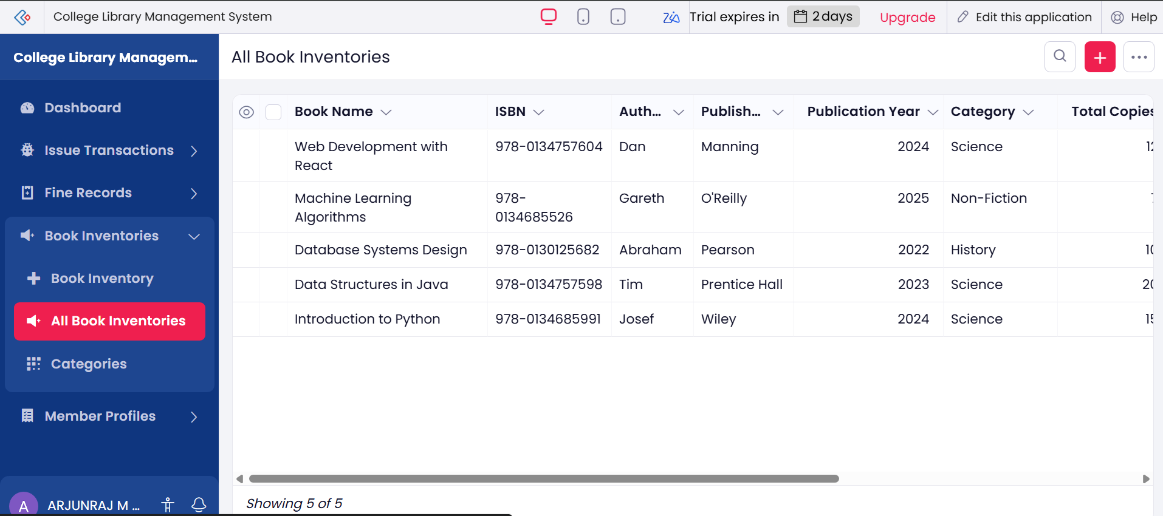
Figure 1: All Book Inventories List report showing five book records.

Screenshots 2 – Grid Report
The Grid report presents the same records in a spreadsheet-like layout with serial numbers against each row, which makes bulk review and inline editing convenient. Changes made in the grid are applied using the Save Changes option.
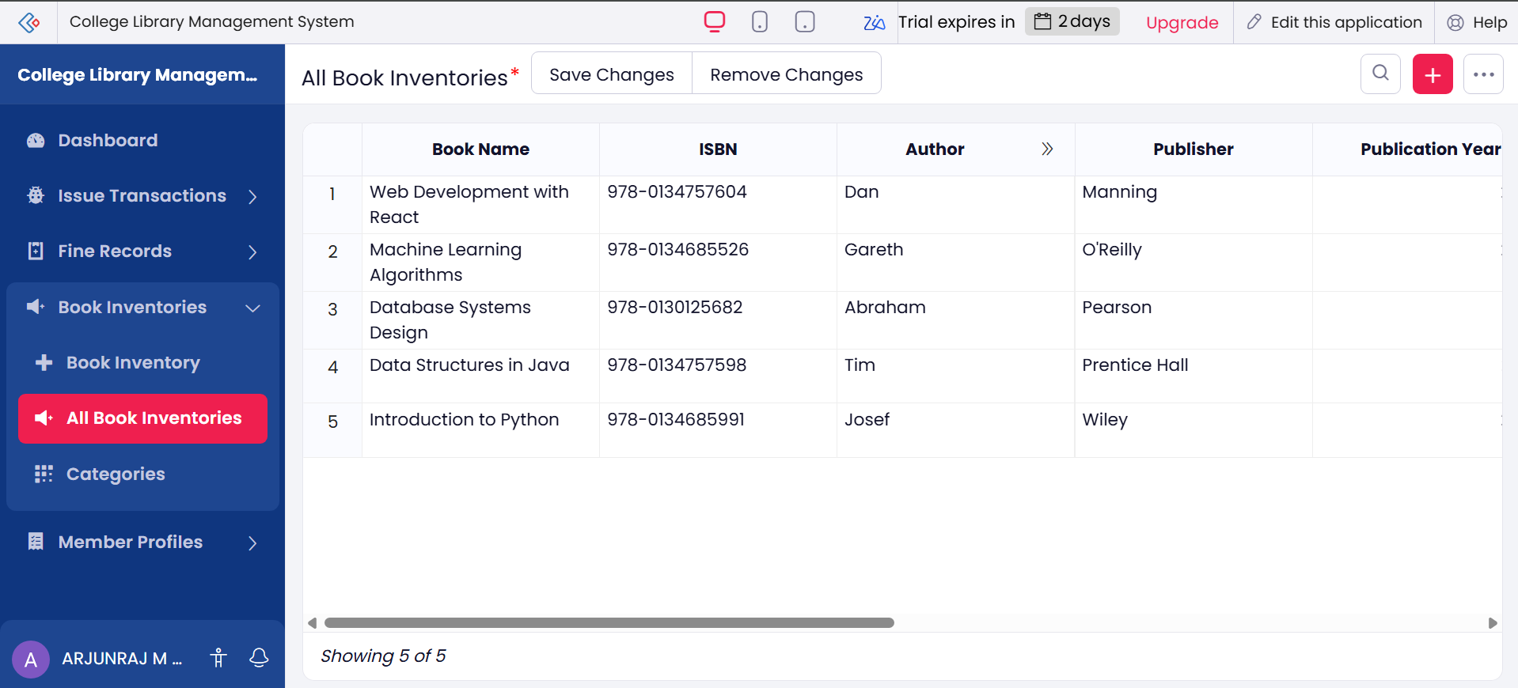
Figure 2: All Book Inventories Grid report with numbered rows and inline editing.

Screenshots 3 – Kanban Report
The Kanban report groups the book records into lanes based on the Category field. Each book is displayed as a card showing the book name and ISBN, and a card can be dragged from one lane to another to change its category. Categories with no records display an empty-lane message.
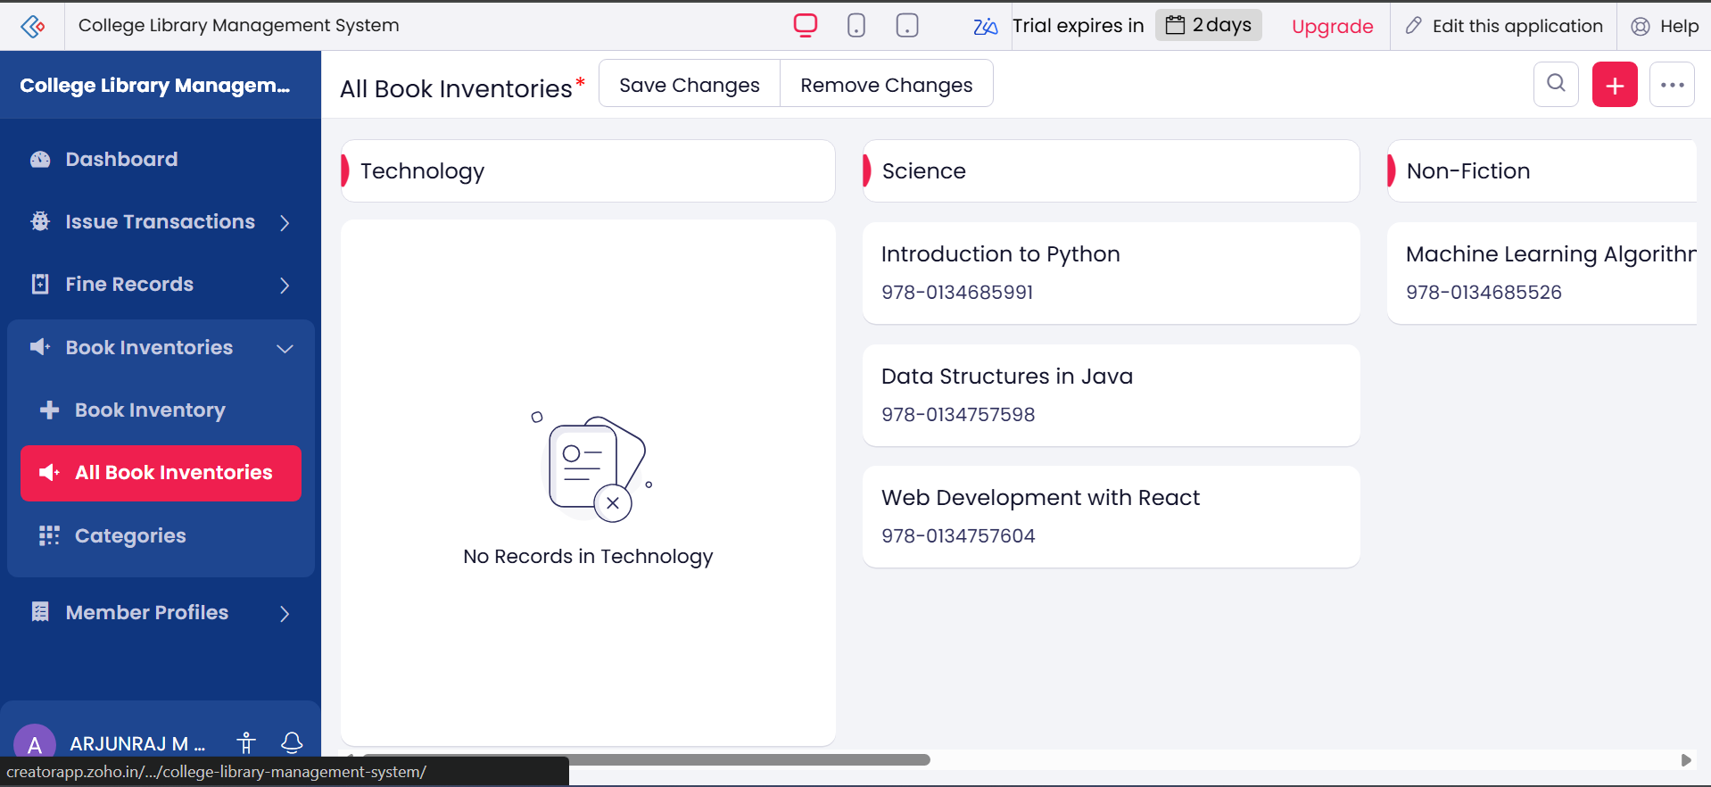
Figure 3: Book Inventories Kanban report grouped by Category, with Technology, Science, and Non-Fiction lanes.

Screenshots 4 – Calendar Report
The Calendar report plots the issue transactions on a calendar using the issue date and due date fields, so that the borrowing period of every transaction is visible as a bar. The view can be switched between Month, Week, and Day.
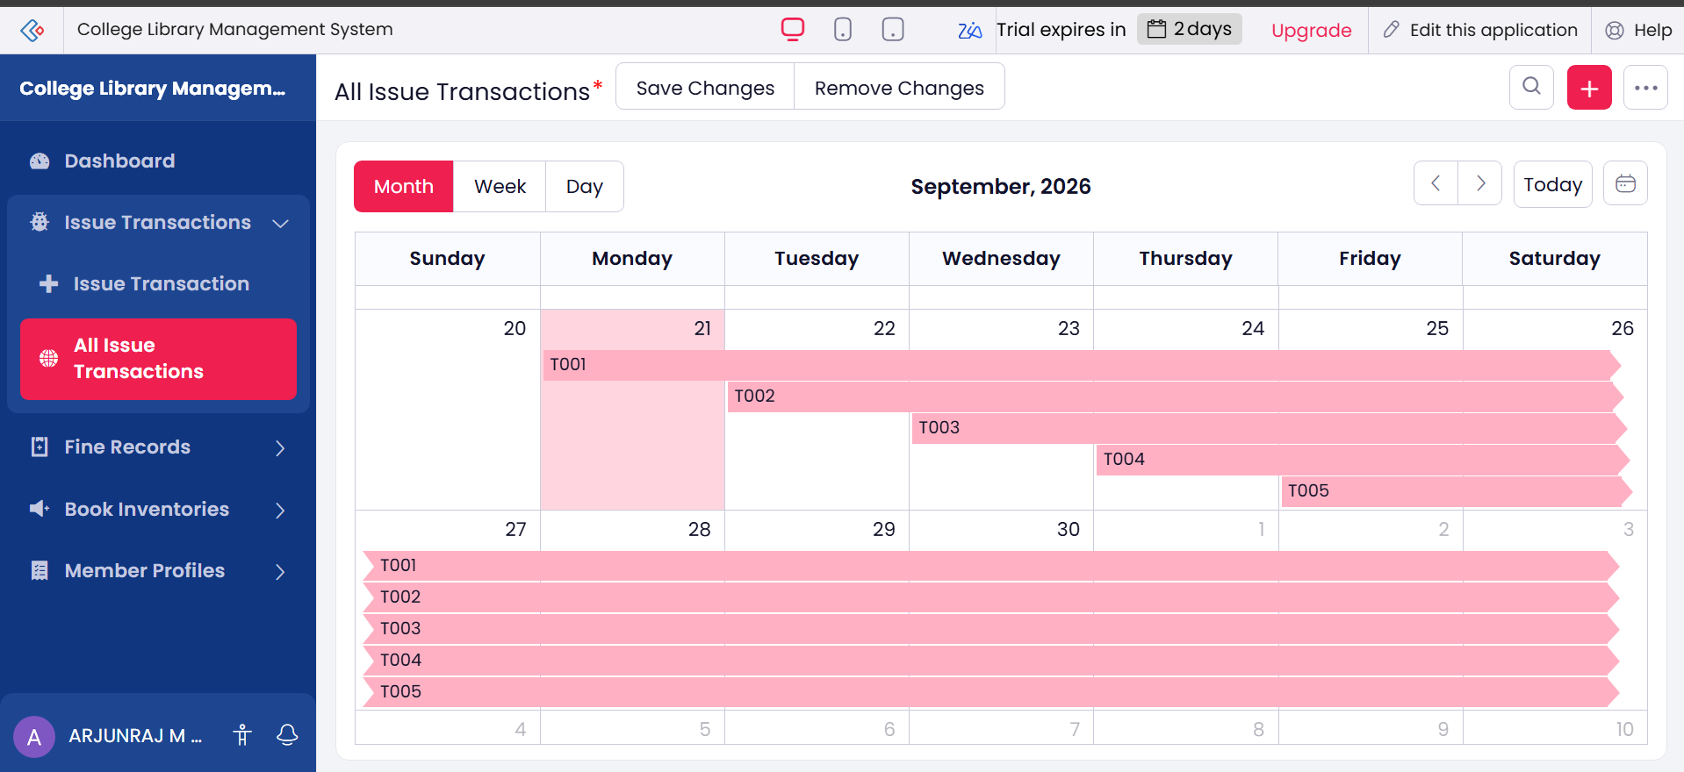
Figure 4.1: All Issue Transactions Calendar report — Month view for September 2026 showing transactions T001 to T005 spanning their issue and due dates.
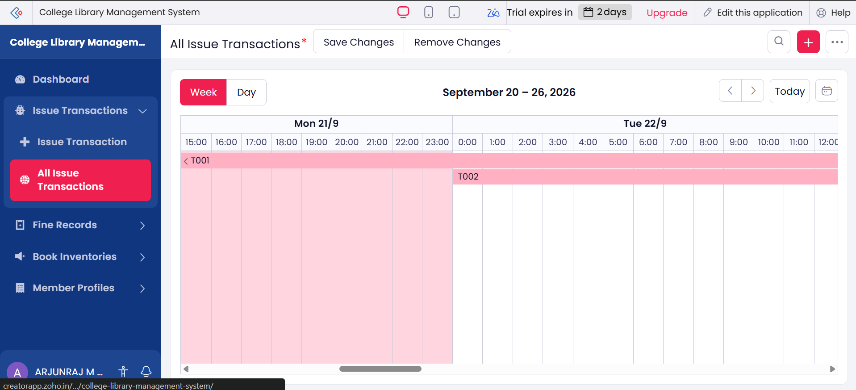
Figure 4.2: All Issue Transactions Calendar report — Week view for 20–26 September 2026 with hour-wise time slots.

Observation
The same Book Inventory data was presented in three different ways — List, Grid, and Kanban — simply by creating different reports on the same form, and no data was duplicated. The Calendar report required only the selection of the issue date and due date fields to visualise the borrowing period of each transaction. This shows that in Zoho Creator the presentation layer is fully separated from the data layer, and that multiple views can be provided for different users without any additional coding.

Result
List, Grid, Kanban, and Calendar reports were successfully created and viewed for the College Library Management System. The records were displayed correctly in each report type, and the grouping, inline editing, and date-based views functioned as required.

