Experiment – 3
Application Building using
Zia Assistant
College Library Management System in Zoho Creator
Department of Computer Science and Engineering
Student Name: Arjunraj M
Roll No: 240701049
Application Name: College Library Management System

Objective
To build a complete, working College Library Management System in Zoho Creator using the Zia AI Assistant (App Builder), by supplying a natural-language description of the required application, reviewing the use cases and data model generated by Zia, and verifying the resulting forms, reports, and dashboard.

Application Overview
Zia is the artificial-intelligence assistant of Zoho Creator. Instead of creating forms field by field, the developer describes the application in plain English and Zia derives the use cases, the data model with all required fields and relationships, the entry forms, the reports, and an analytics dashboard. The generated application is then reviewed and published.
The application built in this experiment allows a college librarian to maintain the book collection, register student and faculty members, record book issue and return transactions, and manage fines for overdue, damaged, or lost books.

Prompt Given to Zia
Create a Library Management Application for a college library. The application should allow librarians to manage books, students/members, book issue and return transactions, and fines.

Modules Generated
- Book Inventory — book name, ISBN, author, publisher, publication year, category, total copies, available copies, and shelf location.
- Member Profiles — profiles of students and faculty members who borrow from the library.
- Issue Transactions — transaction ID, book, member, issue date, due date, return date, overdue flag, fine amount, and notes.
- Fine Records — fine ID, related transaction, member, fine type, calculated amount, paid amount, payment date, and payment status.
- Dashboard — summary tiles, fine analysis charts, transaction distribution, and quick-link actions.

Data Model Generated by Zia
Form | Key Fields | Relationship
Book Inventory | Book Name, ISBN, Author, Publisher, Publication Year, Category, Total Copies, Available Copies, Shelf Location | Referenced by Issue Transaction
Member Profile | Member ID, Name, Contact and membership details | Referenced by Issue Transaction and Fine Record
Issue Transaction | Transaction ID, Book, Member, Issue Date, Due Date, Return Date, Is Overdue, Fine Amount, Notes | Lookup to Book Inventory and Member Profile
Fine Record | Fine ID, Transaction, Member, Fine Type, Calculated Amount, Paid Amount, Payment Date, Payment Status | Lookup to Issue Transaction and Member Profile
Table 3.1: Forms and relationships generated automatically by Zia.

Screenshot-based lab record
The following pages contain the actual Zoho Creator screenshots showing the Zia App Builder prompt, the generated data model, the live forms, the reports, and the analytics dashboard of the College Library Management System.

Screenshots 1 – Zia App Builder
The application description was entered in the Zia App Builder. Zia analysed the prompt and proposed the use cases together with a complete data model before the application was created.
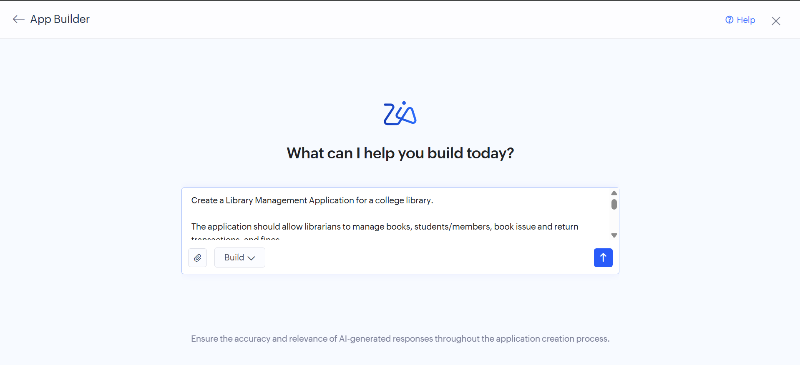
Figure 1.1: Application requirement described in the Zia App Builder prompt.
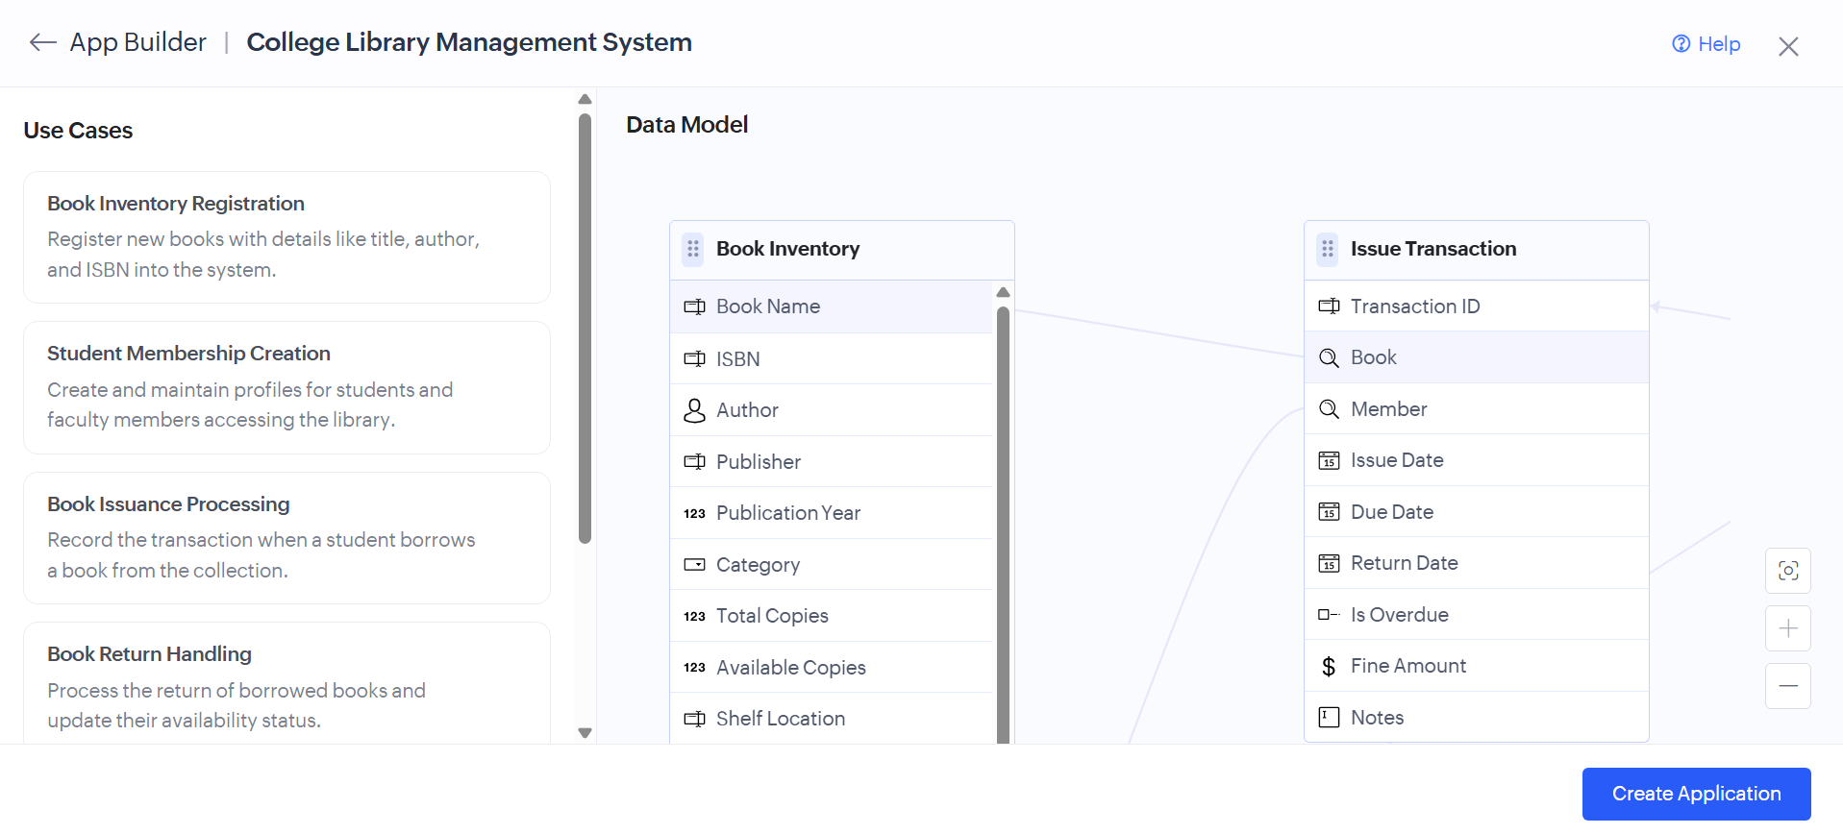
Figure 1.2: Use cases and data model generated by Zia, with the Book Inventory and Issue Transaction forms and their linked fields.

Screenshots 2 – Generated Forms
Zia created the data-entry forms with appropriate field types — single line, number, decimal, date, drop-down, lookup, checkbox, and multi line — along with mandatory-field validation.
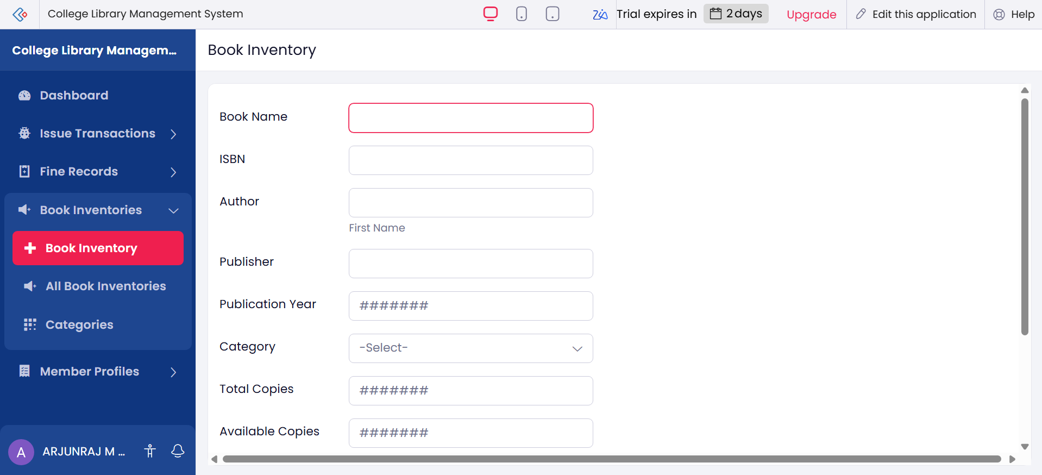
Figure 2.1: Book Inventory form with book details, category drop-down, and copy counts.
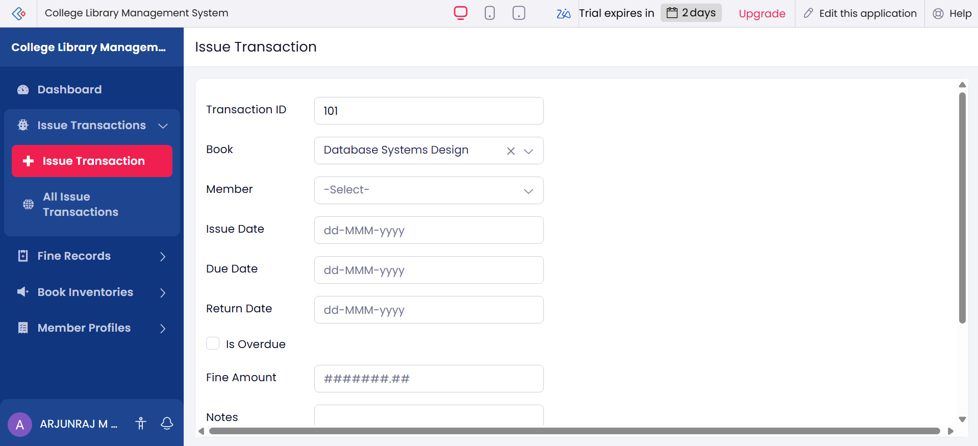
Figure 2.2: Issue Transaction form with book and member lookups, issue, due and return dates, overdue flag, and fine amount.
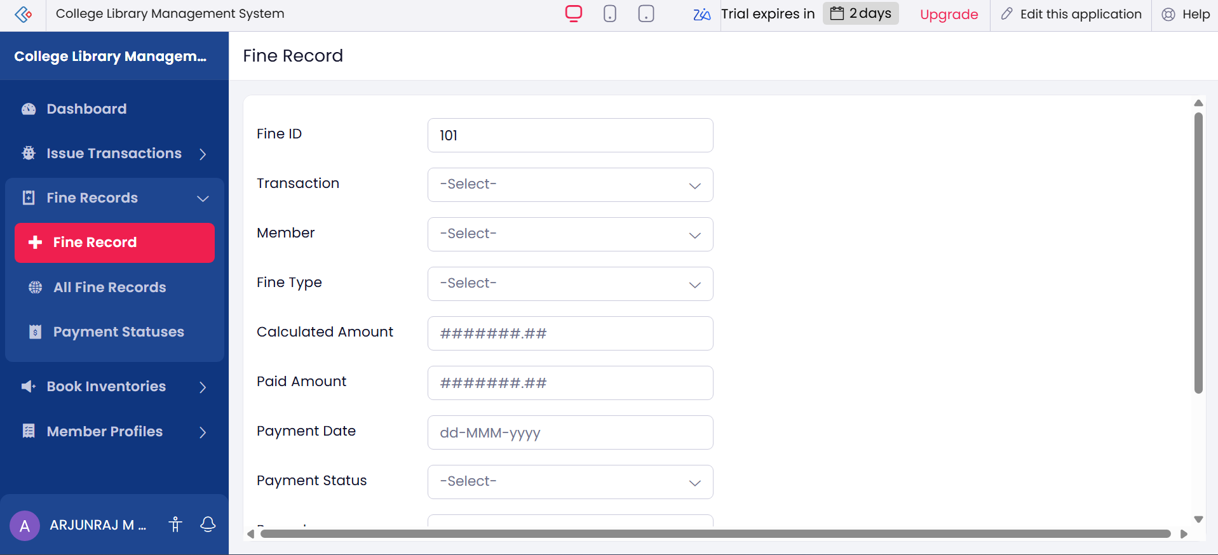
Figure 2.3: Fine Record form with transaction and member lookups, fine type, amounts, and payment status.

Screenshots 3 – Generated Reports
List and kanban reports were generated automatically for every form, allowing records to be viewed, searched, grouped, and summarised.
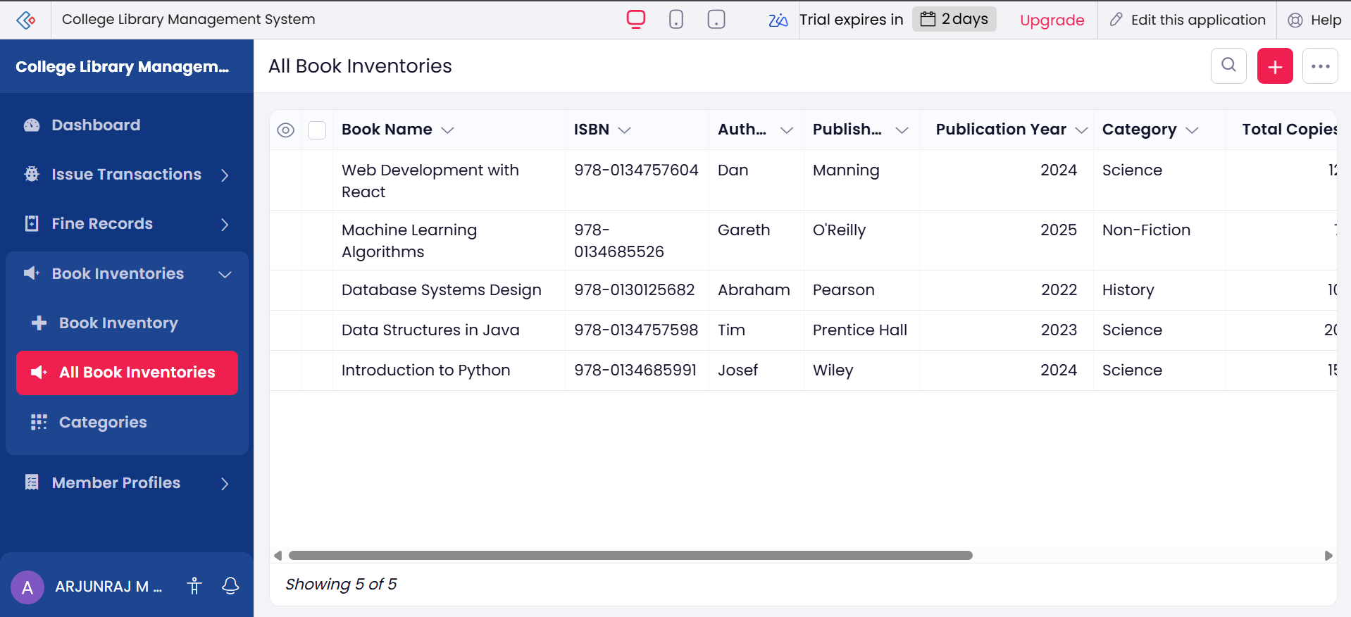
Figure 3.1: All Book Inventories report showing five registered book records.
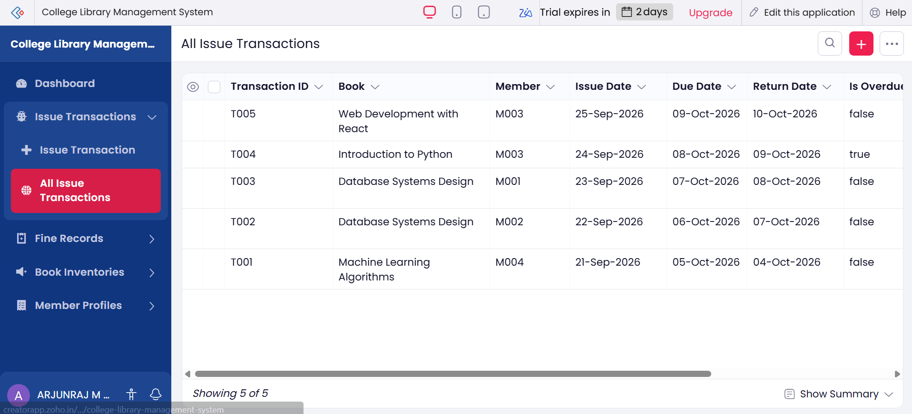
Figure 3.2: All Issue Transactions report showing five issue and return records with due dates and overdue status.
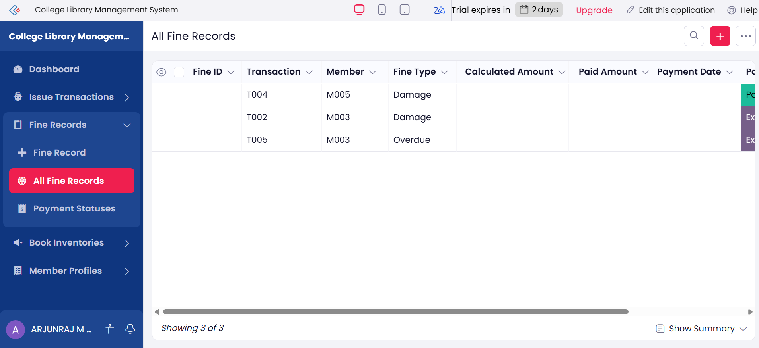
Figure 3.3: All Fine Records report showing three fine entries with fine type and payment status.
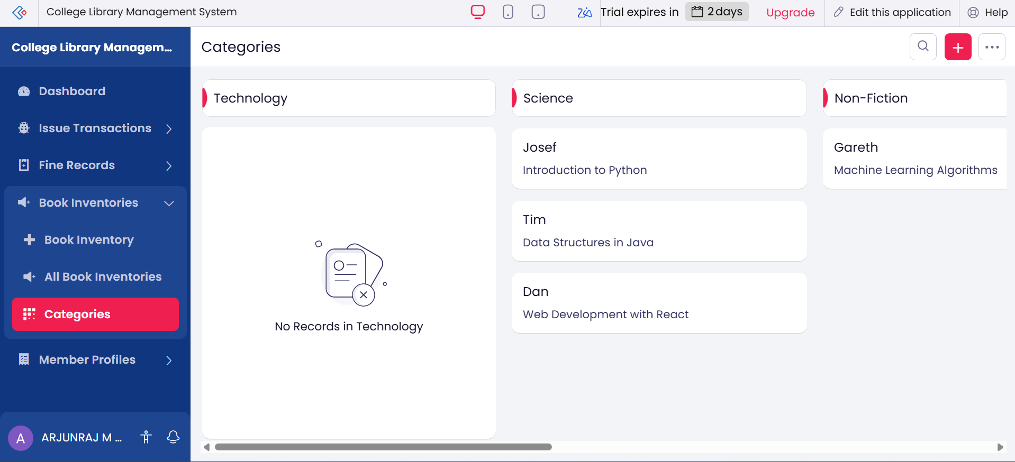
Figure 3.4: Categories kanban report grouping books by category.

Screenshots 4 – Dashboard
Zia also generated an analytics dashboard with summary tiles, charts, and quick links for frequent actions.
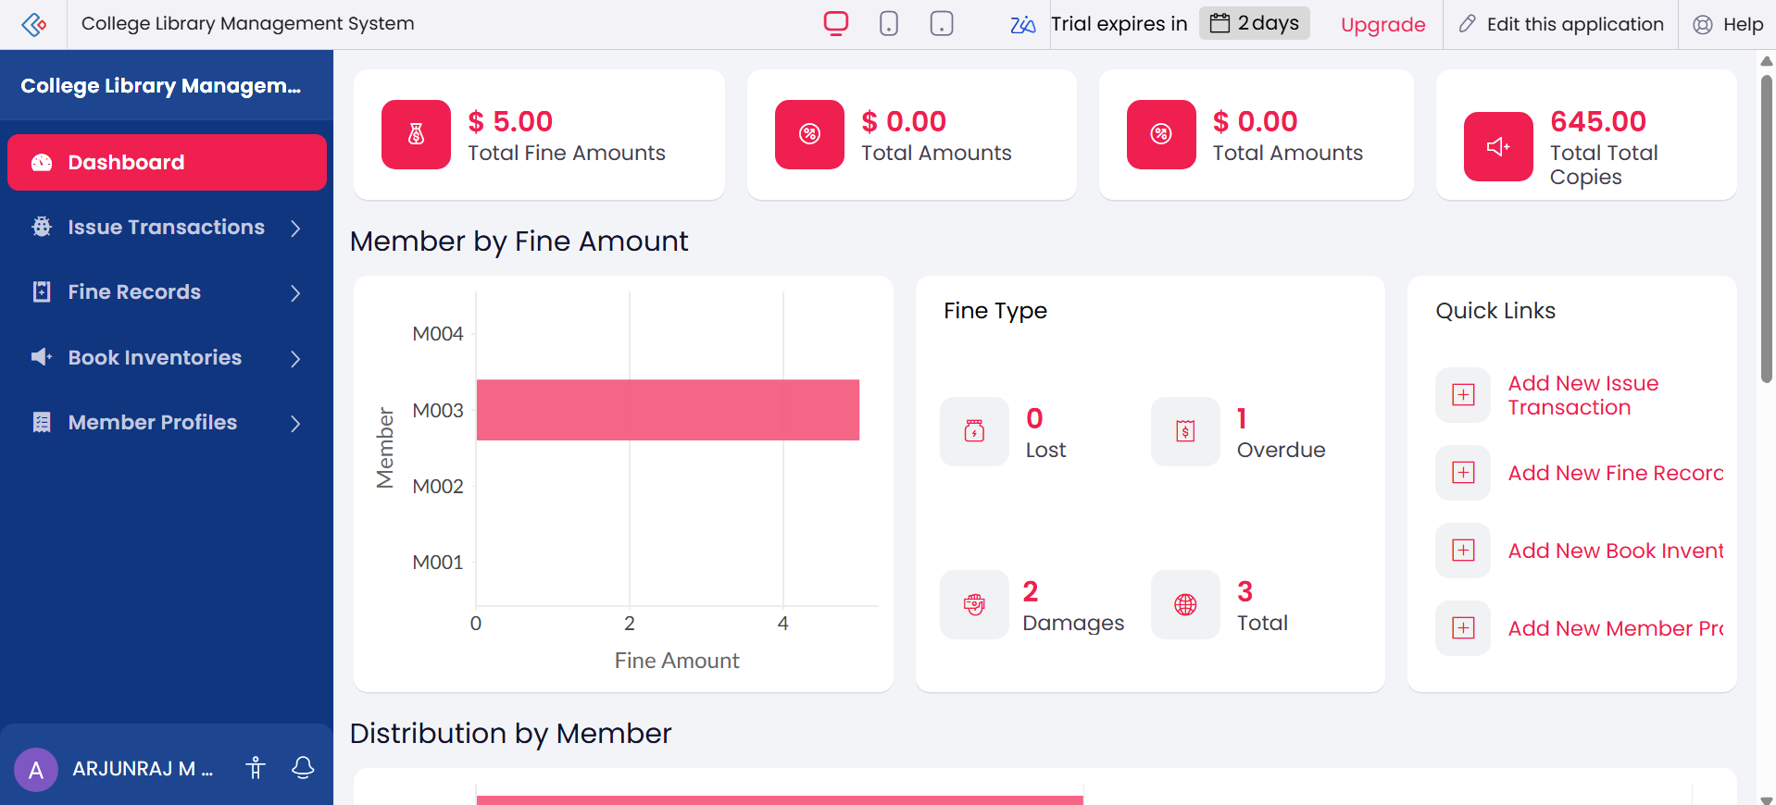
Figure 4.1: Dashboard with summary tiles, member-wise fine amount chart, fine type breakdown, and quick links.
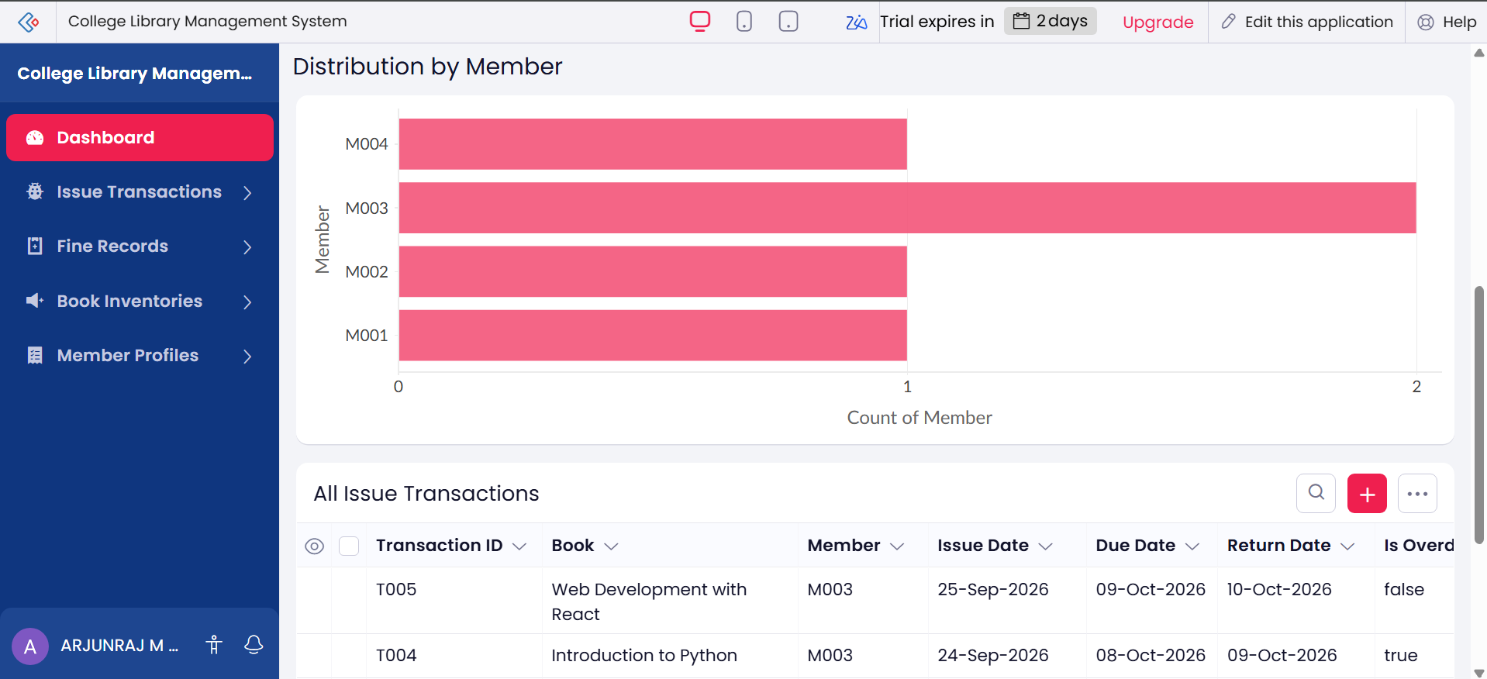
Figure 4.2: Distribution of issue transactions by member, with the transaction list below.

Observation
The entire application — four related forms, the corresponding reports, a kanban view, and an analytics dashboard — was produced from a single natural-language prompt, without manually creating any field, relationship, report, or chart. Zia inferred the lookup relationships between Issue Transaction, Book Inventory, Member Profile, and Fine Record correctly, and assigned suitable data types to each field. Only minor review and data entry were required afterwards, which reduced the development effort further compared with building the same application manually in the Form Builder.

Result
The College Library Management System was successfully built in Zoho Creator using the Zia AI Assistant. The generated data model, forms, reports, kanban view, and dashboard were verified with sample records, and the application functioned as required.

