Experiment – 6
Deluge
Deluge Scripting: Variables, Expressions, Data Types, Conditionals and Lists
Department of Computer Science and Engineering
Student Name: Arjunraj M
Roll No: 240701049
Platform: Deluge Scripting Challenge (Zoho Creator scripting language)

Objective
To practise writing Deluge scripts — the scripting language of Zoho Creator — covering variables, expressions, data types, conditional statements, and the List collection, by solving a graded set of scripting questions in an interactive Deluge challenge and recording the scripts and results.

Introduction
Deluge (Data Enriched Language for the Universal Grid Environment) is the scripting language used in Zoho Creator to add custom logic to otherwise drag-and-drop applications. It is used to validate form data, perform calculations, send notifications, fetch records, and integrate with other services. Deluge is designed to be concise and English-like: variables need no type declaration, statements end with a semicolon, and the data type is decided by the value assigned.
In this experiment, ten Deluge questions were attempted in a scored challenge (Q1 to Q10 of 60 questions). The challenge awards 2.7 points for a correct Hard question and 1.6 points for a correct Medium question, and tracks a running score and a streak of consecutive correct answers.

Deluge Concepts Covered
Concept | Description | Example Used
Variables | Named containers created by assigning a value; no declaration keyword is needed | principal = 1000; total = 0;
Expressions | Combinations of values and operators (+, -, *, /) producing a result | square = n * n;
Data Types | Number, Text, Date, Boolean; converted using functions such as toString() and toDate() | marks.toString(); "01-Jan-2004".toDate(...)
Conditional Statements | if / else if / else blocks that run code depending on a condition | if(age < 13) { ... } else { ... }
List | An ordered collection of values, created with List() and managed with add(), contains(), sort() | rollNumbers.add(101);
Table 6.1: Deluge concepts practised in this experiment.

Summary of Questions Attempted
No. | Topic | Level | Task | Points | Result
1 | Expressions | Hard | Square of n using multiplication | +2.7 | Correct
2 | List | Hard | Create a List and add 101, 102 | +2.7 | Correct
3 | Data Types | Medium | Convert text to Date with toDate() | +1.6 | Correct
4 | Conditional Statements | Hard | if-else-if-else age category | +2.7 | Correct
5 | List | Medium | Check list with contains() | +1.6 | Correct
6 | List | Hard | Sort a list ascending | +2.7 | Correct
7 | Data Types | Hard | Convert Number to Text | +2.7 | Correct
8 | Expressions | Hard | Concatenate names and uppercase | +2.7 | Correct
9 | Variables | Hard | Compute simple interest | +2.7 | Correct
10 | Variables | Medium | Initialise and increment a variable | +1.6 | Correct
Table 6.2: Summary of the ten questions attempted. All ten were answered correctly, giving a final displayed score of 23.4 / 100 and a streak of 10.

Screenshot-based lab record
Each of the following entries gives the question, the Deluge script submitted, the screenshot of the challenge showing the Correct verdict, and a short explanation of how the script works.
Question 1 – Expressions (Hard)
Question: Write an expression that computes the square of variable n and stores it in square using multiplication.
Deluge script:
square = n * n;

Explanation: The arithmetic operator * multiplies n by itself, and the assignment operator = stores the result in the variable square.
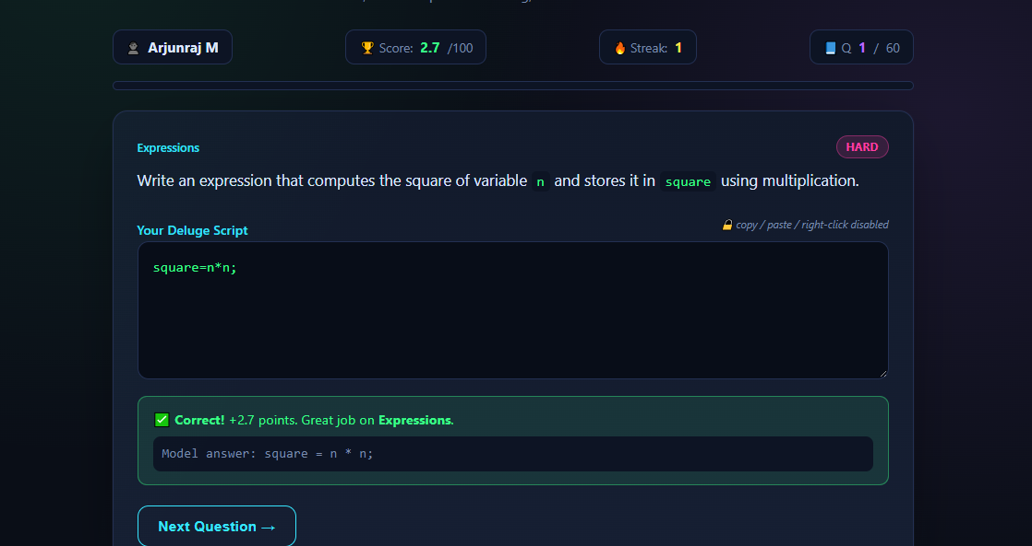
Figure 1: Question 1 of 60 answered correctly — +2.7 points, score 2.7 / 100, streak 1.
Question 2 – List (Hard)
Question: Create an empty List named rollNumbers and then add the values 101 and 102 to it.
Deluge script:
rollNumbers = List();
rollNumbers.add(101);
rollNumbers.add(102);

Explanation: List() creates an empty collection, and the add() function appends each value to the end of the list.
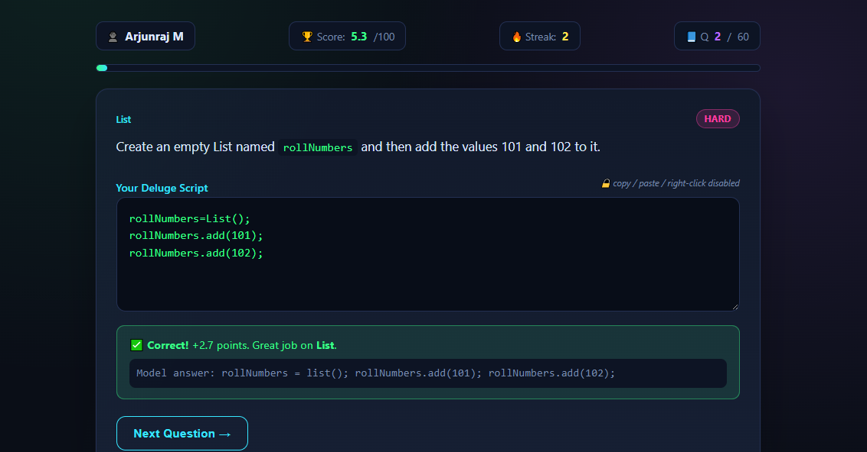
Figure 2: Question 2 of 60 answered correctly — +2.7 points, score 5.3 / 100, streak 2.
Question 3 – Data Types (Medium)
Question: Declare a Date variable dob using the toDate function on the text "01-Jan-2004".
Deluge script:
dob = "01-Jan-2004".toDate("dd-MMM-yyyy");

Explanation: The toDate() function converts a Text value into a Date value, using the format string to tell Deluge how the text is arranged (day-month-year).
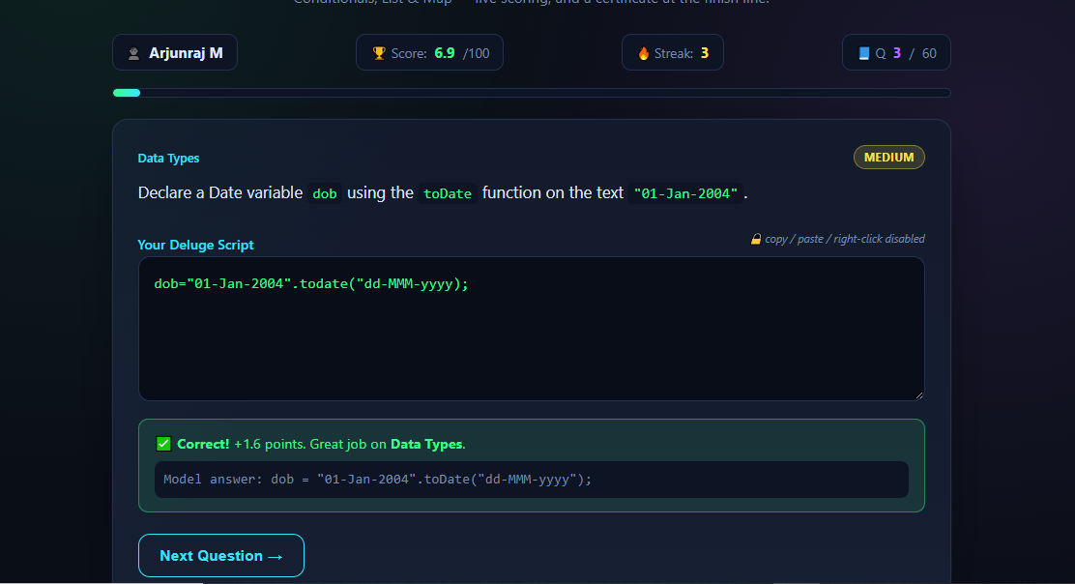
Figure 3: Question 3 of 60 answered correctly — +1.6 points, score 6.9 / 100, streak 3.
Question 4 – Conditional Statements (Hard)
Question: Write an if-else-if-else chain that assigns category based on age: under 13 → "Child", under 20 → "Teen", else → "Adult".
Deluge script:
if(age < 13)
{
category = "Child";
}
else if(age < 20)
{
category = "Teen";
}
else
{
category = "Adult";
}

Explanation: The conditions are evaluated from top to bottom and only the first true branch executes; the final else handles every remaining case.
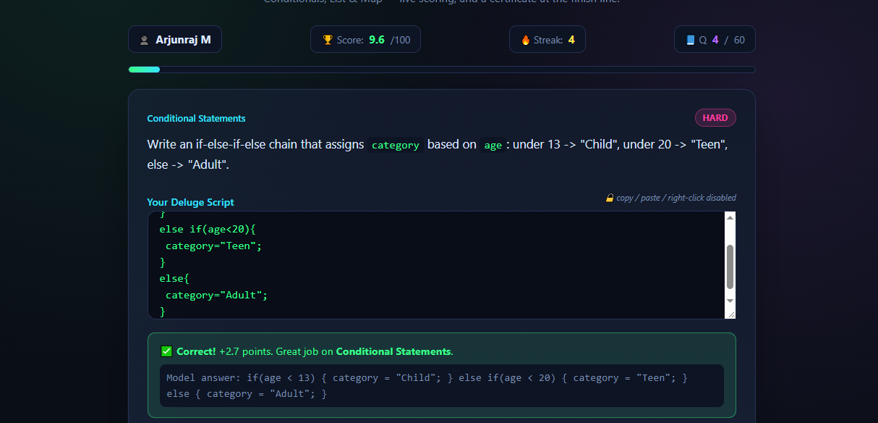
Figure 4: Question 4 of 60 answered correctly — +2.7 points, score 9.6 / 100, streak 4.
Question 5 – List (Medium)
Question: Check whether the list subjects contains the value "Science", storing the Boolean result in hasScience.
Deluge script:
hasScience = subjects.contains("Science");

Explanation: The contains() function returns true if the value is present in the list and false otherwise, which is stored as a Boolean.
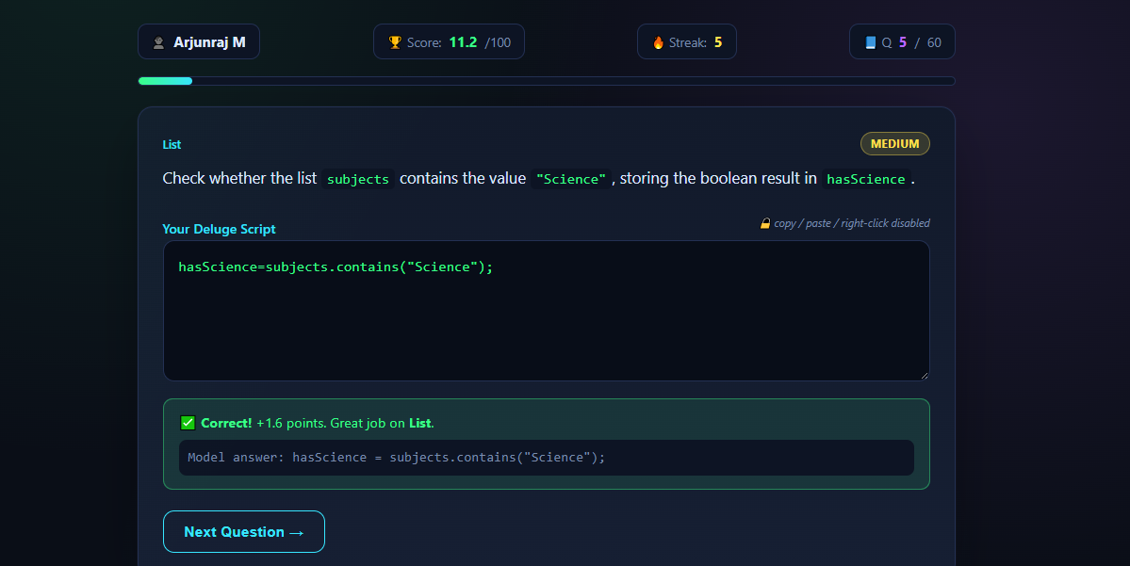
Figure 5: Question 5 of 60 answered correctly — +1.6 points, score 11.2 / 100, streak 5.
Question 6 – List (Hard)
Question: Sort the list marksList in ascending order and store the result in sortedMarks.
Deluge script:
sortedMarks = marksList.sort(true);

Explanation: The sort() function takes a Boolean argument: true sorts in ascending order and false sorts in descending order.
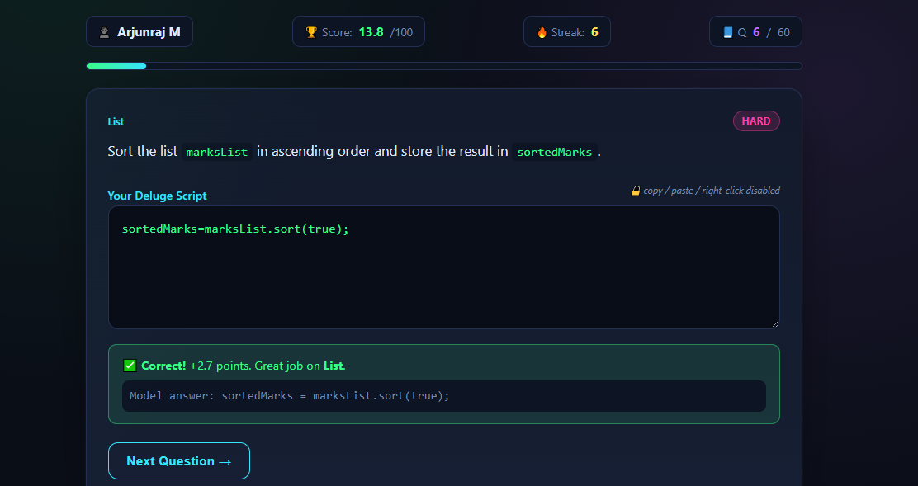
Figure 6: Question 6 of 60 answered correctly — +2.7 points, score 13.8 / 100, streak 6.
Question 7 – Data Types (Hard)
Question: Convert the number variable marks (holding 90) into Text data type and store it in marksStr.
Deluge script:
marksStr = marks.toString();

Explanation: The toString() function converts a Number value into its Text representation, so 90 becomes "90".
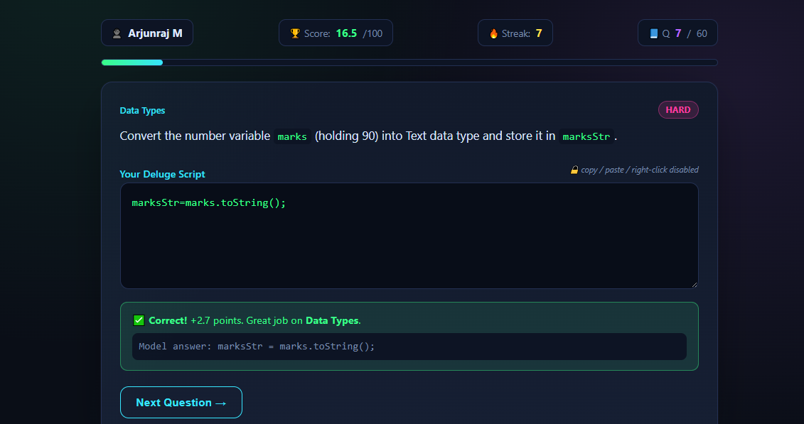
Figure 7: Question 7 of 60 answered correctly — +2.7 points, score 16.5 / 100, streak 7.
Question 8 – Expressions (Hard)
Question: Write an expression that concatenates firstName, a space, and lastName, then converts the result to uppercase, storing it in fullNameUpper.
Deluge script:
fullNameUpper = (firstName + " " + lastName).toUpperCase();

Explanation: The + operator concatenates Text values; the parentheses make the concatenation happen first, and toUpperCase() is then applied to the whole combined text.
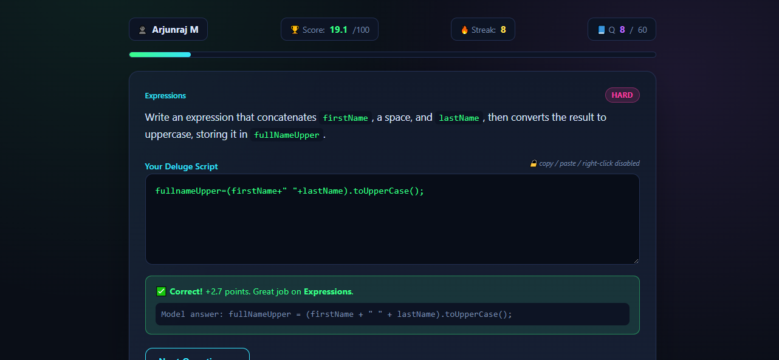
Figure 8: Question 8 of 60 answered correctly — +2.7 points, score 19.1 / 100, streak 8.
Question 9 – Variables (Hard)
Question: Declare variables principal = 1000 and rate = 5, then compute interest as (principal * rate)/100.
Deluge script:
principal = 1000;
rate = 5;
interest = (principal * rate) / 100;

Explanation: Variables are declared simply by assigning a value to them. The simple-interest formula is then evaluated using the stored values, giving interest = 50.
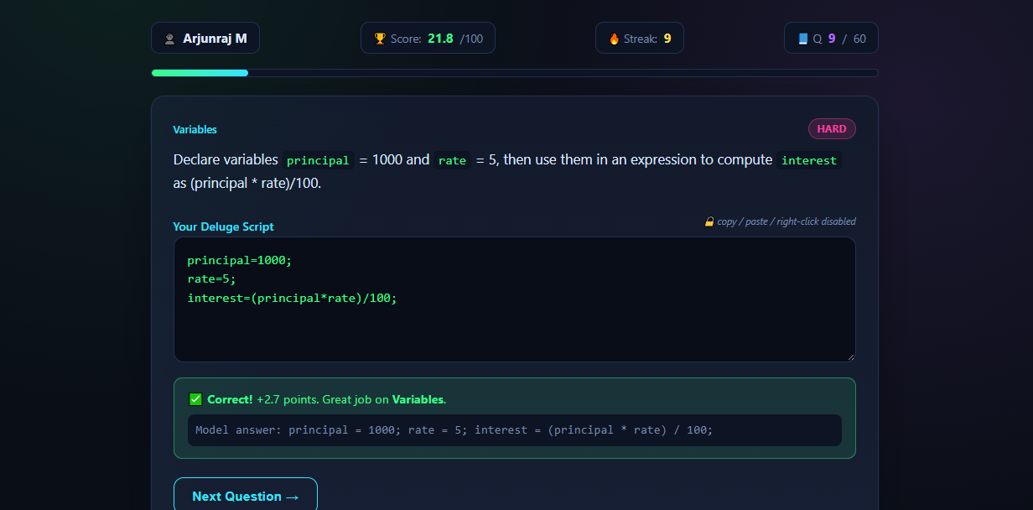
Figure 9: Question 9 of 60 answered correctly — +2.7 points, score 21.8 / 100, streak 9.
Question 10 – Variables (Medium)
Question: Declare a variable total initialized to 0, then increment it by 5.
Deluge script:
total = 0;
total = total + 5;

Explanation: The variable is first initialised and then reassigned to its own value plus 5, so its final value is 5.
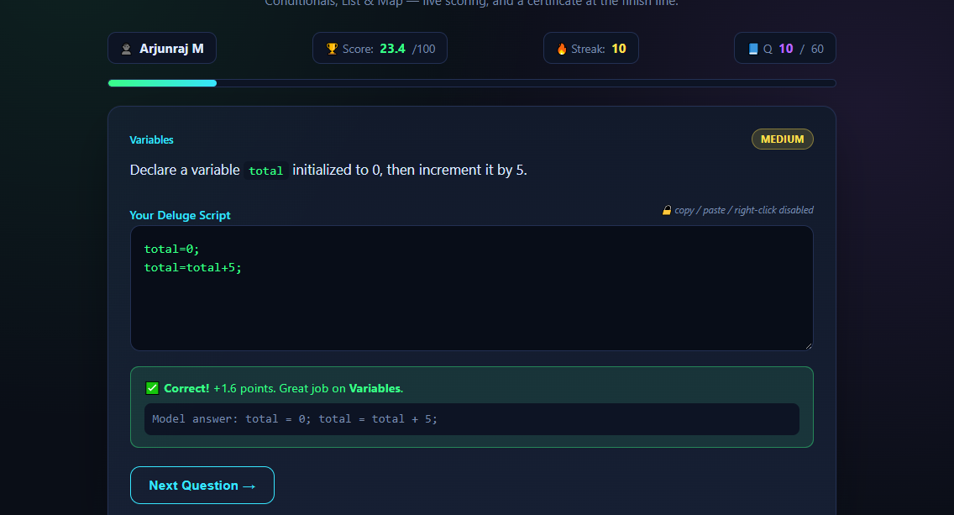
Figure 10: Question 10 of 60 answered correctly — +1.6 points, score 23.4 / 100, streak 10.

Observation
Ten Deluge scripts were written and all were evaluated as correct, with the streak counter rising from 1 to 10 and the score rising to 23.4 out of 100. The questions covered arithmetic and string expressions, type conversion with toString() and toDate(), multi-branch decision making with if-else-if-else, and the creation, searching, appending, and sorting of Lists. Deluge needs no variable declarations or explicit type declarations, so scripts remain very short compared with equivalent code in a general-purpose language, which is what makes it practical for adding validation and business logic to Zoho Creator applications.

Result
Deluge scripts covering variables, expressions, data types, conditional statements, and lists were successfully written and verified in the Deluge challenge. All ten attempted questions were answered correctly.

