Experiment – 1
Form Creation
Student Admission Enquiry Form using
Zoho Creator
Department of Computer Science and Engineering
Student Name: Arjunraj M
Roll No: 240701049
Application Name: Student Admission Enquiry Management Form Name: Admission_Enquiry_Form

Objective
To design and build a functional Student Admission Enquiry Form application in Zoho Creator using all thirteen Basic Fields and generate a report of submitted admission enquiries.

Application Overview
The application captures a prospective student's personal details, contact information, academic preferences, counselling availability, additional remarks, and consent in a structured form. The completed application contains the required four sections: Personal Details, Contact Details, Guardian & Academic Details, and Scheduling & Consent.

Basic Fields Implemented
Name, Email, Address, Phone, Single Line, Multi Line, Number, Date, Time, Drop Down, Radio, Multi Select, and Checkbox.

Screenshot-based lab record
The following pages contain the actual Zoho Creator screenshots showing the Form Builder, live form preview, validation configuration, and submitted enquiry report.

Screenshots 1 – Form Builder
Admission_Enquiry_Form configured in Zoho Creator Form Builder. The screenshots together show the Personal Details, Contact Details, Guardian & Academic Details, and Scheduling & Consent sections with the required Basic Fields.

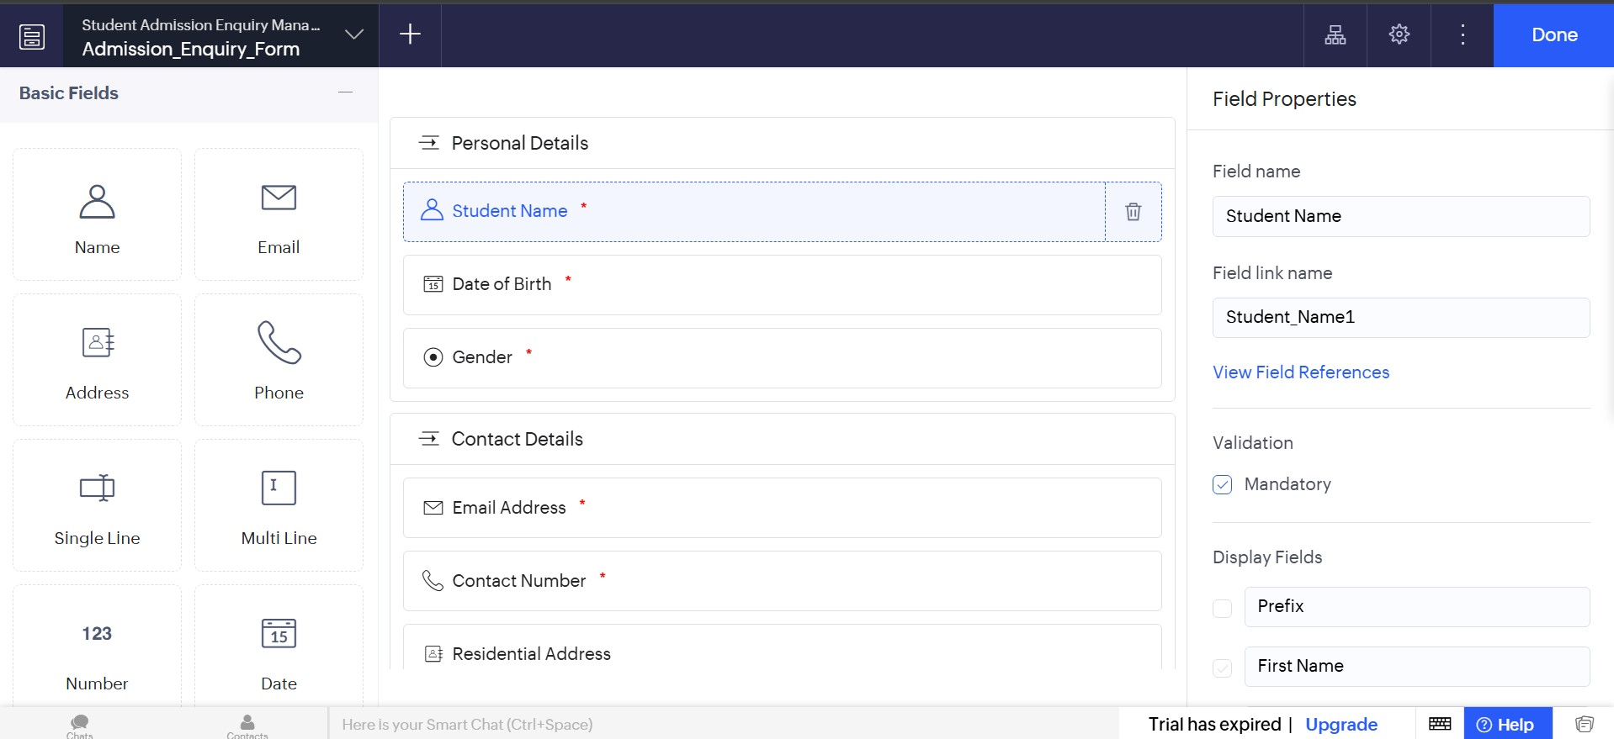
Figure 1.1: Admission_Enquiry_Form in Zoho Creator Form Builder.

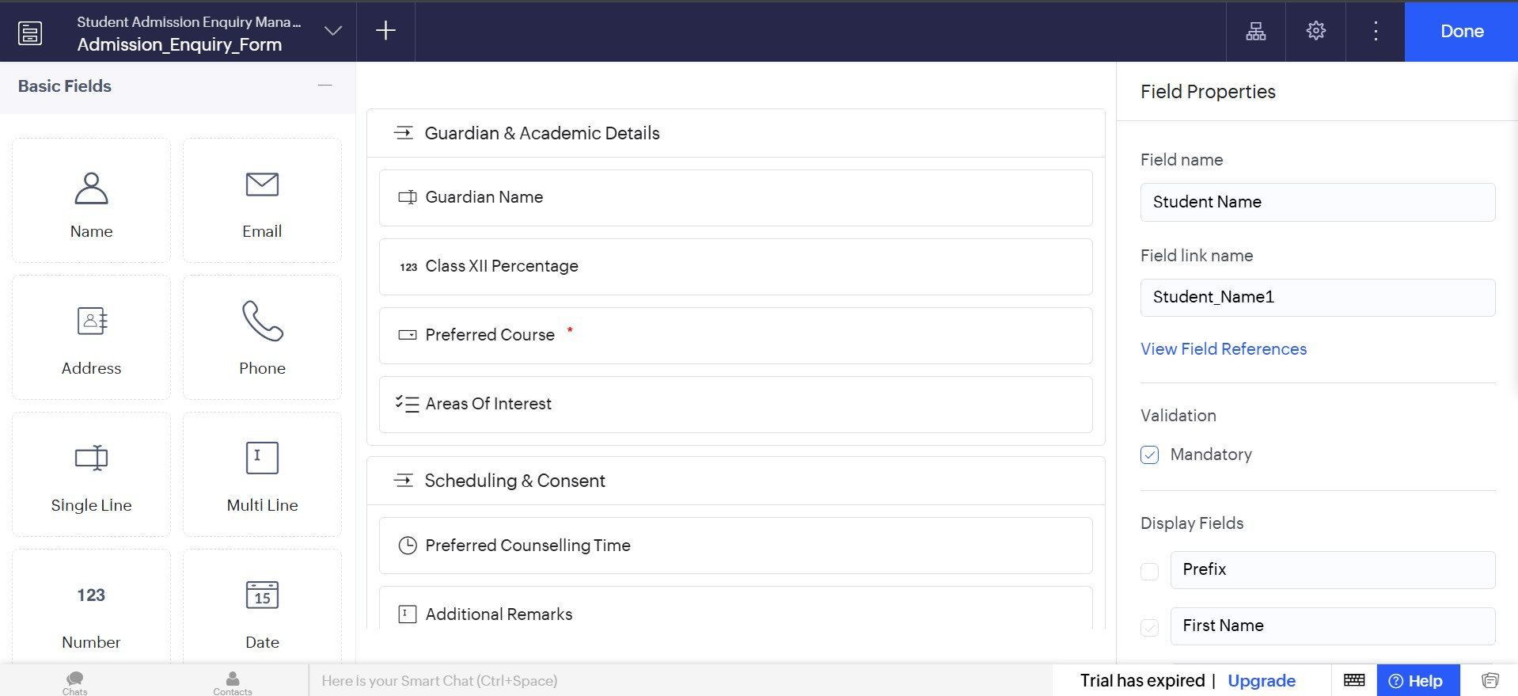
Figure 1.2: Admission_Enquiry_Form in Zoho Creator Form Builder.
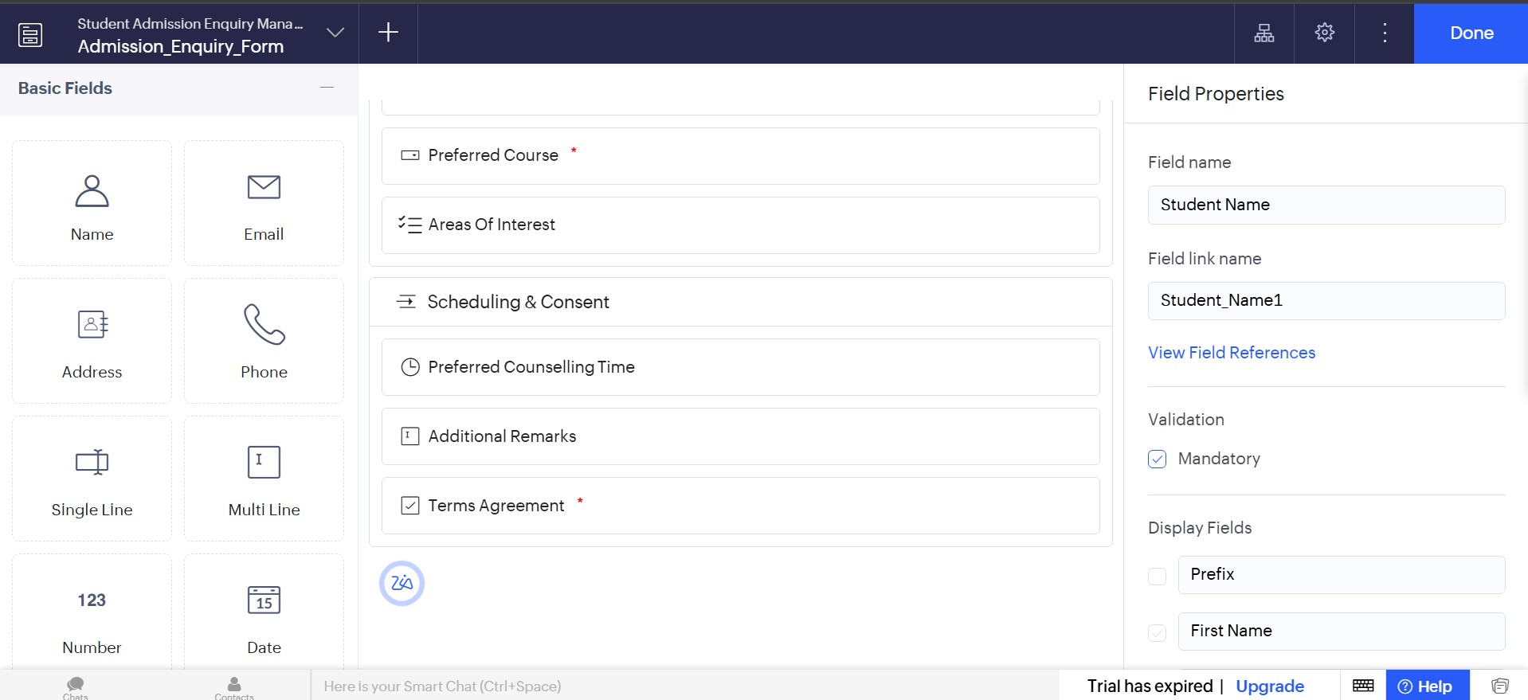
Figure 1.3: Admission_Enquiry_Form in Zoho Creator Form Builder.

Screenshots 2 – Live Form Preview
Live preview of the completed Admission_Enquiry_Form. The screenshots show the form's section-wise layout and field controls as presented to the applicant.

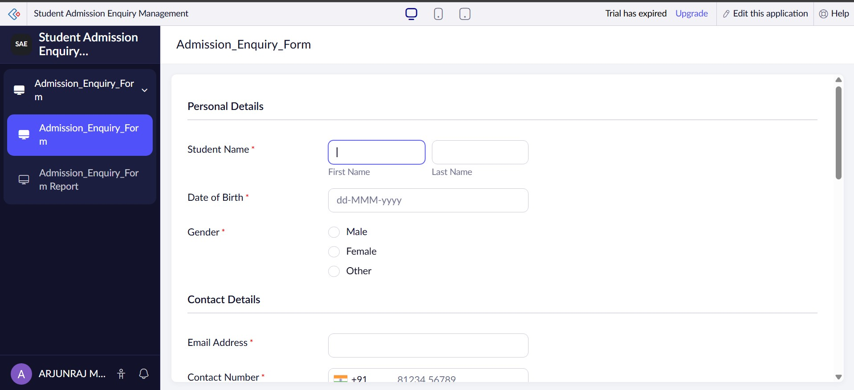
Figure 2.1: Personal Details and Contact Details.

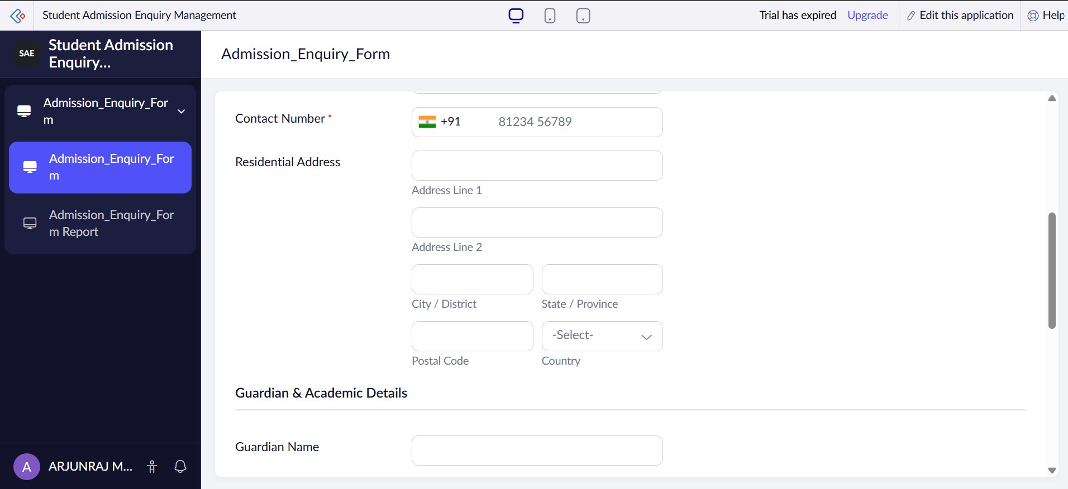
Figure 2.2: Contact Details and Guardian & Academic Details.
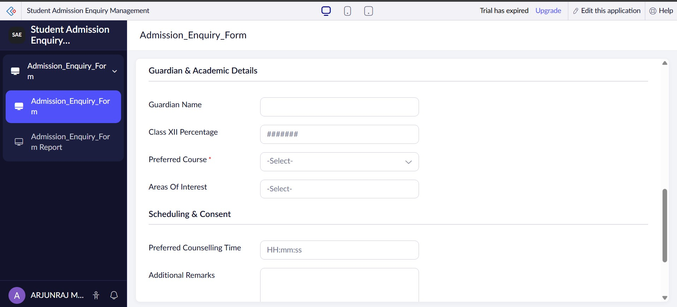
Figure 2.3: Guardian & Academic Details and Scheduling & Consent.

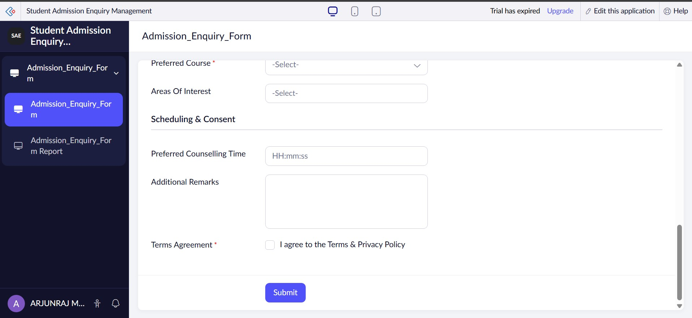

Figure 2.4: Scheduling & Consent with Submit button.

Screenshots 3 – Report View
Admission_Enquiry_Form Report showing three submitted enquiry records. The report contains student name, date of birth, gender, email address, contact number, and residential address columns.
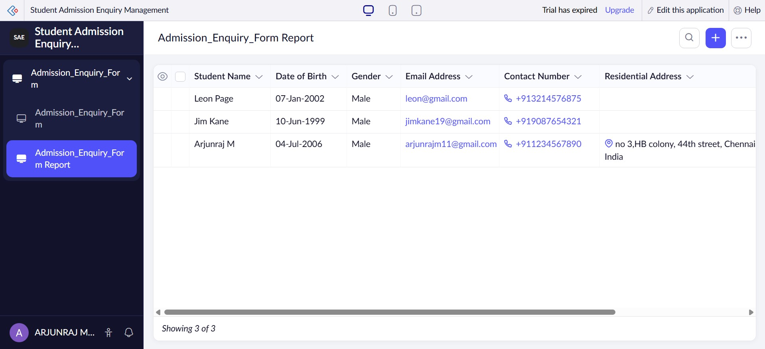
Figure 3: Admission_Enquiry_Form Report showing submitted admission enquiry records.

Validation Configuration
The form submission validation includes a check to prevent a future Date of Birth and a range check to ensure Class XII Percentage remains between 0 and 100. Invalid values trigger an alert and cancel submission.
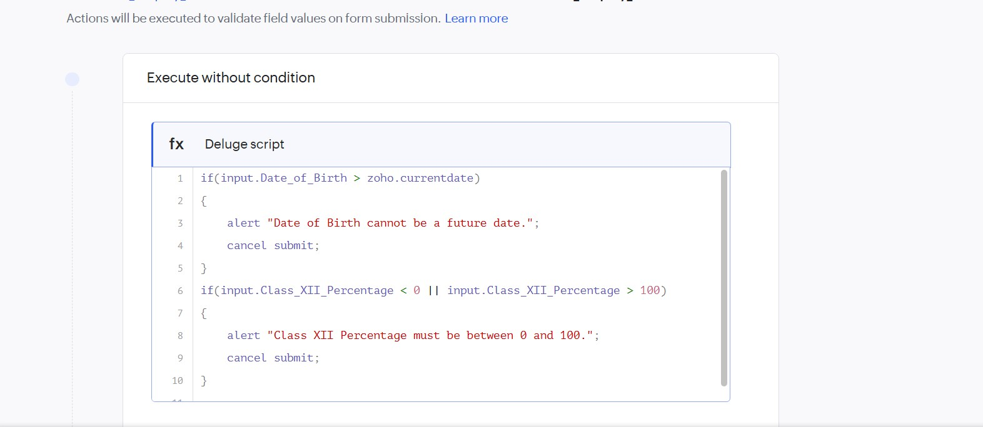
Figure 4: Deluge validation script for Date of Birth and Class XII Percentage.

Result
The Student Admission Enquiry application was successfully created in Zoho Creator. The required Basic Fields, section-wise form layout, validation logic, live form, and report view were implemented successfully.

