TOPIC => BIPOLAR JUNCTION TRANSISTOR

Question No.1:-

(i) Introduction :- The transistor was invented by Dr. William Shockley and Dr. John Bardeen at Bell Laboratory in America in 1951. First time, in 1952 transistor was used in telephone switching circuit. Since then, it has revolution in the field of electronics. The transistor has replaced the bulky vacuum tube in most of the electronic circuit. The transistor is a basic building block of all modern electronic system. It is a three terminal device. The output voltage , current or power are controlled by the input current in a transistor. Therefore, it is also called a current controlled device.

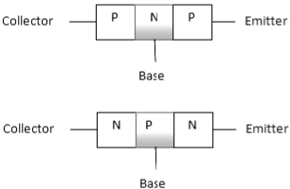

(a) NPN Transistor (b) PNP Transistor

In short transistor is also called as BJT. BJT stands for bipolar junction transistor because the transistor operation is carried out by two type of charge carriers and minority carriers. The transistor has a very important property that it can raise the strength of an input weak signal. This property is called Amplification. Due to this quality, the transistor is one of the widely used semiconductor devices.

Question No.2:-

(i) All about this :- (a) Working of a transistor :- To explain the working of a transistor, we consider an NPN transistor Which is biased for active operation. That means, emitter-base junction is forward biased by battery Vᴇв and collector base junction is reverse-biased by battery Vсв. 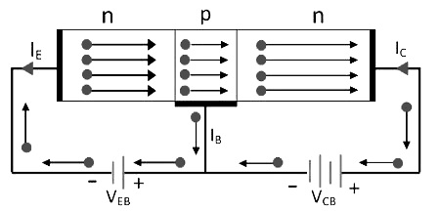

Working of Transistor

The forward biased voltage is small and reverse-biased voltage is quite large. The forward bias on the emitter-base junction pushes a large number of free electrons in the N-type emitter towards the base. This makes the emitter current (Iᴇ). A very few holes also pass from the base region to the emitter region. This flow of electron and holes constitute emitter current (Iᴇ). Since, the electron current is useful in the action of transistor, it is made larger and larger than the hole current by doping the base region more lightly than emitter region. Hence, only a very small portion nearly 0.5% of the emitter current is due to the holes passing from the base to the emitter. The direction of a conventional current is always taken opposite to the flow of electrons. After reaching the base region, the electrons tend to combine with holes. But since the base is very thin and lightly doped, only a very few electrons combine with holes. To constitute the base current (Iв). The remaining electrons pass on to the collector which is a positively biased N-region. These electrons are collected by the collector to constitute the collector current.

There is one another component of collector current due to the thermally generated minority carriers (holes in this case) which pass towards the base.

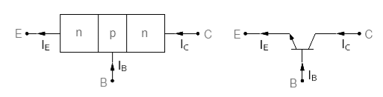Simplified Transistor Working Diagram To Show Different Currents:- (a) Transistor Currents (b) Transistor Current with Transistor symbol

It is clear in figure that the emitter current is the sum of collector and base currents. Mathematically, Iᴇ = Iс + Iв The emitter current of a transistor consists of two components. These are base current and collector current. But the base current is only about 2% of the emitter current whereas the collector current is about 98% of the emitter current. Therefore, from equation, we have Iᴇ = Iс and Iв = 0

(b) Characteristic Curve of Transistor:- We know about some parameters of transistor such as α and β and current. They give a small idea of transistor behavior. The complete behavior of transistor may be observed with the help of some types of curve known as characteristics curve. These characteristics curve relate the transistor current and voltage. There are two types of characteristics curves. 1. Transistor Characteristics in Common-Base Configuration:- In common-base configuration, two types of characteristics are:

(A)Input Characteristic Curve:- Input characteristic curve relate the input or emitter current Iᴇ and input or emitter-to-base voltage Vᴇв keeping output or collector-to-base voltage Vсв constant. (B)Output Characteristic Curve:- Output characteristic curve relate the output or collector current Iс and output or collector-to-base voltage Vсв keeping the input or emitter current Iᴇ constant.

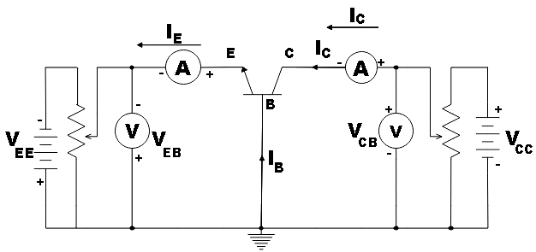

Current arrangement for input and output characteristics curve in CB configuration

1.1. Transistor Input Characteristics in Common-Base Configuration:- The input characteristic in CB configuration are plotted between emitter current Iᴇ and the emitter-base voltage Vсв.

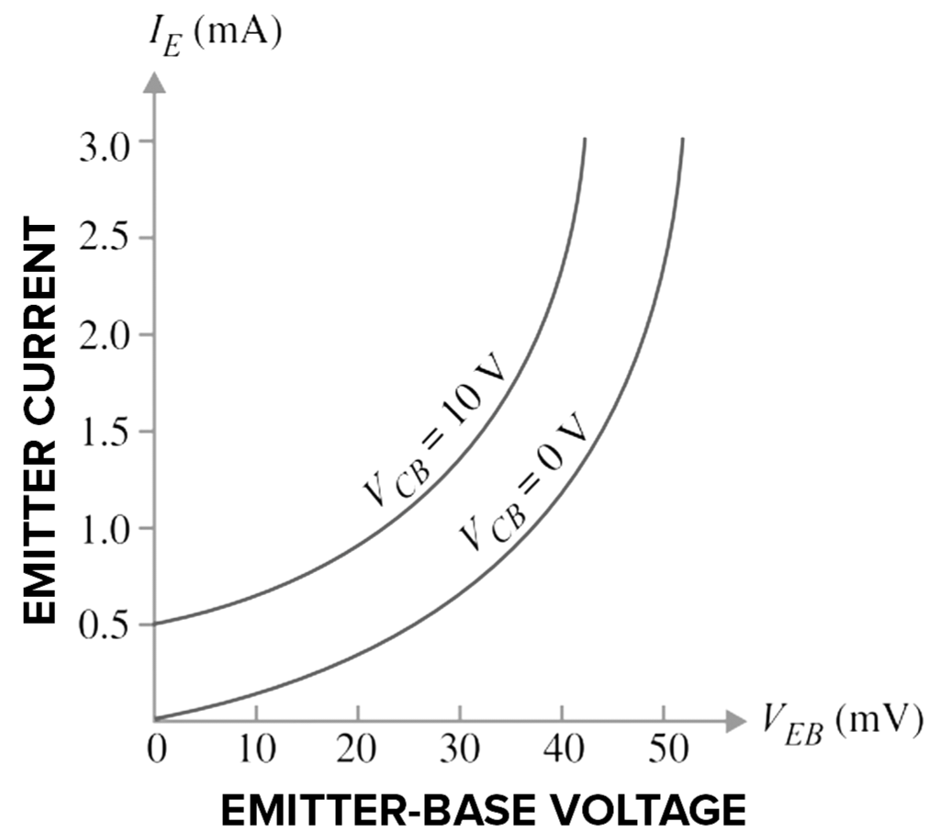

Input characteristics in common-base configuration

1.2. Transistor Output Characteristics in Common-Base Configuration:- The output characteristic curve in CB configuration can be obtained with the help of same circuit arrangement shown in figure. A suitable value of input current (emitter current) is fixed. Collector-to-base voltage Vсв is increased and corresponding changes in collector current are noted and a graph is plotted.

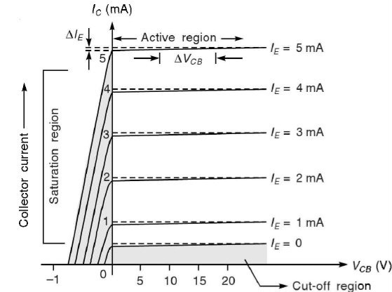

Output characteristics in common-base configuration

2. Transistor Characteristics in Common-Emitter Configuration:- In common-emitter configuration, a transistor has two types of characteristics namely input characteristics and output characteristics. (A) Input Characteristics Curve:- Input characteristics curve relate the base current Iв and the base-to-emitter voltage Vвᴇ keeping collector-to-emitter voltage Vсв constant. (B) Output Characteristics Curve:- Output characteristics curve relate the collector current Iс and collector-to-emitter voltage Vсᴇ keeping base current Iв constant.

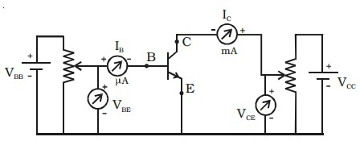

Circuit arrangement for input and output characteristics

2.1. Input Characteristics in Common-Emitter Configuration:- Input characteristics curve may be obtained with the help of circuit arrangement shown in figure, by increasing the Vвᴇ in step and recording the corresponding values of Iв while keeping Vсᴇ constant. In figure, the typical characteristics curves relate Iв and Vвᴇ for various values of Vсв. 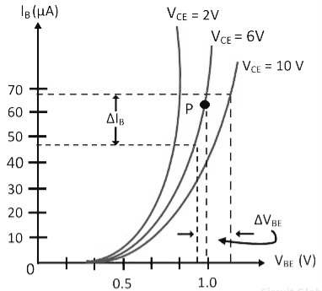 Input characteristics in common-emitter configuration

2.2. Output Characteristics in Common-Emitter Configuration:- Output characteristics in CE configuration can be plotted with the help of circuit arrangement shown in figure . The related output current Iс to the collector-to-emitter voltage for different values of input current Iв. 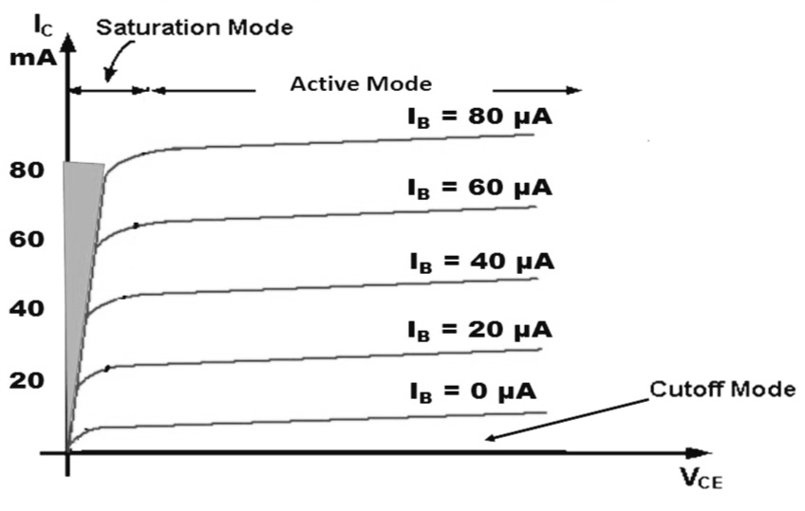 Output characteristics in common-emitter configuration

(c)Transistor Symbol:- There are two types of transistors known as NPN and PNP. When the transistor is used as a circuit in any electronics circuit, it is always represent by its symbol in figure (a) and (b). 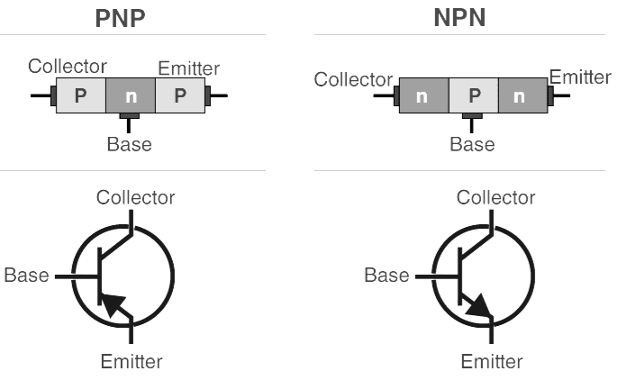 (a) (b) (d) Types of BJT:- There are two types of Bipolar Junction Transistor: 1. NPN BJT:- In NPN BJT, the p-type semiconductor is sandwiched between two n-type semiconductor. 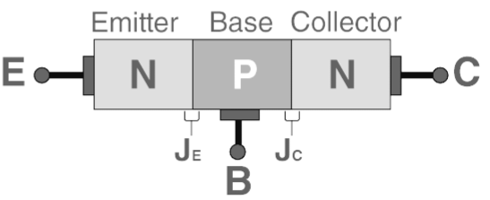 2. PNP BJT:- In PNP BJT, the n-type semiconductor is sandwiched between two p-type semiconductor. 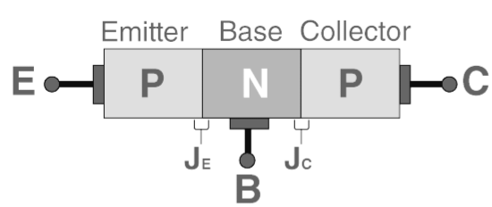

(e) Applications of BJT:- At present, transistor is used in almost every field of electronics.

1. Transistor is used in control system. 2. BJT is used as a detector or also known as a demodulator. 3. Logic circuit and switch circuit use BJT. 4. In digital computer electronics, the transistor is used as high speed electronics switch. 5. In communication system, it is widely used as the premium component in the amplifier. 6. BJT finds application in clipping circuit so that the waves can be shaped.