**Microprocessor & Interfacing**

**(Lab session-01)**

1. **Write an 8085 program to exchange the contents of HL=2345H and DE=0A87H register pairs using the push and pop instructions.**

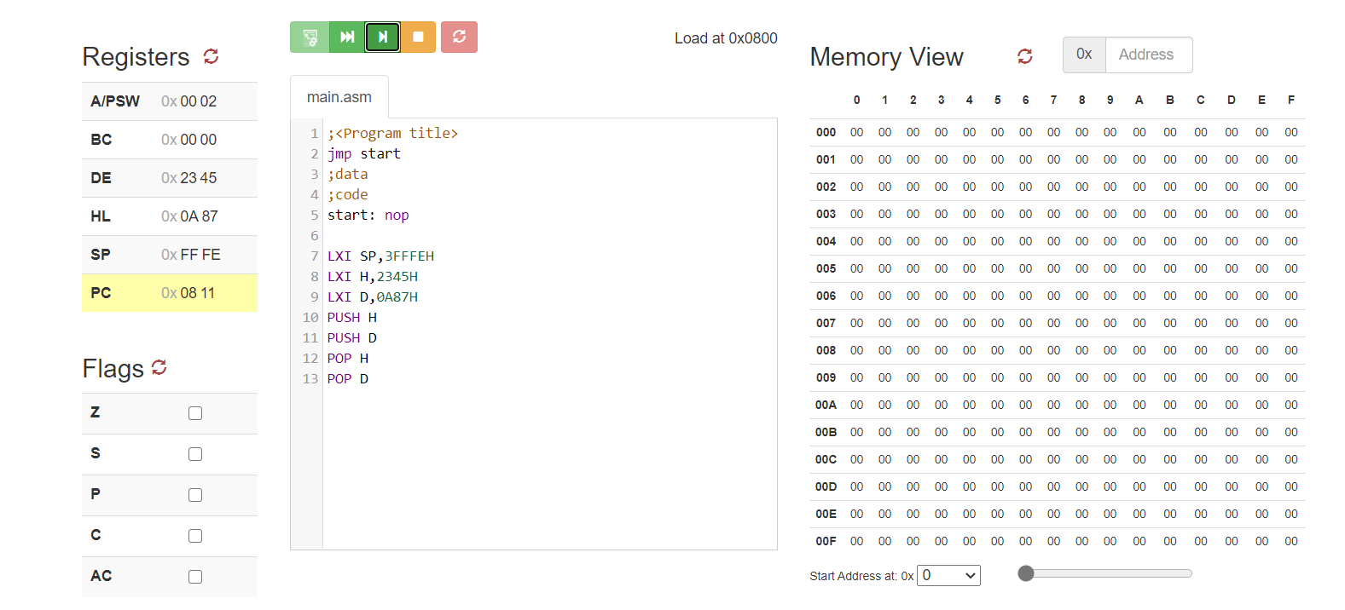

1. **Write a 8085 program to store the content of HL=5643H register pair on to SP.**

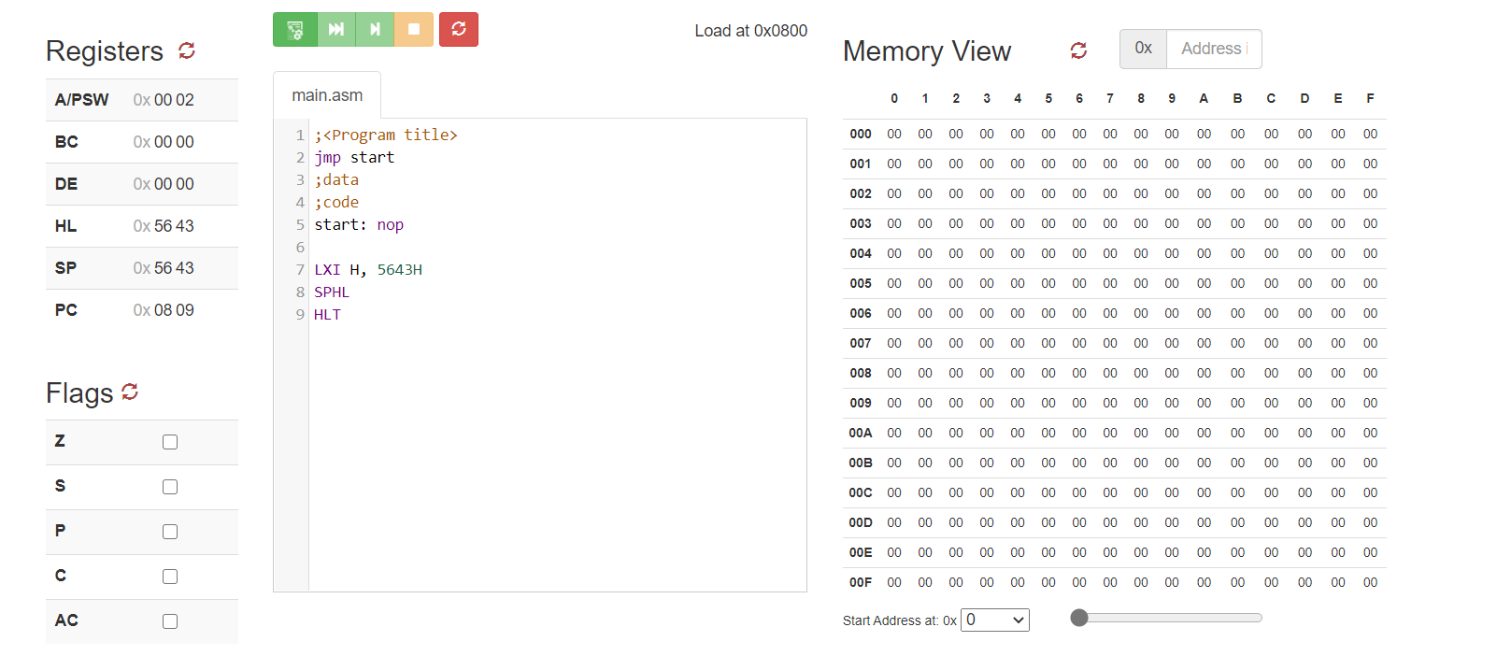

1. **Write an 8085 program to store the contents of A register into memory location 4000H. (Hint: use STAX instruction)**

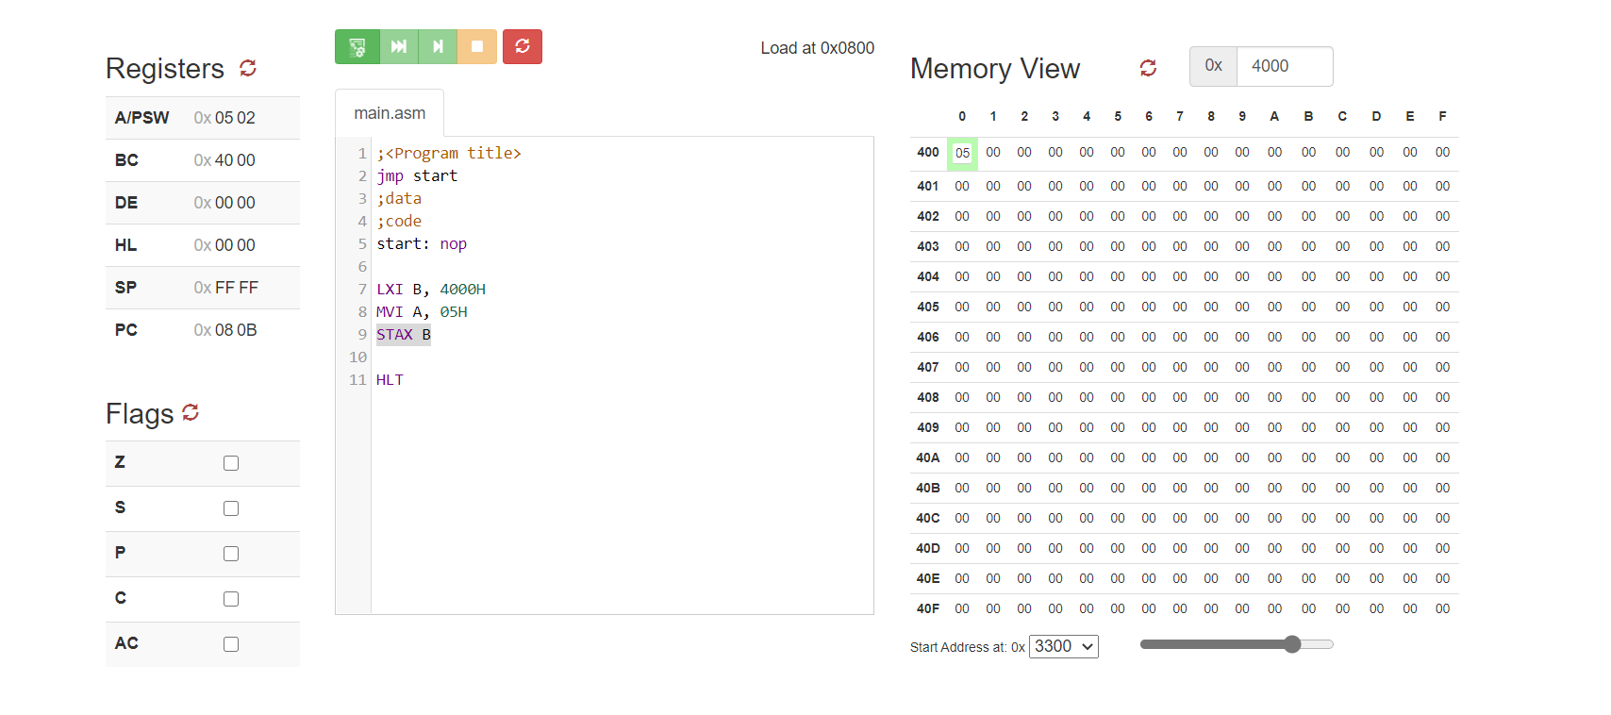

1. **Write an 8085 program to get the contents of memory location 4040H into A register only. (Hint: use LDAX instruction)**

