**Microprocessor & Interfacing**

**(Lab session-10)**

1. **Write 8085 program to call to a label INCR. Perform increment operation for the contents of Register A at label INCR and get back to main program and move the new value to Register B and then halt the program.**

**➢ Program:**

MVI A,27H; MOV IMMEDEATE 27H INTO ACCUMULATOR

CALL INCR; CALL LABEL INCR LABEL

MOV B, A; MOV CONTENT OF A INTO B

HLT

INCR: INR A; INCREMENT THE ACCUMULATOR

RET; RETURN BACK TO MAIN PROGRAM

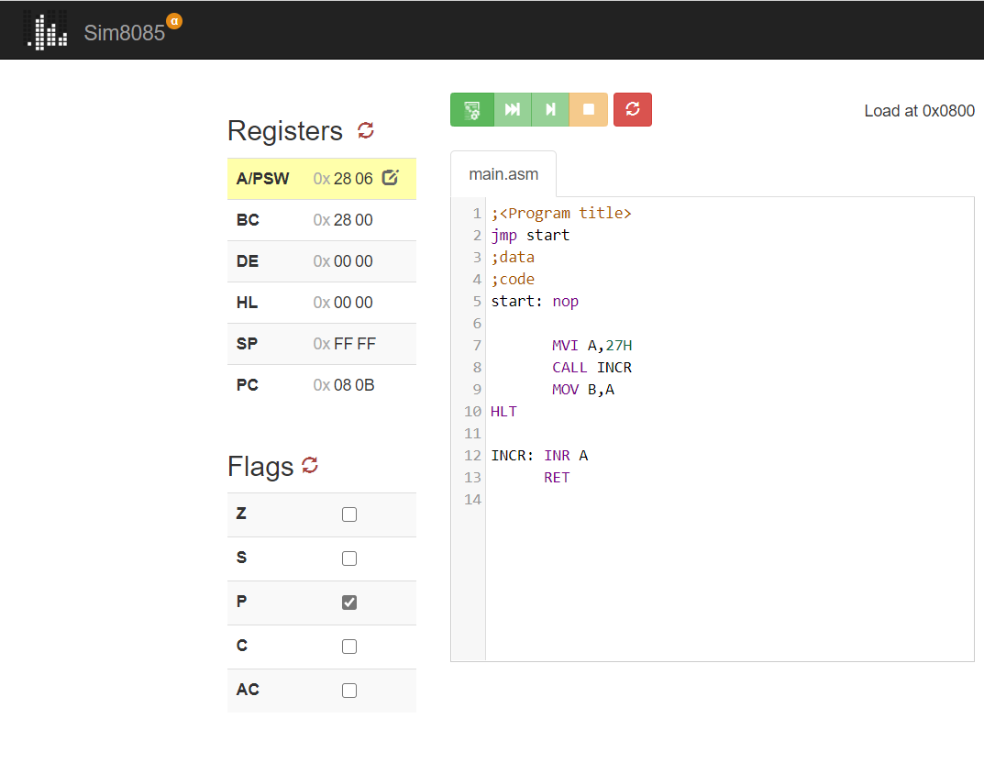

**2) Write 8085 program to demonstrate the working of given list of conditional call instructions:**

**1-> CC - carry=1**

➢ **Program:**

INITIALLY VALUE OF ACCUMULATOR IS 0

STC; SET CARRY FLAG

CC INCR; CALL INCR LABEL

HLT

INCR: INR A; INCREMENT THE CONTENT OF ACCUMULATOR

RET

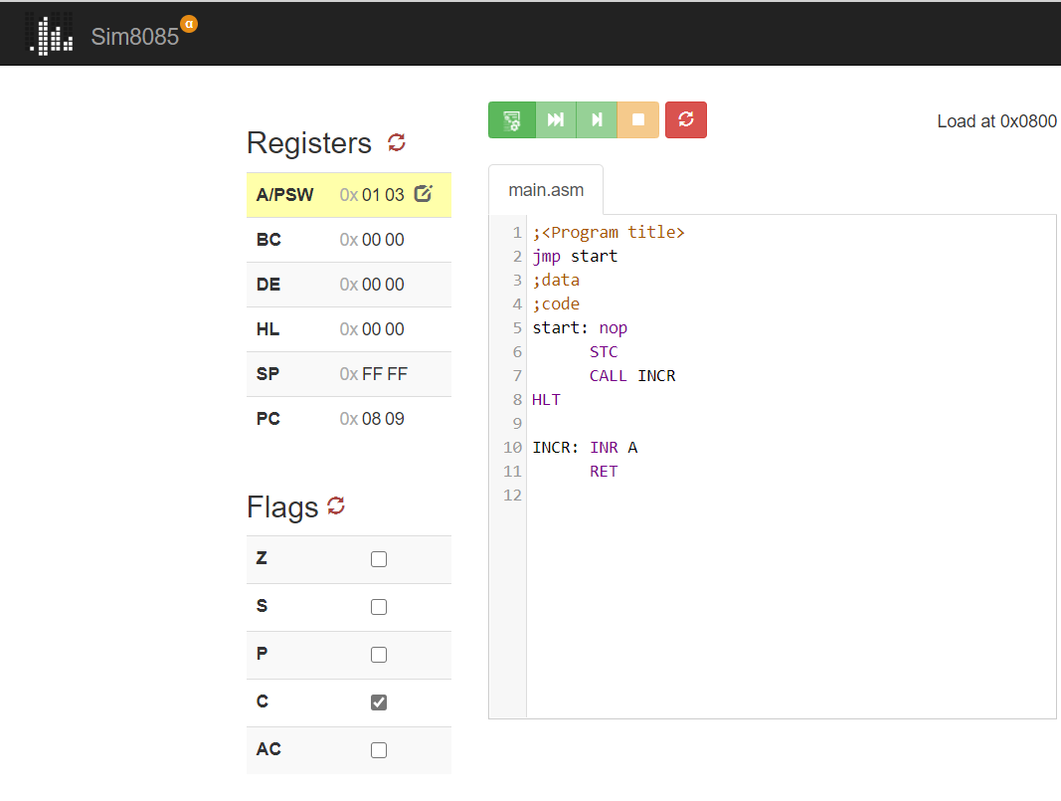

**2-> CNZ - zero=0**

* **Program:**

; INITIALLY C CONTENT 0H

MVI B,26H; MOVE IMMIDIATE 26 IN REGISTER B

MVI A,27H; MOV IMMIDIATE 27 IN ACCUMULATOR

SUB B; SUBTRACT B FROM A..A <= A-B ;

BUT HERE FINAL RESULT IS NOT ZERO MEANS Z WILL BE RESET

CNZ LABEL

HLT

LABEL: INR C

RET

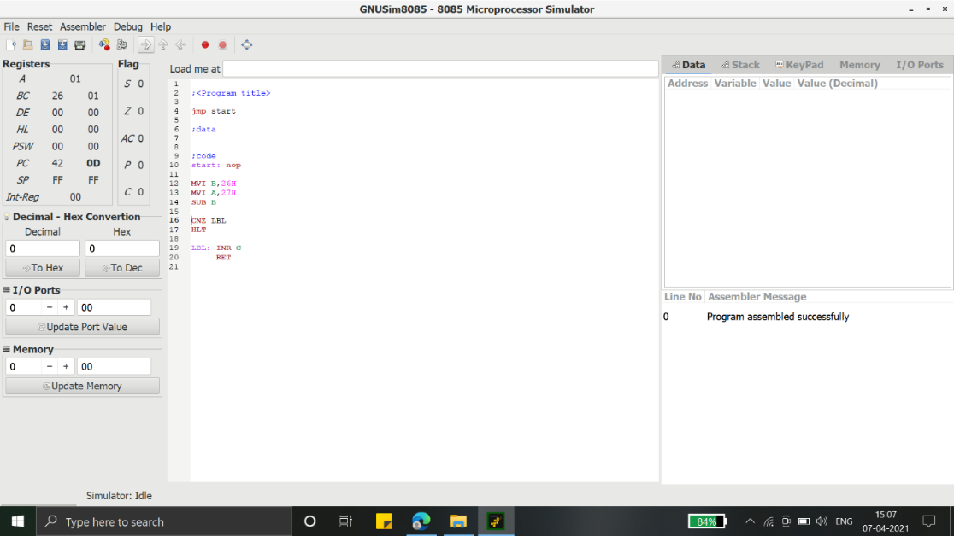

**3 -> CPE – parity=1**

**Program:**

MVI A ,07H; MOV IMMMIDIATE 07H DATA INTO ACCUMULATOR

SUI 02H; A <= A - 02

CPE DECR; CALL DECREMENT LABEL WHEN PARITY FLAG IS SET

HLT

DECR: DCR A; DECREMENT THE VALUE OF ACCUMULATOR

RET; RETURN TO THE MAIN PROGRAM

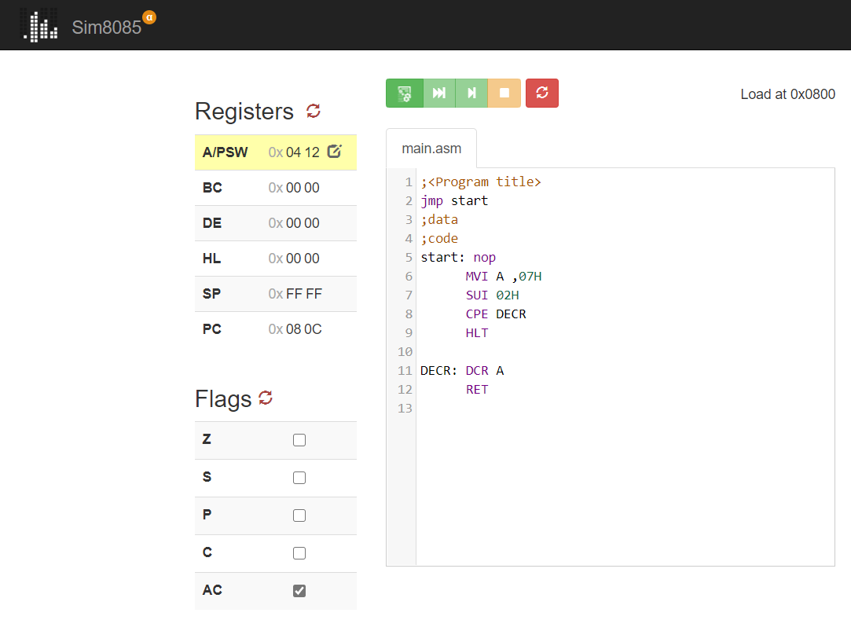

**4 -> CP – sign=0**

**Program:**

MVI A, 27H; TRANSFER IMMIDIATE 27H DATA INTO A

MVI B, 20H; TRANSFER IMMIDIATE 20H DATA INTO B

SUB B; A <= A-B <= 7H;

HERE FINAL RESULT WILL BE POSITIVE MEANS SIGN FLAG = 0

CP INCR; CALL INCR LABEL

HLT

INCR: INR A

RET

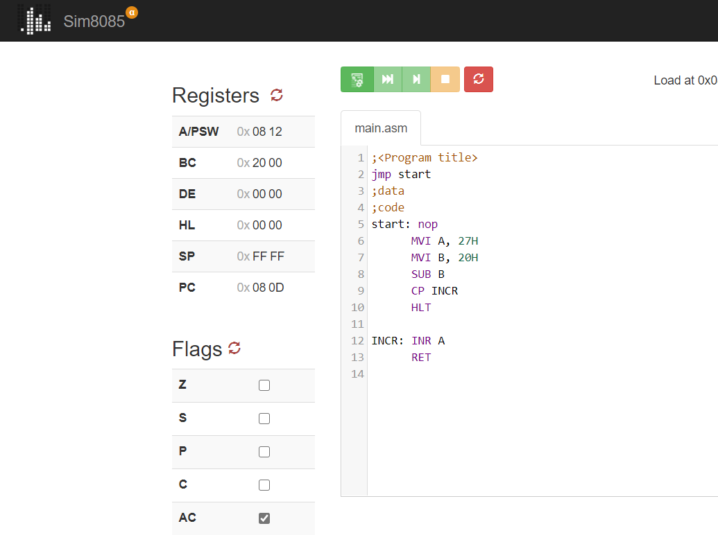

**5 -> RNC - carry=0**

**➢ Program:**

CALL START; CALL INCR LABEL

HLT

START: MVI A, 27H; TRANSFER IMMIDIATE 27H DATA INTO A

MVI B , 20H ; TRANSFER IMMIDIATE 20H DATA INTO B

SUB B; A <= A-B <= 7H;

HERE FINAL RESULT WILL NOT BE GENERATE ANY CARRY BIT;

SO, C = 0

RNC; RETURN TO MAIN PROGRAM ON NO CARRY (C = 0)

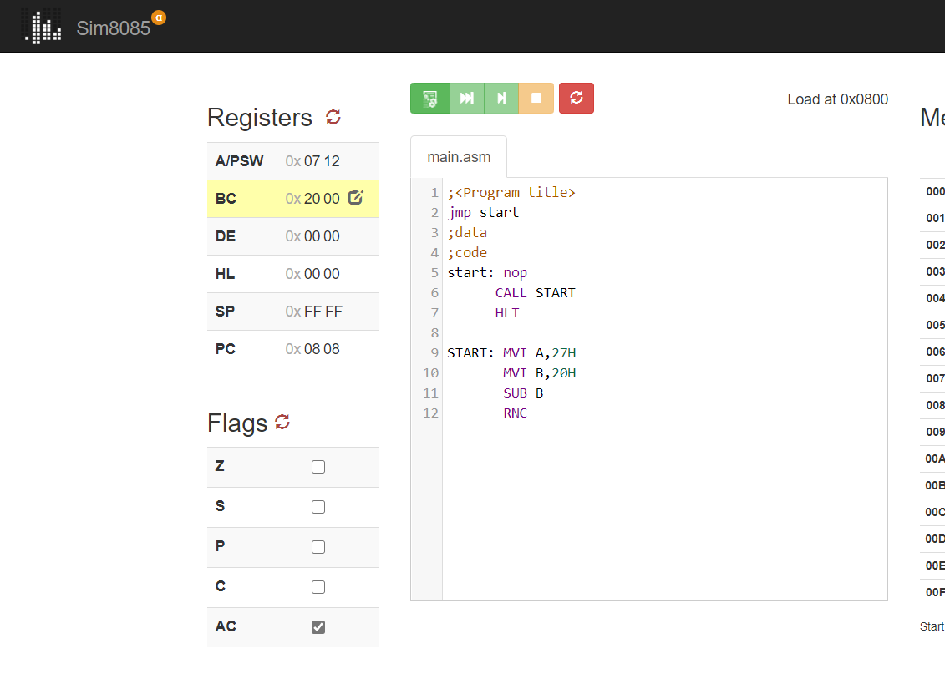

**6 -> RZ - zero=1**

**➢ Program:**

CALL START; CALL INCR LABEL

HLT

START: MVI A, 20H; TRANSFER IMMIDIATE 27H DATA INTO A

MVI B, 20H; TRANSFER IMMIDIATE 20H DATA INTO B

SUB B; A <= A-B <= 0H;

HERE FINAL RESULT WILL BE ZERO MEANS Z=1

RZ; RETURN TO MAIN PROGRAM ON NO CARRY (Z = 0)

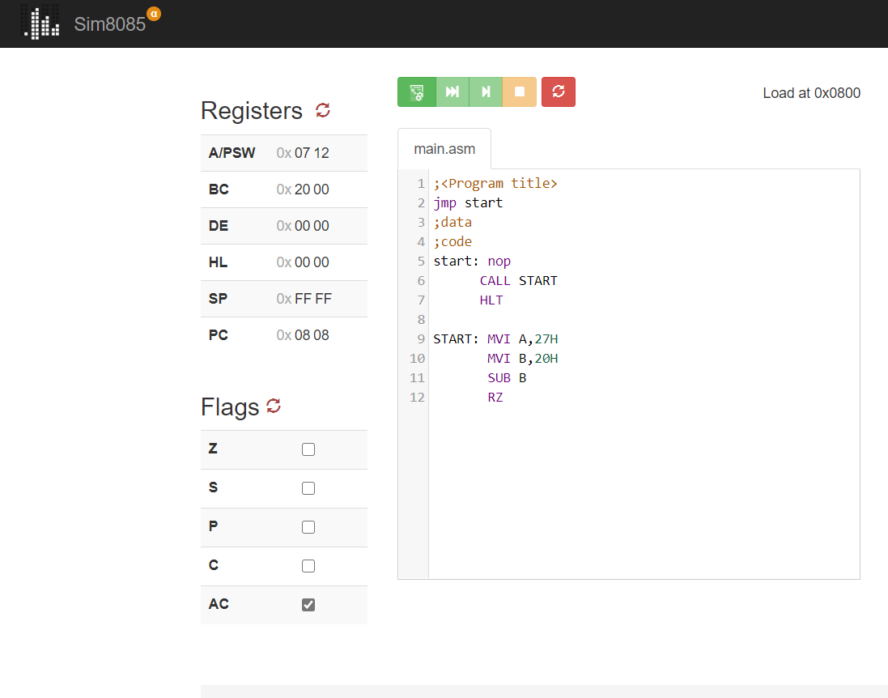

**6 -> RPO - parity=0**

**➢ Program:**

CALL START; CALL INCR LABEL

HLT

START: MVI A, 027H; TRANSFER IMMIDIATE FFH DATA INTO A

MVI B, 020H; TRANSFER IMMIDIATE FFH DATA INTO B

SUB B; A <= A-B <= 7H;

HERE FINAL RESULT WILL BE 7H IT WILL NOT BE GENETATED;

ANY PARITY BIT MEANS P =0

RPO; RETURN TO MAIN PROGRAM ON NO PARITY BIT (P = 0)

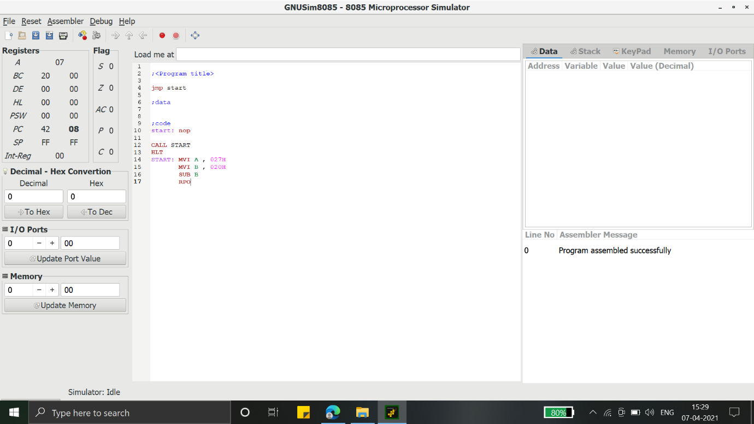

**7 -> RM - sign=1**

**➢ Program:**

CALL START; CALL INCR LABEL

HLT

START: MVI A, 20H; TRANSFER IMMIDIATE FFH DATA INTO A

MVI B,30H; TRANSFER IMMIDIATE FFH DATA INTO B

SUB B; A <= A-B <= -1H;

HERE FINAL RESULT WILL BE NEGATIVE;

SO, S = 1 (SET)

RM; RETURN TO MAIN PROGRAM ON SIGN BIT (S = 1)

