**Microprocessor & Interfacing**

**(Lab session-11)**

**Write an 8085 program to demonstrate the working of given list of conditional jump Instructions: JNC - carry=0 JZ - zero=1 JPE - parity=0 JM - sign=1.**

1. 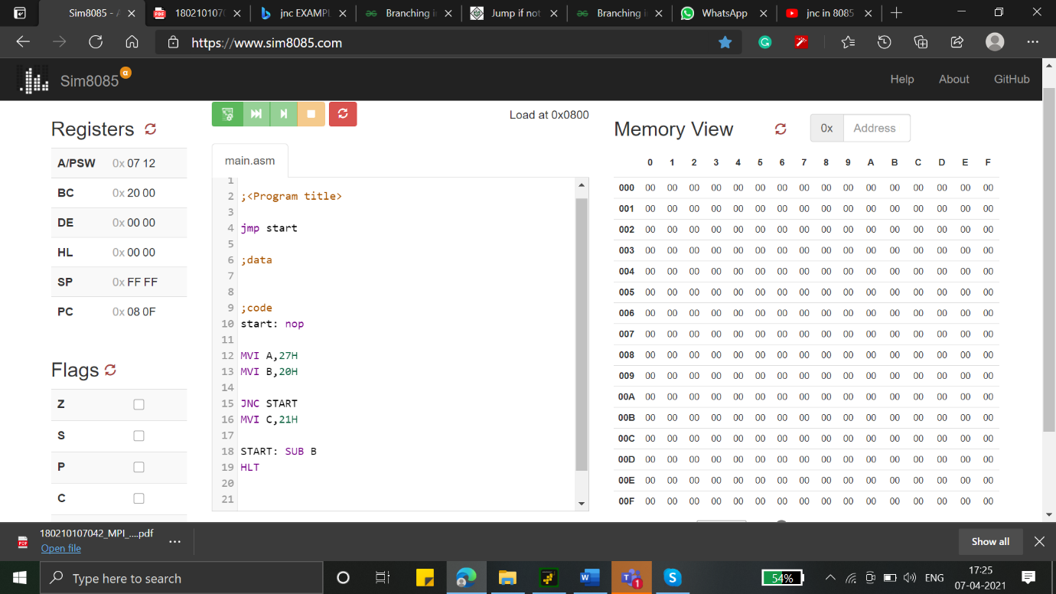**JNC - carry=0**

**Program:**

MVI A,27H

MVI B,20H

JNC START

MVI C,21H

START: SUB B

HLT

1. **JZ - zero=1**

**Program:**

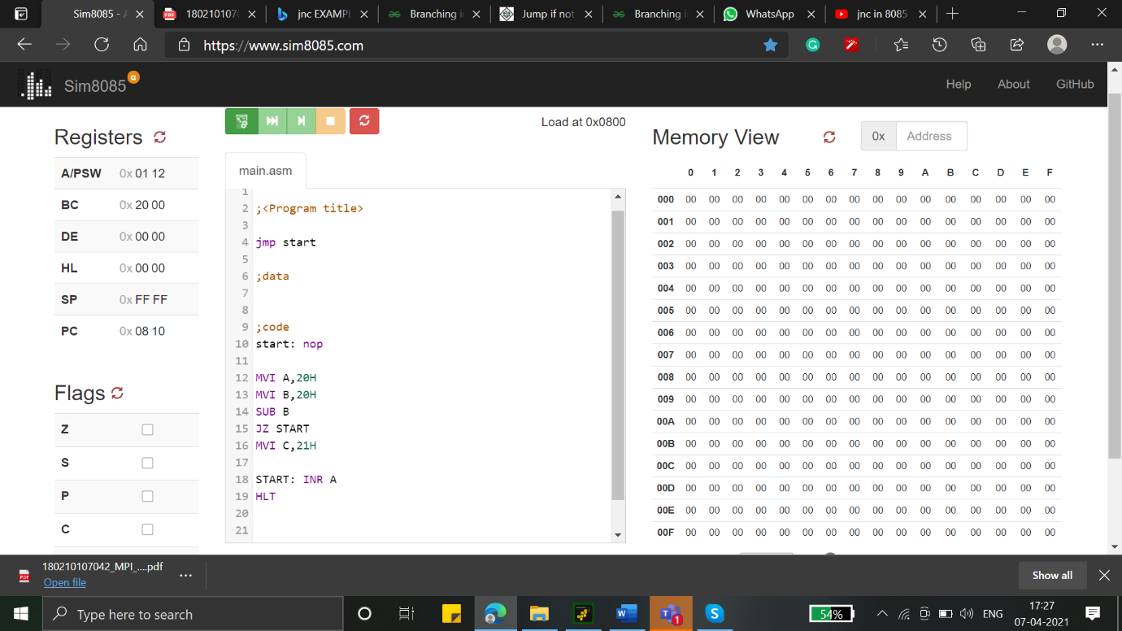

MVI A,20H

MVI B,20H

SUB B

JZ START

MVI C,21H

START: INRA

HLT

1. 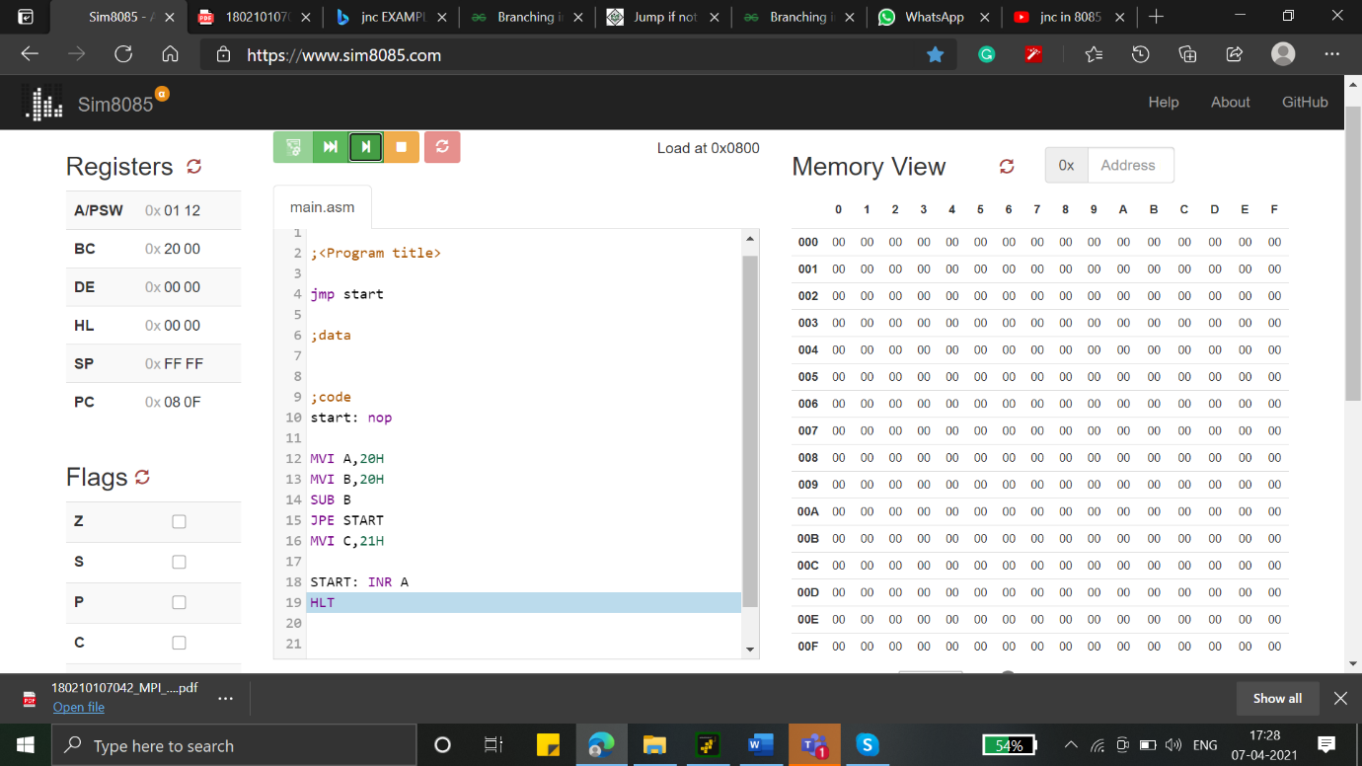**JPE - parity=0**

**Program:**

MVI A,20H

MVI B,20H

SUB B

JPE START

MVI C,21H

START: INRA

HLT

1. 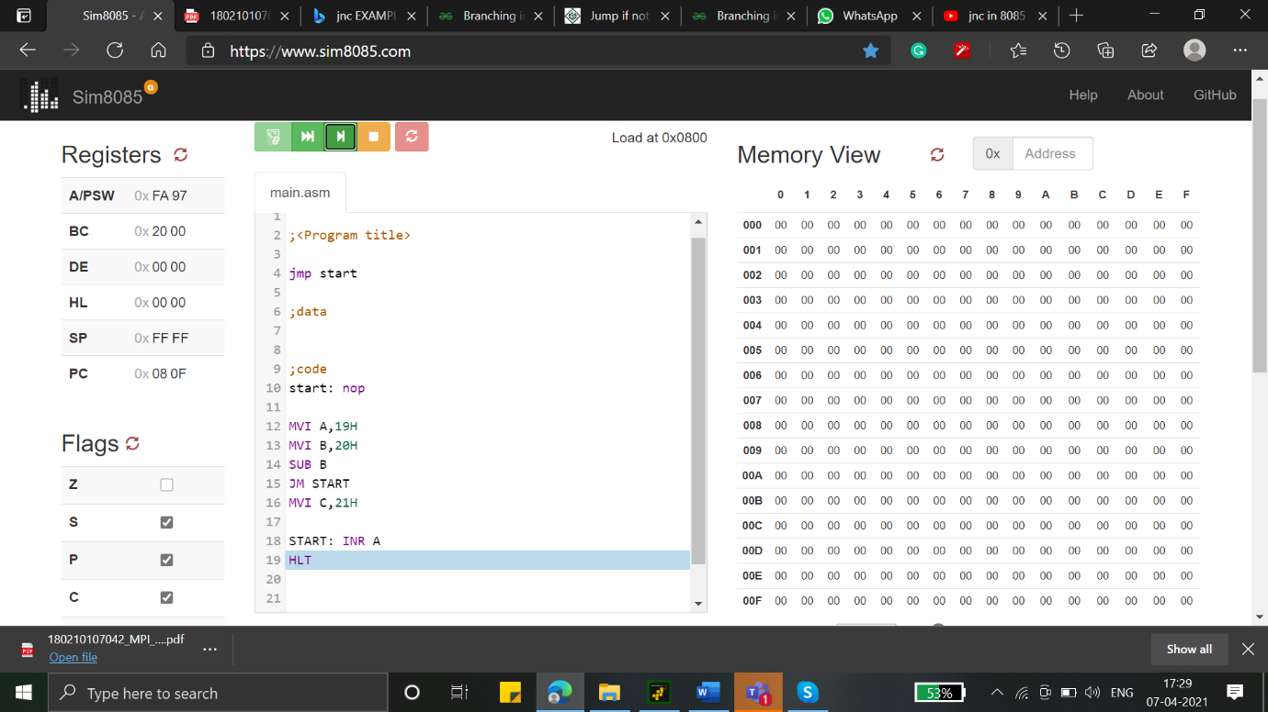**JM - sign=1.**

**Program:**

MVI A,20H

MVI B,20H

SUB B

JM START

MVI C,21H

START: INRA

HLT