**Microprocessor & Interfacing**

**(Lab session-03)**

**Q-1) Write an Assembly language program to exchange the contents of DE and HL register pair. The contents of DE=B5F4H and HL=4289H.  
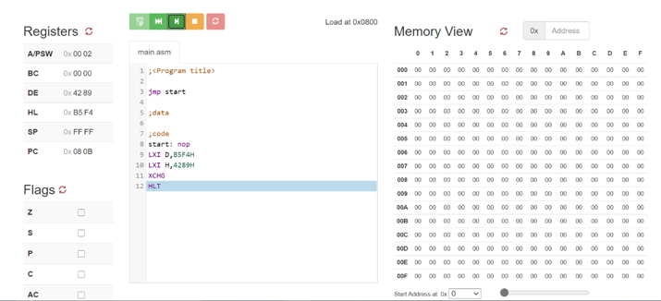**

**Q-2) Write an Assembly language program to exchange the content of HL register pair which is 5678H with the contents stored at 4673H and 4674H which are DEH and 78H respectively.**

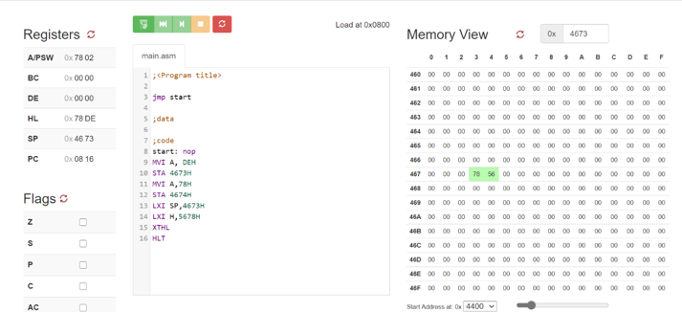

**Q-3) Write an Assembly language program to initialize the content of PC register with 1189H using HL register pair.**

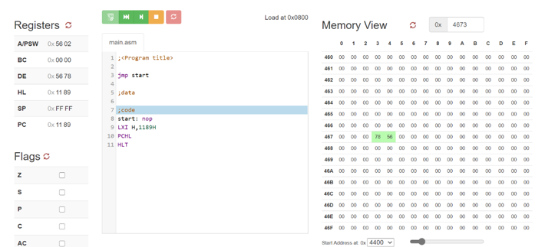

**Q-4) Write an Assembly language program to load the contents stored at two consecutive memory locations starting from 2378H into HL register pair. Use only one single instruction to complete the process of loading data.**

