**Microprocessor & Interfacing**

**(Lab session-04)**

1. **Write an assembly language program to add two 8-bit numbers stored at address 2050 and address 2051 in 8085 microprocessors. The starting address of the program is taken as 2000.**

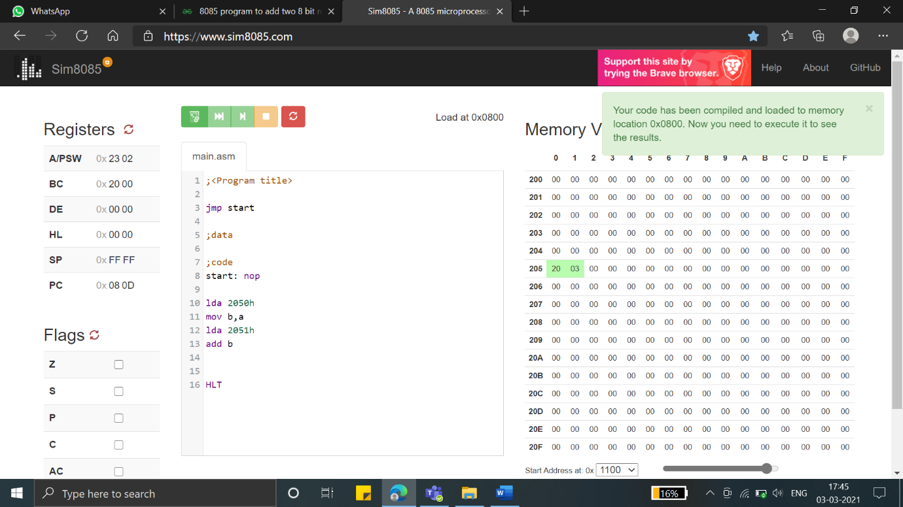

1. **Write assembly language program to do addition of two 8-bit numbers.**

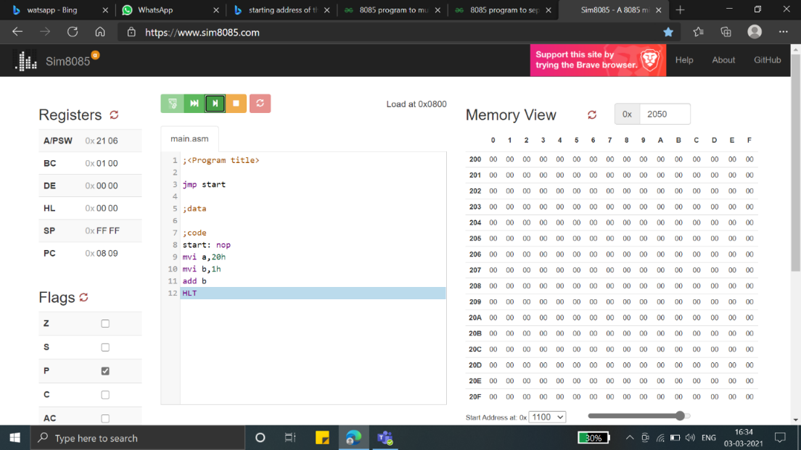

1. **Write an 8085 program to add two 16-bit nos stored in memory locations 2100H and 2200H respectively.**

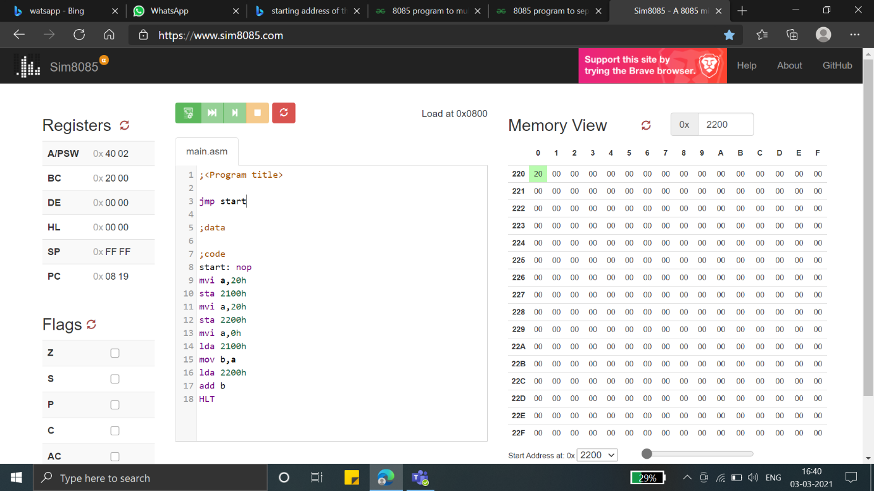

1. **Write an 8085 program to add the contents of HL and SP register pairs.**

