**Microprocessor & Interfacing**

**(Lab session-05)**

1. **Write an 8085 program to subtract two 8-bit numbers with borrow bit. Contents are A=30H and B=10H**

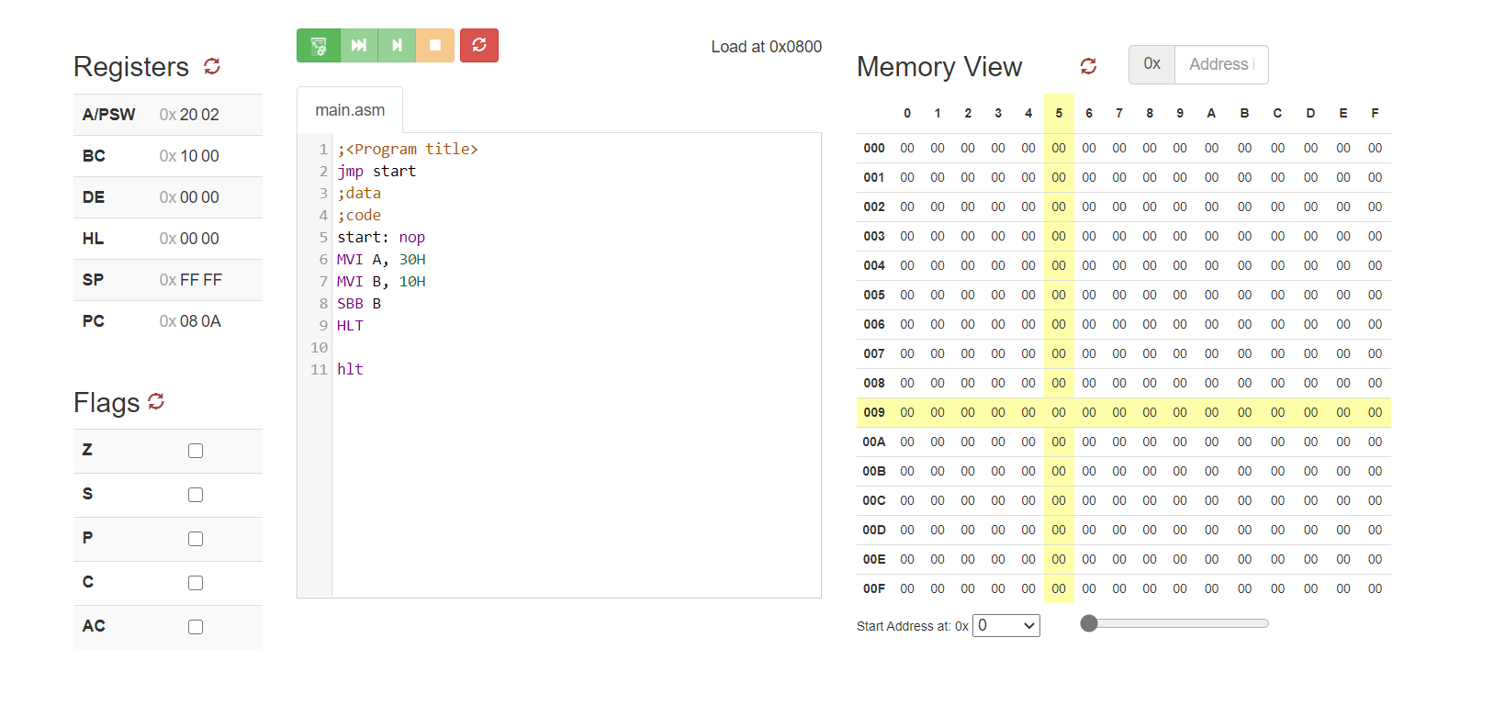

1. **Write an 8085 program to subtract two 8-bit numbers without borrow bit. Contents are H=98H and L=34H**

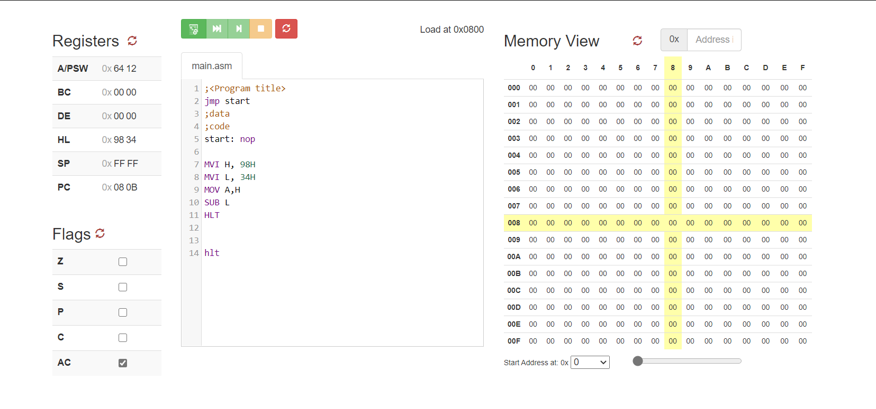

1. **Write an 8085 program to subtract two 8-bit numbers with borrow bit. Contents are [2378H] =09H and [4578H] =03H**

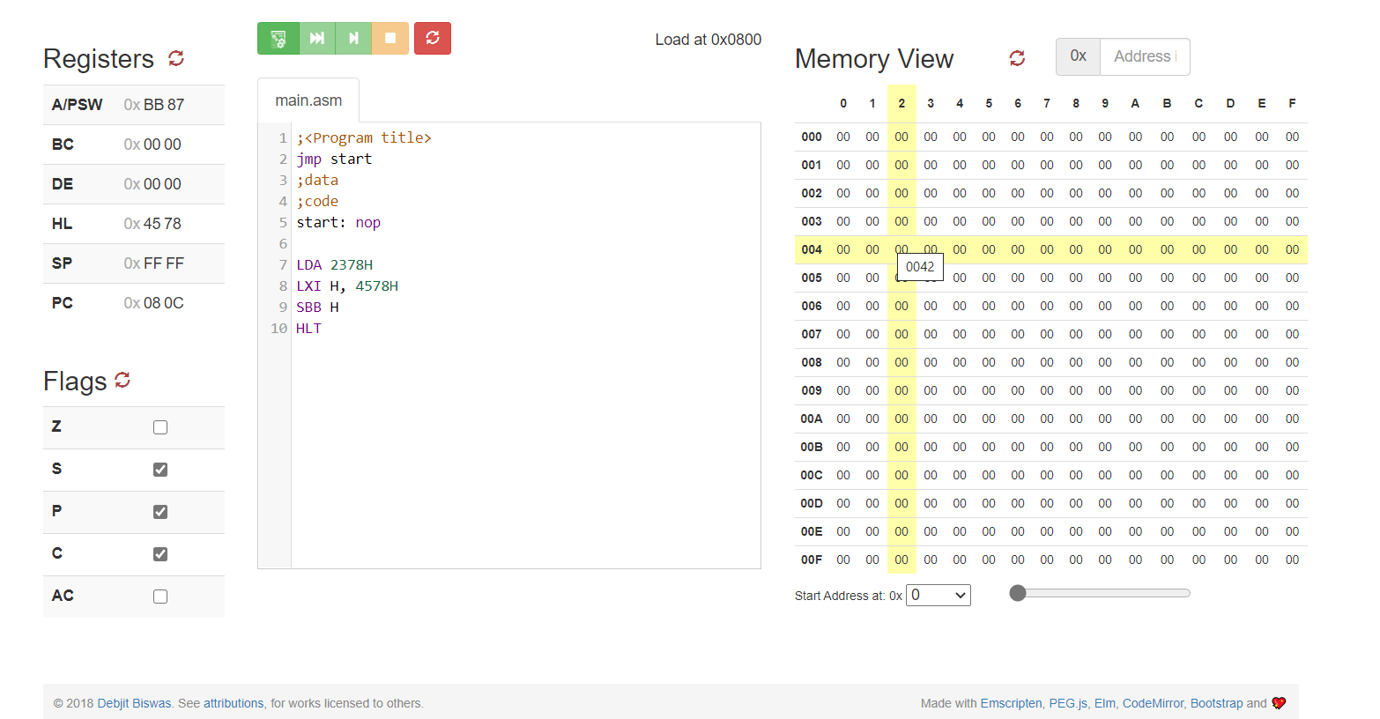

1. **Write an 8085 program to subtract two 8-bit numbers without borrow bit. Contents are [2548H] =56H and [2156H] =22H**

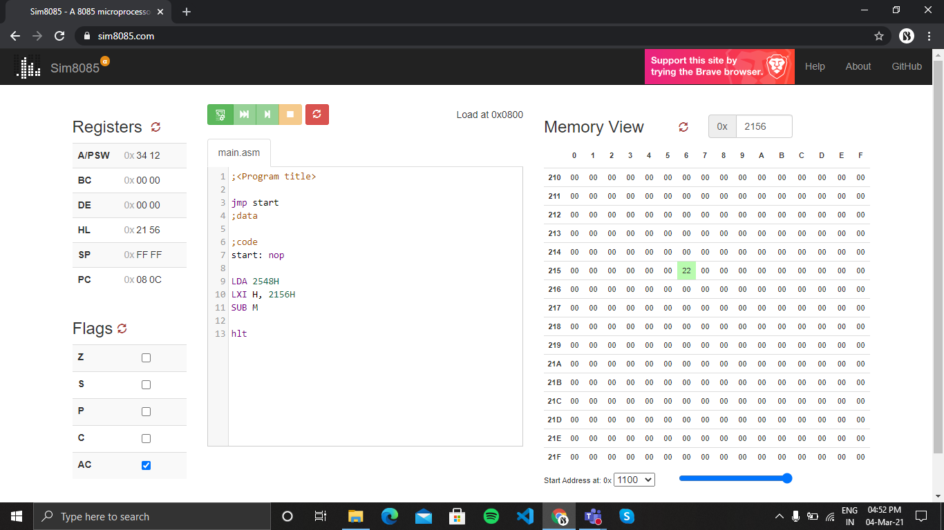

1. **Write an 8085 program to subtract 23H data from the content of accumulator A which is 78H.**

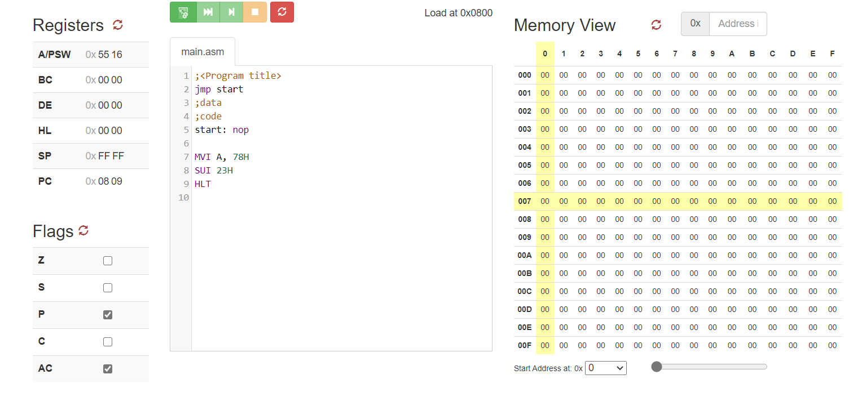

1. **Write an 8085 program to subtract 38H data and carry bit from the content of accumulator A which is 98H.**

