**Microprocessor & Interfacing**

**(Lab session-06)**

* **Increment Decrement Instructions**
* **Write an 8085 program to demonstrate increment operation for 8-bit and 16-bit data.**

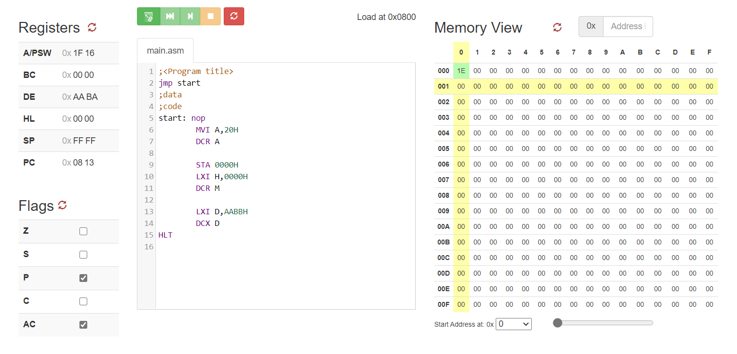

* **Write an 8085 program to demonstrate decrement operation for 8-bit and 16-bit data.**

