**Microprocessor & Interfacing**

**(Lab session-07)**

* **Demonstrate AND, OR and XOR instructions through 8085 programs for following:**

**Assume A contains 89H, Memory Address=0045H**

**1) ANA R, ANA M, ANI 56H**

* **ANA M**

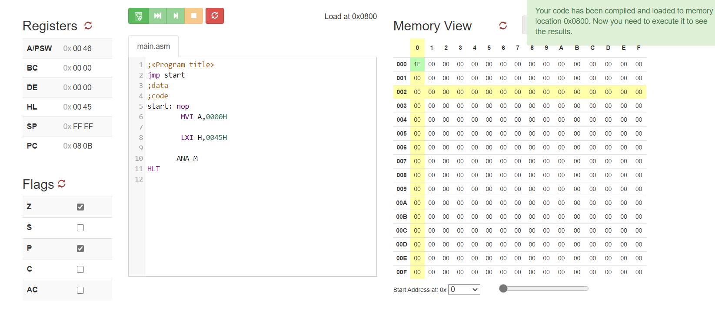

* **ANA R**

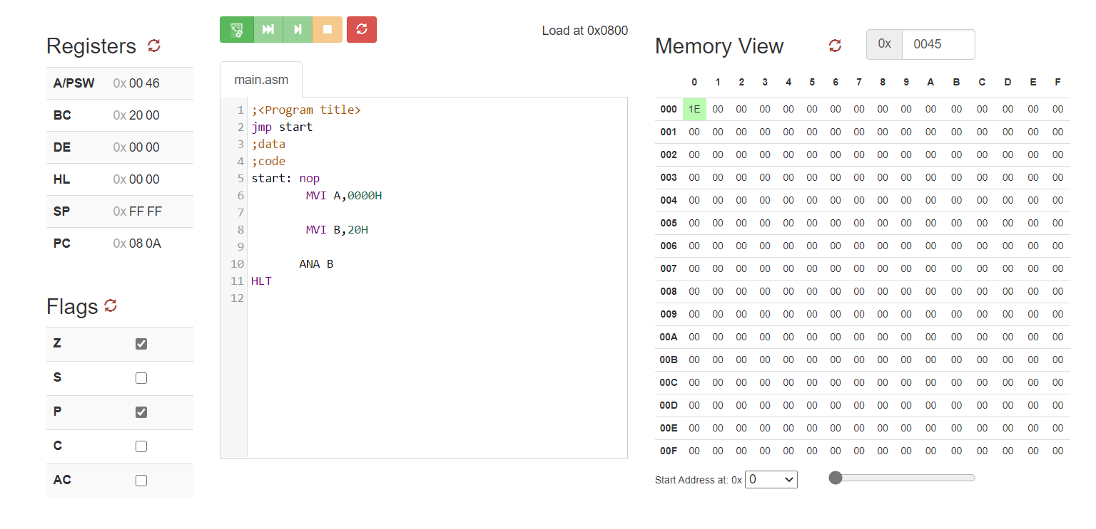

* **ANI 56H**

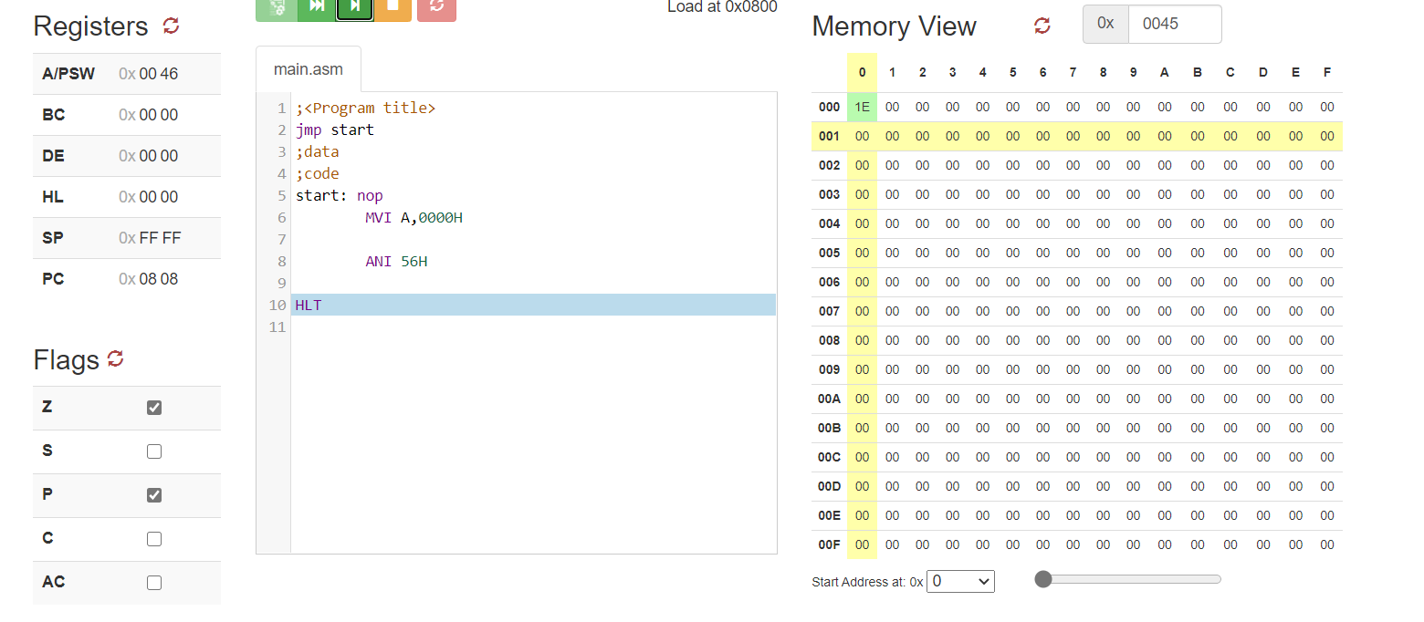

**2) ORA R, ORA M, ORI 34H**

* **ORA** M

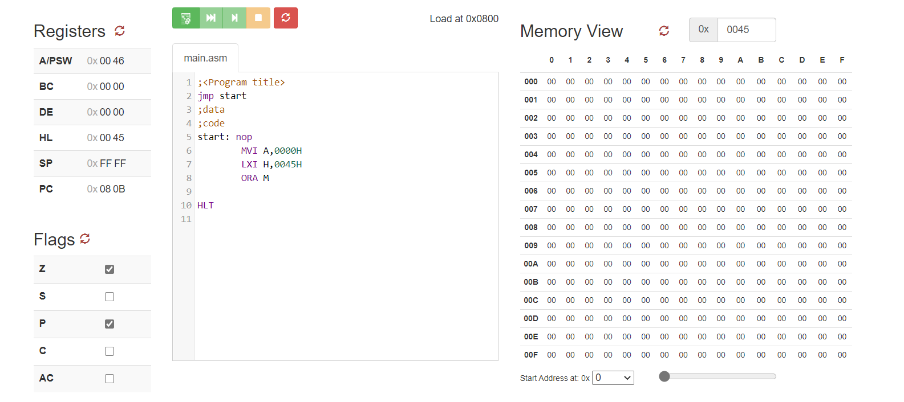

* **ORA R:**

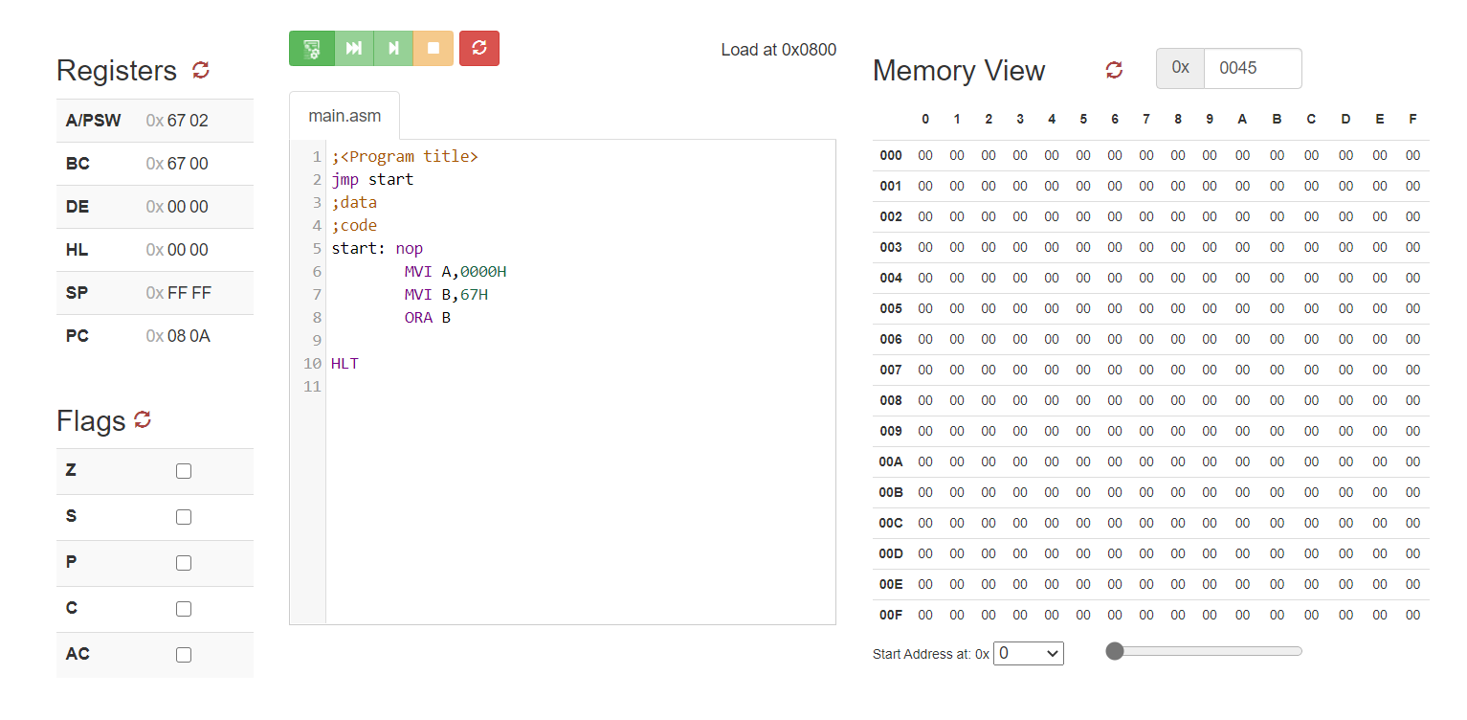

* **ORI 34H**

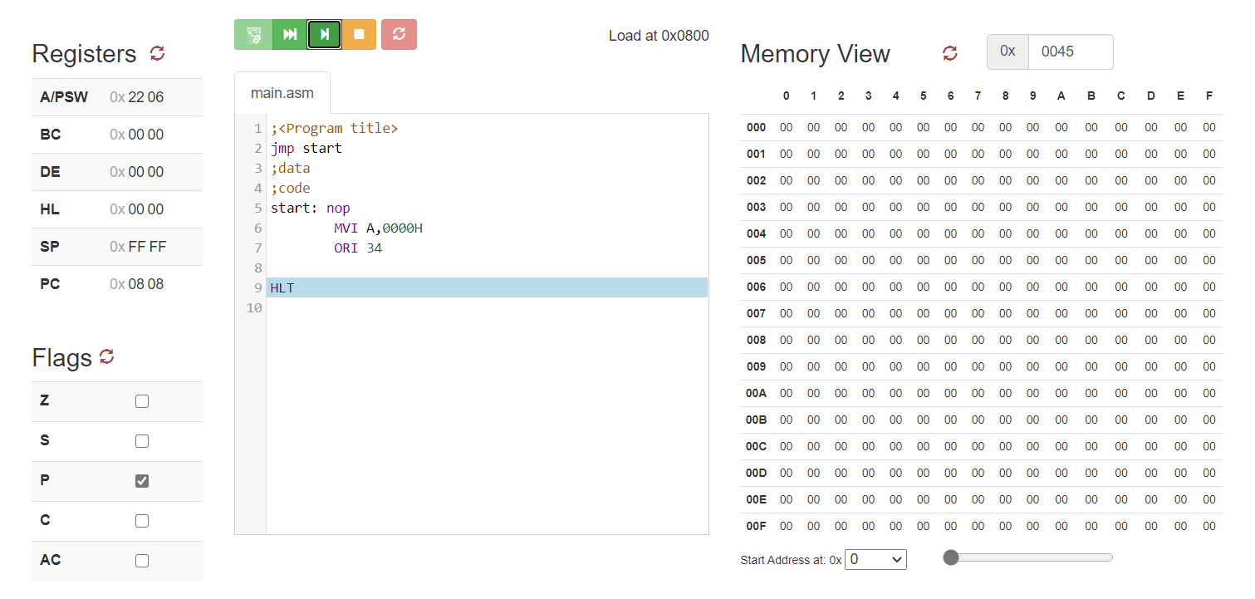

**3) XRA R, XRA M, XRI 67H**

* **XRA M**

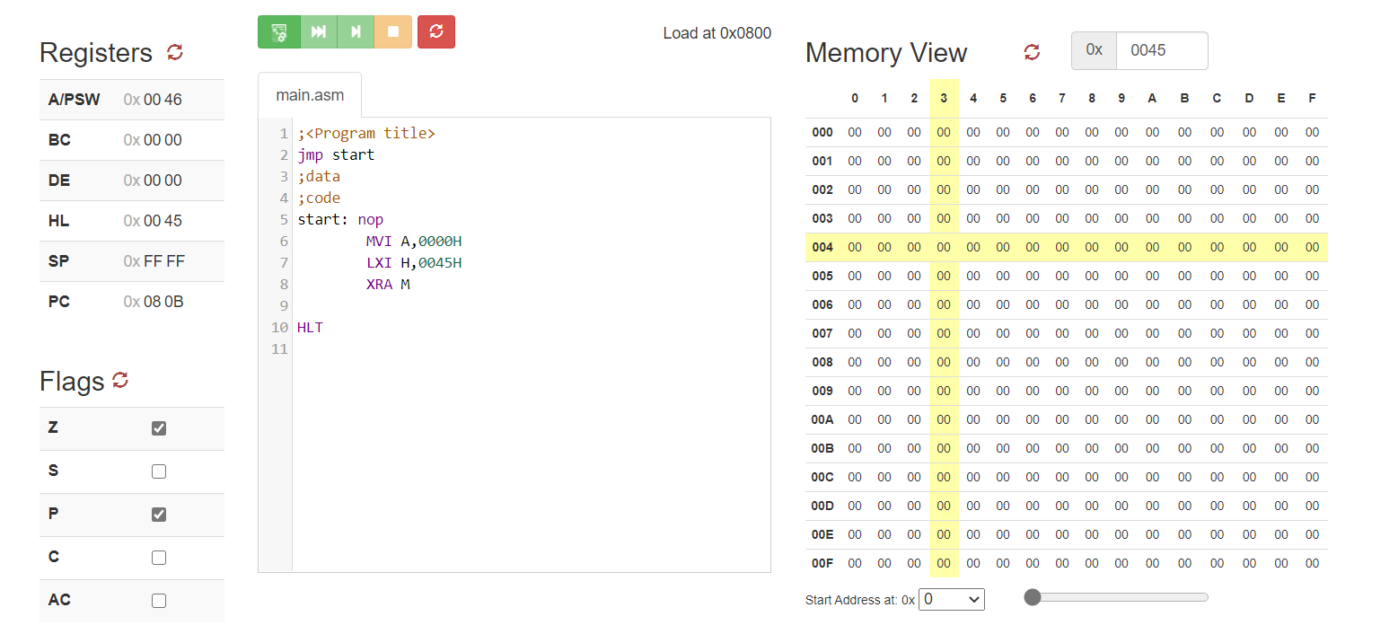

**XRA R**

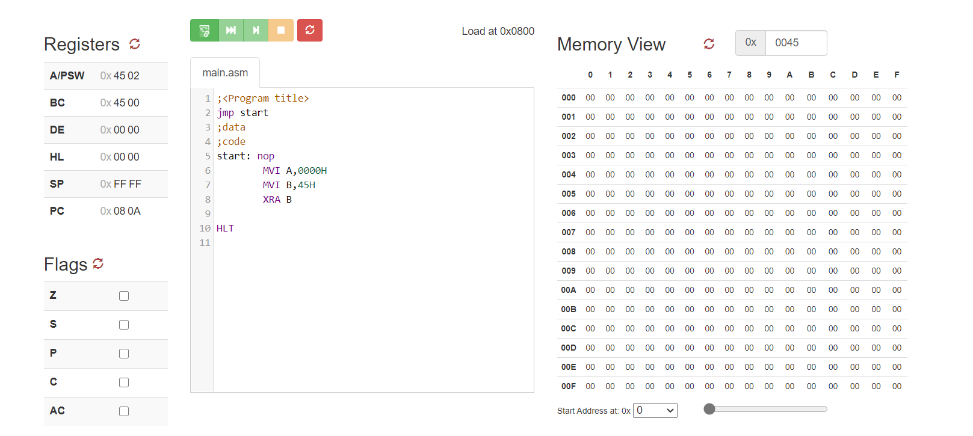

* **XRI 67H**

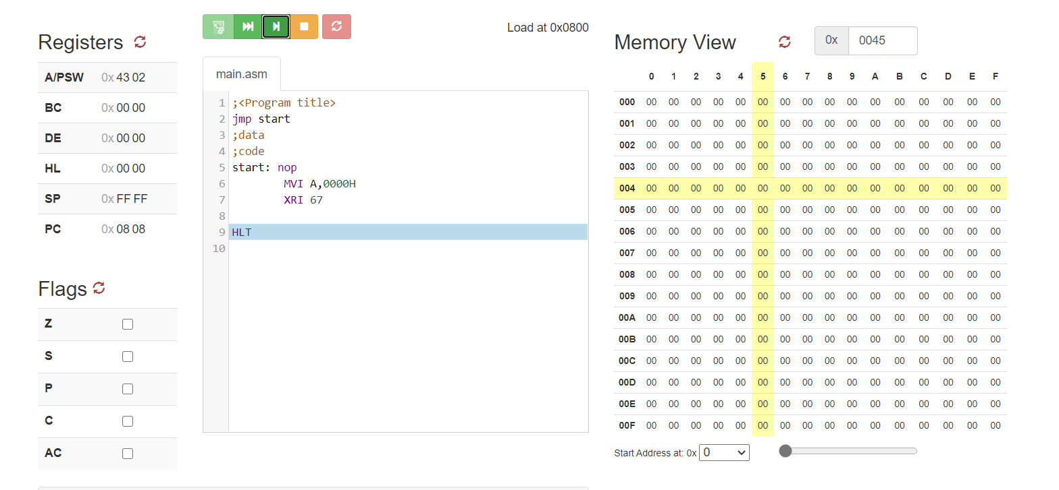

* **Write an 8085 program to clear the higher 4 bits of contents inside register A. Content of Register A = 45H. (ANI 0FH)**

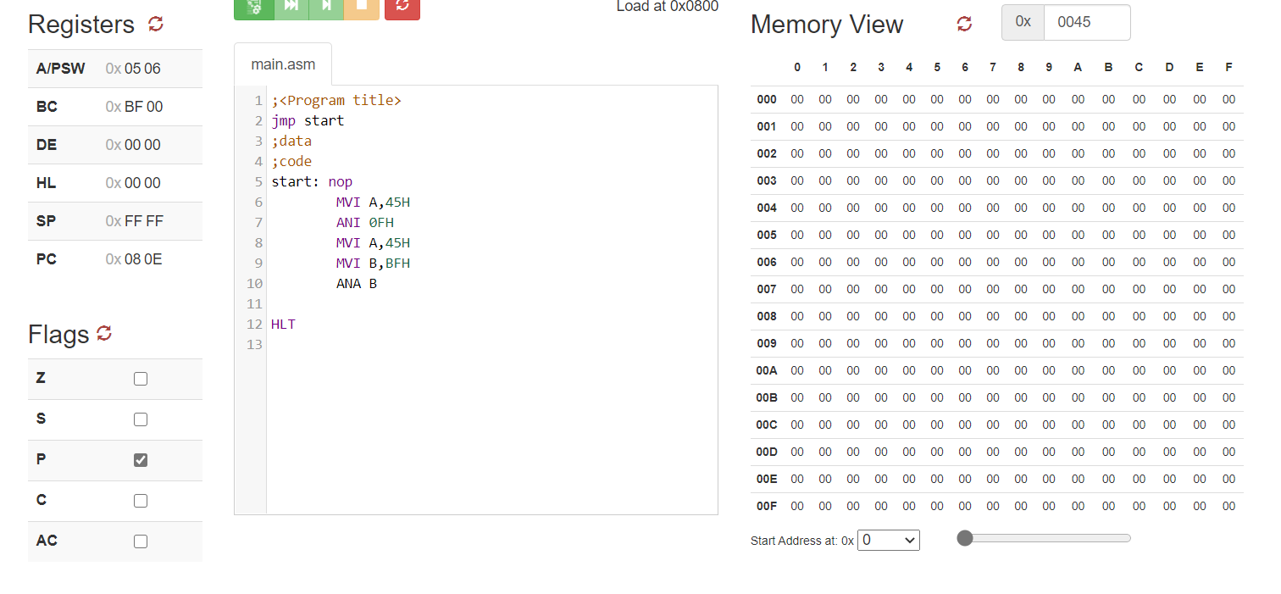

* **Write an 8085 program to set the higher 3 bits of contents inside register A. Content of Register A = 27H. (ORI E0H)**

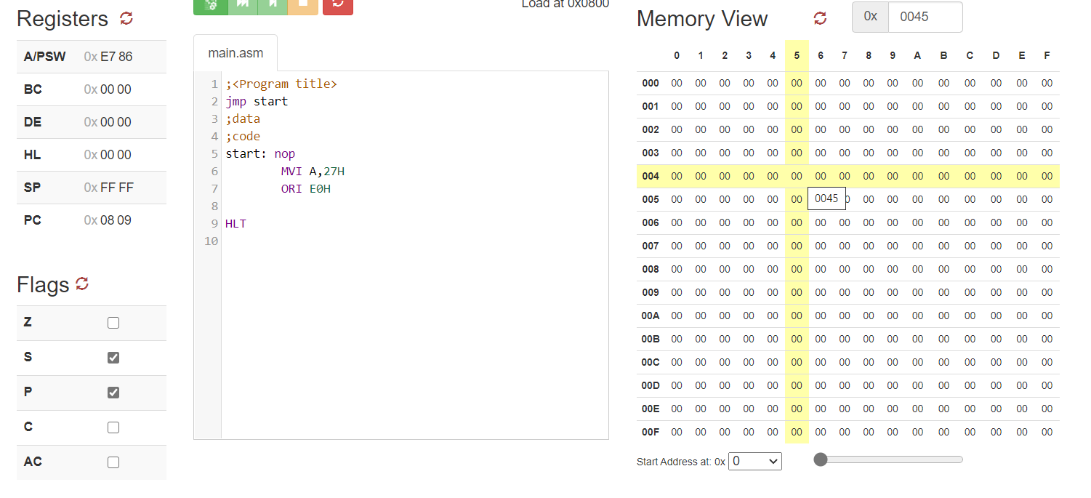

* **Write an 8085 program to complement the lower 4 bits of contents inside register A. Content of Register A = 67H. (XRI 0FH)**

