**Microprocessor & Interfacing**

**(Lab session-08)**

* **Demonstrate Compare instructions through 8085 programs**
* **Write an 8085 program to compare the contents of register A and H which are as follows: A=89H, H=34H. Also derive the conclusion by the end of this operation in reference to the contents of flag register.**

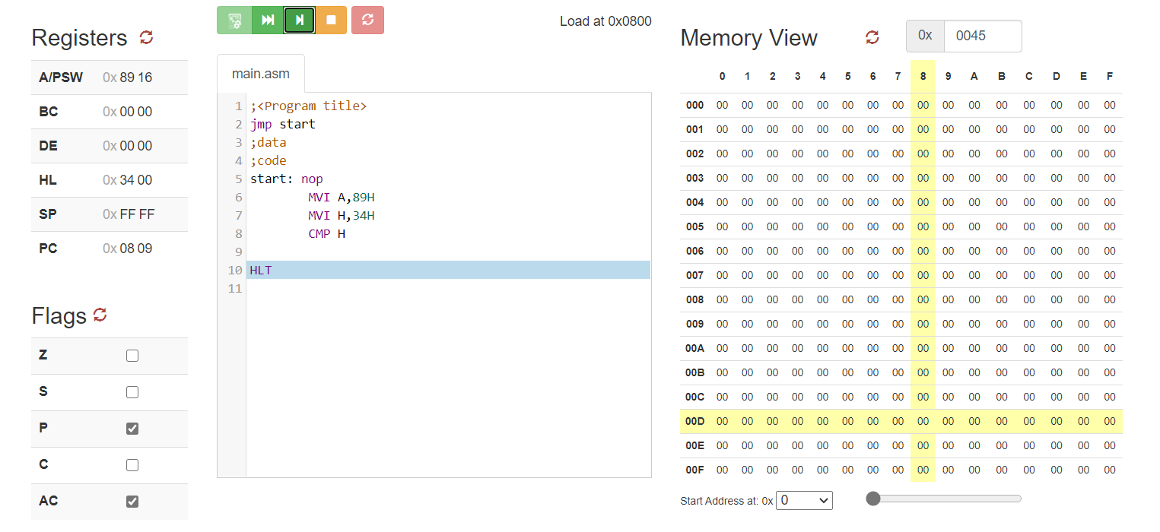

* **Write an 8085 program to compare the contents of register A and content at memory location 2436H which are as follows: A=5BH, [2436] = 5BH. Also derive the conclusion by the end of this operation in reference to the contents of flag register.**



* **Write an 8085 program to compare 67H with the contents of Register A=23H. Also derive the conclusion by the end of this operation in reference to the contents of flag register.**

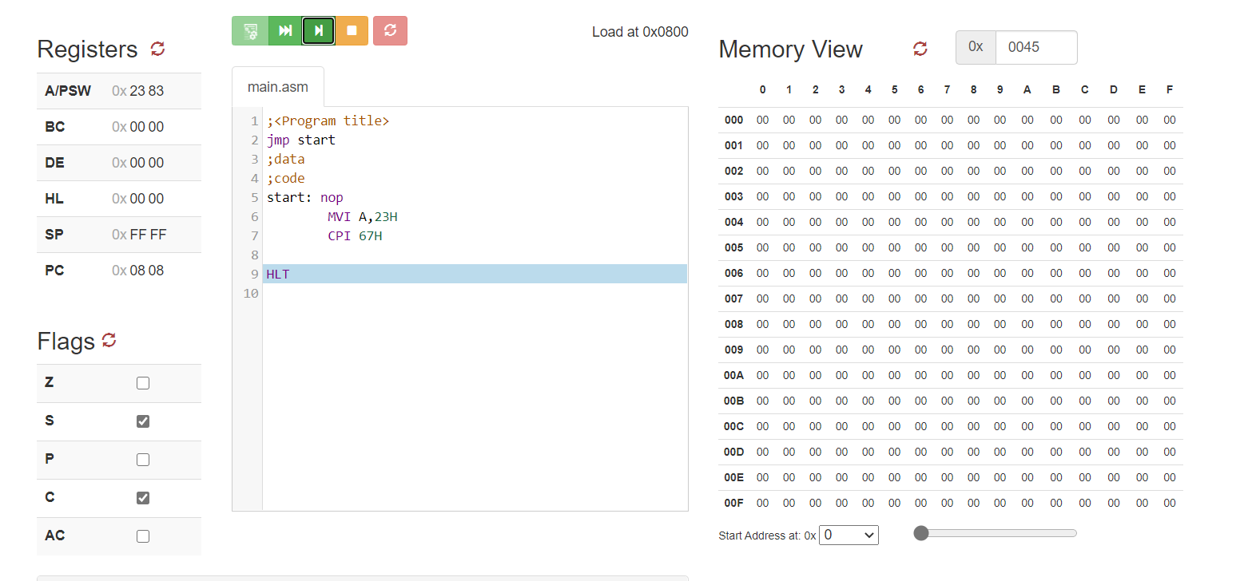

* **Write an 8085 program to complement the current content of Register H and Carry Flag (CY).**

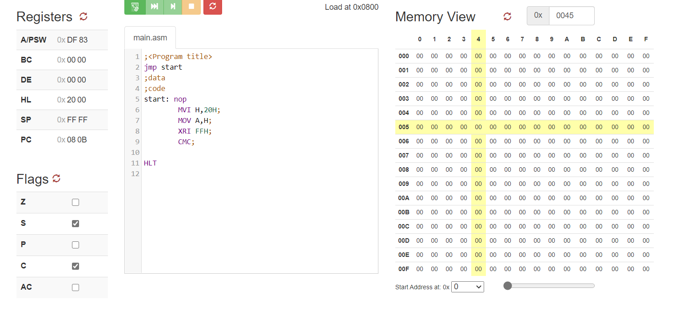

* **Write an 8085 program to set the carry flag**

