**Microprocessor & Interfacing**

**(Lab session-09)**

1. **Write an 8085 program to perform multiplication of the contents of Register B with the contents of Register C using logical instructions. The contents of B=08H and C=04H.**

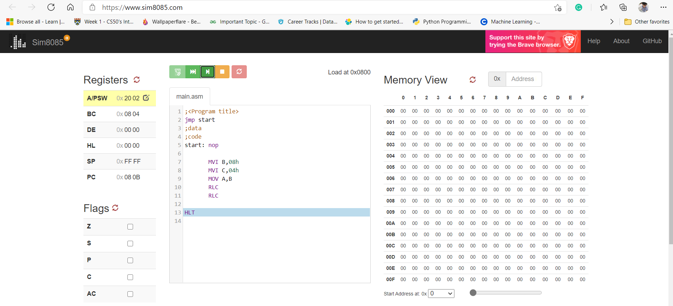

1. **Write an 8085 program to perform division of the contents of Register B by the contents of Register C using logical instructions. The contents of B=10H and C=04H.**

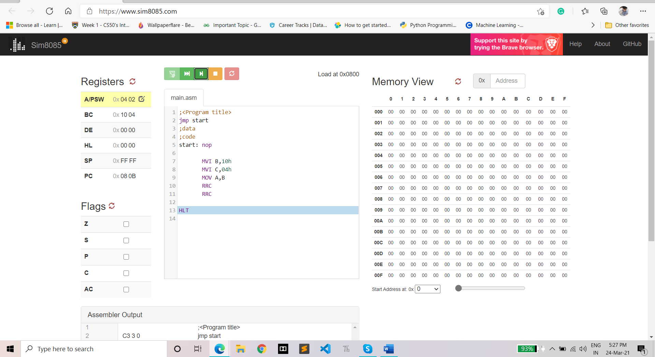

1. **Calculate the decimal value of the number in the accumulator before and after the Rotate instructions are executed and explain the mathematical functions performed by the instructions**
2. **MVI A 18H RLC**

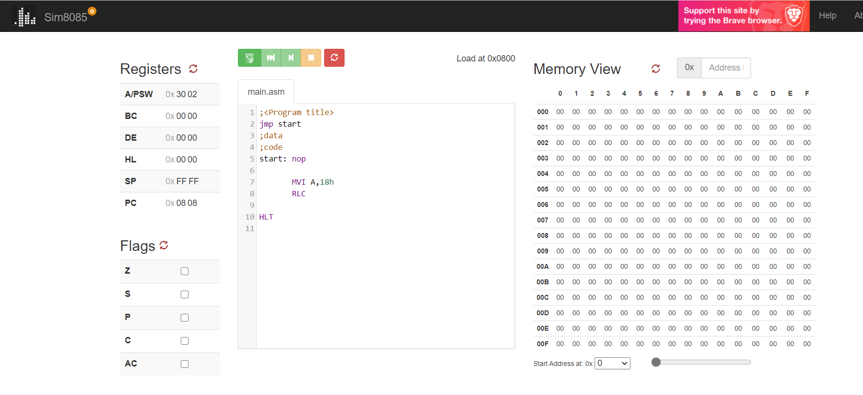

**b) MVI A, 78H RRC RRC**

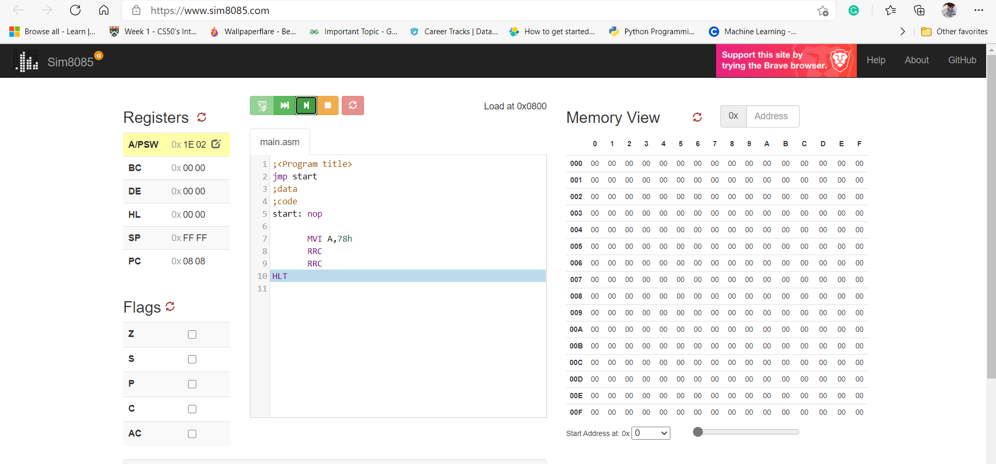

1. **Write an 8085 program to demonstrate the rotate left through carry flag instruction. Assume A=78H and CY=0**

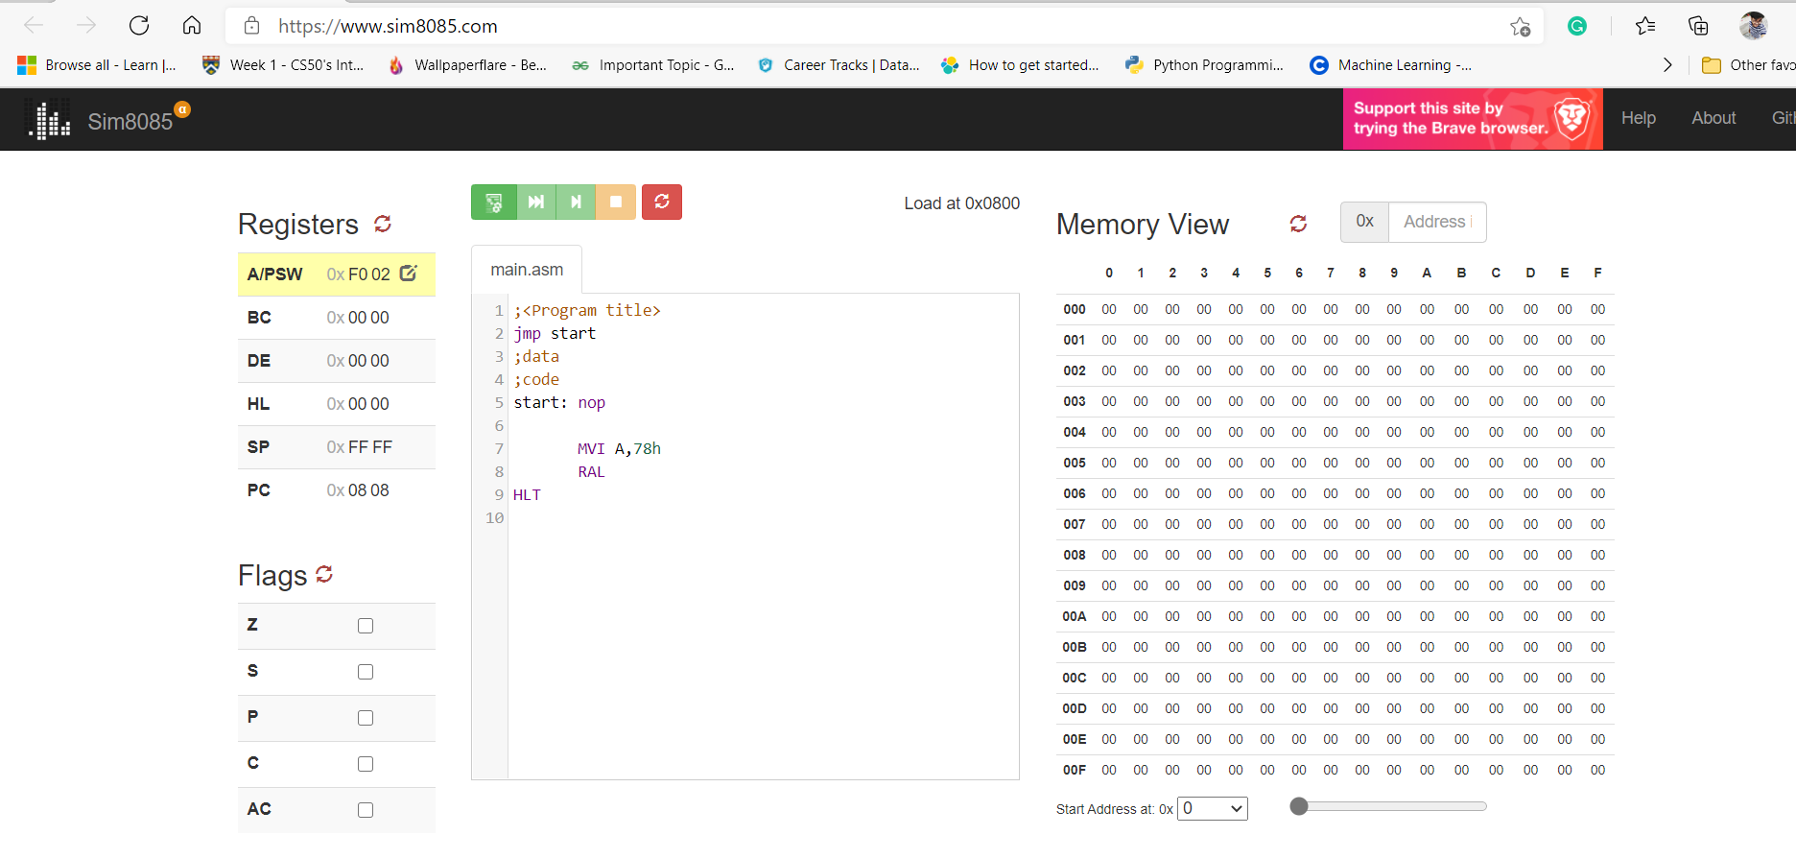

1. **Write n 8085 program to demonstrate the rotate right through carry flag instruction. Assume B=34H and CY=1**

