**Compiler Design**

* **Assignment – 3: Implement below code:**

1. **Generate Histogram of Words:**

**CODE:**

**%option noyywrap**

**%{**

**#include<stdio.h>**

**#include<string.h>**

**%}**

**%%**

**%%**

**char *text;**

**int main()**

**{**

**text=(char *)malloc(100*sizeof(char));**

**char *word=(char *)malloc(10*sizeof(char));**

**char *temp=(char *)malloc(10*sizeof(char));**

**printf("\nEnter the text of max length 99 and max length of any word should be 10\n");**

**gets(text);**

**int len=0;**

**int words=0;**

**int unique=0;**

**while(len<strlen(text))**

**{**

**words++;**

**sscanf(text+len,"%s",word);**

**int ctr=0;**

**int freq=0;**

**while(ctr<strlen(text))**

**{**

**sscanf(text+ctr,"%s",temp);**

**if(strcmp(word,temp)==0)**

**freq++;**

**ctr=ctr+strlen(temp)+1;**

**}**

**if(freq!=1)**

**printf("\n<%s> is not unique and has frequency %d\n",word,freq);**

**else**

**{**

**printf("\nThe word <%s> is unique\n",word);**

**unique++;**

**}**

**len=len+strlen(word)+1;**

**}**

**printf("\nThe number of unique words is %d\n",unique);**

**printf("\nThe total number of words are %d\n",words);**

**getch();**

**}**

**Output:**

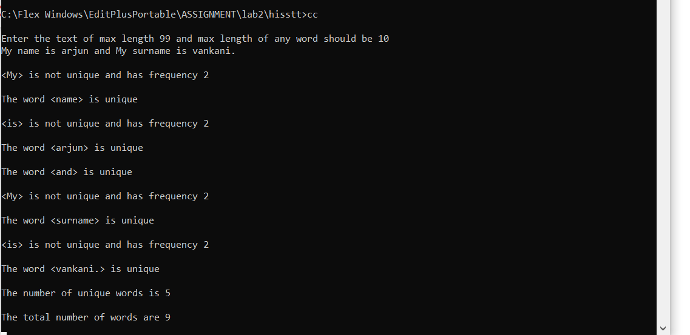

1. **Cesar Cipher**

**CODE:**

%option noyywrap

%{

#include<stdio.h>

%}

%%

[a-z] {char ch = yytext[0];

ch += 3;

if (ch> 'z') ch -= ('z'+1- 'a');

printf ("%c" ,ch );

}

[A-Z] { char ch = yytext[0] ;

ch += 2;

if (ch> 'Z') ch -= ('Z'+1- 'A');

printf("%c",ch);

}

%%

int main()

{

yylex();

return 0;

}

**OUTPUT:**

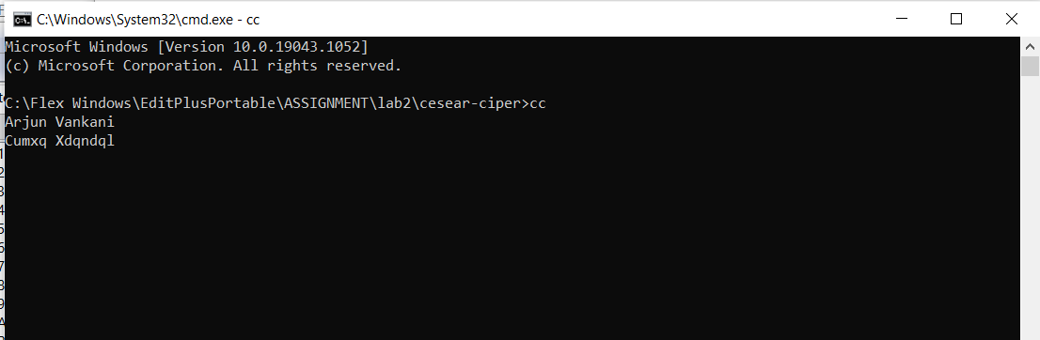

1. **Count Comment:**

**CODE:**

%option noyywrap

%{

#include<stdio.h>

#include<stdlib.h>

int a=0,b=0,c=0,d;

%}

%%

"//".* {a++;}

"/*" {b++;}

.*"*/" {b--;c++;}

%%

void main(int argc,char *argv[]){

yyin=fopen(argv[1],"r");

yylex();

printf("\nSingle line %d \nMultiline %d \n",a,c);

d=a+c;

printf("------------------------");

printf("\nTotal %d \n",d);

}

**OUTPUT:**

